Advanced Visualization Analysis for Investigating Complex Adverse Drug Reactions in Claims Data
Suji Xie
Pharmacovigilance Center, Office of Surgeon General, US Army
7700 Arlington Boulevard
Falls Church, VA
1-703-681-5856
Suji.xie.civ@mail.mil
Geoffrey Gordon
Commonwealth Informatics
260 Charles Street
Waltham MA
1-781-328-1826
ggordon@commoninf.com
Trinka Coster
Pharmacovigilance Center, Office of Surgeon General, US Army
7700 Arlington Boulevard
Falls Church, VA
1-703-681-5860
trinka.s.coster.mil@mail.mil

ABSTRACT
Understanding the suspected association of a medication to an adverse drug reaction (ADR) is challenging because it requires assessing the temporal relationships among many confounding factors (e.g., comorbidities, concomitant medications, and medical procedures) in a patient's medical history. This paper describes visual analytic capabilities developed by the US Army Pharmacovigilance Center (PVC) to support pharmacovigilance safety studies, illustrated with a complex ADR example - Drug Reaction Eosinophilia and Systemic Symptom (DRESS) – as the use case.
Categories and Subject Descriptors
H.5.2 [Information Interfaces]: User-centered design
General Terms
Design, Experimentation, Human Factors
Keywords
Pharmacovigilance, Adverse Drug Reaction, Temporal Pattern Detection, Cohort Selection, Visual Analytics

BACKGROUND
PVC performs medication safety surveillance for the Military Healthcare System (MHS). PVC developed and operates the Pharmacovigilance Defense Application System (PVDAS), a medical datamart and software suite. The PVDAS datamart currently contains longitudinal medical records and claims from 2005 to the present for about 16 million MHS beneficiaries. PVDAS has several analytical modules: (1) a web application that allows users to perform descriptive, exploratory, and evaluative safety analyses by specifying study parameters; (2) a SAS MACRO library for performing statistical queries and operations; and (3) a data analysis tool that lets users define and execute customized ad-hoc queries by constructing step-by-step analyses based on SQL operations. The PVC has also developed patient data visualization tools accessible from these modules, which provide both single-patient and multi-patient graphical timeline displays.

DESIGN CONSIDERATIONS
The temporal relationship between medication exposure and medical events is key to assessing a possible causal relationship between a drug and an adverse event [2]. The visual presentation of temporal medical data has been widely studied [1], -[3]; the frequent conclusion is that population-level overviews are valuable, but excessive detail can mask important patterns. The design objective of the PVDAS visual tools is to give users the power to control selection of patients to be displayed as well as the extent to which the displays focus on a specific suspected drug-event relationship or, instead, on other interesting temporal patterns which may suggest alternative explanations.
The PVDAS visualization framework is a graphical timeline, in which patient data, such as enrollment periods, drugs, medical events, labs and procedures, are displayed for either a single patient or for multiple patients. The single-patient timeline additionally displays complete patient history (including the suspected drug(s)-event(s) relationships). The user interface includes capabilities to zoom to the periods of interest, to explore data at different levels of a terminology hierarchy, and, in the case of multi-patient timelines, to align the data according to significant events rather than absolute time. Navigation between multi-patient timelines and detailed single-patient timelines supports the search for alternative explanations. Close integration between the analytical modules and the patient visualization tools is a key design objective. An additional requirement is the ability to use patient data visualization tools in the process of constructing a custom analysis to help ensure that the analysis steps are actually selecting the desired set of patients.

PVDAS VISUALIZATION TOOLS
PVC has worked with Small Business Innovative Research recipients Stottler-Henke Associates and Commonwealth Informatics, and with an academic institution (Human-Computer Interaction Laboratory at the University of Maryland) to create and enhance several implementations of the graphical patient timeline concept.

3.1. Single Patient Timeline

Single patient timelines present the full history of a patient. We use a multi-panel display, where each panel displays one type of medical data, against a calendar timeline, and where users can decide which panels to display. The interactive user interface has search, highlighting, alignment, and zoom capabilities allowing easy navigation of a patient’s history, essentially providing a computerized chart review tool for case validation studies.

Multi-patient Timeline
In multi-patient displays, the timelines are aligned horizontally by the relative time of a common event experienced by selected patients, such as exposure to the drug of interest or the occurrence of an event after drug exposure. This provides a visual overview of the temporal distribution of the events of interest in the dataset and helps users to quickly identify relevant patients as well as outliers. Point-and-click drilldown from the multi-patient timelines to single-patient timelines is supported, allowing use of the multi-patient display for visual patient selection.

EventFlow
EventFlow software, developed at the University of Maryland [4], was integrated into PVDAS through an export interface. EventFlow supports a visual query mechanism that allows the user to subset the timeline displays, and also has an innovative display in which the individual timelines are aggregated to highlight common temporal patterns.

CASE STUDY: ANALYSIS of DRESS
In December 2014, the FDA warned that ziprasidone is associated with the serious condition DRESS (see http://www.regiscar.org/Diseases_HSS_DRESS.html). DRESS symptoms can include rash, fever, lymphadenopathy, eosinophilia, hepatitis, nephritis, pancreatitis, and inflammation of other organs. Our task was to determine the extent to which this drug-event association existed in the military population. Correctly identifying this syndrome based on claims data is extremely challenging. The current diagnosis standard specifies a list of seven criteria, of which any three will qualify for possible “notification case”, and then -requires for a more nuanced review of the patient’s history to verify an actual case. Our goal was to algorithmically identify “notification cases” and then visually highlight the evidence to help a medical reviewer decide whether to request a detailed chart review.
Our approach was to identify the occurrence of a set of “simple outcomes” for each of the criteria,(fever, blood abnormalities, acute rash, lymph node symptoms or organ inflammation), based on ICD9 codes for each of these outcomes. Then we created a second- level set of “compound outcomes,” which represented co-occurrence of three or more of these simple outcomes within a specified time window (60 days), or of two or more simple outcomes together with hospitalization. We identified approximately 2000 patients within a cohort of 42,000 ziprasidone users who had at least one compound outcome within their medical record. Using the PVDAS web application, we - identified the occurrence of at least one of these compound outcomes within a 60-day time window of exposure to the drug. This analysis identified 339 “notification cases” for DRESS. For review of these cases we loaded the cases into EventFlow and used it to identify patterns of exposure and condition onset (Figure 1). We also reviewed the cases using the multi-patient timeline (Figure 2A) and single-patient timeline (Figure 2B) to investigate other competing diagnoses. Presented with this timeline information, a medical reviewer was able to eliminate about two-thirds of the possible cases within a minute or less per case, and then make an initial determination on the remainder in 10-15 minutes per case. A full chart review will be required for final determination on the set of 30-60 ‘likely’ cases identified through this process.

CONCLUSIONS
When dealing with complex outcomes such as DRESS, “blind” algorithmic approaches are not sufficiently precise – medical review is needed on a case-by-case basis for the final classification. For large cohorts of suspect cases, the cost can be prohibitive. By contrast, the approach described above first used a sophisticated algorithmic approach to filter the suspect cohort to a minimum number requiring human review, and then used innovative visual displays to support a rapid and efficient assessment by a medical reviewer.
While DRESS is at the high end of complexity of clinical outcomes, this approach is often relevant to making an accurate determination. In simpler cases, the visual-analytic review described above might be needed primarily to validate an algorithm, or to cross-check certain cases for which the algorithm is unable to make a full determination.
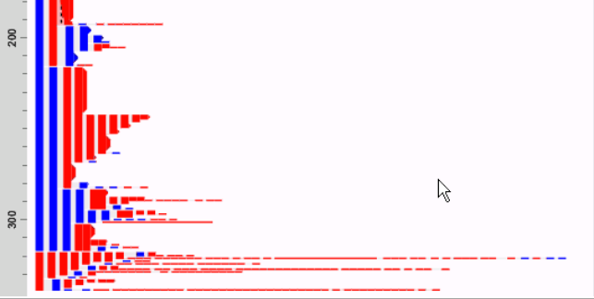
Figure 1: EventFlow aggregate view of suspected cases
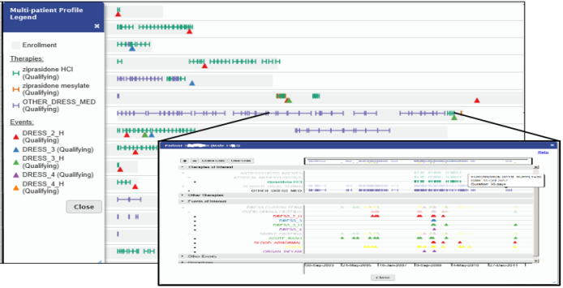
Figure 2: Multi-patient timeline(A) with single-patient drilldown(B)

REFERENCES
- Aigner W., et al. Visual Methods for Analyzing Time-Oriented Data. IEEE Trans. Vis. Comput. Graphics 14(1):47-60.
- Edwards R. and Aronson J. Adverse drug reactions: Definitions, diagnosis, and management Lancet 356 (9237):1255–1259.
- Malik S., et al. Cohort Comparison of Event Sequences with Balanced Integration of Visual Analytics and Statistics. ACM IUI 2015. Atlanta, GA, USA, 38-49.
- Monroe M., et al. Visualizing Patterns of Drug Prescriptions with EventFlow: A Pilot Study of Asthma Medications in the Military Health System HCIL Tech Report HCIL-2013-13.

