Mapping Korean national insurance billing code to OMOP code for drugs used in a Korean tertiary teaching hospital
Soo-Yeon Cho R.N., MPH.¹, Dukyoung Yoon M.D. ¹, Eun Kyoung Ahn R.N., Ph.D¹, Dahye Shin B.S. ¹, Rae Woong Park, M.D., Ph.D¹
¹ Department of Biomedical Informatics, Ajou University School of Medicine, Suwon, Korea

Abstract
International collaborative researches between different hospitals are increasing. However differences in drug codes hinders the collaborative efforts. An insurance billing codes named Electronic Data Interchange (EDI) code is mandatory for every hospitals in Korea. Those we mapped EDI drug codes into RxNorm codes by matching ingredient name, strength, and dose form. Among 3,952 drug codes used in a tertiary teaching hospital, 57.3% of them were mapped into RxNorm clinical drug codes, and another 33.0% of them were mapped with RxNorm ingredient codes. When RxNorm code is not available at any of clinical drug level or ingredient level, then ATC codes were used instead of RxNorm (9.7%). In the further study, validation and in-depth discussion about unmapped drug codes by experts is required, and the additional mapping to the drug codes not included in this study should be followed.

Introduction
Study using clinical information from one medical institution is inevitably accompanied by a sampling bias even the sample size is big enough to analyze. In order to avoid this problem and get better cooperation from various data-holders, Distributed Research Network (DRN) has been constructed^{1,2}. While the mapping between different coding systems is essential in Common Data Model (CDM) for constructing DRN, there has been no mapping tables available between Korean clinical information and international standard coding system. Therefore, we tried to map drug codes of national insurance billing code, named Electronic Data Interchange (EDI) code, with RxNorm codes by matching ingredient name, strength, and dose form.

Method
In this study, we mapped the EDI drug codes which were used in a hospital with RxNorm codes using the Ms-SQL queries. If the drug information is not completely matched, we tried to find the most proper concept manually by considering the synonyms or typos. Additional search was done through national pharmaceutical information center³ for drugs which has missing information about ingredient, strength, or dose form. Every EDI drug code recorded between 1994 and 2013 was extracted from a Korean hospital. Also, OMOP CDM vocabulary version 4.0 was used to find RxNorm and ATC concepts.
The mapping was proceeded in three steps according to the following priority. First, we mapped EDI drug code to RxNorm clinical drug form if all of the information including ingredient, strength, and dose form were matched (Figure 1-a). Next, we mapped EDI drug code to RxNorm ingredient form if only the ingredient name is matched (Figure 1-b). Finally, we mapped EDI drug code to ATC code instead when even the ingredient name does not exists in RxNorm concepts. (Figure1-c)
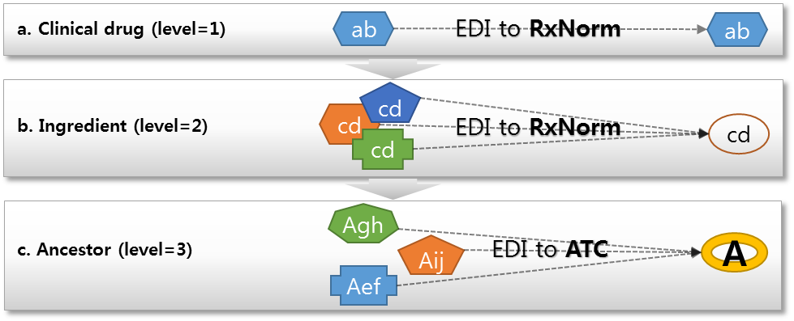
Figure 1. Mapping priorities between EDI drug code and RxNorm code was proceeded in three steps. First, each of ingredient, strength, and dose form information was matched exactly (a), if not possible to find exactly matched concept for strength or dose form, then only ingredient information was matched (b). When we couldn’t find same ingredient name either, we mapped drug codes to ATC code instead as an ancestor concept (c).
After the mapping was completed, we calculated the proportion of successfully mapped EDI drug codes and successfully mapped prescriptions occurred in the hospital.

Result
Among 3,952 EDI drug codes used in the hospital, 57.3% were mapped with RxNorm clinical drug codes, and another 33.0% of them were mapped with RxNorm ingredient codes. When RxNorm codes are not available at any of clinical drug level or ingredient level, then ATC codes were used instead of RxNorm (9.7%).
Table 1. Proportion of mapped EDI drug codes and prescription records
Mapping level | Number of drug code (%) | Total number of Prescription (%)
RxNorm Clinical drug | 2,261 (57.32) | 70,103,264(60.46)
RxNorm Ingredient | 1,305 (33.02) | 37,644,898(32.47)
ATC Code | 385 (9.74) | 8,193,192(7.07)
No ATC Code | 1 (0.03) | 0(0.00)
Total | 3,952 (100.00) | 115,941,354(100.00)

Conclusion
The mapping between different drug coding systems is very complicated even if there are proper concept code to map with, because descriptions and name of codes are frequently not complete, recorded as synonyms or having typos. Therefore, manual review for each code pair mapped was an inevitable process to increase the quality of the mapping.
Even though the ingredient of a drug was found in RxNorm concepts, suitable clinical drug concept couldn’t be mapped because of the inconsistency in strength or dose form. In these cases, which accounts for one-third of total EDI drug codes, we had no choice but to take the loss of information while mapping those codes with RxNorm ingredient concepts. If we could map the drug codes separately to the each of ingredient, strength and dose form of OMOP concepts, it will be possible to provide more detailed information about over 90% of the drug prescription data in Korea.
In the further study, validation and in-depth discussion about unmapped drug codes by experts is required, and the additional mapping to the drug codes not included in this study should be followed.

Funding source
This study was supported by a grant of the Korea Health technology R&D Project, Ministry of Health & Welfare, Republic of Korea (HI14C3201).

Acknowledgement
We have no conflict of interest.

References
- Platt R, Wilson M, Chan KA, Benner JS, Marchibroda J and McClellan M. The new Sentinel Network--improving the evidence of medical-product safety. The New England journal of medicine 2009; 361:645-647
- Observational medical outcomes partnership common data model specifications version 4.0. In: Implementation common data model CDM specifications V4.0 http://omop.org/CDM
- Korea Pharmaceutical Information Center. http://www.health.kr/

