Comprehensive Multiaxial Hierarchy of
Psychiatric and Neurological Assessment Tools in OMOP CDM

Dmitry Dymshyts MD¹, Polina Talapova MD¹, Yevhenii Bezeha¹, Qi Yang², Mui Van Zant²
, Kristin Kostka², Christian Reich², Olga Carmen Torre², Shilpa Ratwani², Andrew Williams³, Dongyun Lee⁴, Eunyoung Lee⁴, Xinwei Zhang⁵,Haoyan Cai⁵, Emma Cable⁶, Jeremy Leigh⁶, Mathilde Fruchart⁷, Antoine Lamer⁷
1 - Odysseus Data Services Inc., Cambridge, MA, USA
2 – IQVIA, Plymouth Meeting, PA, USA
3 – TUFTS, Medford, MA, USA
4 – AJOU, University Suwon-si, Gyeonggi-do, South Korea
5 – SmindU, Chaoyang District, Beijing, China
6 – Akrivia Health, Bierton, England, United Kingdom
7 – University of Lille, Lille, Hauts-de-France, France

Abstract
On behalf of OHDSI Psychiatry Working Group, we would like to put forward a proposal to build the comprehensive multiaxial hierarchy for psychiatric and neurological assessment tools in OMOP CDM. This will allow researchers and physicians to generate evidence-based decisions in Neurology and Psychiatry on an equal footing with other healthcare professionals.

Research Category: Observational data management

Introduction
According to the World health report provided by WHO, mental disorders affect one in four people during lifetime¹. However, in the context of COVID-19, each of us is exposed to the increased psychological stress that changes statistics significantly. In parallel, the increased need in the comprehensive study of COVID-19 influence on the human organism poses new challenges to psychiatrists and neurologists around the world. Thus, staying on guard of OHDSI collaborators’ calm, the OHDSI Psychiatry working group² continues to work on the data harmonization process across the area of Mental Health and the improvement of OMOP Common Data Model and Standardized Vocabularies from the perspective of the pandemic.

Challenge
The greatest challenge of psychiatric and neurologic assessment instruments such as scores and scales are their current representation in the OMOP CDM owing to architectural singularity and limited adaptiveness of Gold Standard Ontologies³. As a result:
- A lot of tools do not have any Standard equivalent, even if they are widely used and not burdened by licenses (e.g. Hamilton Anxiety Scale⁴).
- Scales represented in OMOP Vocabularies often have multiple standard equivalents in different domains and vocabularies⁵ (Tables 1 and 2), but the only one concept for a particular measurement should be chosen.

Table 1. Examples of multiple semantic axes in SNOMED for one psychiatric assessment scale.
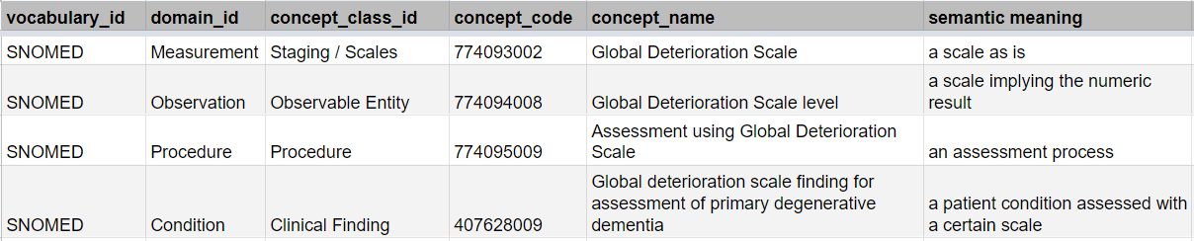
Table 2. Examples of unpredictable domains’ behavior in LOINC for psychiatric assessment tools.
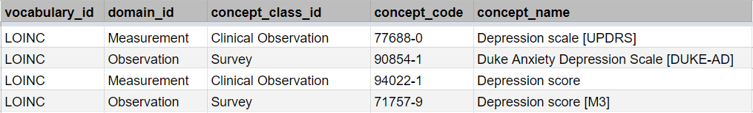

Solution
- To define regions of interests among Standard Observable entities as a basis for psychiatric or neurologic assessment tools’ hierarchy (Figure 1).
- To extend the pool of Standard Observable entities adding concepts representing nosological categories to the OMOP Extension (Figure 2).
- To collect the scales used in patient data. Map them to OMOP concepts. Identify those not having equivalents in OMOP.
- To add psychiatric or neurologic assessment instruments as new OMOP Extension concepts and build the hierarchy using a particular set of relationships as shown in Table 3.

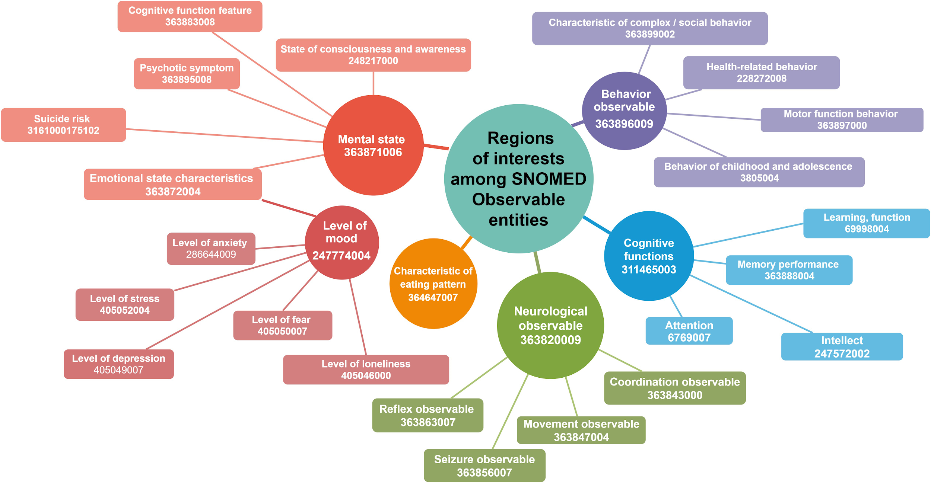
Figure 1. Regions of interests in Neurological and Psychiatry assessment tools.

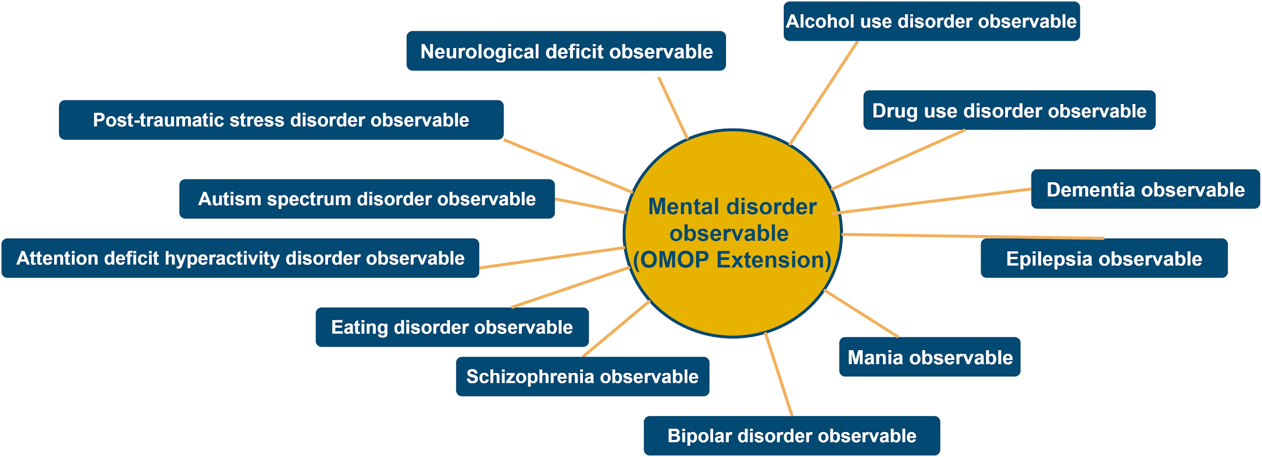
Figure 2. Possible enrichment of the SNOMED Observable entities hierarchy by OMOP Extension.

Table 3. The set of potential relationships for Psychiatric or Neurologic Assessment Tools in OMOP Extension vocabulary
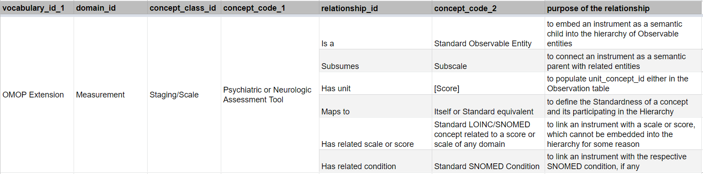
Conclusion
The implementation of the proposed approach will make Psychiatry or Neurology-related observational cohort studies based on OMOP CDM effective and comfortable. Also, the multiaxial hierarchy for neurological and psychiatric assessment tools can increase the sample size through the automatic expansion of the concept set coverage.

References
- World health report. Mental disorders affect one in four people [Internet]. 2019 [cited 2020 Jul 11]. Retrieved from: https://www.who.int/whr/2001/media_centre/press_release/en/#:~:text=Geneva%2C%204%20October%E2%80%94%20One%20in,ill%2Dhealth%20and%20disability%20worldwide.
- Observational Health Data Sciences and Informatics. Psychiatry Working Group. [Internet]. 2020 [cited 2020 Jul 11]. Retrieved from: https://www.ohdsi.org/web/wiki/doku.php?id=projects:workgroups:psychiatry
- Eunyoung Lee, Dongyun Lee, Heirim Lee, Sang Joon Son, Bumhee Park. An approach for psychiatric data standardization into the OMOP Common Data Model [Poster]. OHDSI Symposium.
- Hamilton M.The assessment of anxiety states by rating. Br J Med Psychol 1959;32:50–55. Retrieved from: https://dcf.psychiatry.ufl.edu/files/2011/05/HAMILTON-ANXIETY.pdf
- Use of SNOMED CT UK Edition for Scored Assessments Implementation Guidance [Internet]. 2009 [cited 2020 Jul 11]. Retrieved from: https://confluence.ihtsdotools.org/download/attachments/57807983/NPFIT-FNT-TO-DSD-0160-04_Consideration%2520of%2520the%2520UK%2520position%2520on%2520Assessment%2520Scales_1.0.pdf?api=v

