Name: | Sigfried Gold
Affiliation: | Janssen contractor and OHDSI collaborator, Visualization Working Group member
Email: | sigfried@sigfried.org
Presentation type : | Poster

CHRONOS: Cohort exploration through individual patient profiles
Sigfried Gold, MFA, MA¹, Clair Blacketer, MPH^{1,2}, Anthony Sena^{1,2}, Frank J. DeFalco^{1,2}
¹Observational Health Data Sciences and Informatics (OHDSI), New York, NY; ²Janssen Research and Development, Raritan, NJ

Abstract
The Chronological Health Report for the OHDSI Network of Subjects (CHRONOS) is an interactive timeline visualization and patient profile tool built into the ATLAS framework of OHDSI applications. CHRONOS will enable researchers to review patient profiles and refine candidate cohort definitions. It provides a visual timeline of a patient’s medical events, a table showing event details, a word cloud of the most frequently occurring events in the patient’s records, and basic patient demographic data. When a profile is loaded, the user can zoom and pan across specific time periods, highlight particular concepts or event domains, search and filter on event description, and by these methods zoom and filter to a small enough collection of events that it is possible to display concept labels on the visual timeline rather than just colored dots.

Introduction
ATLAS is the central OHDSI tool for cohort definition, generation, and analysis. The cohort definition process is generally iterative: researchers formulate cohort criteria, generate cohorts from OMOP data sources, and then examine the results to gauge congruence between the clinical patterns they were attempting to capture and the actual patients selected by the criteria in their definition. As they discover discrepancies and anomalies, they may add, remove, or refine criteria. Currently the most effective method for evaluating cohort definitions is often examination of the histories of individual patients. This is challenging, especially for large cohorts, as patient records may include thousands of events. If the patient history is presented as a textual or tabular report, it will generally be large and repetitive and reviewing it will be tedious and inefficient. We have added an interactive, visual patient profiling tool to ATLAS to facilitate quick and robust examination of patient records.

Methods
CHRONOS fetches data from the OHDSI WebAPI. WebAPI is an Apache Tomcat application written in Java and able to query the OMOP Common Data Model (OMOP CDM) for patient-level data from several standard DBMS platforms (SQL Server, PostgreSQL, Oracle, Redshift). CHRONOS uses the person service in the OHDSI WebAPI to reduce patient events from multiple domains (conditions, drugs, condition and drug eras, measurements, observations, and visits) to a common record format containing: a concept name and id, a start date, and an end date. On the visual timeline these records are separated into a horizontal band for each domain and represented as squares or, in the case of events with duration of more than a day, horizontal rectangles.
On the client (browser) side, CHRONOS builds on JavaScript code already existing in ATLAS. It uses the D3.js visualization library for managing chart display and interaction.

Results
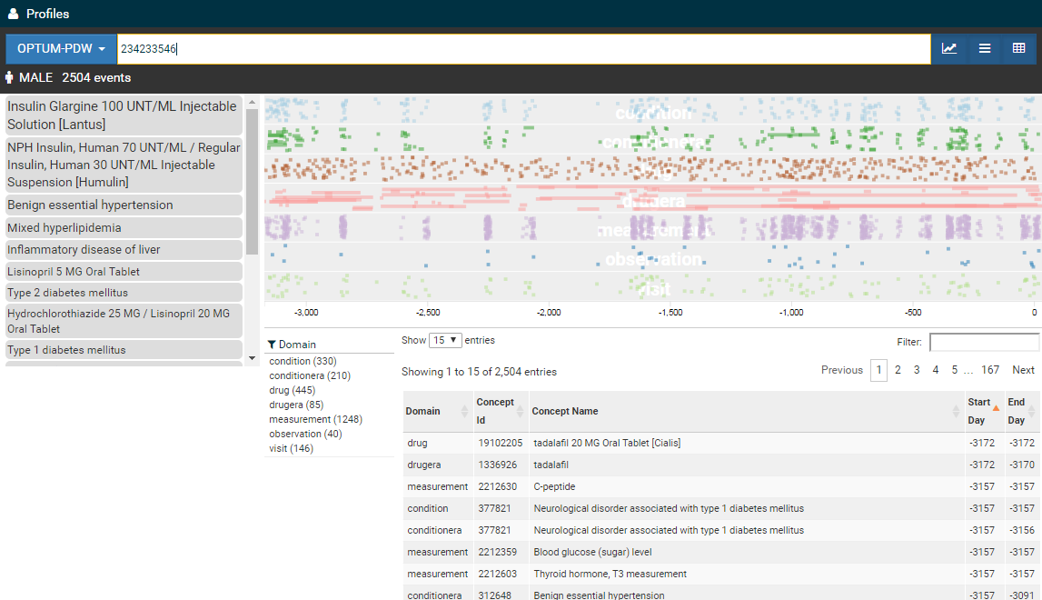
Figure 1: CHRONOS screenshot
As shown in Figure 1, the CHRONOS patient profile initially displays all events from all domains for a single patient. Events appear visually in the timeline. Events also appear visually and textually in a searchable, sortable, filterable table. The most commonly occurring concepts also appear in a word cloud list below basic patient demographic information. By hovering over a dot in the timeline, users will see a tooltip showing a concept label for that dot. By hovering over a concept in the word cloud, all dots representing that concept will be highlighted in the timeline. By typing into the filter search box above the table, the table, the timeline, and the word cloud will all be filtered to only the events representing concepts containing the typed text. By dragging over a portion of the timeline, the timeline will zoom to the period dragged over; the table and word cloud will also be filtered to events in that period. When zoomed into a region a small reference visualization will appear inset at the upper right of the timeline showing the entire timeline with the zoomed area highlighted. This highlighted area can then be dragged left or right to allow panning of the short period to earlier or later portions of the complete patient history.

Discussion
CHRONOS includes only rudimentary features for selecting specific patients from a cohort for examination; these will be developed further in future iterations. We intend to display more domain-specific details, such as dosage for drugs or results for lab tests, in subsequent versions. We want profiles to also offer indications of the degree to which features of a patient’s history are typical of the cohort at large.

Conclusion
CHRONOS answers a great demand on the part of the OHDSI user community. It eliminates the need for the time-consuming, repetitive chore of exporting and manipulating patient data to flat files for display in third-party tools and has been enthusiastically received by early users. [By the time of the symposium, many more users will have spent time with it and it will have grown in response to their feedback.]

.

