Decisions
- Add Cost_Method_Concept_ID to indicate method of cost derivation: Average, Direct/Indirect Allocation, Direct Measurement, etc. Add/choose concepts.
- Add Cost_Type_Concept_ID to indicate source of Cost data. Add/choose concepts.
- Release:
  - Release the table now
  - Update documentation, including use cases
  - Present to the community
  - Assess utilization of old tables by community. If not used, retire now
Suggestions
- Add QA recommendations ensuring that payments contributing to totals and subtotals sum up correctly.
- Educate users very specifically on the new id fields and how to use them and how to find total paid for a service when there is more than one payer
Clarifications
- Is secondary vs primary payer important to know? It can only be assessed indirectly via paid_by_cob = 0 vs paid_by_cob >0. Same applies to cost to charge ratio that is even harder to derive.
- Scenarios with revenue_code on p. 18 should be provided. I assume it will be a mix of procedure and visit cost records? Needs clarification.
- Use case on Page 14 needs clarification: “The Payer_Plan_ID is set to “0” because the source of the cost information comes from the hospital and does not include a breakdown by payer. Payer information for each person is kept in the payer_plan_period table.”
- If there are two payers for one cost record but we only know the identity of one, do we still create two cost records or do we only create one and use cob to track the payment of the other payer? (Use case on page 13)

- This section is by Fern, did not change the original because Fern was not present at the discussion.
I am concerned about defining cost as charges and payments. Cost accounting systems would likely include charges and payments but would also include more sophisticated methods of cost accounting. I looked around on the VA web and found a description of the spectrum of costing methods that may help for illustration (see below).

Maybe we define a entity attribute relationship (so you pick the aspects of cost you are defining for your entry) for determining costs that includes:
• The data element or data element type we are costing. Some cost methods might only relate indirectly to individual transactions in the database. For example cost per day of hospital stay might sum costs of individual transactions occurring on a given service day or might be profiled at average cost per day (summing costs and averaging across the number of days in the encounter.
• The cost determination method we are using
○ Charge
○ Payment
○ Average (separately specify type like per day, per visit per clinic type, per dispense…)
○ Cost allocation
§ Indirect (specify what is included and excluded like labor, depreciation of facility, depreciation of durable equipment, cost of non-revenue producing departments…)
§ Direct-labor allocation for minutes spent, supplies used,…)
○ Direct measurement

***From VA Web Page Below***
There is a spectrum of cost determination methods (see Figure 1). Accounting and billing systems use direct measurement methods, whereby very detailed estimates of time and products (inputs) are combined with unit costs to estimate total costs. Sometimes these systems are called activity based cost (ABC) systems. The highly precise methods are extremely challenging to implement because a single inpatient stay or outpatient procedure might have hundreds or thousands of inputs. Even when there is just a single input, such as a pill or medication, the cost can vary by location or day. Researchers can use less precise methods, such as an average cost per day. These methods are easier to implement than the more precise methods, but their ease of use comes at a cost of decreased precision. Researchers need to identify the level of precision necessary for their study.
Figure 1
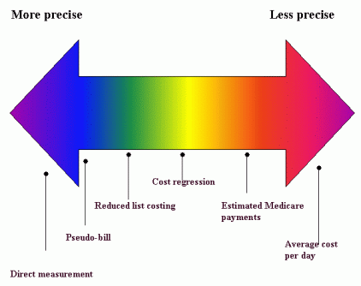
Blending two or more methods in a study is frequently needed because a researcher might need to estimate the cost of an intervention and the cost of subsequent health care. Different methods may be ideal for each of these goals. After we describe the methods, we discuss which method is best.
On precision and accuracy: Direct measurement is more precise than an average cost per day. This added precision might not yield greater levels of accuracy. Researchers should choose a method that offers a sufficient amount of precision and then work to validate the accuracy of the data.

From <http://www.herc.research.va.gov/include/page.asp?id=determining-costs>

