ODAC: learning from local to global - an efficient
algorithm for integrating time to event healthcare system data
Rui Duan, BS¹, Chongliang Luo, PhD¹, Martijn J. Schuemie, PhD², Yong Chen, PhD¹
¹University of Pennsylvania, Philadelphia, PA; ²Janssen Research and Development, Raritan, NJ

Is this the first time you have submitted your work to be displayed at any OHDSI Symposium?
Yes __x___ No______
Abstract
Institutional data integration becomes a trend in EHR-based studies, as it improves the confidence of
study results by increasing the sample size and also reduce potential biases that come from disparities
in patient population or clinical practice. To overcome the barrier of patient-level data sharing, we
propose a privacy-preserving and communication-efficient distributed algorithm for Cox proportional
hazard model to study the time to event outcome. The performance of the algorithm is investigated
through simulation study and application to datasets from the Observational Health Data Sciences and
Informatics (OHDSI). The results demonstrate that the proposed algorithm can provide relatively
accurate estimation when studying rare events.
Introduction
Multicenter analysis confers distinct advantages over single-center studies, including the ability to study rare exposures or outcomes which require larger sample sizes and discover more generalizable findings. Direct sharing of patient-level data across institutions is impractical due to considerations on both privacy protection and communication cost. Current distributive networks, such as the Observational Health Data Sciences and Informatics (OHDSI), often rely on sharing summary statistics across sites and synthesizing evidence through meta-analyses. However, in the case where the outcomes or exposures are rare, or some of the sites have limited sample size, accuracy of meta-analysis is not guaranteed. We propose a One-shot Distributed Algorithm for Cox regression (ODAC) by extending the surrogate likelihood function approach proposed by Jordan et al. (2018)³, and the One-shot Distributed Algorithm for Logistic regression⁴. We investigate the performance of ODAC by comparing it to the commonly used meta-analysis and the gold standard estimator where all data are pooled together.
Methods
Let $X$ $∈R^{p}$ be the risk factors, T be the time-to-event outcome. $λ\left(t | X\right)=λ_{0}\left(t\right)exp\left(β^{T}X\right)$ where$λ_{0}\left(t\right)$ is the baseline hazard function, and $β$ are the log-hazard ratios. $δ$ is the censoring indicator, i.e. $δ=1$ indicating an event. The observed data are $\{T_{i},δ_{i},x_{i}\}$ for the $i$-th subject. $R\left(t\right)=\text{\backslash \{}i;T_{i}≥t\}$, is the risk set at time t. The data are stored in $K$ clinical sites, $N=\sum_{j=1}^{K}{n_{j}}$. For the i-th patient in the j-th site, we observe $\{T_{ij},δ_{ij},x_{ij}\}$. The risk set in site j at time t is $R_{j}\left(t\right)=\{\left(i,j\right);T_{ij}≥t\}$, and $R\left(t\right)=∪_{j}R_{j}\left(t\right)$. Let $R_{ij}=R\left(T_{ij}\right)$ and$T_{j}$ the set of event times at site j. The overall Cox partial log likelihood is
$L\left(β\right)=\frac{1}{N}\sum_{j=1}^{K}{\sum_{i=1}^{n_{j}}{δ_{ij}log\frac{exp\left(β^{T}x_{ij}\right)}{\sum_{\left(s,k\right)∈R_{ij}}{exp\left(β^{T}x_{sk}\right)}}}}≜\sum_{j=1}^{K}{n_{j}L_{j}\left(β\right)}$ (1)
Assume we only have the patient level data of the “local” site, say site 1. We propose a distributed algorithm for Cox regression model. Using second-order approximation,
${\tilde{L}}_{1}\left(β\right)=L_{1}\left(β\right)+\left\langle ∇L\left(\overline{β}\right)−∇L_{1}\left(\overline{β}\right),β\right\rangle +\frac{1}{2}{\left(β−\overline{β}\right)}^{T}\text{\backslash \{}∇^{2}L\left(\overline{β}\right)−∇^{2}L_{1}\left(\overline{β}\right)\text{\backslash \}}\left(β−\overline{β}\right),$ (2)
where $L_{1}\left(β\right)$ is the local likelihood function defined in (1), 𝛻 and $∇^{2}$ denote the first and second order gradients of a function. $\overline{β}$is an initial value close to the true parameter value, e.g. a fixed-effect meta-analysis estimator. After constructing the surrogate likelihood function (2) at site 1, we can obtain an estimator by ${\tilde{β}}_{1}=argmax_{β}{\tilde{L}}_{1}\left(β\right),$and obtain the variance ${\tilde{V}}_{1}$. If the other sites are also available to be a local site, we can obtain ${\tilde{β}}_{j}$ for each site j and aggregate them as $\tilde{β}={\left(\sum_{j=1}^{K}{{\tilde{V}}_{j}^{−1}}\right)}^{−1}$ $\sum_{j=1}^{K}{{\tilde{V}}_{j}^{−1}{\tilde{β}}_{j}}$.
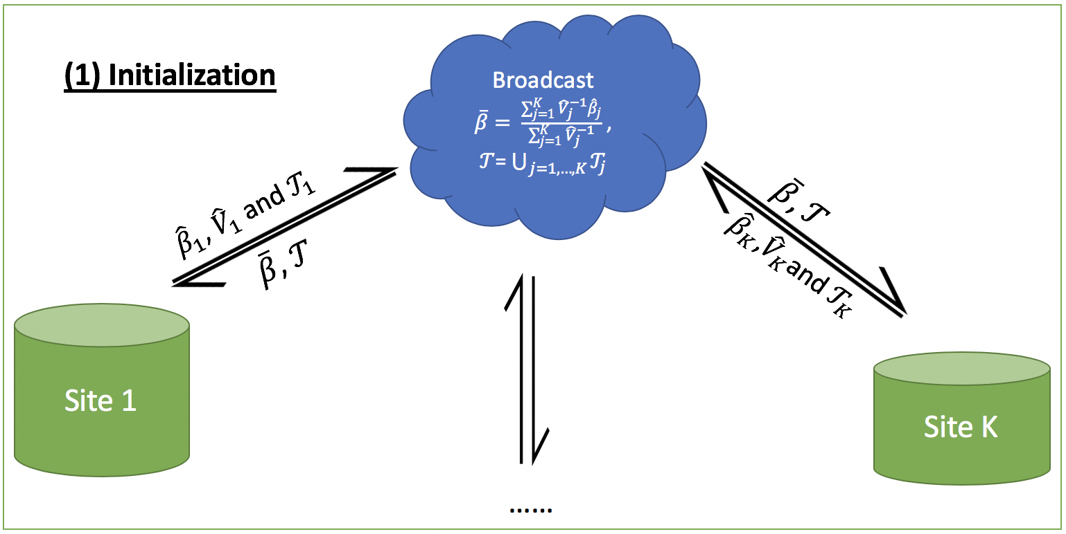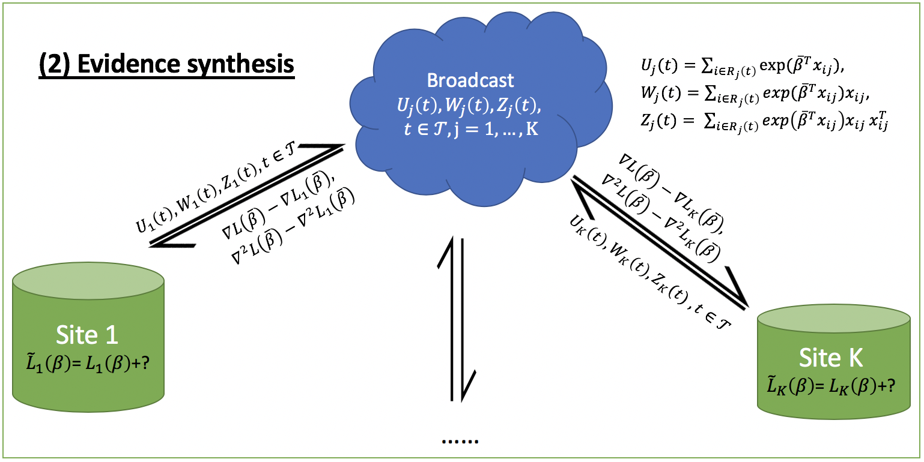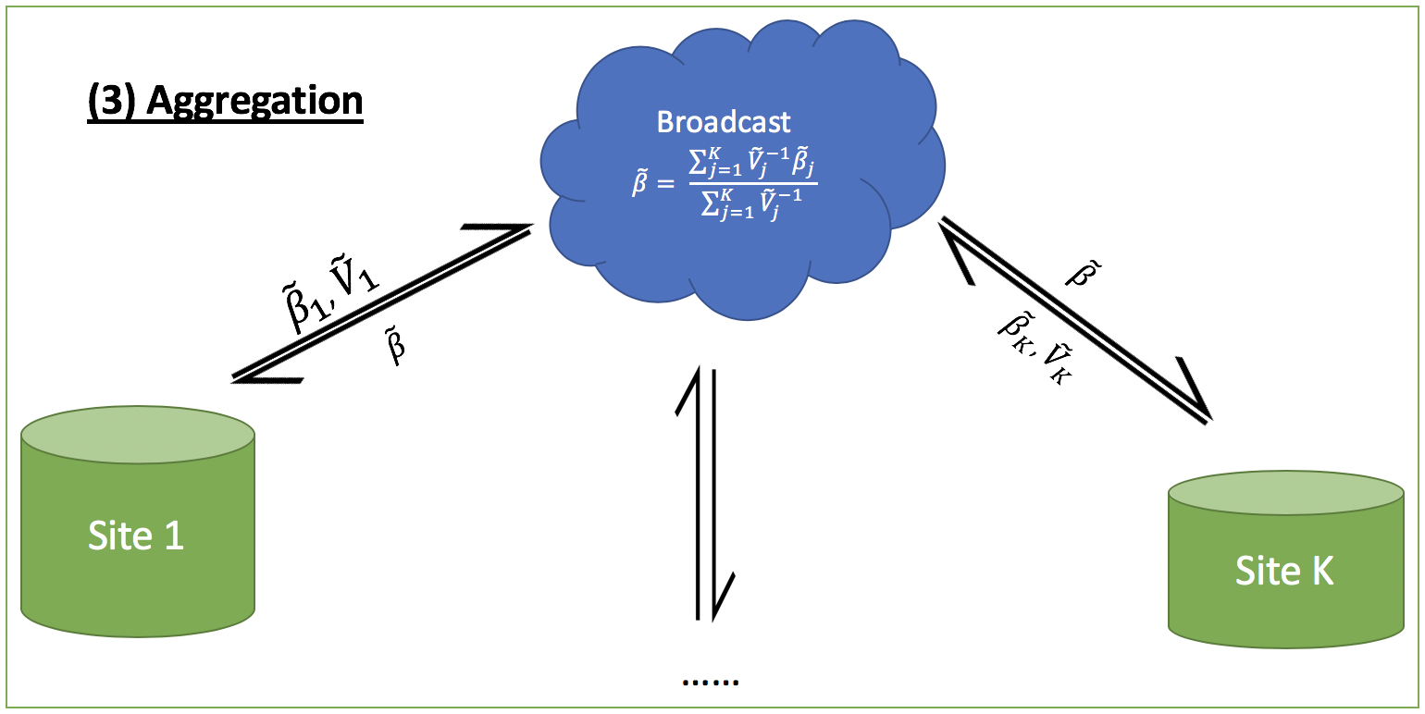
Fig. 1: Schematic illustration of the proposed ODAC algorithm.
Application to OHDSI network
We apply ODAC to observational studies of the risk factors of acute myocardial infarction (AMI) and stroke using claims data from 4 different databases at OHDSI⁵. The overall event rates for both of the two outcomes are below 1%. The effect size estimation with 95% confidence intervals are in Fig. 3.

Fig. 3: Effect size estimation of risk factors of AMI and Stroke.
Conclusion
When outcome is rare, each site might have limited number of events, which can cause large bias in meta-analysis. ODAC can provide fairly accurate estimation of the time to event analysis. In real OHDSI data analyses, the bias to the pooled estimator is almost negligible. ODAC algorithm is privacy-preserving since only aggregated information is transferred across sites. ODAC is communication efficient since it only requires 3 rounds of broadcasting (including the initialization) among all sites.

References
- Wu, Y., et al., Grid Binary LOgistic REgression (GLORE): building shared models without sharing data. Journal of the American Medical Informatics Association (2012). 19(5): 758-64.
- Lu CL, Wang S, Ji Z, Wu Y, Xiong L, Jiang X, Ohno-Machado L. WebDISCO: a web service for distributed cox model learning without patient-level data sharing. Journal of the American Medical Informatics Association (2015);22(6):1212-9.
- Jordan, M.I., Lee J.D., and Yang Y. Communication-efficient distributed statistical inference. Journal of the American Statistical Association (2018): 1-14.
- Duan R, Boland MR, Moore JH, Chen Y. ODAL: A one-shot distributed algorithm to perform logistic regressions on electronic health records data from multiple clinical sites. InPacific Symposium on Biocomputing. Pacific Symposium on Biocomputing 2019 (Vol. 24, pp. 30-41). NIH Public Access.
- Hripcsak, George, et al. "Observational Health Data Sciences and Informatics (OHDSI): opportunities for observational researchers." Studies in health technology and informatics 216 (2015): 574.
- Cox, D.R., 1972. Regression models and life‐tables. Journal of the Royal Statistical Society: Series B (Methodological), 34(2), pp.187-202.

