Simulacra and Simulation: How simulated data can enable OHDSI application development, methods research, and user adoption.

Frank J. DeFalco¹, Clair Blacketer¹, Anthony Molinaro¹, James Wiggins²
¹Janssen Research & Development, Raritan, NJ; ²Amazon, Seattle, WA

Is this the first time you have submitted your work to be displayed at any OHDSI Symposium?
Yes _____ No___X___

Abstract
The lack of open source, representative, patient level health data can make it challenging for OHDSI community members to perform application development, methods research and provide opportunities for training and adoption. We address this issue by leveraging Synthea(1) to generate simulated patients and episodes of care and then convert the Synthea data format to the OMOP common data model (CDM) using the newly developed ETL Synthea Builder package(2) for conversion between the Synthea and OMOP data models. We demonstrate how the simulated data can be used by a variety of OHDSI tools and methods and describe how to scale the solution to generate large, synthetic, common data model compliant data sets.

Background
The OHDSI community is comprised of individuals with a wide variety of skills: clinicians, statisticians, epidemiologists and computer scientists to name a few. While some members of the community have access to patient level data this is not consistent across all members. Limitations on distribution of data due to licensing or privacy restrictions impedes the community’s ability to share research methods and tools. Additionally, the rapid evolution of health data elements including geographic, genomic, dietary, sensor, and patient reported outcomes are slow to arrive in existing sources of available health data. Existing synthetic data such as OSIM or Synpuf have lacked adequate flexibility and update frequency for the purposes of community members.

Data Generation
Synthea is software capable of producing a “source of synthetic electronic health records that is readily available; suited to industrial, innovation, research, and educational uses; and free of legal, privacy, security, and intellectual property restrictions.”¹ Synthea provides a generic module framework(3) to define a progression of states including “conditions, encounters, medications, and other clinical events.” ² This framework enables flexible and configurable simulation of a variety of clinical encounters. For each synthetic patient, Synthea data contains a complete medical history, including medications, allergies, medical encounters, and social determinants of health. We leverage existing modules contributed by the Synthea community and develop our own modules to produce a clinically reasonable, customizable patient level data set.

Data Conversion
We developed the ETL Synthea Builder R package to provide a data format conversion process to migrate data from the Synthea CSV format to the OMOP Common Data Model 5.3.1 format. The ETL Synthea Builder package is available from the OHDSI GitHub repository along with instructions on how to install and run the conversion process.³ We leveraged standard OHDSI ETL tools during the development including WhiteRabbit(4) to produce documentation on the conversion logic (see Figure 1). ⁴ Once conversion was completed the CDM data was exposed through ATLAS and reviewed using the Data Sources module (see Figure 2). The 5.3.1 release of the ETL Synthea Builder populates data in the visit, measurement, observation, observation period, condition, drug, procedure, and person related tables. The ETL Synthea Builder package is freely distributed under the Apache 2.0 license and can be downloaded from https://github.com/ohdsi/etl-synthea.

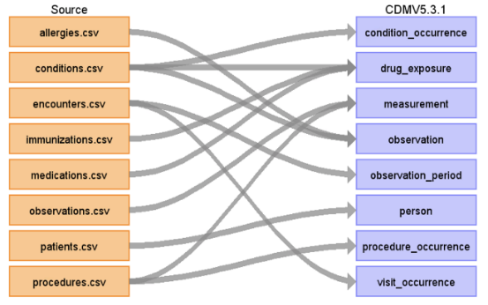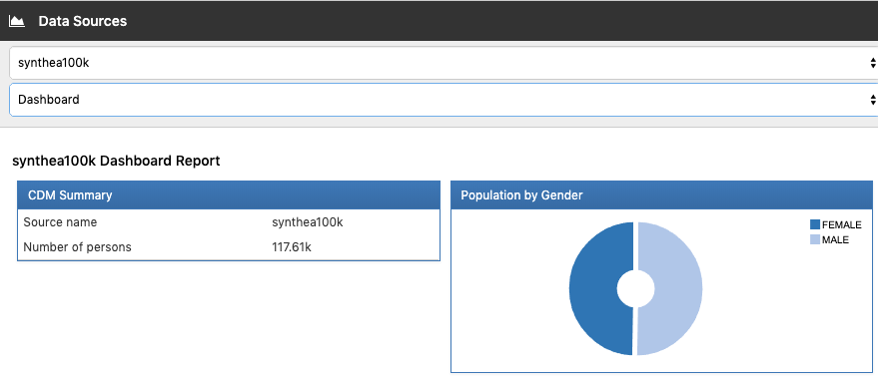
FIGURE 1 FIGURE 2

Scalability
The scalability of the ETL Synthea Builder solution was tested by generating a 100K patient data set and a 2.7M patient data set using Synthea and transforming that data to the OMOP CDM format. Scalability testing identified JVM heap size and console output recommendations that optimized performance. Figure 3 illustrates the infrastructure configuration used and Table 1 summarizes the cost and performance of the two execution examples.
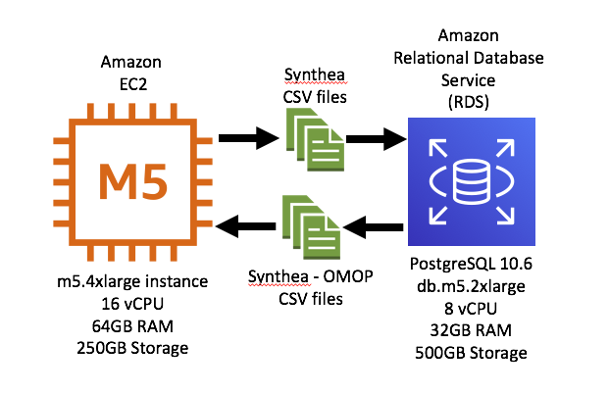
FIGURE 3

Table 1 – Cost and Performance
Synthea Data Set Size | Generation Time | ETL Conversion Time | Total AWS Cost
100,000 patients | 25 minutes | 18 minutes | ~$0.66
2.7M patients | 8 Hours | 6 Hours | ~$12.00

Conclusion
Data sets were tested and shown to support use in WebAPI, ATLAS, and R Methods Packages such as CohortMethod and FeatureExtraction. Leveraging Synthea provides unique functionality previously lacking from any other simulated data approach including on demand updates, scaling, and custom modules. Additionally, the Synthea community is very active in integrating novel data attributes into their simulator that can be leveraged by the OHDSI community in the future. Ongoing development of the ETL Synthea Builder package will ensure availability of data in the 5.3, 5.3.1 and 6.0 CDM formats. This solution provides a forward-looking approach to generating realistic, freely available, customizable, patient level data sets for use in OHDSI deployments to support training, testing, and development.
References

1. Walonoski J, Kramer M, Nichols J, Quina A, Moesel C, Hall D, et al. Synthea: An approach, method, and software mechanism for generating synthetic patients and the synthetic electronic health care record. Journal of the American Medical Informatics Association. 2017;25(3):230-8.
2. Blacketer C, DeFalco F, Molinaro A. Synthea ETL Builder 2019 [Available from: https://github.com/ohdsi/etl-synthea.
3. Walonoski J. Synthea Generic Module Framework 2019 [Available from: https://github.com/synthetichealth/synthea/wiki/Generic-Module-Framework.
4. Schuemie M. 2019 [Available from: https://github.com/OHDSI/WhiteRabbit.

