Extending OHDSI’s Standard Terminologies with Pre-clinical Terminologies
Erik M. van Mulligen¹, Marcel de Wilde¹, Solène Grosdidier¹, Jan A. Kors¹, and Johan van der Lei¹
¹Dept of Medical Informatics, Erasmus University Medical Center, Rotterdam, The Netherlands

Is this the first time you have submitted your work to be displayed at any OHDSI Symposium?
Yes X___ No______

Abstract
Integration of pre-clinical terminologies with OHDSI’s Standard Vocabularies is important for translational drug safety research. Mappings between pre-clinical and clinical terminologies have been developed using a two-step approach: existing resources have been used to create an initial mapping that has been refined by experts. SNOMED-CT has been used as the intermediary terminology since it allows for mapping between concept expressions (pre-coordinated) and individual concepts.
Introduction
The eTRANSAFE IMI project¹ develops an integrative data infrastructure that aims to drastically improve the translational safety assessment during the drug development process. One of the challenges in this project is to combine pre-clinical (animal) data with clinical (human) data where both have their own typical terminologies. We describe here our approach to map the pre-clinical terminologies (Histopathology Clinical Pathology, and selected SEND code lists) to the clinical terminologies (MedDRA).
Methods
We added pre-clinical terminologies to OHDSI’s Standard Vocabularies already populated with MedDRA and SNOMED-CT². SNOMED-CT is a knowledge source that can decompose expressions of concepts to individual concepts, e.g. adverse event and organ concepts. In order to map pre-clinical concepts to clinical concepts we chose to use SNOMED-CT as an intermediary (see Figure 1). Initial mappings between the pre-clinical terminologies and clinical terminologies have been obtained with OHDSI (Usagi), EBI (OLS, OxO, and ZOOMA), NLM (UMLS), and BioPortal.
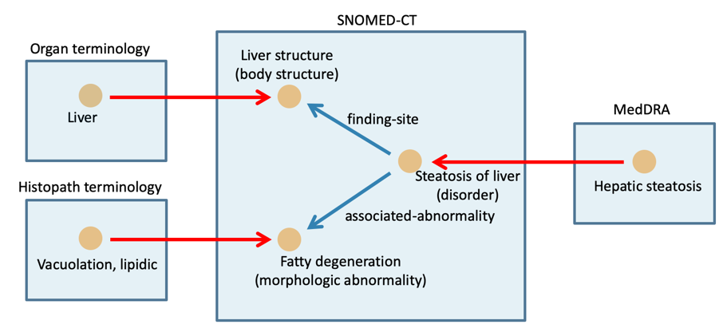
Figure 1. Mapping using SNOMED-CT as intermediary terminology.
Experts have manually verified these initial mappings for liver related adverse events. The adverse event concepts from Histopathology and Clinical Pathology were prioritized by the frequency in a pre-clinical database and adverse events concepts from MedDRA by frequency in ClinicalTrials.gov.
The pre-clinical vocabularies and their mapping have been added as well to the Standardized Terminologies with “Maps to” and “Mapped from” concept relations. On top of these we have developed a mapping service that provides two functions: (1) expansion of a concept with all its children and (2) returning mapped concepts for either pre-clinical or clinical concepts. The latter service contains the logic to exploit SNOMED-CT to perform the mapping between pre- and post-coordinated concepts.
Results
The results for the initial mapping are shown in Table 1 for those concepts present in the various clinical and pre-clinical databases. The last row shows the mapping to SNOMED-CT as an intermediary terminology.
Table 1. Mapping results obtained from existing resources.
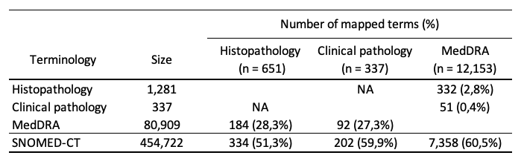
Experts have used these initial mappings to approve the mapping or provide new mappings. The results for a first selection of liver related adverse event concepts are shown in Table 2. The mapped concepts are used in more than 99% of all records in pre-clinical and clinical databases.
Table 2. Mapping results after manual revision.
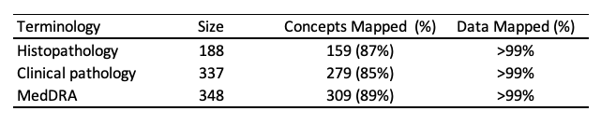
Conclusion
The terminology tables as contained in the OMOP CDM can be easily used to also store pre-clinical terminologies with their mappings. For the mapping we chose to use SNOMED-CT as an intermediary to bridge the differences between pre- and post-coordinated terminologies. Revision with the mapping tool brought the coverage from 50-60% for the suggested mappings to 85-90% for the liver domain. These pre-clinical terminologies and their mappings have been made available in a web service that provides query expansion and query translation to eTRANSAFE.
References
- eTRANSAFE. http://etransafe. Accessed June 24, 2019.
- SNOMED CT. http://www.snomed.org/snomed-ct Accessed June 24, 2019.

