OHDSI on AWS Reference Architecture Poster
James Wiggins, Amazon Web Services, Seattle, WA
Frank DiMartini, IQVIA, Plymouth Meeting, PA
Mui Van Zandt, OHDSI, New York, NY and IQVIA, Durham, NC

Abstract
A reference architecture with automation to deploy a full-featured OHDSI environment on AWS including Atlas, WebAPI, RStudio, Achilles, PatientLevelPrediction, CohortMethod, and all required dependencies. This architecture has been recently updated to include automated end-to-end SSL encryption even from public facing endpoints (Atlas and RStudio). It is modular and can accept version numbers of the OHDSI projects as parameters allowing users to provide various version combinations for testing or upgrading. This architecture will be used for the tutorial training classes, so attendees can reference it to learn more about the environment they used.
Introduction
- One of the challenges often faced when working with big data tools is the expense of the infrastructure required to run them. Another challenge is the learning curve to implement and begin using these tools. Amazon Web Services has enabled us to address many of the classic IT challenges by making enterprise class infrastructure and technology available in an affordable, elastic, and automated way. This poster illustrates how to combine many OHDSI projects (Atlas, Achilles, WebAPI, PatientLevelPrediction, CohortMethod and the OMOP Common Data Model) with AWS technologies. By doing so, you can quickly and inexpensively implement a health data science and informatics environment. This architecture is used globally by IQVIA to support their OHDSI and OMOP environments. IQVIA cites the ability to turn environments on and off and also to scale environments up and down quickly as advantages of this architecture.

Architecture Features
- Deploys an enterprise OHDSI environment automatically, configured with the latest versions of more than a dozen OHDSI tools in just a few hours.
- Uses deployment parameters to configure environments from small to petabyte-scale, geographically redundant implementations.
- Includes several options for public, synthetic, sample datasets. Can also load your data private datasets automatically.
- Deploys with internet access, or can be accessible only from within your organization’s private network.
- Provides role-based access control.
- Deploys in an isolated, three-tier VPC with high availability.
- Uses data-at-rest and in-flight encryption.
- Uses managed services from AWS. OS, middleware, and database patching and maintenance are largely automatic.
- Creates automated backups for operational and disaster recovery.
- Produces a low monthly cost compared to comparable on-premises architectures.

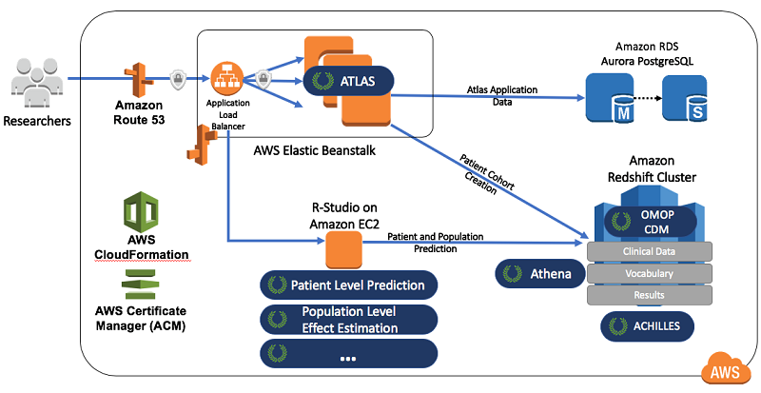

Figure 1. Shows the mapping of OHDSI projects to AWS Services.

Detailed Technical Architecture
This architecture uses AWS CloudFormation, an infrastructure as code and automation service to build out the environment. As you can see below, it is able to take various OHDSI project version numbers as parameters, allowing you to easily deploy new test or upgraded environments.
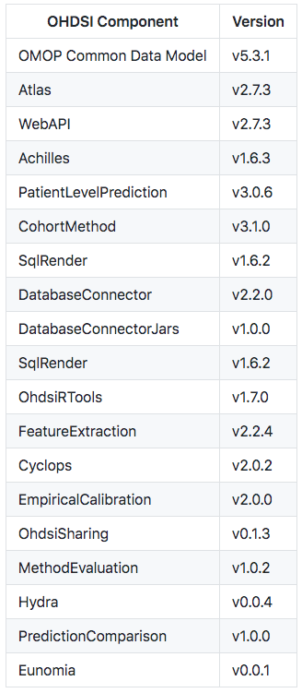
Figure 2. OHDSI project version parameters
ent. The network architecture is constructed with three separate tiers across two AWS Availability Zones, providing defense-in-depth network security and high-availability. The AWS Certificate Manager service is used to provide trusted SSL certificates to encrypt user interaction with Atlas and RStudio.
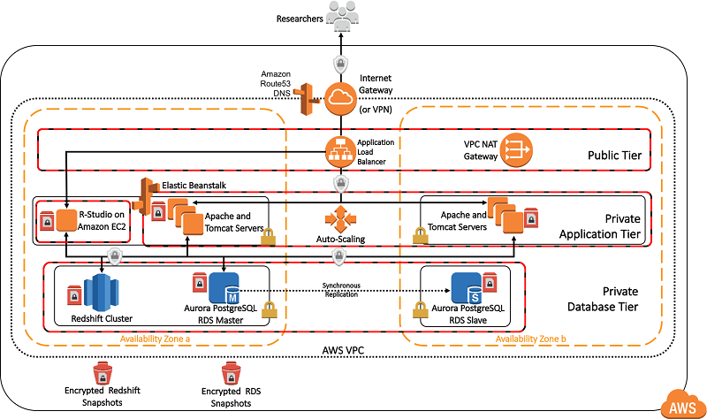

Figure 3. Shows the network architecture

Conclusion
The intention if this architecture and automation is to reduce the level of effort and cost associated with deploying and maintaining OHDSI-based research environments. That way, less time, energy, and money can be spent on undifferentiated IT infrastructure allowing researchers to do more science.

