Behind the curtain: Development and evaluation of a systematic process to transform a network of observational data into the OMOP Common Data Model to enable end-to-end reproducible research
Frank J. DeFalco¹, Clair Blacketer¹, Ajit A. Londhe, MPH¹, Anthony Molinaro¹, Anton Ivanov²
¹Janssen Research & Development, Raritan, NJ; ²Arcadia, Saint Petersburg, Russia

Is this the first time you have submitted your work to be displayed at any OHDSI Symposium?
Yes _____ No___X___

Abstract

Background
The OHDSI mission is “to improve health by empowering a community to collaboratively generate the evidence that promotes better health decisions and better care” (1) and the objectives state that “accurate, reproducible, and well-calibrated evidence is necessary for health improvement.” Before research can be conducted, patient-level data sets need to be identified, understood, acquired, processed, standardized, and evaluated. Given the complexity of the overall process, we determined that our initial manual processes for patient level data set transformation were unsustainable for the timely delivery of 11 data sources. While individual data sets can vary greatly, transforming a network of observational data sources into the OMOP Common Data Model (CDM) can be described as a systematic process. This systematic process has been developed and evaluated by our data, integrity, standardization, characterization and operations (DISCO) team.

Methods
We introduced a workflow management layer into our process leveraging the Jenkins project. “Jenkins is the leading open source automation server supported by a large and growing community of developers, testers, designers and other people interested in continuous integration, continuous delivery and modern software delivery practices.”(2) We developed pipelines within Jenkins to manage the end-to-end processing of our patient level data source transformations (Figure 1). The pipelines leveraged our existing investment in cost-effective, serverless CDM builds (3). In addition, we integrated our post processing steps to complete data source characterization and quality checks through Achilles (4) and other cohort characterization and testing routines.

To support these post processing steps, we deployed the transformed date using Amazon Spectrum, which reduces cost and simplifies the infrastructure deployment needs. Pipeline parameters allow for customization and re-use of existing pipelines as well as restarting of pipelines while skipping previously successful steps to recover in the case of step failures (Figure 2).

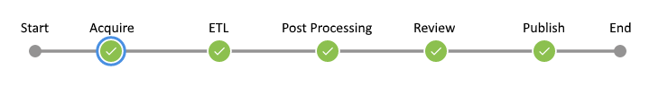
Figure 1

Results  The established pipelines provide structure and visibility to the steps required for successful integration of each patient level data set update. In the manual process each next step required manual intervention which attributed to much of our process time, as person time is never as consistently available as machine time. An automated process removes the requirement for manual intervention and allows for processing to continue across disparate systems.  The built-in performance and log capture allow for the review of build statuses, performance over time, and errors within the build steps (Figure 3) This provides an ongoing source of metric capture that was previously unavailable or required manual effort. Often, simple questions such as: “How long did the last build take?” or “Which step in build process is slowest?”, go unanswered, making improvements and planning particularly difficult. The logging capabilities offer insights to performance, planning, and scalability that can typically be overlooked while focusing on studies for which we should have the data in the first place.  Automating processes allows our team to focus on data quality and characterization efforts rather than issues related to the manual steps of managing data source integration. These pipelines have allowed us to complete CDM sprints more rapidly and with a systematic process that includes documented benchmarks and statuses.  Conclusions  Establishing a repeatable, systematic process for standardizing and evaluating patient level data sets provides the foundation for reproducible research. Improving the efficiency of our processes ensures that timely and high-quality data can be delivered to our researchers. | 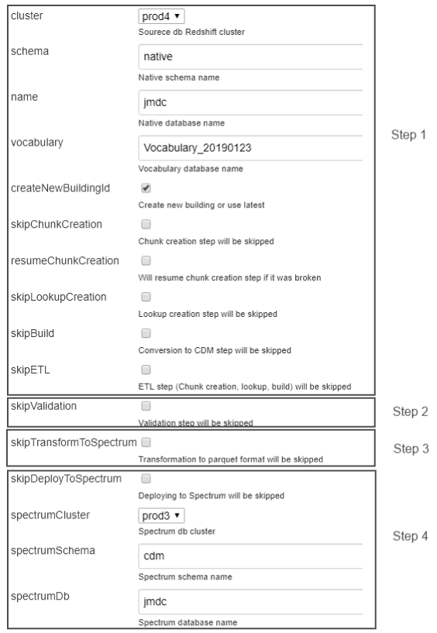  Figure 2  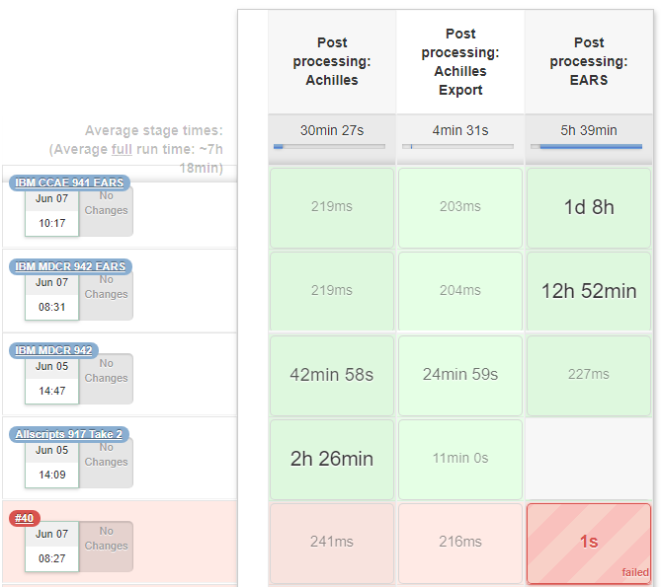Figure 3

References

1. ohdsi.org. Mission, Visions & Values 2019 [OHDSI Mission, Visions & Values]. Available from: https://www.ohdsi.org/who-we-are/mission-vision-values/.
2. jenkins.io. Jenkins Press Information 2019 [Available from: https://jenkins.io/press/.
3. Ivanov A, Arestenko A, Anisimov G, Draschinsky M, Efimov A, Londhe AA. Utilizing Serverless CDM Builder to Improve Performance and Reduce Cost. OHDSI Symposium 2018; Bethesda, MD2018.
4. Ryan PB, Schuemie M, Huser V, Knoll C, Londhe AA, Abdul-Basser T. Achilles: Automated Characterization of Health Information at Large-scale Longitudinal Evidence Systems 1.6 ed: OHDSI; 2019. p. Descriptive statistics and data quality checks on an OMOP CDM v5 databases.

