


New phenotyping of asthmatics using long-term followed measurement data
Trajectory clustering of lung function data over 15 years
Youjin Park, Pharm.D¹, Seng Chan You, MD, MS², Youngsoo Lee, MD³, Hyun Young Lee, Ph.D⁴, Eun Young Lee, MS², Hae-Sim Park, M.D, Ph.D³, Rae Woong Park, MD, Ph.D^{1,2,5}
¹Department of Biomedical Sciences, Ajou University School of Medicine, Suwon, Korea; ²Department of Biomedical Informatics, Ajou University School of Medicine, Suwon, Korea; ³Department of Allergy and Clinical Immunology, Ajou University School of Medicine, Suwon, Korea; ⁴Department of Statistics, Clinical Trial Center, Ajou University School of Medicine, Suwon, Korea;
⁵FEEDER-NET (Federated E-Health Big Data for Evidence Renovation Network), Suwon, South Korea
- Introductions and backgrounds
- What & Why “Trajectory clustering”?
Trajectory is the course of measured variables over age or time. Even though people had same condition and treated with same treatment, each person can have different trajectory. Long-term accumulated data and the development of statistical technology made trajectory analysis become possible. Accordingly, there are several studies that defined new phenotypes of patients with long-term trajectory patterns.

- Latent class mixed model (LCMM)
Latent class mixed model (LCMM) is an innovative statistical method used to identify subgroups of participants with heterogeneous trajectories. It offers a way of incorporation additional heterogeneity which can be used to uncover distinct subgroups and to classify individuals. It is made up for two parts. One is the multinomial logistic regression model to express for each patient probability to belong to class, and the other is the linear mixed model to find the latent profile of trajectories in each class. (the ‘lcmm’ R package)

- Severe asthmatics
Asthma is a common chronic disease that affects approximately 300 million persons worldwide. In Korea, asthma is the sixth biggest disease burden among chronic diseases. Among asthmatics, there were severe asthmatics that asthma patients who un controlled despite adequate therapy. Severe asthma affects less than 10% of asthmatics and is associated with substantial morbidity and mortality and a large fraction of the health care cost. However, the patterns of lung function differ among patients receiving the same step of drug therapy. So, it is important that figure out how lung function changes among severe asthmatics.

- Forced expiratory volume in one second (FEV₁)
The forced expiratory volume in one second (FEV₁) measurement show the amount of air a person can forcefully exhale in one second. It shows the severity of disease. FEV₁ (%) is strongly associated with the risk of attack in asthma and mainly used as a lung function index when rating respiratory disorders.

- Asthma exacerbation
Asthma exacerbations (asthma attacks) are acute or subacute episodes, which are characterized by a progressive increase in one or more typical asthma symptoms. It is one of the most important prognostic factors of asthma. Asthma exacerbations were often defined as the need of systemic corticosteroid more than 3 days or the emergency room/inpatient visits.

- Objects of this study
- To classify severe asthmatics according to long-term changes of lung function using the LCMM
- To find out that different classes have different prognostic aspect
- To develop prediction model of classes using EHR data
Finally, we wanted to show that long-term changes over time can be used to define phenotype.

- Methods and Results
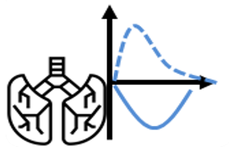

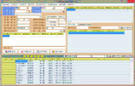


- ICARUS database
Pulmonary Function Test
Electronic Health Record
Biomarker
Genomic SNP
OMOP-CDM
Figure 1 Construction of ICARUS database
We constructed Immune/Inflammatory Disease Common Data Model Augmentation for Research Union System (ICARUS) database for analysis of immune diseases. Patients who visited department of allergy and clinical immunology base on the EHR of Ajou University medical center from 1995 to 2017. ICARUS database was implemented as the Observational Medical Outcome Partnership (OMOP) Common Data Model (CDM). It could be analyzed with the OHDSI tools. Total 4,893 persons were included.
ICARUS database
Patients visiting Ajou University Hospital, Dept. of allergy & clinical immunology between 1995 to 2017
N = 4,893
Severe asthmatics
Patients initiating GINA guideline step 4―5 medication
N = 1,388
Patients with at least 1 FEV₁(%) value
N = 1,174
Figure 2 Flow diagram showing enrolled patient number

- Severe asthmatics
Using ATLAS, severe asthmatics were defined. Patients who newly started the Global Initiative for Asthma (GINA) guideline step 4―5 treatment were defined as severe asthmatics. GINA guideline step 4―5 treatment was high dose or medium dose ICS (HD or MD ICS) plus long acting beta-agonist (LABA) combination. Total count of severe asthmatics was 1,388 persons.

- Temporal FeatureExtraction
Temporal FEV1 (%) values over 15 years were collected using the FeatureExtraction package. As a result, severe asthmatics with at least 1 FEV₁ (%) value (N = 1,174) were enrolled.

- Trajectory clustering using LCMM
Using the LCMM, 1,174 persons were classified according to trajectory of FEV₁ (%). Multiple LCMMs with different trajectory shapes including linear and non-linear parameters were tested. Trajectory analyses were performed by changing the number of groups from 2 to 5. The shapes and optimal number of classes were determined by the following criteria; (1) the lower Bayesian information criterion (BIC) score; (2) proportions of each classes were more than 5%. According to the criterial mentioned, a model of linear parameters with 3 groups was chosen.

Table 1 Latent class mixed model (LCMM) results of model fitting process
 | AIC | BIC | %Class1 | %Class2 | %Class3 | %Class4 | %Class5
LCMM_linear_group2 | 73752.78 | 73803.25 | 6.26 | 93.74
LCMM_quadratic_group2 | 73741.75 | 73802.32 | 4.61 | 95.39
LCMM_cubic_group2 | 73711.28 | 73781.94 | 4.43 | 95.57
LCMM_linear_group3 | 73749.14 | 73819.80 | 12.61 | 34.75 | 52.64
LCMM_quadratic_group3 | 73696.37 | 73782.18 | 2.61 | 4.61 | 92.78
LCMM_cubic_group3 | 73634.20 | 73735.15 | 3.57 | 3.83 | 92.61
LCMM_linear_group4 | 73743.37 | 73834.23 | 31.57 | 9.30 | 7.83 | 51.30
LCMM_quadratic_group4 | 73679.05 | 73790.10 | 2.17 | 2.09 | 2.52 | 93.22
LCMM_cubic_group4 | 73623.74 | 73754.97 | 3.65 | 0.61 | 3.65 | 92.09
LCMM_linear_group5 | 73739.72 | 73850.76 | 10.17 | 24.00 | 52.52 | 5.04 | 8.26
LCMM_quadratic_group5 | 73684.59 | 73820.88 | 1.83 | 3.04 | 9.22 | 63.65 | 22.26
LCMM_cubic_group5 | 73595.67 | 73757.19 | 3.13 | 0.70 | 5.74 | 0.96 | 89.48

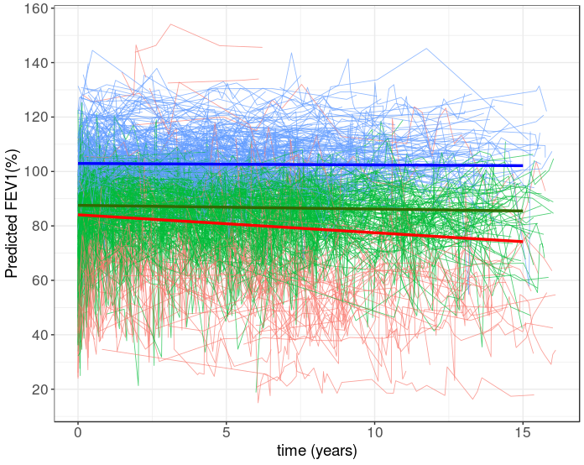
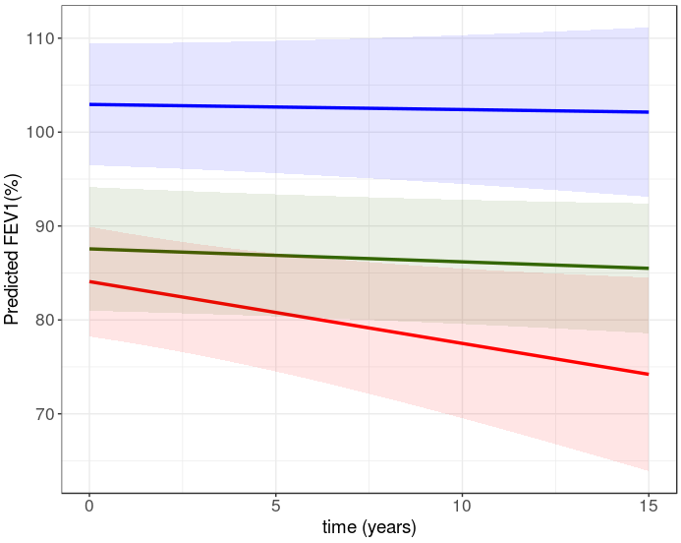
Figure 3-(a) Observed individual lung function trajectories and estimated representative trajectories
Figure 3-(b) Estimated representative trajectories. The shaded areas indicate 95% confidence intervals

Table 2 Intercepts and slopes of three estimated representative trajectories
 | Persistently high  (N = 408, 34.75 %) | Persistently low  (N = 618, 52.64 %) | Declining  (N = 148, 12.61 %)
Intercept (95% CI) | 102.947 (96.47, 109.42) | 87.57 (80.98, 94.15) | 84.08 (78.23, 89.93)
Slope (95% CI) | -0.05 (-0.38, 0.27) | -0.14 (-0.36, 0.09) | -0.66 (-1.27, -0.05)

The declining and persistently low groups had similar FEV1 (%) values in time = 0 (years). However, only declining group showed a significantly negative slope.

- Comparing baseline characteristics among three groups

Table 3 Baseline characteristics of three groups
 | Persistently high  (N = 408, 34.75 %) | Persistently low  (N = 618, 52.64 %) | Declining  (N = 148, 12.61 %) | p value
Age, years | 38.00 ± 15.03 | 38.82 ± 13.8 | 46.42 ± 13.55 | <0.001
Follow-up duration, years | 7.05 (4.15, 10.74) | 6.59 (3.37, 10.72) | 8.15 (4.11, 11.57) | 0.105
Female, n (%) | 252 (61.76) | 337 (54.53) | 89 (60.14) | 0.059
BMI, kg/m² (N) | 24.12 ± 13.17 (167) | 25.71 ± 33.78 (373) | 24.24 ± 4.81 (110) | 0.705
Total IgE (KU/L) | 213.5 (79.3, 512.8) (346) | 241 (92, 477) (501) | 199 (46.5, 535) (103) | 0.688
Blood eosinophil (%) | 3.7 (1.9, 6.8) (375) | 4.2 (1.8, 7.5) (562) | 4.4 (2.7, 8.5) (127) | 0.034
Blood neutrophil (%) | 55.4 (49.4, 61.9) (374) | 54.9 (48.4, 62.7) (560) | 55.7 (48.8, 62.1) (126) | 0.764
Serum EDN (ng/mL) | 46.5 (30.5, 63.3) (61) | 50.1 (31.3, 83.1) (102) | 65.8 (45.9, 100.2) (24) | 0.009
Rhinosinusitis, N (%) | 284 (69.6) | 383 (62.0) | 83 (56.1) | 0.005
Urticaria/angioedema, N (%) | 36 (8.8) | 47 (7.6) | 2 (1.4) | 0.010
Anaphylaxis, N (%) | 17 (4.2) | 20 (3.2) | 3 (2.0) | 0.443
Hypertension, N (%) | 13 (3.2) | 28 (4.5) | 9 (6.1) | 0.291
Diabetes Mellitus, N (%) | 7 (1.7) | 12 (1.9) | 3 (2.0) | 0.956
Osteoporosis, N (%) | 10 (2.5) | 9 (1.5) | 5 (3.4) | 0.257
GERD, N (%) | 12 (2.9) | 21 (3.4) | 6 (4.1) | 0.802
Ischemic heart disease, N (%) | 2 (0.5) | 9 (1.5) | 7 (4.7) | 0.002
Mean ± Standard; Median (interquartile range); BMI, Body mass index; EDN, Eosinophil-derived neurotoxin;
GERD, Gastroesophageal reflux disease.
Baseline characteristics were compared using the ANOVA test, Kruskal-wallis test, and χ² test. Declining group aged more than the other groups, but age wasn’t the only factor to affect lung function. The medians of baseline EDN which was known to be related to the severity of asthma also was different among groups, and declining group was the highest.

- Comparing prognosis of asthma among three groups
To compare prognosis of asthma, we calculate the yearly count and the 1-year survival of asthma exacerbation. The asthma exacerbation was defined in two ways using ATLAS; (1) prescription with 15mg/day of prednisolone or its equivalent dose for 3 consecutive days; (2) emergency room visit or inpatient visit with asthma ICD 10 code.
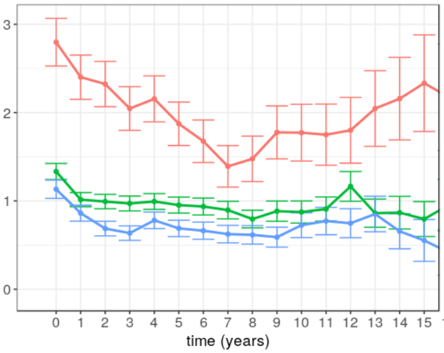
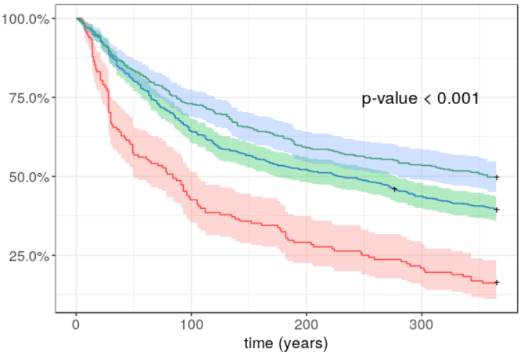
Yearly count of asthma exacerbation defined by prescribing with oral corticosteroid was always more frequent in the declining group than the other groups over 15 years. Yearly counts of asthma exacerbation of the persistently high and persistently low group were similar. 1-year asthma exacerbation requiring corticosteroid free survivals had statistically different among three groups. Declining group had the poorest survival curve. Asthma exacerbation defined by emergency room visit showed similar aspect. The declining group had the most frequent emergency room visits due to asthma exacerbation. 1-year emergency room visit due to emergency room visit free survivals were similar between persistently low and persistently high group, but the declining group had poor survival (P < 0.001).
Figure 4-(a) Anual counts of asthma exacerbation requiring oral corticosteroid
Figure 4-(b) Kaplan-Meier survival curve for the time to the asthma exacerbation requiring oral corticosteroid
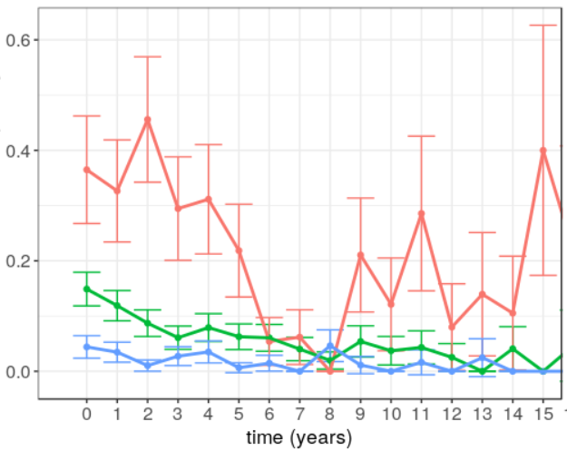
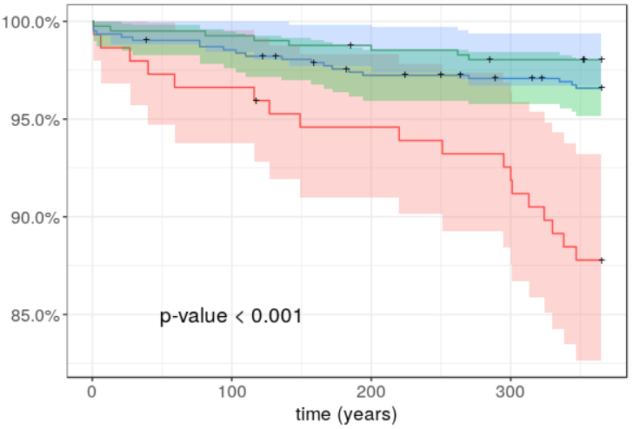
Figure 4-(c) Anual count of emergency room visit due to asthma exacerbation
Figure 4-(d) Kaplan-Meier survival curve for the time to emergency room visit due to asthma exacerbation
- Development of the model predicting the declining group using the PatientLevelPrediction package
Using the data 1 year before starting the GINA guideline step 4―5 treatment, the declining group could be predicted using lasso logistic regression and gradient boosting model. PatientLevelPrediction setting was as followed.
  - Target cohort: severe asthmatics who started the GINA guideline step 4―5 treatment with at least one measurement of FEV₁(%) value
  - Outcome cohort: patients who classified in the declining group
  - Index date: the GINA guideline step 4―5 treatment starting date
  - Covariate setting:
    - useDemographicsAge = TRUE
    - useMeasurementValueLongTerm = TRUE
    - longTermStartDays = -365
    - endDays = 0
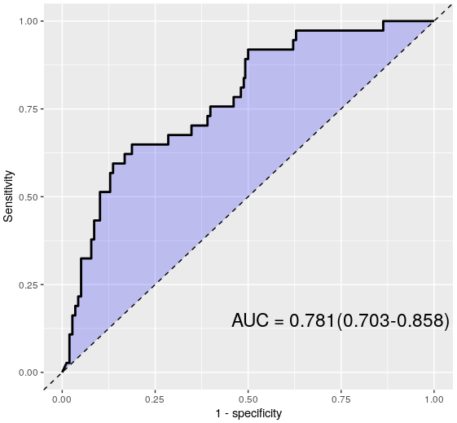
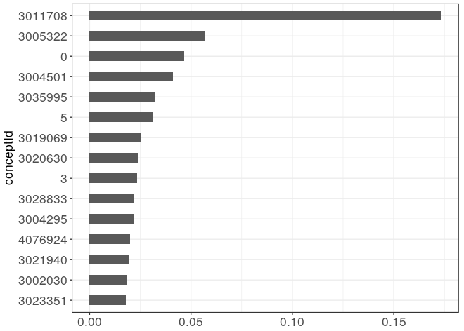
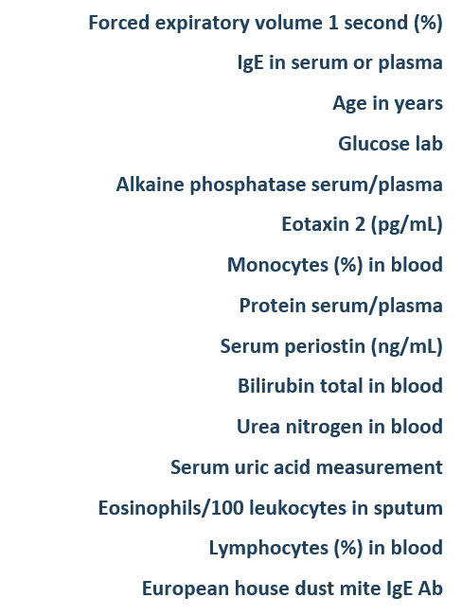
AUC scores were 0.727 (0.644, 0.811) and 0.781 (0.703, 0.858) in lasso logistic regression and gradient boosting model.
B

- Conclusion
  - Severe asthmatics can be classified according to long-term changes of lung function using the LCMM
  - The declining lung function had poor prognosis compared with the other trajectories and can be predicted by data before 365 days using the PatientLevelPrediction OHDSI package
  - Not only cross-sectional phenotyping, it is also important to define phenotype by long-term changes over time

- Open Sources
  - LcmmOhdsi: https://github.com/ABMI/LcmmOhdsi.git
    - Extended Mixed Models using latent classes and latent processes dedicated to OMOP-CDM
  - ICARUS WINGS: https://github.com/ABMI/ICARUSviewer.git
    - Immune/Inflammatory Diseases CDM Augmentation for Research Union System (ICARUS) Web-based INfographic Service (WINGS)

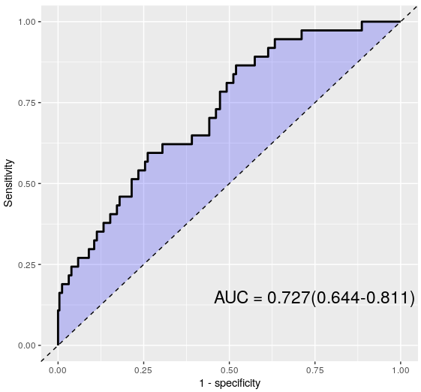
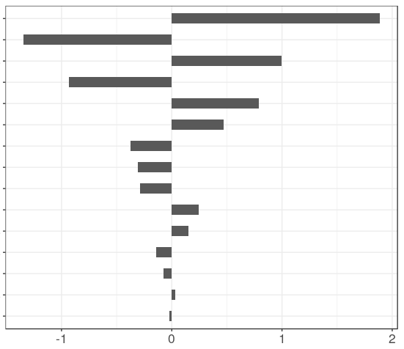
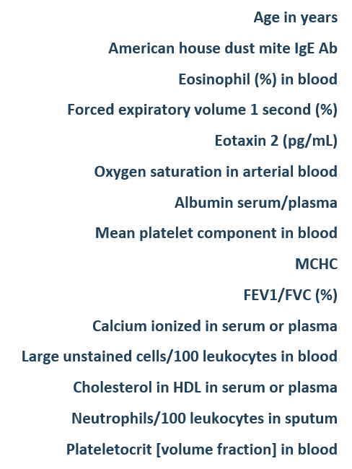
A
B
Figure 5 The AUROC curves and top 15 contributed covariates to predict the declining group.
A: lasso logistic regression, B: gradient boosting model

If you are interested at our study, join the journey!

- acknowledgement
This work was supported by the Bio Industrial Strategic Technology Development Program (20001234) funded By the Ministry of Trade, Industry & Energy (MOTIE, Korea) and a grant from the Korea Health Technology R&D Project through the Korea Health Industry Development Institute (KHIDI), funded by the Ministry of Health & Welfare, Republic of Korea [grant number: HI16C0992].

Corresponding: Rae Woong Park, MD, Ph.D
Contact: veritas@ajou.ac.kr

