Conversion of Nationwide Health Insurance Claims Data into the Common Data Model in Korea: Data Validation with 7.6 Million Cancer Patients’ Healthcare Utilization Data for the Past 11 Years
Yeunsook Rho¹; Jiwoo Kim¹; Jimyung Park²; Jaehyeong Cho²; Youjin Park²; Seng Chan You³; Yejin Son¹; Rae Woong Park^{2,3}; Yun Jung Heo¹
¹Health Insurance Review and Assessment Service, Wonju, Korea; ²Department of Biomedical Sciences, Ajou University Graduate School of Medicine, Suwon, Korea; ³Department of Biomedical Informatics, Ajou University School of Medicine, Suwon, Korea
Is this the first time you have submitted your work to be displayed at any OHDSI Symposium?
Yes __O__ No _____
Abstract
This paper statistically verifies if the nationwide health insurance claims data of cancer patients extracted from the Health Insurance Review and Assessment Service (HIRA) database is suitable to be used in distributed research when Common Data Model (CDM) is applied. The converted CDM data and original claims data had the identical statistic values in number of claims and patients at different dimensions. In addition, the statistic values of major cancer incidence based on CDM showed consistent results with National Cancer Registry Statistics, indicating that CDM may be able to replace claims data as a research material going forward. Yet, building a universal mapping system is essential to prevent data loss and/or distortion as the current coding system for claim submission does not always follow the clinical terminology coding system of the international norm.
Background
In Korea, National Health Insurance claims data are collected and managed in a standardized manner under the domestic laws and regulations. However, they have different data language and format when compared against that of major healthcare data holding organizations in Korea and abroad. Another limitation of utilization of such data is that privacy protection act and other legal constraint do not allow proactive use of the claims data. Against this backdrop, this paper attempts to transform HIRA claims data by applying CDM with standardized data language and format in order to i) statistically verify whether the converted data produces consistent outcome with existing analysis of original data, and ii) compare cancer crude rates of converted CDM data and that of National Cancer Registry Statistics to see if the two are consistent.
Methods
For this study, some 7.6 million cancer patients’ healthcare utilization data of 11 years were extracted from HIRA claims data (2.6TB). The data were converted to OMOP CDM by applying global standard terminologies in healthcare, and statistics were produced for different perspectives (diagnosis, procedure, and drug) of the claims. Alongside, crude rates of major cancers (colon, stomach, lung, liver, breast and thyroid cancer) based on the CDM data were calculated to compare against National Cancer Registry Statistics by the National Cancer Center (NCC) in Korea.
Results
According to the results, the original claim data and CDM data showed identical values in the number of claims and patients by year, confirming that the data conversion was done without any significant loss (“Person” and “Visit Occurrence” tables) (Table 1). In more precise comparison, number of claims and the order of most frequently claimed items in diagnosis, procedure, and drug also matched between the two data sets (“Condition,” “Procedure” and “Drug” tables) (Figure . Also, cancer crude rates of HIRA CDM data showed similar tendency with National Cancer Registry Statistics (Figure 1). Provided, continued data quality management seems necessary to minimize distortion in research outcome as there is the risk of 1:N and N:1 mapping resulting from inconsistent coding system in the process of CDM conversion from claims (administration) data.

Table 1. Comparison of Number between HIRA claims data and its CDM Data
(Unit: Claim)
Year | Male |  | Female
Year | Claims Data | CDM | Claims Data | CDM
2007 | 42,502,347 | 42,502,332 | 62,591,132 | 62,591,147
2008 | 55,340,140 | 55,340,127 | 79,753,877 | 79,753,890
2009 | 59,542,182 | 59,542,167 | 85,028,987 | 85,029,002
2010 | 61,211,630 | 61,211,560 | 86,562,014 | 86,562,084
2011 | 63,673,447 | 63,673,418 | 88,639,102 | 88,639,131
2012 | 70,111,734 | 70,111,652 | 95,482,910 | 95,482,992
2013 | 70,014,749 | 70,014,610 | 94,787,914 | 94,788,053
2014 | 69,990,126 | 69,990,046 | 94,915,921 | 94,916,001
2015 | 68,970,486 | 68,970,419 | 93,099,552 | 93,099,619
2016 | 69,881,740 | 69,881,682 | 94,932,930 | 94,932,988
2017 | 68,993,355 | 68,993,302 | 94,179,624 | 94,179,677

Figure 1. Comparison of Number b/w HIRA Claims Data and Its CDM Data: Diagnosis_Colon Cancer
(Unit: Claim)
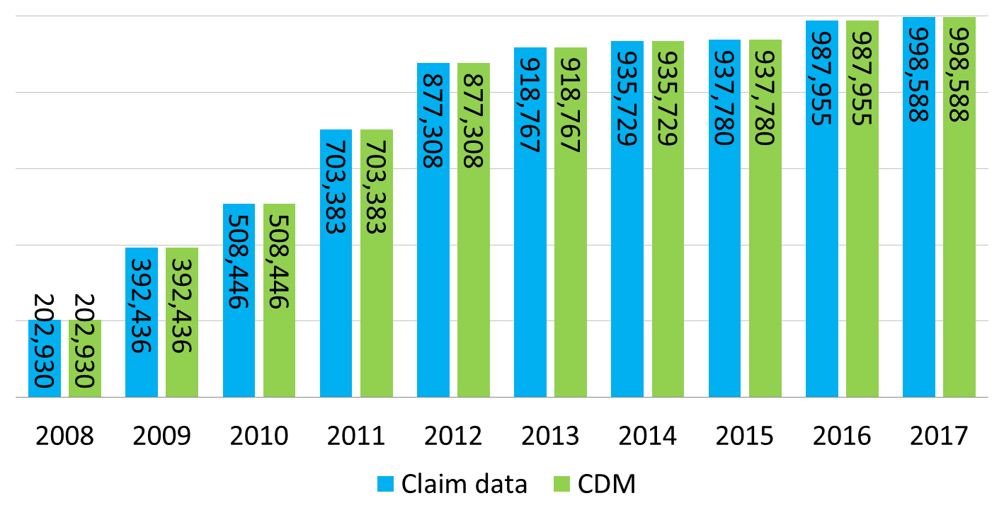

Figure 2. Comparison of Number b/w HIRA Claims Data and Its CDM Data: Procedure_Colonoscopy
(Unit: Claim)
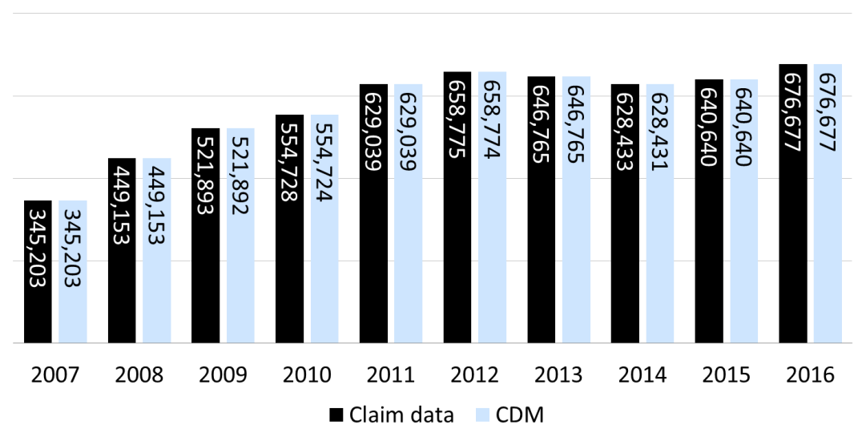

Figure 3. Comparison of Number b/w HIRA Claims Data and Its CDM Data: Drug_Iressa (Gefitinib 250mg)
(Unit: Claim)
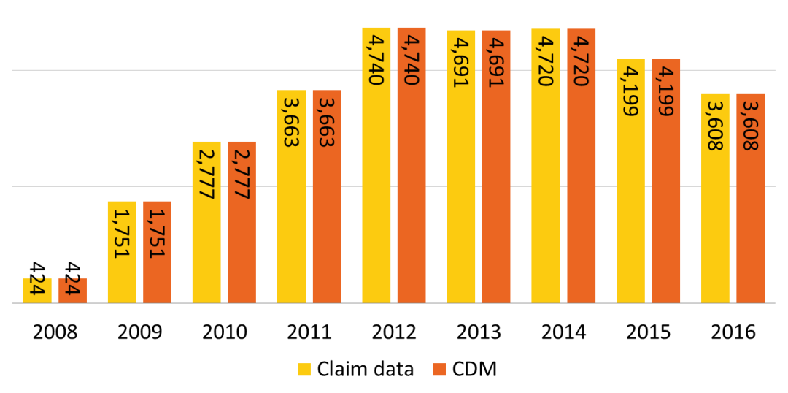

Figure 4. Trend Changes in the Crude Rates (CRs) of Stomach and Colon Cancers
(Unit: Rate per 100,000)
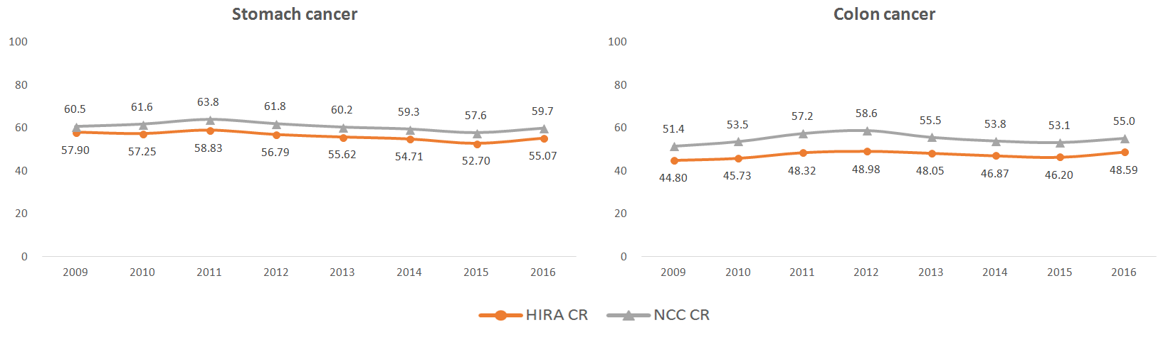

Conclusions
This study investigated the quality of the converted CDM data of the massive nationwide health insurance claims data of HIRA, and tested the possibility of multi-organization analysis using standardized data, free from the risk of personal information leaks. The same approach may be adopted in other areas of clinical and healthcare policy research in the future.

References
1. Health Insurance Review & Assessment Service. National Health Insurance Benefit Claim Instructions. 2018 July.
2. Health Insurance Review & Assessment Service. 2018 HIRA Guidelines for National Health Insurance Statistics. 2018 Dec
3. National Cancer Center. Annual Report of Cancer Statistics in Korea in 2016. 2019 Apr

