Distributed Learning from Electronic Health Records Across Multiple Sites for Zero-Inflated Count Outcomes
Mackenzie J. Edmondson, MS¹, Chongliang Luo, PhD¹, Rui Duan, PhD², Mitchell Maltenfort, PhD³, Justine Shults, PhD¹, Patrick B. Ryan, PhD⁴, Christopher B. Forrest, MD, PhD³, Yong Chen, PhD¹

¹Department of Biostatistics, Epidemiology, and Informatics, University of Pennsylvania Perelman School of Medicine, Philadelphia, PA, USA; ²Department of Biostatistics, Harvard T.H. Chan School of Public Health, Boston, MA, USA; ³Department of Pediatrics, Children’s Hospital of Philadelphia, Philadelphia, PA, USA; ⁴Janssen Research and Development, Titusville, NJ, USA

Abstract
Electronic health records (EHRs) are widely used in modern healthcare research, containing useful information characterizing patients' clinical visits. Due to privacy concerns surrounding patient-level data sharing, many clinical data analyses are performed at individual sites, resulting in studies that are often underpowered and lacking generalizability. Distributed learning algorithms have been developed in recent years to conduct analyses across sites by sharing only aggregated information, preserving patient privacy. We propose a one-shot distributed algorithm for performing hurdle regression (ODAH) across multiple sites, using patient-level data at one site and aggregated data from all other sites to approximate the complete data log likelihood. We evaluate ODAH through extensive simulations and an application to EHRs from the Children’s Hospital of Philadelphia (CHOP).
Research Category (please highlight or circle which category best describes your research)
Observational data management, clinical characterization, population-level estimation, patient-level prediction, other (if other, please indicate)
Introduction
Recent years have seen a rise in multicenter studies¹, which improve analyses by using larger, more inclusive sample from the target population. Many analyses in multicenter studies are carried out via meta-analysis, only requiring sharing of summary statistics between institutions²⁻⁴. While simple to use, meta-analysis has been shown to lead to inaccurate effect estimates in some settings, particularly in the context of rare events⁵. An established alternative to performing meta-analysis is to use distributed algorithms, which allow for a model of interest to be fit distributively across participating institutions. Many distributed algorithms are iterative, requiring extensive communication among institutions to reach convergence of parameter estimates^{6,7}.
Duan et al. recently proposed two algorithms which perform non-iterative distributed regression, offering communication-efficient alternatives to previously proposed iterative algorithms^{5,8}. We build upon this framework of communication-efficient distributed algorithms and present an algorithm for performing hurdle regression, ODAH (One-shot Distributed Algorithm for performing Hurdle regression), to model zero-inflated count data. Zero-inflated count outcomes are common in EHRs; while count outcomes are traditionally modeled via either Poisson or Negative Binomial regression, many count outcomes in healthcare feature more zero counts than would be expected in these distributions⁹. We evaluate ODAH through extensive simulations before using it to analyze risk factors of pediatric avoidable hospitalization in patients at the Children’s Hospital of Philadelphia (CHOP).
Methods
A hurdle model is an altered, two-part count model in which the processes of generating zero and positive counts are not constrained to be the same¹⁰. The proportion of zero counts are modeled using logistic regression and positive counts are modeled with a zero-truncated Poisson model.
In the context of a distributed data network, we assume that we do not have access to the combined data from all collaborating institutions; instead, we only have access to data at one of the sites (the local site), as well as aggregate information from all other sites. Using methods developed by Jordan et al., we construct a surrogate log likelihood function, which approximates the complete data log likelihood using patient-level data from the local site and aggregate information from the other sites¹¹. The aggregate information used in our work is the set of first- and second-order gradients of the log likelihood function at the non-local sites. Only two non-iterative rounds of communication are necessary for transferring information across sites; thus, ODAH is considered a one-shot approach for performing distributed inference. The ODAH algorithm is outlined in detail in Figure 1.

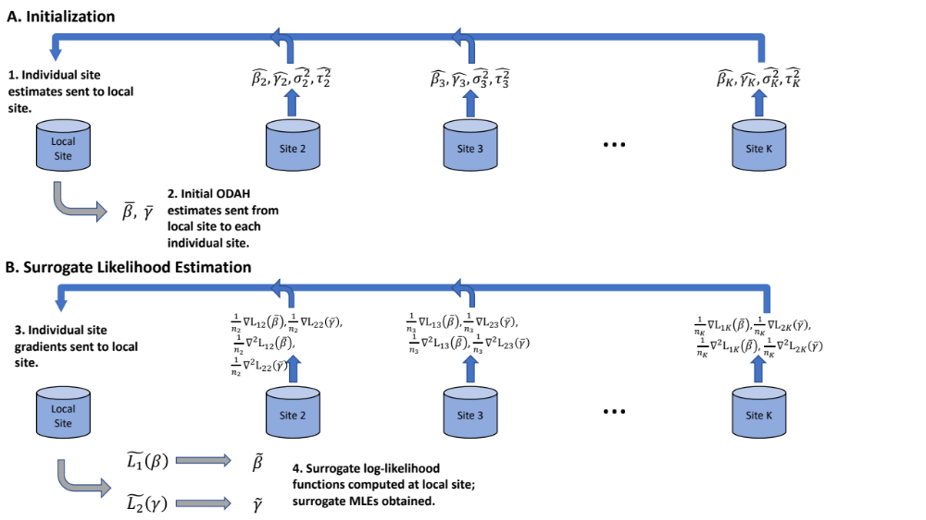
Figure 1. Visual representation of one-shot algorithm for performing hurdle regression (ODAH).
- Initialization. Local effect size and variance estimates are obtained from fitting separate hurdle models at each site and are sent to the local site (1); these estimates are then used in a meta-analysis to produce initial estimates for ODAH (2).
- Surrogate likelihood estimation. First- and second-order gradients are computed at each site, evaluated at the initial estimates obtained in step (2) and sent to the local site (3). These gradients are used in conjunction with data from the local site to construct surrogate likelihood functions ${\tilde{L}}_{1}\left(β\right)$ and ${\tilde{L}}_{2}\left(γ\right)$, which are then maximized to produce surrogate maximum likelihood estimates $\tilde{β}$ and $\tilde{γ}$ (4).

To evaluate ODAH empirically in a controlled setting, we conducted a simulation study to primarily compare the performance of ODAH to that of meta-analysis. We also compare ODAH performance to that when using only local data and all subject-level data (pooled, the gold standard). Motivated by our real data application, we sought to examine how varying levels of low outcome prevalence and event rate affect ODAH performance relative to pooled analysis. Performance was measured in terms of bias relative to pooled analysis estimates.
To examine the performance of ODAH on real world data, we applied our algorithm to EHRs for patients in the CHOP health system, modeling total number of avoidable hospitalizations given a collection of EHR variables. To mimic a scenario in which individual sites do not have access to patient-level information at other sites, we assigned patients to the primary care site they attended most during the study period and carried out analysis as if patient-level information could not be shared across sites. In total, patients were assigned to 27 different primary care sites; we selected six of these sites to illustrate our method, made up of 70,818 patients.
Results
In simulations, ODAH always produced estimates nearly identical to and sometimes more accurate than meta-analysis in terms of relative bias to the pooled estimate. ODAH estimates exhibited bias relative to the gold standard of less than 0.1% across all ten unique settings examined. Conversely, meta-analysis estimates exhibited relative bias up to 12.7%, largely dependent on the event rate; as event rates decreased, meta-analysis bias relative to pooled analysis increased. Data analysis results are summarized in Figure 2. ODAH relative bias ranged from 0.08% to 5.02% in the logistic component and less than 0.5% in the Poisson component. In contrast, relative biases for meta-analysis ranged from 4.15% to 63.6% for the logistic component and from 5.89% to 11.7% for the Poisson component.
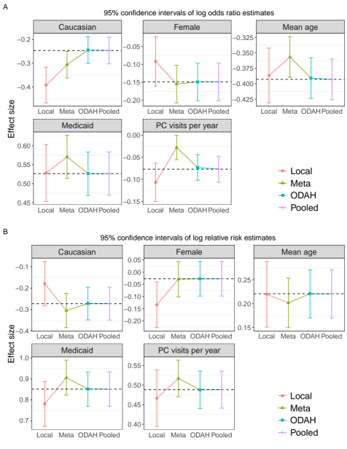
Figure 2. Log odds ratio (A) and log relative risk (B) estimates (along with corresponding 95% confidence intervals) for each covariate in the fitted hurdle model. Dashed horizontal line represents pooled estimate, our gold standard for comparing methods.

Conclusions
As demonstrated by simulations and a real-world EHR application, our method consistently produced parameter estimates comparable to and sometimes better than those produced by meta-analysis. Our method’s utility is especially evident in settings featuring a count outcome with severe zero-inflation and very low event rate, as we demonstrated the tendency of only meta-analysis to produce biased estimates under these circumstances. As our group continues to develop a collection of privacy-preserving algorithms for distributed learning, we believe ODAH is a worthy alternative to meta-analysis when one seeks to model multi-site zero-inflated count outcomes.
References
- Friedman CP, Wong AK, Blumenthal D. Achieving a nationwide learning health system. Sci Transl Med. 2010;2: 57cm29.
- Vashisht R, Jung K, Schuler A, Banda JM, Park RW, Jin S, Li L, Dudley JT, Johnson KW, Shervey MM, Xu H. Association of hemoglobin A1c levels with use of sulfonylureas, dipeptidyl peptidase 4 inhibitors, and thiazolidinediones in patients with type 2 diabetes treated with metformin: analysis from the observational health data sciences and informatics initiative. JAMA network open. 2018 Aug 3;1(4):e181755-.
- Duke JD, Ryan PB, Suchard MA, Hripcsak G, Jin P, Reich C, Schwalm MS, Khoma Y, Wu Y, Xu H, Shah NH. Risk of angioedema associated with levetiracetam compared with phenytoin: Findings of the observational health data sciences and informatics research network. Epilepsia. 2017 Aug;58(8):e101-6.
- Hripcsak G, Ryan PB, Duke JD, Shah NH, Park RW, Huser V, Suchard MA, Schuemie MJ, DeFalco FJ, Perotte A, Banda JM. Characterizing treatment pathways at scale using the OHDSI network. Proceedings of the National Academy of Sciences. 2016 Jul 5;113(27):7329-36.
- Duan R, Luo C, Schuemie MJ, Tong J, Liang CJ, Chang HH, Boland MR, Bian J, Xu H, Holmes JH, Forrest CB, Morton SC, Berlin JA, Moore JH, Mahoney KB, Chen Y. Learning from local to global: An efficient distributed algorithm for modeling time-to-event data. Journal of the American Medical Informatics Association, ocaa044, https://doi.org/10.1093/jamia/ocaa044
- Wu Y, Jiang X, Kim J, Ohno-Machado L. Grid Binary LOgistic REgression (GLORE): building shared models without sharing data. J Am Med Inform Assoc. 2012;19: 758–764.
- Lu CL, Wang S, Ji Z, Wu Y, Xiong L, Jiang X, Ohno-Machado L. (2015). WebDISCO: a web service for distributed cox model learning without patient-level data sharing. Journal of the American Medical Informatics Association, 22(6), 1212-1219.
- Duan R, Boland MR, Liu Z, Liu Y, Chang HH, Xu H, Chu H, Schmid C, Forrest CB, Holmes JH, Schuemie MJ, Berlin JA, Moore JH, Chen Y. Learning from electronic health records across multiple sites: A communication-efficient and privacy-preserving distributed algorithm. Journal of the American Medical Informatics Association, Volume 27, Issue 3, March 2020, Pages 376–385, https://doi.org/10.1093/jamia/ocz199
- Du J, Park YT, Theera-Ampornpunt N, McCullough JS, Speedie SM. The use of count data models in biomedical informatics evaluation research. J Am Med Inform Assoc. 2012;19(1):39‐44.
- Cameron, AC & Trivedi, PK (1998). Regression analysis of count data. Cambridge, UK: Cambridge University Press.
- Jordan MI, Lee JD, Yang Y. Communication-efficient distributed statistical inference. Journal of the American Statistical Association. 2019 Apr 3;114(526):668-81.

