Lessons Learned Converting Patient Level Data to the OMOP Common Data Model to Support the COVID-19 Crisis
Erica A Voss, MPH ^{1,2,3}, Martijn J Schuemie, PhD ^{1,2}, Peter R Rijnbeek, PhD ^{2,3}
¹Janssen Research and Development, Titusville, NJ; ²OHDSI collaborators, Observational Health Data Sciences and Informatics (OHDSI), New York, NY; ³Department of Medical Informatics, Erasmus University Medical Center, Rotterdam, Netherlands
evoss3@its.jnj.com; mschuemi@its.jnj.com; p.rijnbeek@erasmusmc.nl

Observational data management

Introduction
Health data comes in many forms: electronic health records (EHRs), general practitioner data, clinical registries, longitudinal survey data, and much more. When health data is generated it is often collected and stored in different ways making standardized research across health data difficult. Conversion of health data to a common data model facilitates research by transforming the data into a common format with a standardized vocabulary. This data standardization allows for systematic analysis across disparate health data sources [1]. The Observation Health Data Sciences and Informatics (OHDSI, pronounced “Odyssey”) community relies on their common data model called Observational Medical Outcomes Partnership (OMOP) Common Data Model (CDM) [2]. This person centric model is the backbone of how OHDSI improves observational research to produce comprehensive understanding of health and disease [3].
However, the process of converting health data to a common data model, often referred to as the Extract, Transform, and Load (ETL) process, requires specific expertise in order to run efficiently [4-6]. Ong et al, identified 24 technical challenges that are typically faced during the ETL process; this includes challenges with source data, technical difficulties, issues with knowledge management, code management & versioning issues, data quality concerns, and ETL operations challenges [6]. Experiencing these difficulties in practice, the OHDSI community has documented a process to design, implement and evaluate an ETL that converts health data into the OMOP CDM. This process has been developed over years of trial and error within the community. However, this process that is thought to be best practice for developing an ETL has never been measured or tested.
During the coronavirus disease pandemic (COVID-19) crisis the European Health Data & Evidence Network (EHDEN) held a COVID-19 Rapid Collaboration Call where institutions with COVID-19 data could apply for financial and technical support to convert their data to the OMOP CDM [7]. The goal was to produced high quality CDMs needed to run important drug safety research in the upcoming months, in particular to support COVID-19 research. Twenty-five data partners were selected to be awarded the EHDEN grant and this provided a unique opportunity to review the ETL process. The Data Partners work closely together with an EHDEN Taskforce that consists of vocabulary and ETL experts. This Rapid Collaboration Call provides a unique opportunity to understand key success factors for the development of an ETL, where success can be defined as producing an OMOP CDM in a timely manner with a high final data quality score. The COVID-19 crisis has provided incentive world-wide to make data available as quickly as possible, through this data conversion push we learned what yields timely and high quality CDMs.

Methods
The current OMOP CDM ETL development process suggested by the OHDSI community can be found in Figure 1. This process was used to guide the EHDEN data partners to generate their CDMs. At a high level a data partner will summarize their source data using a tool called White Rabbit [8, 9]. This summary will allow the teams to learn about their data as well as use a tool called Rabbit-in-a-Hat which produces a graphical user interface to design the ETL process. While designing an ETL there may be source vocabularies that need to be mapped to standard terminologies, and a tool call USAGI facilitates this [10, 11]. When the ETL is designed and all codes needed are mapped, a data partner is ready to implement their ETL. Once the ETL has transformed the data in into the CDM that CDM can be evaluated using tools such as ACHILLES and the DataQualityDashboard [12, 13]. This iterative quality control process will result in a research ready CDM. These tools and process are described in detail in the Book of OHDSI [3].
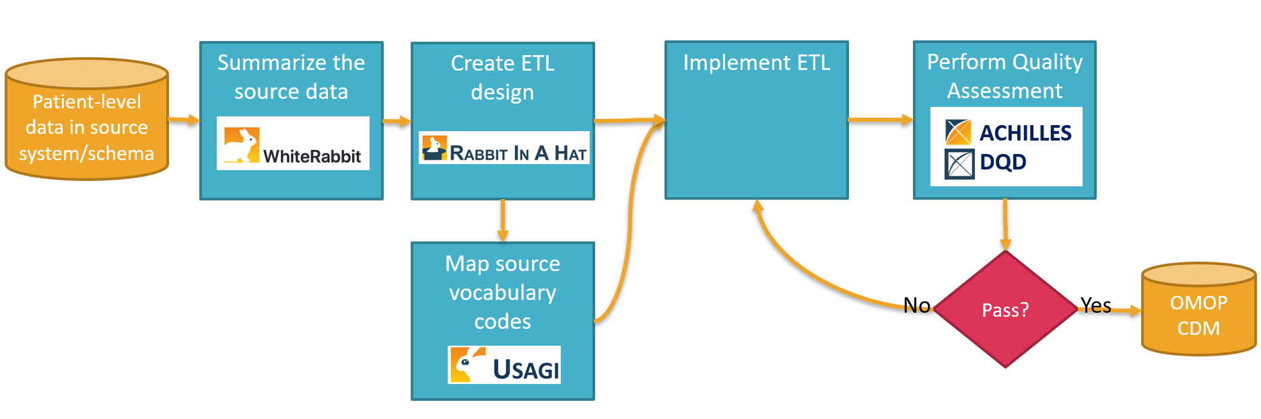
Figure 1: Observational Medical Outcomes Partnership (OMOP) Common Data Model (CDM) Extract, Transform, and Load Development Process
Even though this process is the current OHDSI best practice, it has never been measured or tested. Using the Rapid Collaboration Call we gathered information about the process through three surveys and by closely monitoring the process. The first survey gathered information about the experience of the individuals participating in the ETL process, the second and third surveys gather information related to the Framework for Classification of Electronic Health Data ETL Challenges described by Ong et al [6]. The second survey focused on the framework’s first three challenge themes: as challenges with source data, technical difficulties, and issues with knowledge management. The third survey focused on the last three challenge themes: code management & versioning issues, data quality concerns, and ETL operations challenges. The information gathered in these surveys allows us to assess the ETL process.
Usually OHDSI recommends ETLs to be defined in person over the course of a few days. However, due to the COVID-19 crisis, meeting in person were not possible. Therefore, for each data partner a Microsoft (MS) Teams environment was setup to communicate with the EHDEN Taskforce and to keep track of the progress. Virtual ETL workshops were organized to define the ETL with the local team. There was a planner to track the duration of steps described in Figure 1. Weekly status calls allowed for each team to track their process in the planner and thus track how long each step took. Additionally, when the CDM was completed the DataQualityDashboard was run on it. This tool runs over 3,000 check for data quality and provides and overall score. Data partners would run this tool multiple times ultimately stopping when they felt the quality was high enough. The final DQD score will be the measure of the CDM’s quality.

Results
Preliminary results for Survey 1 included 42 completed surveys, 27 from the data partners and 15 from task force members. These results represent 7 unique data partners of which two already started their CDM prior to the Rapid Collaboration call and were in various stages of the ETL process.
Seven of the 7 data partners teams had an individual that would identify their primary role as technical (computer scientist, data manager, informatician, or statistician) and 4 of the 7 data partner teams had someone who represents the clinical side of the data (clinical scientist, epidemiologist, or medicine). Every data partner had at least one individual who considers themselves either competent, proficient, or expert in their data source. About half of the data partner individuals consider themselves experienced to expert in converting data to a research model, this represented 6 of the 7 data partner teams. It is promising that most data partners have brought good skills and past experience to the process (e.g. meaning the teams have experience with health data and/or technical experience performing data tasks such as an ETL).
In general individuals on the data partner teams thought the process would be in the timespan of months rather than weeks (5 out of 27 individuals across 4 data partners thought the process would take less than 4 weeks). There were 4 individuals within 4 different data partners that each thought the process would take more than 6 months. Therefore, the majority of the individuals believe that the Rapid Collaboration Call should take less than 6 months.
More results will be available for and presented at the 2020 OHDSI Symposium.

Discussion
The COVID-19 Data Partner Call is currently ongoing, and more lessons learned will be presented at the time of the symposium. It will be interesting to learn from these 25 ETLs what the bottlenecks are in the mapping process. Speed by itself is not a goal but it is important to understand how we can improve the processes and tools further to decrease the necessary resources from the data partner. Quality control is very important in all the steps in the process and we will report on this in more detail once this data is available.

References
1. Reisinger, S.J., et al., Development and evaluation of a common data model enabling active drug safety surveillance using disparate healthcare databases. J Am Med Inform Assoc, 2010. 17(6): p. 652-62.
2. Common Data Model (CDM). Available from: https://github.com/OHDSI/CommonDataModel.
3. Observational Health Data Sciences and Informatics, The Book of OHDSI. Independently published.
4. Overhage, J.M., et al., Validation of a common data model for active safety surveillance research. J Am Med Inform Assoc, 2012. 19(1): p. 54-60.
5. Voss, E.A., et al., Feasibility and utility of applications of the common data model to multiple, disparate observational health databases. Journal of the American Medical Informatics Association, 2015. 22(3): p. 553-564.
6. Ong, T., et al., A Framework for Classification of Electronic Health Data Extraction-Transformation-Loading Challenges in Data Network Participation. EGEMS (Wash DC), 2017. 5(1): p. 10.
7. European Health Data & Evidence Network (EHDEN). COVID-19 Rapid Collaboration Call. 2020; Available from: https://www.ehden.eu/04-2020-covid19-data-partner-call/.
8. OHDSI White Rabbit. Available from: http://ohdsi.github.io/WhiteRabbit/index.html.
9. OHDSI / WhiteRabbit. GitHub.
10. OHDSI USAGI. Available from: https://www.ohdsi.org/web/wiki/doku.php?id=documentation:software:usagi.
11. OHDSI / USAGI. GitHub.
12. OHDSI / Automated Characterization of Health Information at Large-scale Longitudinal Evidence Systems (ACHILLES). GitHub.
13. OHDSI / DataQualityDashboard (DQD) GitHub.

