NCCD – RxNorm: Linking Chinese Clinical Drugs to International Drug Vocabulary
Yaoyun Zhang, PhD¹, Jing Li², Mui Van Zandt²

¹Melax Technologies, Inc, 7000 Fannin St Suite 1900, Houston, TX, USA; ² Real World Solutions, IQVIA, Durham, NC, USA

Abstract
The emerging pandemics make it urgent to establish a clinical research network on a global scale. The expansion of clinical research from China to the international community will greatly facilitate cooperative efforts. However, due to the language barrier and different vocabulary systems, important clinical knowledge in China remains unexchangeable with the other countries. This project aims to map concepts of chemical drugs in a Normalized Chinese clinical drug (NCCD) knowledge base with RxNorm and the international RxNorm extension in OHDSI research network, and build an efficient channel for clinical research both locally and globally.

Research Category (please highlight or circle which category best describes your research)
Observational data management, clinical characterization, population-level estimation, patient-level prediction, other (if other, please indicate)

Introduction
Expanding the clinical research network from China to the international community will greatly facilitate the collaborative efforts to conquer emerging pandemics globally. However, little effort has been devoted to making clinical drug information in China exchangeable with the rest of the world. This project aims to link clinical drugs in China with those in the USA and beyond, by mapping concepts of chemical drugs in a Normalized Chinese Clinical Drug (NCCD) knowledge base¹ with RxNorm² and the international RxNorm Extension³ in the OHDSI research network.⁴

Method
The workflow of mapping drug concepts in NCCD to RxNorm and RxNorm Extensions is illustrated in Figure 1: (1) Data cleanup: The NCCD was first cleaned up to remove concepts of Chinese Patent Drugs and noises of mislabels; (2) Concept translation: Terms (Synonyms) of drug concepts in NCCD were translated into English, by using known Chinese-English term pairs in existing resources,⁵ and manual check based on output from auto-translators. (3) Concept matching: To process English translations that cannot find exact string match in RxNorm terms, a search engine with indexed RxNorm terms was built. By querying the search engine, the semantic similarity will be calculated between the English translation and each RxNorm term of the same semantic type using the BM25 information retrieval model.⁶ The most semantically similar RxNorm terms will be returned for manual review. Semantic drugs that cannot find matches in RxNorm will further go through RxNorm-Extension to increase the coverage. (4) Enrich RxNorm-Extension: the rest concepts in NCCD that cannot find any match will be added into RxNorm-Extension.

Result
The statistics of current mapping results is illustrated in Table 1. In total, 2 159 ingredients (64.83%), 931 dose forms (90.92%) and 88 branded names (1.80%) in NCCD can be mapped to RxNorm. 2,247 (25.39%) and 588 (6.64%) semantic clinical drugs in NCCD can be mapped to RxNorm and RxNorm Extension, respectively. We further validated the mapping results using top 1,000 Chinese drugs frequently used in clinical settings. Specifically, among the top 1,000 most frequent clinical drugs in China, 673 (67.3%) drugs are mapped to RxNorm at the ingredient level, 358 and 52 are mapped to semantic clinical drugs in RxNorm and RxNorm Extension (41.0%).
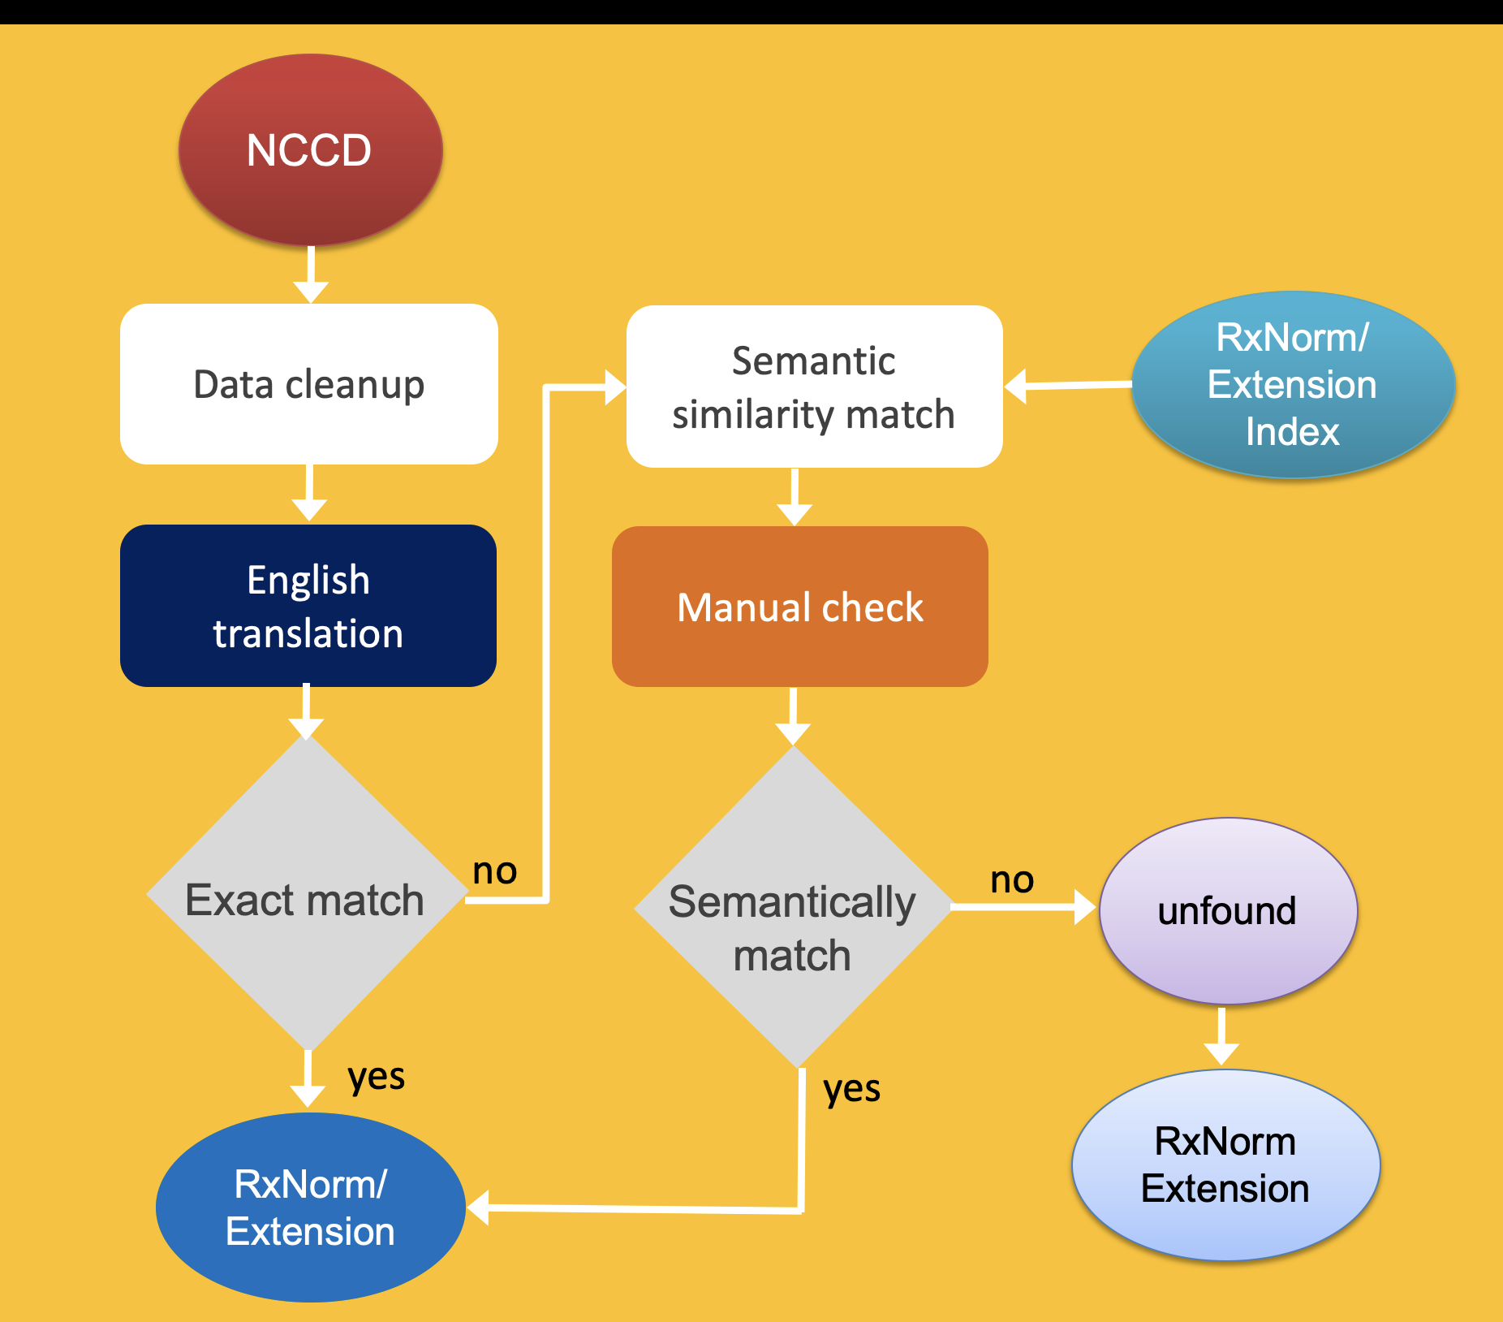
Figure 1. Workflow of semantic mapping between NCCD and RxNorm/Extension.

Table 1. Statistics of semantic mapping between NCCD and RxNorm/Extension.
Chemical Drug Concept in NCCD | Mapping to RxNorm/Extension
Ingredient (IN) | 2,159 / 64.83%
Dose form (DF) | 931 / 90.92%
Brand name (BN) | 88 / 1.80%
Semantic clinical drug form | 3,075 / 37.63%  788 / 9.64% (Extension)
Semantic clinical drug component | 2,226 / 33.06%  578 / 8.58% (Extension)
Semantic clinical drug | 2,370 / 22.70%  588 / 5.63% (Extension)

Conclusion
The mapping between NCCD to RxNorm/Extension will serve as an efficient channel to promote clinical research both locally and globally. Studies using real-world data will be conducted in the near future to further validate and improve the usability of the generated drug information resources.
References
1. Wang, L. et al. Toward a normalized clinical drug knowledge base in China—applying the RxNorm model to Chinese clinical drugs. J. Am. Med. Inform. Assoc. 25, 809–818 (2018).
2. RxNorm. https://www.nlm.nih.gov/research/umls/rxnorm/index.html.
3. Documentation:international_drugs [Observational Health Data Sciences and Informatics]. https://www.ohdsi.org/web/wiki/doku.php?id=documentation:international_drugs.
4. Research Network – OHDSI. https://www.ohdsi.org/join-the-journey/research-network/.
5. National Medical Products Administration. http://english.nmpa.gov.ex2.ipv6.nmpa.gov.cn/.
6. Okapi BM25: a non-binary model. https://nlp.stanford.edu/IR-book/html/htmledition/okapi-bm25-a-non-binary-model-1.html.

