Treatment Patterns and Risk of Switch to Mania in Bipolar Depressive Patients Treated with Antidepressants: A real world study using the OHDSI Network

L. Feng^{1,2*}, W.W. Wang^{1,2*}, X.L. Wang^{3,4}, X.W. Zhang⁵, P.P. Miao⁵, Y.J. Feng^{3,4}, M.V. Zandt^{3,4}, S. Seager^{3,4}, K. Kostka^{3,4}, C. Reich^{3,4}, G. Wang^{1,2}

¹ National Clinical Research Center for Mental Disorders & Beijing Key Laboratory of Mental Disorders, Beijing Anding Hospital, Capital Medical University, Beijing, China
² Advanced Innovation Center for Human Brain Protection, Capital Medical University, Beijing, China
³ Real World Solutions, IQVIA, Durham, North Carolina, USA
⁴ Observational Health Data Sciences and Informatics, New York, New York, USA
⁵ SmindU Medical Science & Technology Co., Ltd., Beijing, China
*L. Feng and W.W. Wang contributed equally to the work

Abstract:
The use of antidepressants (AD) for treating bipolar depression remains controversial due to the potential risk of inducing switch to mania. This multinational, large-scale, observational study is to describe the use of AD among bipolar depressive patients, and the potential risk of manic switch associated with the use of AD alone or in combination with antipsychotic or mood stabilizer. In the study, four electronic health record databases and one administrative claims database from four countries were used in this retrospective, observational study. Demographic characteristics of the bipolar depressive patients and their treatment pathways were described. Incidence rate ratio (RR) of manic switch was calculated by comparing the patients treated with AD group with those who were not AD group in acute phase and in maintenance phase after the treatment. Rate ratios comparison were used to evaluate the protective effects of concurrent treatments on manic switch. A total of 2.8 million patients from the five databases were included for the analysis, 70% of whom received AD as initial treatment for bipolar depression. Proportion of AD monotherapy ranged from 19.6% to 46.9% across the databases. AD group had lower incidence rates of manic switch than Non-AD group in both acute and maintenance phase. It indicated that AD had been widely used in clinical practice to treat bipolar depression. The use of AD did not increase the risk of manic switch when compared to non-AD treatment.
Research Category
Clinical characterization
Introduction
Bipolar disorder is a recurrent and chronic affective disorder, throughout the course of the disease, depression episodes accounted for 72% of the duration of the illness, and it also takes a longer time to remission. However, the use of AD in bipolar depressive episodes treatment remains controversial due to the potential risk of inducing a switch from depression to hypomania or mania (McGirr et al., 2016; Truman et al., 2007; Valentí et al., 2012). In this study, we conducted a large-scale, retrospective, observational study across five databases standardized to Observational Medical Outcomes Partnership Common Data Model (OMOP CDM) to investigate the treatment patterns for the bipolar depression and risk of switch to mania amongst the patients treated with AD.
Methods
Four electronic health record databases and one administrative claims database from four countries were used in this retrospective, observational study. The bipolar depression patients from the databases were included in the study cohort (Fig. 1). Demographic characteristics of the bipolar depressive patients and their treatment pathways were described. Incidence rate ratio (RR) of manic switch was calculated by comparing the patients treated with ADs (AD group) with those who were not (Non-AD group) in 0-3 months (acute phase) and in 3-9 months (maintenance phase) after the treatment. Patients were further categorized to AD monotherapy (AD-mono group) and AD in combination with antipsychotics or mood stabilizers (AD-con group). Rate ratios comparison were used to evaluate the protective effects of concurrent treatments on manic switch.
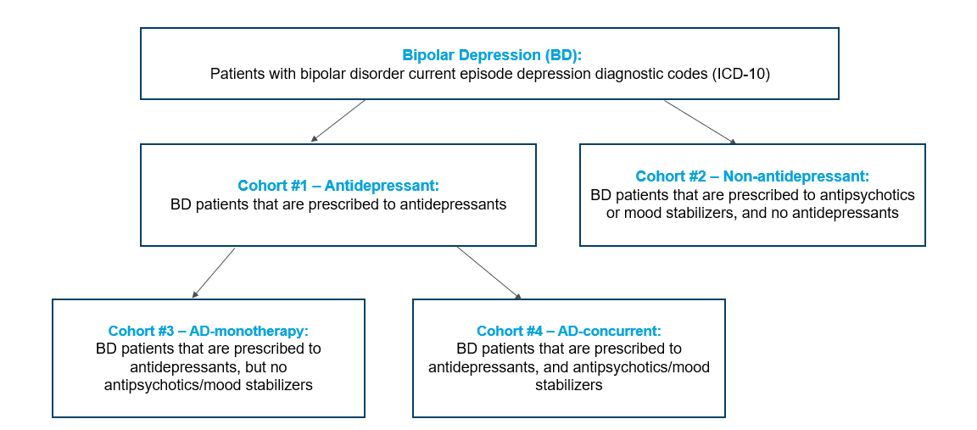
Figure 1. Flow diagram of patient selection
Results
A total of 2.8 million patients from the five databases were included for the analysis, 70% of whom received AD as initial treatment for bipolar depression. Proportion of antidepressants monotherapy ranged from 19.6% to 46.9% across the databases. Data from China showed a wider spread of therapies which indicated more treatment alternatives and combinations (Fig. 2). AD group had lower incidence rates of manic switch than Non-AD group in both acute and maintenance phase. Furthermore, incidence rates of manic switch were lower in AD-mono group than AD-con group in both acute and maintenance phase.
Conclusion
This study indicated that antidepressants had been widely used in clinical practice to treat bipolar depression, even as initial treatment. The use of antidepressants did not increase the risk of manic switch when compared to non-antidepressants treatment, whether alone or in combination with mood stabilizers or atypical antipsychotics. Therefore, antidepressants could be used as a safe and effective alternative treatment for bipolar depression and be recommended as first-line treatment.
References
- McGirr A, Vöhringer PA, Ghaemi SN, Lam RW and Yatham LN (2016) Safety and efficacy of adjunctive second-generation antidepressant therapy with a mood stabiliser or an atypical antipsychotic in acute bipolar depression: a systematic review and meta-analysis of randomised placebo-controlled trials. The Lancet Psychiatry.
- Truman CJ, Goldberg JF, Ghaemi SN, Baldassano CF, Wisniewski SR, Dennehy EB, Thase ME and Sachs GS (2007) Self-reported history of manic/hypomanic switch associated with antidepressant use: data from the Systematic Treatment Enhancement Program for Bipolar Disorder (STEP-BD). The Journal of clinical psychiatry 68, 1472–9. Available at http://www.ncbi.nlm.nih.gov/pubmed/17960960.
- Valentí M, Pacchiarotti I, Bonnín CM, Rosa AR, Popovic D, Nivoli AMA, Goikolea JM, Murru A, Undurraga J, Colom F and Vieta E (2012) Risk factors for antidepressant-related switch to mania. Journal of Clinical Psychiatry.

