Proof-of-concept model targeting patient-level prediction of 90-day mortality after colorectal cancer surgery kickstarts OHDSI journey ​
Rasmus Peuliche Vogelsang, Andreas Weinberger Rosen, Eldar Allakhverdiiev, Ismail Gögenur
Background
Denmark is known for good-quality health data registries. Danish health registries contain highly granular patient-level information and have nationwide coverage along with the rigorous annual validation process to make the data quality and consistency reliable. Denmark has 23 cancer registries, and the effort is led by the Danish Multidisciplinary Cancer Group (DMCG). One of the cancer databases with good coverage and granularity is the Danish Colorectal Cancer Group's database (DCCG.dk) (1). DCCG.dk was designed by medical doctors and all data collected was chosen based on the notion that it should be clinically relevant in describing patients with colorectal cancer. This means that the database contains various demographic data, general health data, pathology investigations, previous diagnoses, and perioperative surgical data, including key surgical outcome parameters. We considered it an interesting process to investigate the performance of such data in terms of predictive power for surgical outcomes. Acknowledging the need for data interoperability in personalized medicine, we started our OHDSI journey to standardize the data from custom DCCG.dk coding vocabularies and build a CDM based on the OMOP common vocabularies.
We approached the implementation and standardization of data by inviting end-users – medical doctors – to help us do the concept mapping of the Danish diagnosis classification system (SKS) and custom DCCG.dk vocabularies. This effort was a strenuous process where a dedicated team of doctors undertook manual mapping and curation of the 1747 covariates in DCCG. Concurrently with this process, our team of bioinformaticians and external collaborators worked on designing the structural mapping of DCCG in CDM format and designing the ETL process.
After designing and running the pilot version of the DCCG-CDM, we considered how we could best apply this new data structure to a clinical problem. We opted to develop a patient-level prediction model assessing risk of death within 90 days of colorectal cancer surgery. In addition, to comply with a clinically relevant issue, we chose to use both pre- and intraoperative covariates to make a model applicable immediately after surgery to optimize the postoperative patient course.
Methods
We designed our CDM through an iterative data collection process, concurrent concept mapping by medical doctors and structural mapping using OHDSI tools such as White Rabbit and Rabbit in a Hat, data de-identification and data curation by rigorous quality control and automated testing to capture all errors that might have occurred. This left us with a high-quality CDM based on a nationwide colorectal cancer database.
We conducted a nationwide cohort study including all patient entries in the DCCG.dk database. Our target cohort consisted of all patients undergoing surgery for colorectal cancer from January 1, 2004, through December 31, 2015. We used a LASSO logistic regression model (2) trained on 121 pre- and intra-operative variables and internally validated in a holdout test dataset. Model performance was assessed in terms of discrimination and calibration.
Results
Results from the POC prediction model
In total, 49 607 patients were registered during the period. Overall, 16 680 patients were excluded from the cohort due to, e.g., advanced disease at the time of diagnosis (i.e., no clinical indication of surgery), which left 32 927 patients to be included in the analysis. A total of 1754 (5.3%) deaths were recorded. Targeting high-risk individuals, the model identified 5.5% of all patients with a risk of >35% risk of death within 90 days, equivalent to a 6.7 times higher risk than the average population. The model also correctly identified 20.9% of patients with a <0.3% risk, or a 17.7 times lower risk than the average population. The model used 121 covariates in the Lasso Regression, and the top-10 positive and negative weighing covariates are presented in table 1. The model discriminated with an AUROC of 85.3% (95% CI, 83.6 to 87.0) and excellent calibration with a 0.04 Brier score and 32% average precision.
Results of implementation of CDM on nationwide colorectal cancer data
We found that the process of creating a CDM based on the nationwide quality assurance data shows great promise in moving personalized medicine and surgery forward. This has led to the design and development of a larger-scale project at the Center for Surgical Science aiming to create a CDM enriched with other nationwide patient data sources (e.g., lab values, microbiology data, medical prescriptions, detailed pathology data, diagnoses data, and causes of death data).
Concept ID | Domain | Vocabulary | Covariate name | Covariate count, n | Covariate count, % | Covariate coefficient (LASSO)
n/a | Demographic | n/a | age group: 90-94 | 420 | 1,28 | 1,58
n/a | Demographic | n/a | age group: 85-89 | 2311 | 7,02 | 1,27
4159411 | Measurement | SNOMED | Measurement above normal range American Society of Anesthesiologists physical status classification | 384 | 1,17 | 0,9
n/a | Demographic | n/a | age group: 80-84 | 3987 | 12,11 | 0,88
432851 | Condition | SNOMED | Secondary malignant neoplastic disease | 373 | 1,13 | 0,6
2108119 | Procedure | CPT4 | Transfusion, blood or blood components | 5107 | 15,51 | 0,51
n/a | Demographic | n/a | age group: 75-79 | 5445 | 16,54 | 0,5
36716945 | Condition | SNOMED | Renal insufficiency | 702 | 2,13 | 0,41
42538860 | Measurement | SNOMED | Measurement above normal range Charlson Comorbidity Index | 3047 | 9,25 | 0,37
198700 | Condition | SNOMED | Secondary malignant neoplasm of liver | 1694 | 5,14 | 0,3
4310250 | Observation | SNOMED | Ex-smoker | 11 533 | 35,03 | -0,37
4059384 | Procedure | SNOMED | Preoperative course of radiotherapy | 2460 | 7,47 | -0,41
2000056108 | Observation | DCCG.dk | No evidence of: Disease of liver, mild | 32 703 | 99,32 | -0,44
n/a | Demographic | n/a | age group: 45-49 | 861 | 2,61 | -0,48
n/a | Demographic | n/a | age group: 60-64 | 4005 | 12,16 | -0,49
4159411 | Measurement | SNOMED | Measurement below normal range American Society of Anesthesiologists physical status classification | 25 567 | 77,65 | -0,51
n/a | Demographic | n/a | age group: 50-54 | 1778 | 5,4 | -0,61
n/a | Demographic | n/a | age group: 55-59 | 2362 | 7,17 | -0,67
4166767 | Procedure | SNOMED | Optional surgery | 30 112 | 91,45 | -0,67
3025315 | Measurement | LOINC | Measurement value Body weight (kilogram) | 28 331 | 86,04 | -0,92
Table 1. Top-10 positive and negative weighing covariates in cohort

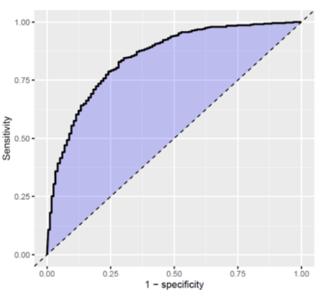
Figure 1. ROC curve for 90-day postoperative mortality following colorectal cancer surgery.
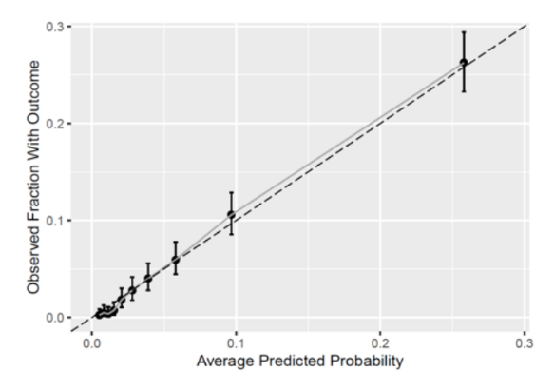
Figure 2. Calibration plot for 90-day postoperative mortality following colorectal cancer surgery.

Conclusion
From the implementation of the OMOP-CDM framework on the Danish Colorectal Cancer Group's database, we found that it was feasible to combine the qualifications from both medical doctors and data scientists, but this was a significant strength of the project. The project's success and international interest have led us to expand the project to involve creating and unifying multiple CDMs to improve further prediction models based on the data. We also found that our first prediction model based on nationwide quality assurance data resulted in great discriminatory and excellent calibration power, which is very encouraging for future work and implementing decision support tools in clinical practice.
References
1. Ingeholm P, Gögenur I, Iversen LH. Danish colorectal cancer group database. Clin Epidemiol. 2016;8:465–8.
2. Observational Health Data Sciences and Informatics. The Book of OHDSI. 2019;1–470. Available from: https://ohdsi.github.io/TheBookOfOhdsi/TheBookOfOhdsi.pdf

