Mapping UK Biobank to the OMOP CDM: challenges and solutions using the delphyne ETL framework

Sofia Bazakou¹, Maxim Moinat¹, Alessia Peviani¹, Anne van Winzum¹, Stefan Payralbe¹, Vaclav Papez², Spiros Denaxas²
¹The Hyve, Utrecht, The Netherlands; ²University College London, London, United Kingdom;

Background
UK Biobank¹ (UKB) is a large-scale registry containing medical and genetic data from 500.000 consented participants aged between 37 and 73 years. The initial data were collected from 2006 to 2010 and are being enriched constantly. The dataset is well documented and structured, including multiple initial baseline assessments (such as surveys, samples, imaging), linkages to electronic health records (primary care data, cancer and death registrations, hospital data) and, recently, information on COVID-19 testing.
As part of the European Health Data Evidence Network² (EHDEN), we collaborated with University College London (UCL) to map the UKB data to the OMOP CDM v5.3. The Hyve performed the technical part of the mapping, whilst UCL provided the source data expertise. The main goal of the collaboration was to make the dataset available for research related to the COVID-19 pandemic.
As with any vast amount of information, mapping to a different model has challenges. The biggest challenge was the conversion of a wide format table to a long format. Participants can have up to 4 baseline assessments that span multiple visits and are in the form of questionnaires, interviews, measurements and samples (blood, urine, saliva), data from activity monitors or scans. Thus for each patient, a wide variety of variables and time points needed to be extracted from a 500,000 by 9,000 table. There is also a large heterogeneity of source terms amongst data providers. For some fields, the terms included free text or were captured using a mix of ontologies (some of which have now been deprecated). As a result, reviewing, harmonising and mapping these terms to the OMOP standard vocabularies required a significant effort.

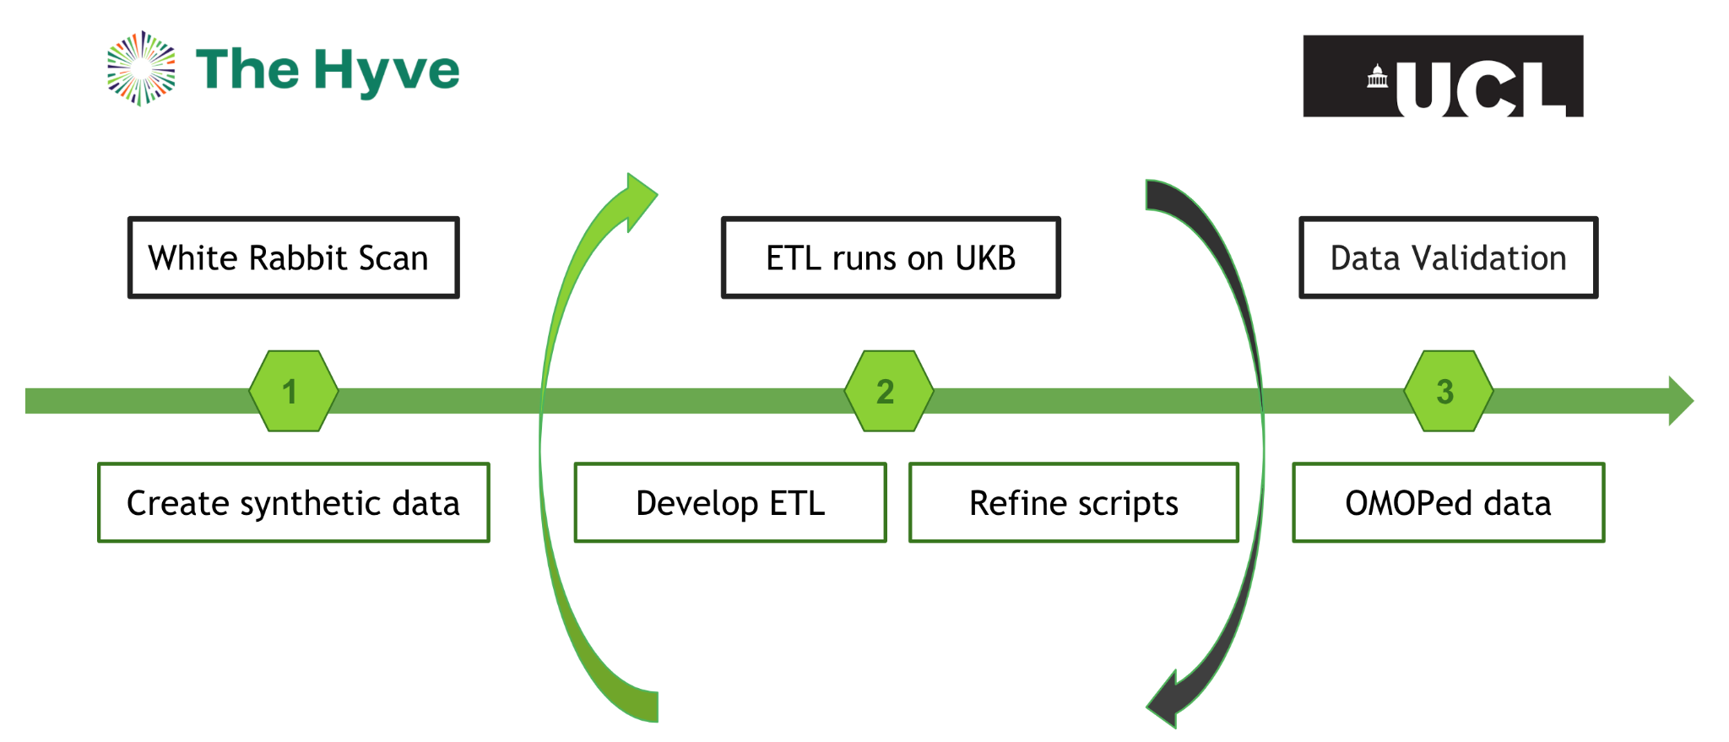
Figure 1. Iterative development approach based on the collaboration between The Hyve and UCL.
In addition to technical challenges, we also faced the organizational challenge of developing the scripts relying entirely on synthetic data. UCL provided The Hyve with a White Rabbit scan report from the source data, which was used to generate synthetic datasets for ETL development. Once tested, the code would then be run locally by UCL on the original data. With an iterative development approach, including frequent meetings with our collaborators, we were able to optimize the data processing steps.
To achieve a high quality mapping, we used several tools from the OHDSI quiver, however the bulk of the transformation code was implemented using Delphyne³, a Python package developed by the Hyve.

Methods
As mentioned above, we initially used White Rabbit to generate synthetic datasets. Next, we created the syntactic mappings to the OMOP CDM and the documentation with Rabbit in a Hat (RiaH), and the semantic mappings of source codes to standard concepts with both Usagi (free text fields) and Delphyne (standardized ontologies). We wrote the main transformation code with Delphyne and we implemented tests with the R testing framework functionality of RiaH. The code was then deployed at UCL with Docker to be executed on the original data. Lastly, we performed quality assessments with both Achilles and the Data Quality Dashboard (DQD).

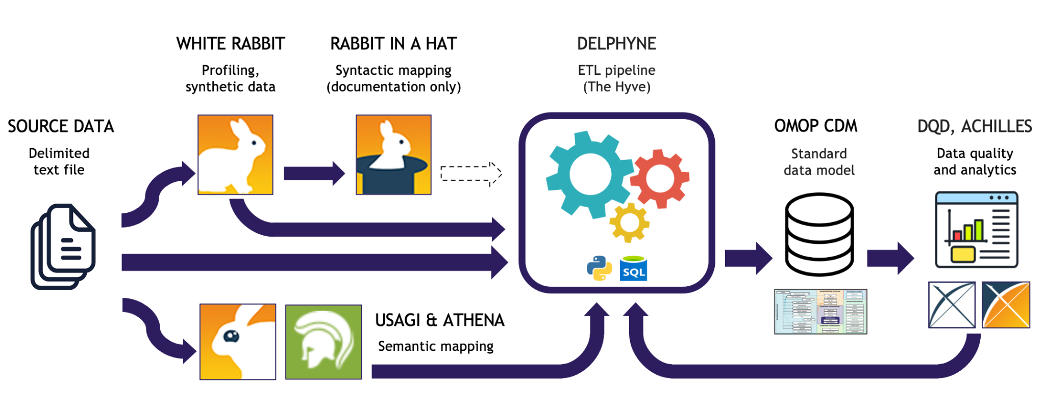
Figure 2. Data conversion workflow using existing OHDSI tools together with Delphyne.

Delphyne was developed as a framework for the conversion of data to the OMOP CDM. It provides a core component to orchestrate the execution of transformation scripts and automate time-consuming setup steps, such as the creation of target tables, and the loading of vocabularies. The package provides out-of-the-box functionality to, amongst others, perform custom semantic mappings, extend the target CDM model with additional tables and columns, and tweak execution performance (for example, through the caching of source data or the manipulation of table constraints). The design of the package allows for an efficient and greatly customizable data conversion process, and is well-suited for an iterative development approach, like used here.

Results
Our effort to convert the UK Biobank data to the OMOP CDM is an excellent example of successful collaboration and community engagement. Besides working with UCL to enable the UKB data to be used for research, the Hyve actively participated in the OHDSI community, by founding and leading the UKB working group, as well as initiating and taking part in OHDSI Forums discussions on issues that arose from the mapping and would benefit the community as a whole.
In total, the ETL codebase includes 35 table to table transformation scripts, and makes use of 19 OMOP vocabularies for the semantic mapping. So far, the code has been executed successfully at UCL on a representative subset of the data with the DQD currently achieving a 99% pass rate.
Such a high rate is a direct result of regular conversations with UCL, from which we gained useful insights for code adjustments, as well as the use of Delphyne’s informative execution logs and summary reports to facilitate the investigation of data quality issues.

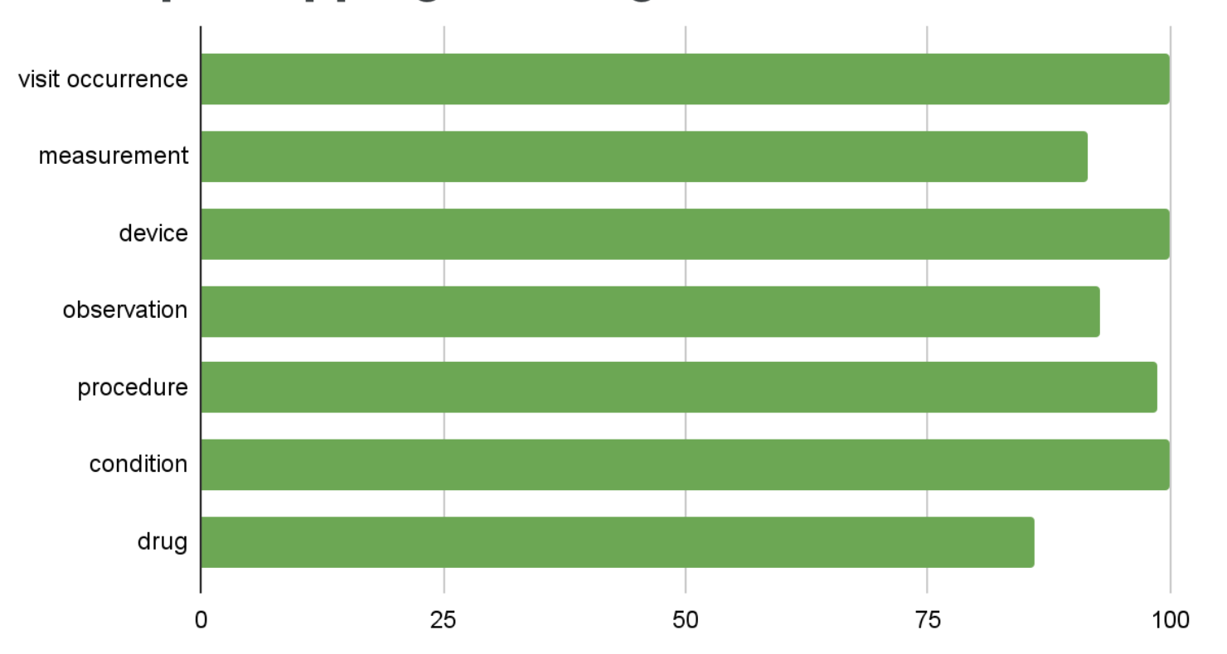Figure 3. Percentage of UKB source codes mapped to a standard OMOP concept per domain by record frequency (preliminary results based on a representative subset of the full dataset). We achieved a near full mapping coverage for the visit, device and condition domains (>99%) and the lowest mapping coverage was for the drug domain (86%).

Conclusion
We have delivered a high quality mapping of the UKB baseline, linked EHR and covid testing data to OMOP, enabling future EHDEN network studies on COVID-19. The OMOP CDM was well-suited to capture UKB data and we managed to convert nearly all source fields. Delphyne simplified the implementation of the transformations by providing built-in classes and functions, solved memory issues arising from running the ETL on such a vast dataset, and allowed us to track execution steps in detail, leading to a sustainable development process.
UKB is an incredible resource for healthcare research, and given its size and complexity, a powerful and flexible ETL framework such as Delphyne was invaluable in carrying out the conversion effort in a timely manner.
References/Citations
- UK Biobank. Available from: https://www.ukbiobank.ac.uk/ [Accessed 15 June 2021]
- European Health Data Evidence Network (EHDEN). Available from: https://www.ehden.eu/ [Accessed 1 June 2021]
- Delphyne user documentation. Available from: https://delphyne.readthedocs.io/en/latest/ [Accessed 17 June 2021]

