The secret (outpatient) garden:
Using the OMOP CDM to better differentiate between outpatient and inpatient diagnoses in VA EHR data
Elise Gatsby, Benjamin Viernes, Michael E Matheny, Scott L DuVall, Kristine E Lynch
Background
The ability of administrative coding data to accurately identify a condition can vary across databases and multiple approaches to mitigate misclassification exist. For instance, requiring 2 or more outpatient diagnosis records or 1 or more inpatient diagnosis records is a common approach to remove rule-out or differential diagnoses which may be recorded in ambulatory care settings. This requires a clear differentiation between outpatient and inpatient settings which may vary between electronic health record (EHR) systems. In the Department of Veterans Affairs (VA), differentiating between outpatient and inpatient settings can be challenging as a portion of inpatient consultations are documented as outpatient visits in order to capture clinical workload. For users of the VA Corporate Data Warehouse (CDW) (the source data for VA OMOP), one approach to separating outpatient and inpatient records is to classify diagnoses according to the source table: outpatient workload vs. inpatient files. A limitation of this approach is that it does not address diagnoses that may be inpatient events but stored in the outpatient workload file. As part of the transformation process from CDW to OMOP, we developed heuristics to identify and assign the inpatient workload that appeared as outpatient appropriately within the VISIT_OCCURRENCE table. Specifically, VISIT_CONCEPT_ID identifies the sub-type of visit.
Methods
Using a list of 4,021 ICD-10 codes for 95 conditions defined for use in the VA’s COVID-19 Shared Data Resource (CSDR), outpatient and inpatient records for calendar year 2019 were gathered from CDW. These ICD-10 codes were selected as the CSDR already maps them to a specific condition and they are relatively common both in terms of number of patients and number of records. This query resulted in 129,021,102 records for 5,106,915 patients. Each record was classified as outpatient or inpatient corresponding to the source table. For the OMOP-based approach, the same diagnosis records were classified as either outpatient or inpatient based on VISIT_CONCEPT_ID from the VISIT_OCCURRENCE table. See Table 1 for classification system. Using each approach, patients qualified as having the condition if they had 2 or more outpatient diagnoses on different dates or 1 or more inpatient diagnoses. Absolute and relative frequency of qualifying patients were compared between approaches.
Results
Frequency of qualifying patients varied per condition and by approach. The percent change from the source table-based approach to the OMOP-based approach ranged from -2.44% (more patients from source table-based) to +105% (more patients from OMOP-based) with the median percent change being +1.35%. In other words, approximately 1.35% more patients qualified as having a condition during 2019 when using the OMOP-based approach as compared to the source table-based approach.
Patients who did not qualify using the source table-based approach but did qualify using the OMOP-based approach had outpatient workload records that were classified as Outpatient Visit Within Inpatient Visit in OMOP. Thus, a singular outpatient record which would not have qualified the patient under the source table-based approach did under the OMOP-based approach. For the reverse, patients who did qualify using the source table-based approach but did not qualify using the OMOP-based approach typically did not qualify because inpatient records were classified as Non-hospital Institution Visit in OMOP (outpatient). Thus, a singular inpatient record which would have qualified the patient under the source table-based approach no longer did under the OMOP-based approach. Similarly, but affecting less patients, inpatient records were classified as No matching concept in OMOP and excluded.
Conclusion
Defining conditions by 2 or more outpatient diagnosis records or 1 or more inpatient diagnosis records requires a clear definition of clinical setting of record. For VA researchers, using the source table alone to differentiate between outpatient and inpatient diagnoses may not be sufficient. Utilizing VISIT_CONCEPT_ID from OMOP is a quick and easily way to sub-type and refine clinical records into outpatient vs. Inpatient categories. The change in patient counts may vary depending on the condition of interest with some having only minor changes and others having substantial decreases or increases.

Table 1. Categorization of VISIT_CONCEPT_ID into Outpatient or Inpatient
VISIT_CONCEPT_ID | VISIT_CONCEPT_NAME | STANDARD_CONCEPT | Instances | Categorization
9202 | Outpatient Visit | S | 105,906,651 | Outpatient
9203 | Emergency Room Visit | S | 1,452,533 | Outpatient
42898160 | Non-Hospital Institution Visit | S | 755,834 | Outpatient
800000002 | Outpatient Visit Within Inpatient Visit | S | 14,072,151 | Inpatient
9201 | Inpatient Visit | S | 5,483,053 | Inpatient
800000001 | Inpatient Observation Visit | S | 1,324,659 | Inpatient
0 | No matching concept |  | 26,219 | Excluded
800000003 | Outpatient Visit - Cancelled | S | 0 | Excluded
800000004 | Outpatient Visit – No Show | S | <11 | Excluded
820000085 | Audiology | S | 0 | Excluded

Figure 1. Top 5 Conditions with more patients identified by OMOP-based approach | Figure 2. Top 5 Conditions with more patients identified by Source Table-based approach
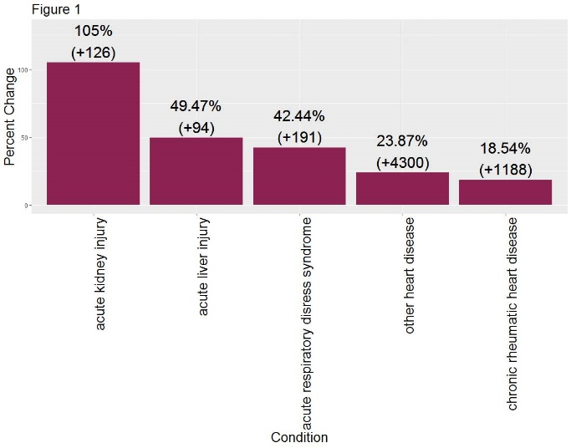 | 