The concept of anchoring in observational study design and its influence on baseline patient characteristics and study estimates
Anna Ostropolets, Talita Duarte-Salles, Xintong Li, Rupa Makadia, Daniel Prieto-Alhambra, Gowtham Rao, Peter R. Rijnbeek, Martijn Schuemie, Anthony G. Sena, Azza Shaoibi, Marc A. Suchard, Patrick B. Ryan, George Hripcsak
Background
Cohort method is one of the most common methods in comparative effectiveness and safety studies. In a cohort study, we compare rates of events during time-at-risk in target and comparator groups. Such rates are, therefore, dependent on the choice of starting point for time-at-risk or, as we call it, anchoring. Choice of anchoring may influence both the rates of observed outcomes and baseline patient characteristics, which are subsequently used in propensity score models or outcome models. Despite the extensive use of cohort method, the impact of anchoring on the abovementioned measures and, as a result, on the study estimates has not been studied systematically.
The current COVID-19 vaccination campaign requires rapid yet robust safety monitoring of potential adverse events. When cohort method is applied in vaccine safety studies, a vaccinated population is compared to an unvaccinated population. The latter cohort does not have a clear index date, which is left up to researchers’ judgment. We, therefore, investigate the influence of anchoring unvaccinated population on a visit or random date on incidence rates of 15 adverse events occurring during different time-at-risk windows. Additionally, we investigate its impact on baseline patient characteristics in unvaccinated and vaccinated populations.

Methods
We modified the study design described elsewhere (1). Briefly, we used 12 data sources to study incidence rates of 15 adverse events of special interest in unvaccinated population in 2017-2020 in a number of time-at-risk intervals (0 – 1 days, 1 – 28 days, 1 – 42 days, 1 – 90 days and 1 – 365 days). We then compared incidence rate ratios (IRR) of incidence rates in two pairs of cohorts with different index dates (“anchoring”): a) patients entering a cohort on January 1st with a visit in the next year versus patients entering on a random visit and b) patients entering on January 1st with a well visit in the next year versus patients entering on a well visit. We performed random-effect meta-analysis across data sources.
To study the effect of anchoring on baseline patient characteristics we studied patients with COVID-19 vaccine. We compared their baseline characteristics with the baseline characteristics of unvaccinated patients entering the cohort on a) a date matched to the index date of one of the target group, b) a visit matched to the index date of one of the target group. Additionally, each target and comparator groups were matched on age and sex. Baseline characteristics were assessed on day 0, 30 days to 1 day prior to the index date and 180 days to 31 days prior to the index date. This analysis was conducted on the data sources with COVID-19 vaccination data available (CUMC and Optum EHR).

Results
Influence of anchoring on incidence rates
While we observed high variation across data sources, the overall trends displayed great consistency. Incidence rates across all data sources and all conditions were highly sensitive to the choice of anchoring. For a short time-at-risk (0-1 day) anchoring on a visit was associated with up to a 100-fold increase in incidence when compared to anchoring on January 1st (pooled IRR 26.8 (95% CI 21.9-32.8)). Acute conditions such as anaphylaxis were impacted the most (pooled IRR 47.6 (95% CI 32.8 – 69.1)). The effect was attenuated for longer times at risk (Figure 1) but was still present. For example, for 1 – 28 days window, pooled IRR was 1.4 (95% CI 1.3-1.5).
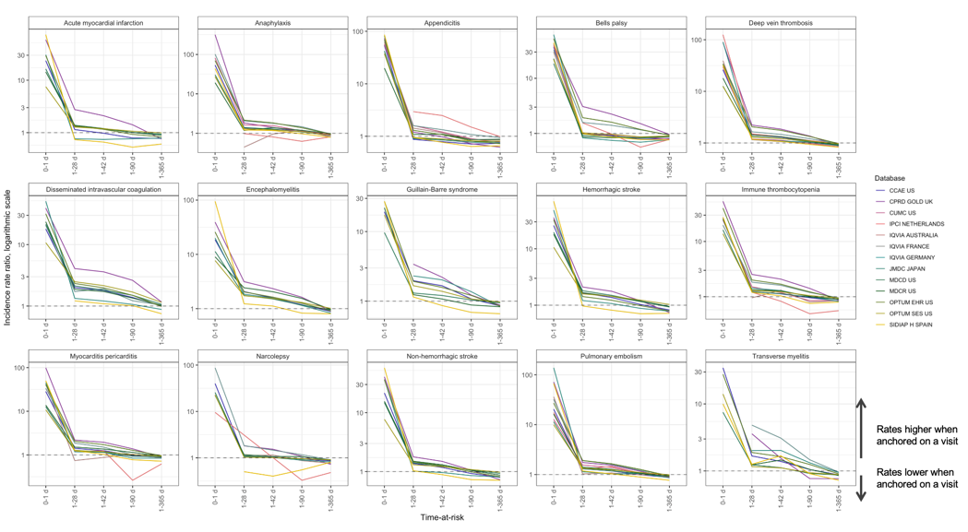
Figure 1. Incidence rate ratio of incidence rate of outcomes when entering the cohort on a random visit versus entering on January 1st in patients with a visit in the next year, time-at-risk 0-1 day, 1-28 days, 1-42 days, 1-90 days and 1-365 days.

We observed similar trends for anchoring on a well visit with the pooled IRR of 1.21 (95% CI 1.11-1.31) (Figure 2). Overall, anchoring on a well visit was associated with higher incidence rates with several conditions (such as Bell’s palsy or narcolepsy) being highly sensitive.
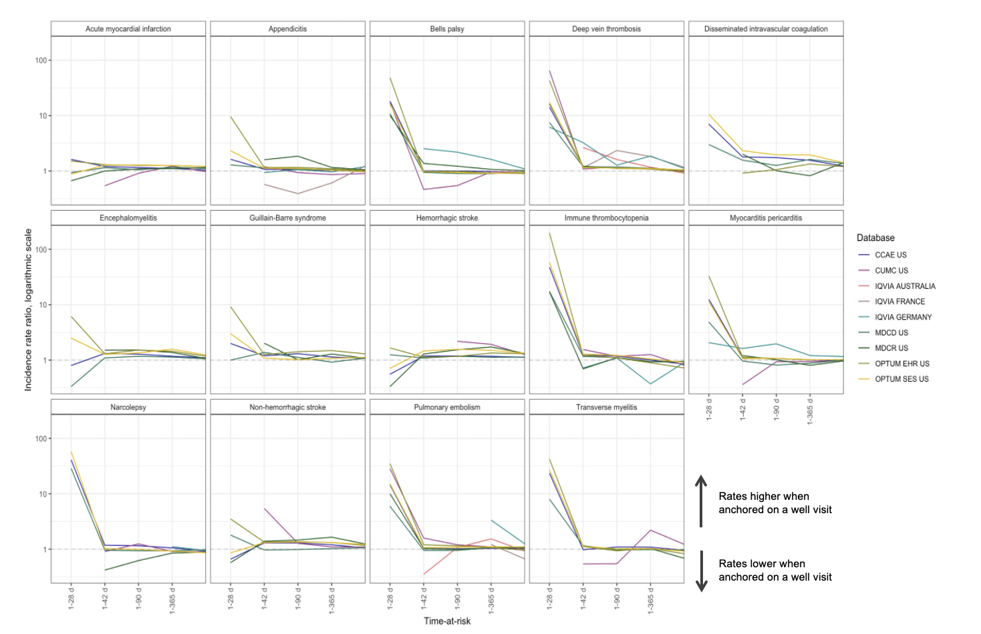
Figure 2. Incidence rate ratio of incidence rate of outcomes when entering the cohort on a well visit versus entering on January 1st in patients with a visit in the next year, time-at-risk 0-1 day, 1-28 days, 1-42 days, 1-90 days and 1-365 days.
It is, therefore, highly important to specify an appropriate comparator anchoring event that represent the vaccination best, especially when such event is not clearly defined (as in unexposed/unvaccinated population).

Influence of anchoring on baseline characteristics
When looking at the baseline characteristics, unvaccinated population had more events on day 0 than vaccinated population regardless of the anchoring event (Figure 3). Similarly, the effect attenuated with increased lookback window but was still present.
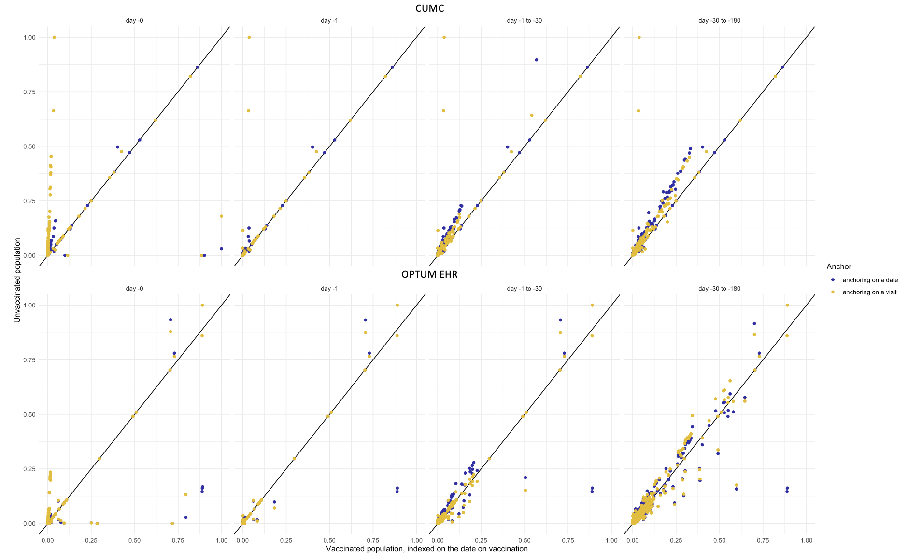
Figure 3. Comparison of baseline characteristics in unvaccinated versus COVID-19 vaccinated patients in CUMC and Optum EHR. Each dot represents one covariate, blue – unvaccinated patients anchored on a date, yellow – unvaccinated patients anchored on a visit.
Vaccinated patients had fewer lab tests (such as body weight, blood pressure or respiratory rate), co-morbidities (diabetes, hyperlipidemia, dyspnea etc.) and visits on day 0 when compared to a random date or a random visit in unvaccinated population. In patients vaccinated with an influenza vaccine (not shown here) compared to patients not vaccinated with influenza vaccine the opposite trend was observed: the former had more lab tests and co-morbidities on day 0 than unvaccinated patients.

Conclusion
Anchoring influences both baseline patient characteristics and incidence rates of conditions observed after the index date. It is important to select an anchoring that represents the target index date best. Balance on visit on day 0 should be assessed in any cohort study.

References
1. Li X, Ostropolets A, Makadia R, Shoaibi A, Rao G, Sena AG, et al. Characterising the background incidence rates of adverse events of special interest for covid-19 vaccines in eight countries: multinational network cohort study. BMJ. 2021 Jun 14;n1435.

