“Perseus”: Design and run your own ETL to CDM

Anton Ivanov, MS¹, Samus Sergey, MS¹, Alexander Efimov, MS¹, Maxim Draschinsky, MS¹,
¹Arcadia Inc., St. Petersburg, Russia



Abstract
There are several opensource ETL tools designed for CDM and available for OHDSI community. Tools for code mapping and quality control provide a good starting point to design ETL process for getting CDM but ETL implementation still requires technical skills in programming languages and platforms. Presented solution addresses this need and provides a visual designer for ETL implementation targeting CDM.

Research Category
Open-source analytics development
Introduction
Converting database to CDM usually requires significant efforts and consists of several major steps. OHDSI community provides several tools for all steps.

Step | Tools
Design ETL | White Rabbit, and Rabbit-in-a-Hat
Create code mappings | Usagi
Implement ETL | ETL-Synthea, ETL-CDMBuilder, ETL-LambdaBuilder
Quality control | Achilles, DQD

Available ETL tools (ETL-Synthea, ETL-CDMBuilder and ETL-LambdaBuilder) cover only limited set of databases. If source database of interest is not in that list, a lot of cases would require custom ETL implementation. But in a lot of cases ETLs can be configured without coding needed.

Methods
“Perseus” is combination of Web application for ETL configuration and services for: conversion of native data into CDM, data quality check, code mapping, generating ETL document and vocabulary search.

“Perseus” allows to:
- Visually map source data structure to CDM
- Combine source tables.
- Use pre-built sql functions (replace, concat…)
- Use pre-built source to source and source to standard vocabulary lookups (icd9, icd10, ndc…)
- Create new lookups for concept_id fields.
- Use constant values for CDM fields.
- Use System/Auto generated values for CDM fields.
- Automatically map similar fields
- Combine fields into groups​.
- Configure conditional mappings.
- Perform quality check through DQD integrated.
- Search through vocabulary (two engines: OHDSI Athena API and embedded OMOP Vocabulary)
- Map source codes - create mappings between coding systems and vocabulary standard concepts.

Conversion service (CDM Builder):
- Has embedded logic for creating eras (DRUG_ERAs, CONDITION_ERAs…)
- Has embedded logic for grouping visit occurrence/observation_period records.
- Automatic domain switching

General workflow
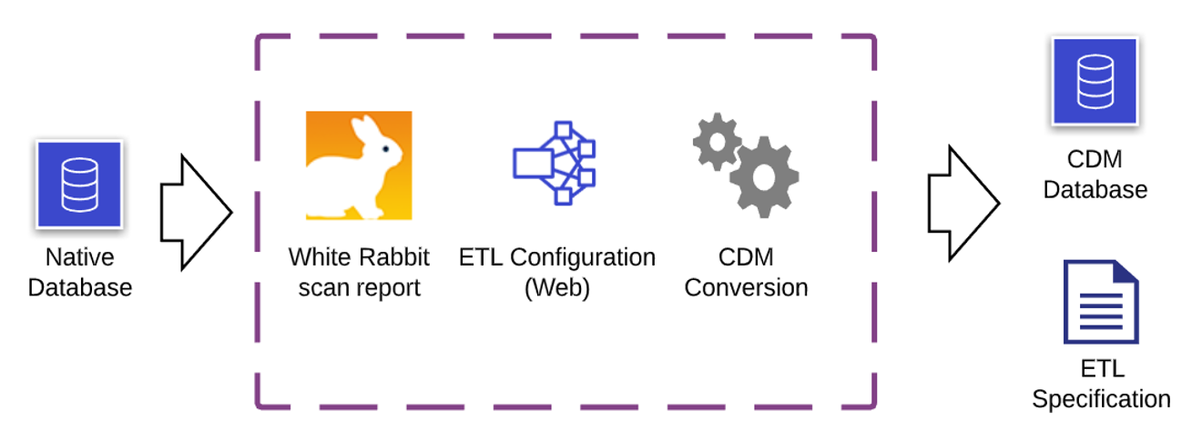

Screenshots:
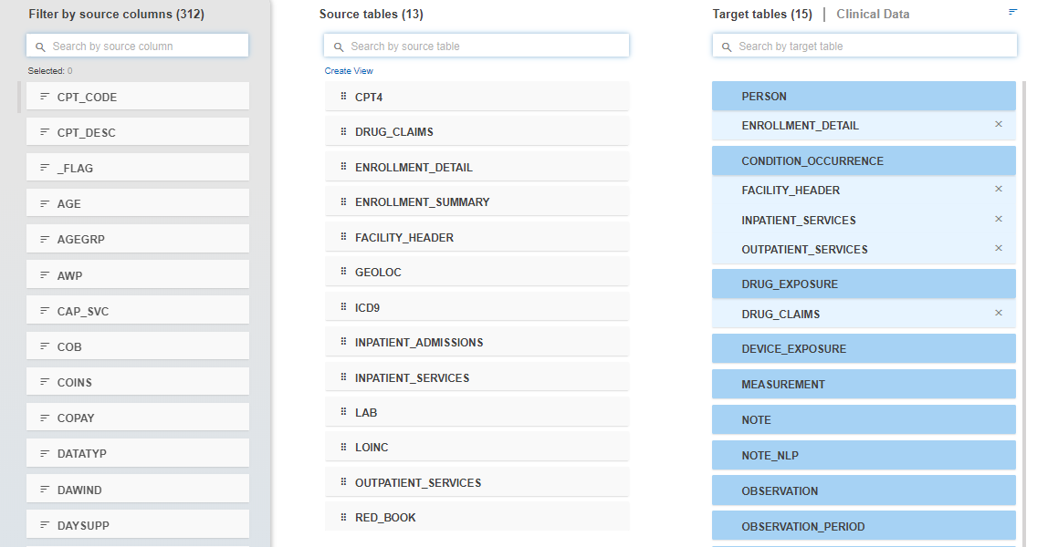
Figure 1, Link Tables screen
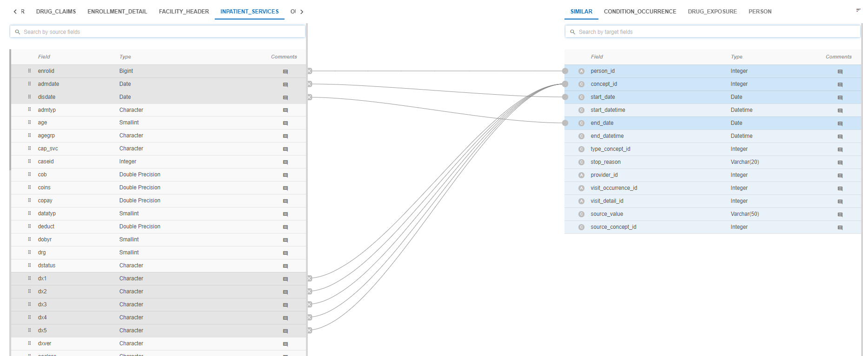
Figure 2, Link fields screen

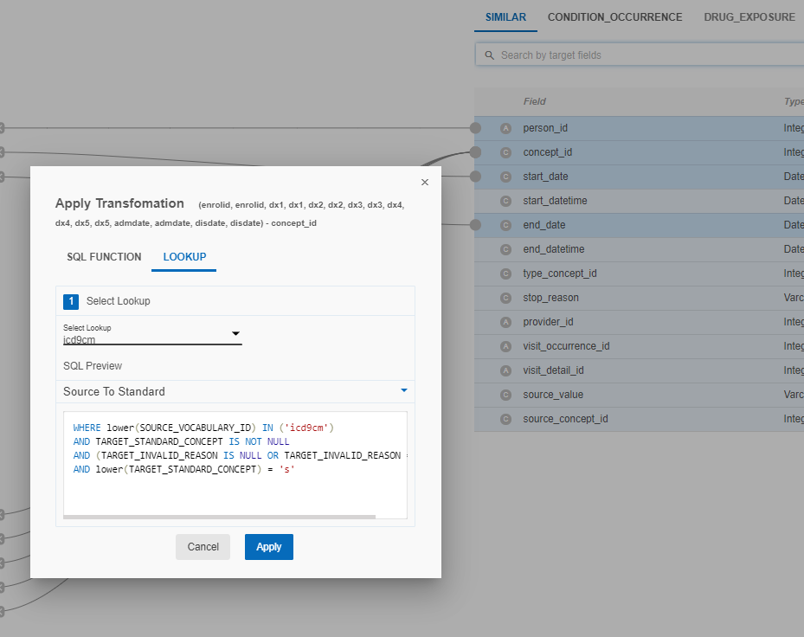
Figure 3, Transformation dialog

Conclusion
“Perseus” reduces the time spent on manual processes such as writing code and mapping source data to target systems. The configuring and running ETLs with “Perseus” makes it repeatable, shareable and saves time.

References
- Perseus - https://github.com/SoftwareCountry/Perseus
- White Rabbit, and Rabbit-in-a-Hat https://github.com/SoftwareCountry/WhiteRabbit
- Usagi - https://github.com/OHDSI/Usagi
- Achilles - https://github.com/OHDSI/Achilles
- DQD - https://github.com/SoftwareCountry/DataQualityDashboard
- CDM Builder - https://github.com/SoftwareCountry/ETL-CDMBuilder

