CohortIncidence: A Standardized Framework for Characterizing Incidence Using OMOP Common Data Model and OHDSI tools
Christopher A. Knoll, Anthony G. Sena

Introduction
A common analytic use case for observational data is to characterize incidence – the frequency by which new occurrences of medical events occur within a given population at-risk. More formally, incidence rate is calculated as the number of new outcomes within a defined time-at-risk, divided by the person-time within the population at-risk, while incidence proportion is calculated as the number of persons with a new outcome within a defined time-at-risk, divided by the number of persons with at least 1 day at-risk within the population at-risk. Within the OHDSI ecosystem, there have been several implementations for calculating the incidence of an outcome, with one such notable instance in ATLAS. However, there isn’t a formalized implementation of an incidence calculator within HADES or in the OHDSI GitHub organization that is accessible via R. This software demonstration will demonstrate an R package that can be used as a standard approach for calculating incidence.

Methods
We have developed an R Package that accepts a comprehensive set of parameters that improves on the approach found in ATLAS. In addition to the basic parameters of target and outcome cohorts with a specified time at risk, this package supports additional parameters and a more sophisticated implementation that supports multiple start-of-follow-up events and multiple outcomes using a clean window parameter while eliminating overlapping time-at-risk and immortal time bias. The parameters can be persisted in a JSON form for easy distribution across a network of CDM sources.

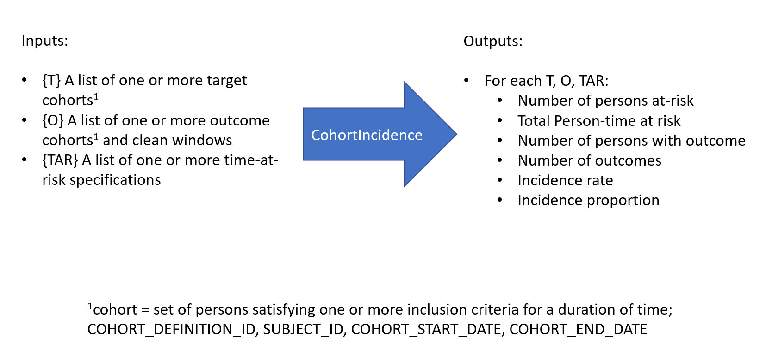

Figure 1 illustrates the general algorithm for incidence characterization. For each person, the time-at-risk specification is applied to the target cohort records, and clean windows are applied to each outcome cohort entry (A). These records are then erafied into periods of ‘potential time-at-risk’ and periods of ‘immortal time’ where no outcomes can occur(B). The true time-at-risk is then determined as the potential time-at-risk that does not overlap with immortal time, and outcomes are then identified as those outcome cohort records which started within the time-at-risk (C).
Figure 1A: 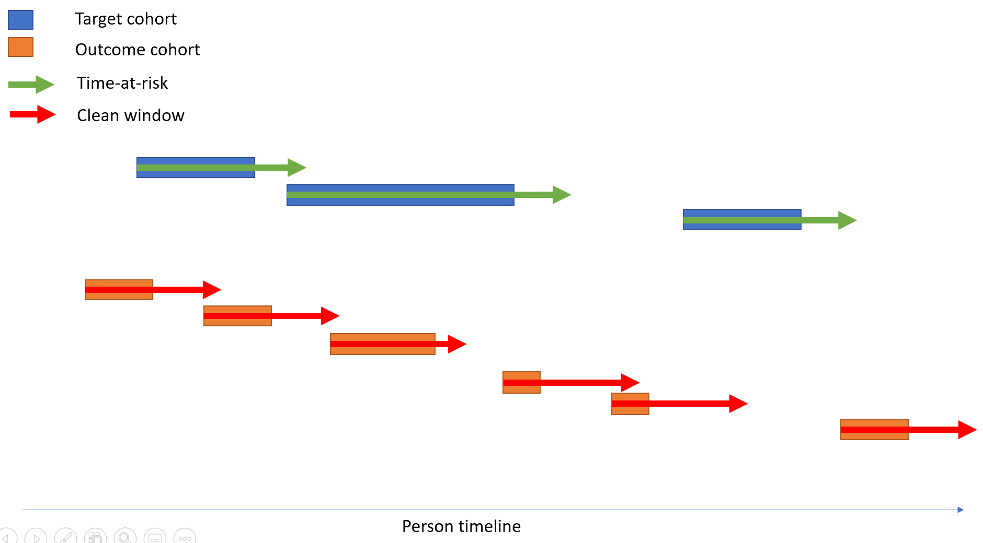
Figure 1B: 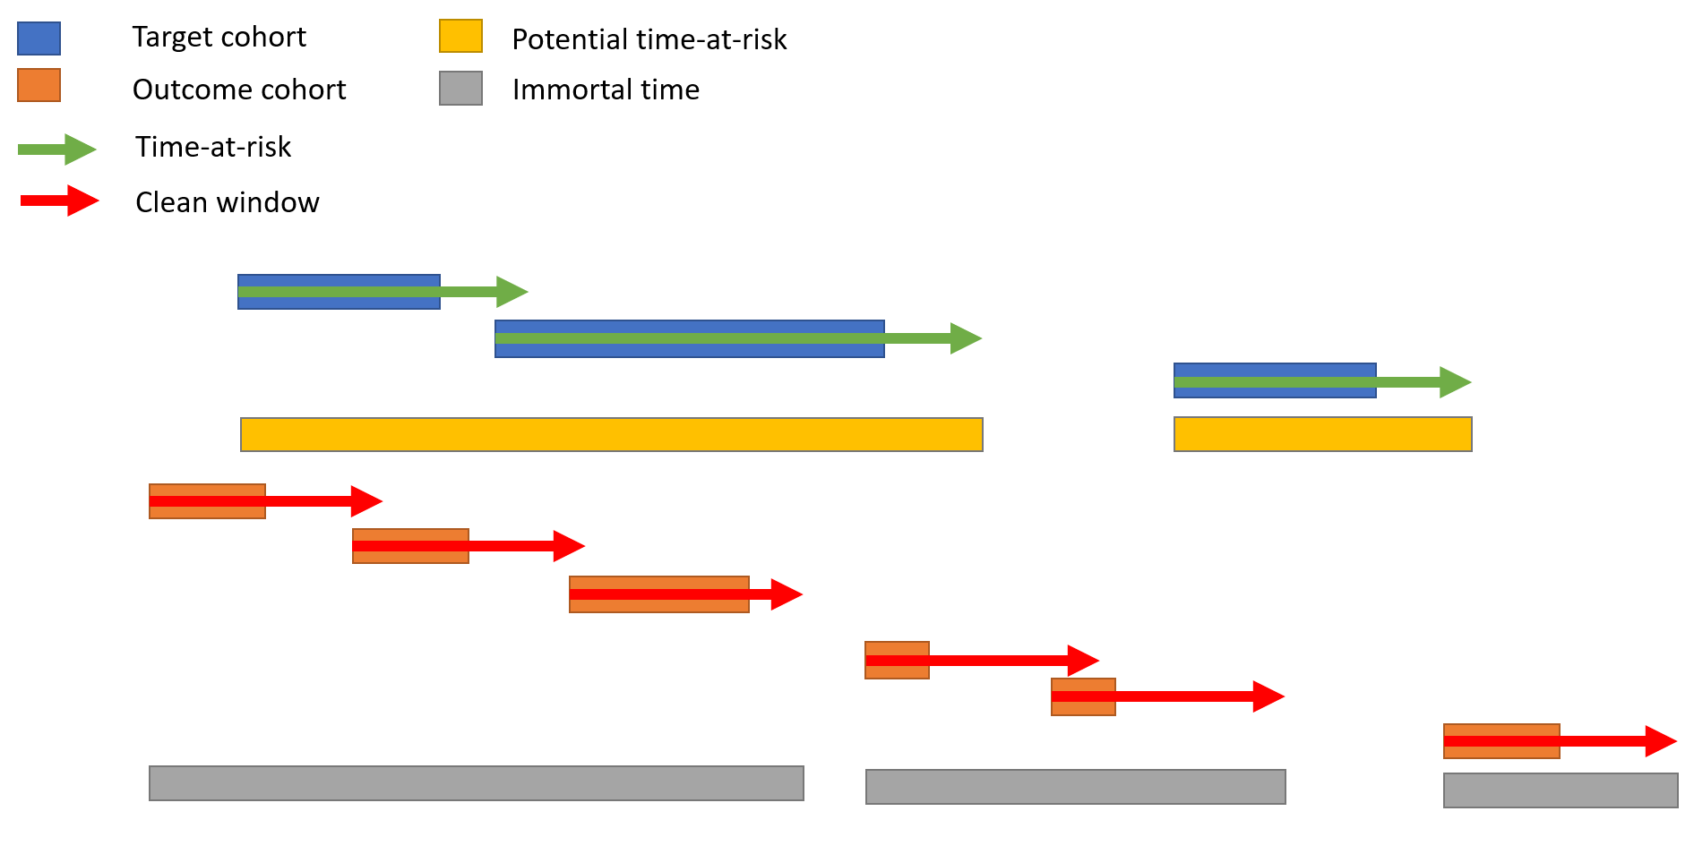
Figure 1C: 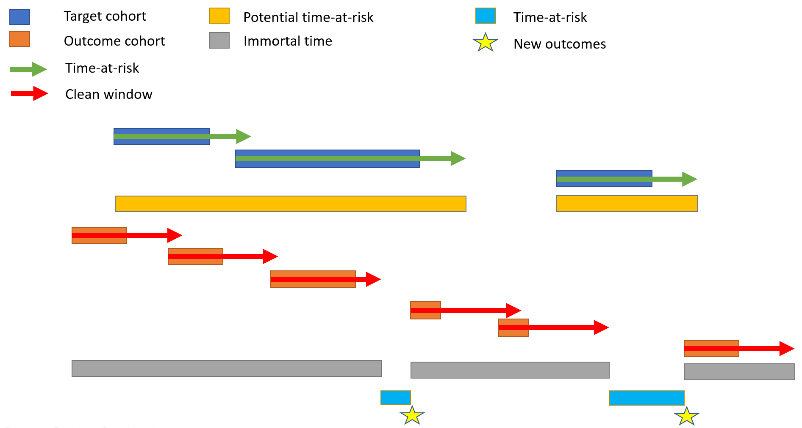

Results

The initial algorithmic development was successfully applied within the COVID-19 AESI Incidence Characterization study (https://github.com/ohdsi-studies/Covid19VaccineAesiIncidenceCharacterization) to evaluate a wide range of target cohorts and outcomes across a network of OHDSI databases, as published in BMJ (https://www.bmj.com/content/373/bmj.n1435). This study demonstrated the feasibility and computational efficiency of characterization approach, and allowed for further development to generalize the process for other future studies.
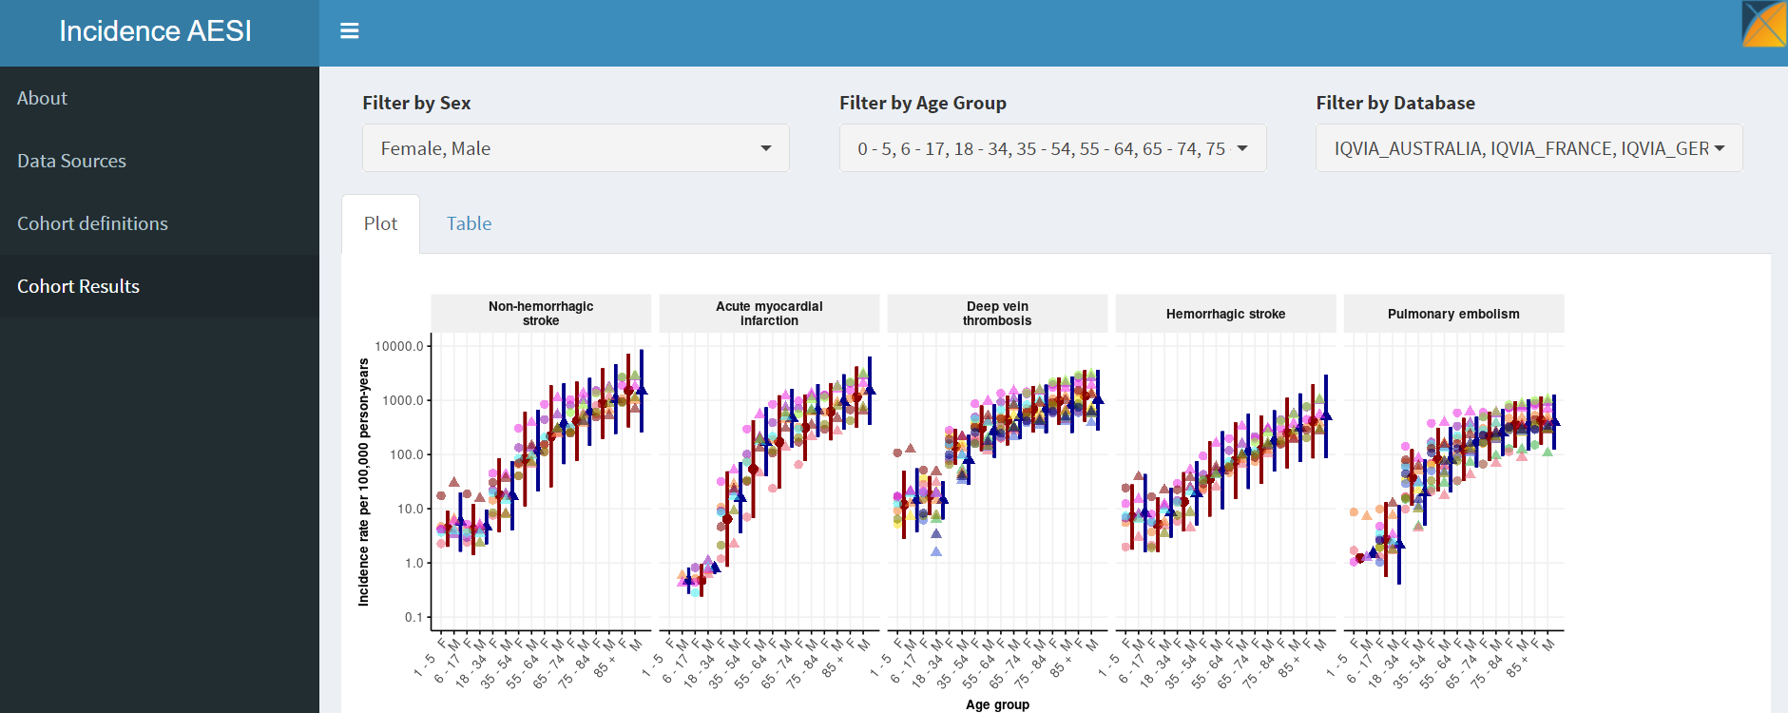

The developed R Package is available as Open Source Software (OSS) and is freely available at https://github.com/ohdsi/cohortincidence. This package includes vignettes for usage, test cases for correctness and is open for public contribution.

Conclusion
A standardized approach for incidence calculation is critical for reproducible research. By encapsulating the incidence rate calculation into an R package with formalized parameters, we now have a standardized method for calculation that is available for anyone needing this function in their study.

