Examination of Characteristics and Treatments in Pediatric and Adult Hidradenitis Suppurativa

Jill Hardin, Rupa Makadia, Emily Brouwer, Shawn Black, Irene Lara-Corrales, Lucia Z Diaz, Joslyn Sciacca Kirby, Cynthia Marie Carver DeKlotz
Background
Hidradenitis Suppurativa (HS) is a chronic inflammatory disease affecting pediatric and adult patients. Age of onset typically occurs in the second or third decade of life(1). HS also occurs in pediatric patients, generally after the onset of puberty(2). Among adolescents, HS can be associated with significant comorbidities including diabetes, metabolic syndrome, psychiatric disorders, and inflammatory arthritis(3, 4). Current treatment consists of topical and/or systemic antibiotics, hormonal interventions, analgesics and, in selected cases, the tumor necrosis factor (TNF) inhibitor monoclonal antibody adalimumab (FDA approved for pediatric patients ≥12 years of age), and surgical excision(5-7). Analysis of real-world data that address the clinical treatment of pediatric HS patients and how treatments compare with adult HS patients has not been reported.
Methods
HS adult (>18 years) and pediatric (< 18 years) subjects were identified in three US administrative claims databases, [IBM MarketScan® Commercial Claims and Encounters (CCAE), Multi‐state Medicaid (MDCD), and Optum's de-identified Clinformatics® Data Mart Database (Optum)] that were transformed into the Observational Medical Outcomes Partnership (OMOP) Common Data Model (CDM)(8), version 5.3. Subjects were required to have two SNOMED codes (59393003) for HS and at least 365 days of prior observation time to the first HS diagnosis. HS cohorts were characterized with respect to demographics and comorbidity information assessed in the 30 days after and 180 days prior to the index HS diagnosis. Treatment pathways illustrated the use of therapies using the following exposure categories: topical treatments, oral antibiotics, biologics, and surgical treatments. Oral antibiotics included tetracycline, doxycycline, lymecycline, minocycline, amoxicillin, pristinamycin, ceftriaxone, and metronidazole. Biologics included adalimumab, infliximab, anakinra, and anti-TNF. Topical treatments included clindamycin and resorcinol. Surgical treatments included laser procedures, incision and drainage of abscess, excision of skin and subcutaneous tissue, and acne surgery. Exposures prescribed within 14 days of each other were considered a combination therapy.
Results
A total of 2047, 2522, and 709 pediatric and 21158, 12666, and 11061 adult HS subjects with mean ages of 15.1, 14.8, and 15.0 (pediatric) and 37.7, 36.4, and 44.0 (adult) years, with female predominance (pediatric: 84%, 84%, 85%; adult: 78%, 83%, 73%), were identified from CCAE, MDCD, and Optum. Depression and anxiety were less prevalent in pediatric than in adult HS patients; 8 – 11% of pediatric
patients exhibited these comorbidities. Not unexpectedly and indirectly confirming the demographics of the pediatric population assessed, acne was 3- to 4-fold more prevalent in the pediatric population and Type 2 diabetes mellitus was 10- to 20-fold more prevalent in adult than in pediatric patients. Children and adults both frequently use oral antibiotics as a first line treatment for HS. Children were
found to use an oral antibiotic in combination with a topical at a slightly higher rate, which is not surprising
given that topical clindamycin (the drugs used more frequently in pediatric patients compared to adults)
is a common treatment of acne (which is more common in adolescents). Additionally, while the use
of surgical procedures and biologics is infrequent in both children and adults, use in children appears
more limited.

Table 1. Characterization of pediatric and adult HS cohorts
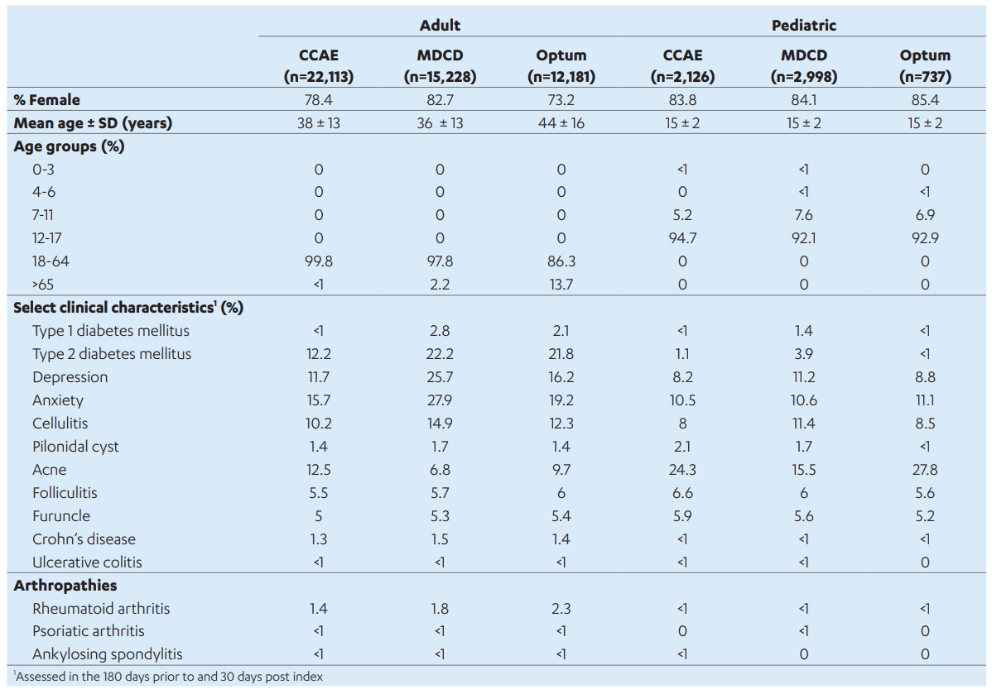

Conclusion
This study illustrates that associated conditions and therapeutic treatment of HS in adults and pediatrics is very similar. These data support similarity of disease treatment practices which may inform development of drugs for the pediatric population.
References/Citations
1. Alikhan A, Lynch PJ, Eisen DB. Hidradenitis suppurativa: a comprehensive review. Journal of the American Academy of Dermatology. 2009;60(4):539-61; quiz 62-3.
2. Liy-Wong C, Pope E, Lara-Corrales I. Hidradenitis suppurativa in the pediatric population. Journal of the American Academy of Dermatology. 2015;73(5 Suppl 1):S36-41.
3. Liy-Wong C, Kim M, Kirkorian AY, Eichenfield LF, Diaz LZ, Horev A, et al. Hidradenitis Suppurativa in the Pediatric Population: An International, Multicenter, Retrospective, Cross-sectional Study of 481 Pediatric Patients. JAMA dermatology. 2021.
4. Tiri H, Jokelainen J, Timonen M, Tasanen K, Huilaja L. Somatic and psychiatric comorbidities of hidradenitis suppurativa in children and adolescents. Journal of the American Academy of Dermatology. 2018;79(3):514-9.
5. Gulliver W, Zouboulis CC, Prens E, Jemec GB, Tzellos T. Evidence-based approach to the treatment of hidradenitis suppurativa/acne inversa, based on the European guidelines for hidradenitis suppurativa. Reviews in endocrine & metabolic disorders. 2016;17(3):343-51.
6. Kimball AB, Okun MM, Williams DA, Gottlieb AB, Papp KA, Zouboulis CC, et al. Two Phase 3 Trials of Adalimumab for Hidradenitis Suppurativa. The New England journal of medicine. 2016;375(5):422-34.
7. Zouboulis CC, Desai N, Emtestam L, Hunger RE, Ioannides D, Juhász I, et al. European S1 guideline for the treatment of hidradenitis suppurativa/acne inversa. Journal of the European Academy of Dermatology and Venereology : JEADV. 2015;29(4):619-44.
8. Voss EA MR, Matcho A, Ma Q, Knoll C, Schuemie M, et al. . Feasibility and utility of applications of the common data model to multiple, disparate observational health databases. . J Am Med Inform Assoc 2015;22(3):553-64.

