Predicting complications after surgery for colorectal cancer
Identifying patients at risk
Viviane Lin, Adamantia Tsouchnika, Eldar Allakhverdiiev, Andreas Weinberger Rosen, Mikail Gögenur, Johan Stub Rønø Clausen, Karoline Bendix Bräuner, Ismail Gögenur

Background
Postoperative complications in colorectal cancer surgery are associated with increased mortality in the immediate postoperative phase up to the first year after resection (1). They also have been reported to be associated with adverse long-term oncological outcomes (2).
Predicting risk of postoperative complications can aid in decision-making for patients with colorectal cancer, e.g. whether a patient is a candidate for curative surgery, or also how closely a patient should be monitored in the early postoperative phase and determine how aggressive therapeutic interventions could be and whether a change in surgical strategy is appropriate.

Postoperative complications are graded by severity in the Danish Colorectal Cancer Group (DCCG) database using the Clavien-Dindo complications classification, which can be seen in figure 1 (3). This grades the severity of the complication by the necessity, manner and invasiveness of a resulting intervention:

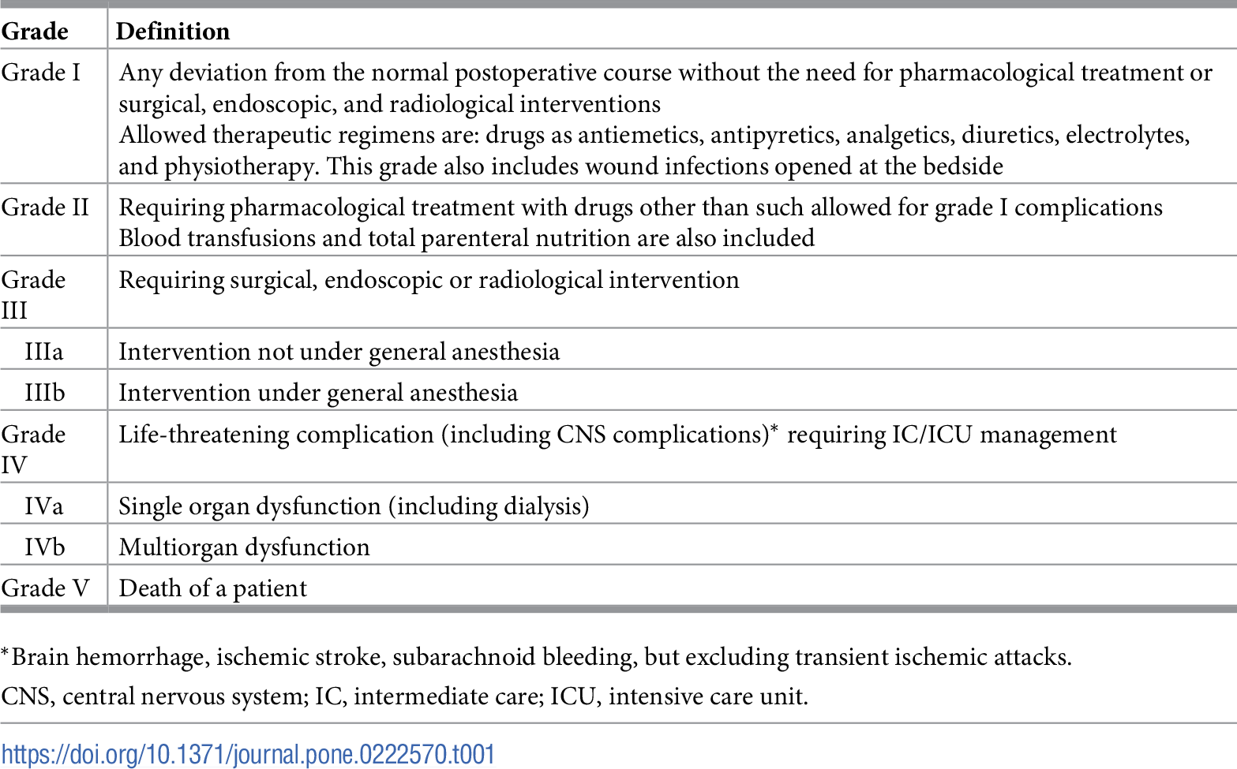

Figure 1: Overview of Clavien-Dindo postoperative complications scale (3)

The consequences of knowing whether a patient has a high risk of developing a severe complication that might require surgery, ICU admission or results in death, can be several.

Patients with a high risk for severe postoperative complications might be candidates for pre-habilitation programs prior to surgery (4). An increased surveillance as to these patients in order to identify complications early in the postoperative phase and potentially lower mortality, can be another method for these high-risk patients (5).

The American College of Surgeons National Surgical Quality Improvement Program (ACS NSQIP) has previously used machine-learning methods, to construct a prediction model that had good predictive ability to predict specific complications in patients undergoing colorectal, pancreatic and liver resections (6).

We developed a prediction model using the DCCG database to predict the risk of developing postoperative complications Clavien-Dindo ≥ 3B for patients undergoing colorectal cancer surgery.

Methods
A Common Data Model was built using all data from the validated Danish Colorectal Cancer Group (DCCG) Database, a quality assurance database containing all colorectal cancer surgeries in Denmark since 2001.
ATLAS, R and the ‘OHDSI/PatientLevelPrediction’ package were used to create a prediction model using preoperatively available variables to predict postoperative complications 30 days after colorectal cancer surgery. Preoperative variable domains comprised conditions, measurements, procedures, observations and custom covariates of age groups and specific scales (e.g. ASA and Performance Score). Postoperative complications of Clavien-Dindo Grade 3B or higher were considered an outcome event. Data was split by person, and 25% of data were used for testing. Different models were constructed, wherein Lasso Logistic Regression was selected due to it performing best.
Results
From 2014-2019, 23.738 patients underwent surgery for colorectal cancer in Denmark and were recorded in the DCCG database.
2.781 patients (11.7%) experienced a Clavien-Dindo complication grade ≥ 3B. The PLP was able to predict patients at elevated risk for postoperative complications using 77 out of 156 preoperatively known covariates with AUC = 0.675 (0.654-0.679, and AUPRC = 0.227. The calibration plot of the testing set can be seen in figure 2, while the prevalence of variables with and without the outcome can be seen in figure 3. Calibration of the testing set was good, with CalibrationInLarge 1.00 (ratio of mean predicted risk/mean observed risk), CalibrationIntercept -0.08 and CalibrationSlope 0.95. Brier score was 0.10.
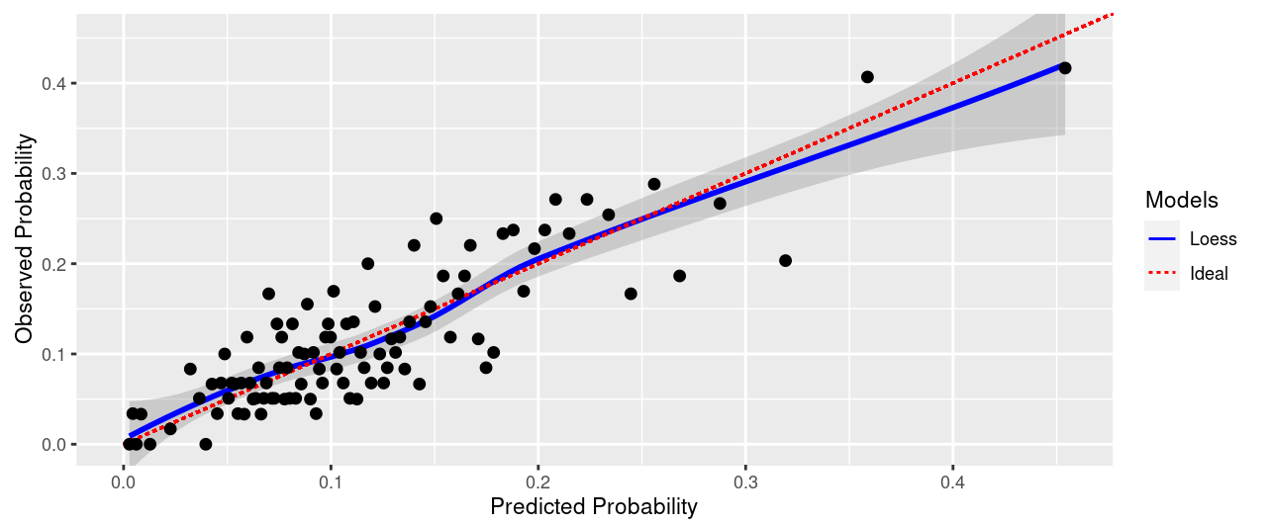
Figure 2: Calibration of covariates in testing set for prediction of postoperative complications after colorectal cancer surgery
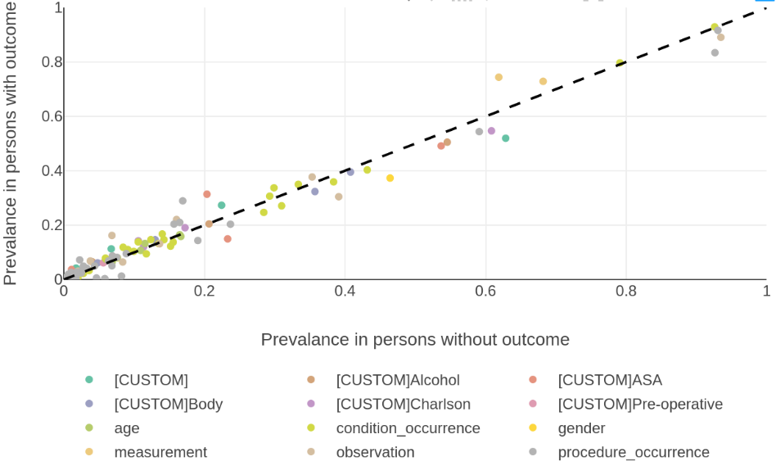
Figure 3: Prevalence of variables with and without the outcome of postoperative complications after colorectal cancer surgery
Predictors in the model used to calculate risk, were found to be in agreement with the current literature. Those predicted to have the outcome more often were patients with an ASA score of 4, Performance score ≥ 2, undergoing abdominal colectomies, requiring emergency surgery, and were more often > 95 or < 40 years of age. Similarly, variables in the model identified more often in those that did not have complications were often more minor procedures such as endoscopic resections, lower T-stages and patients with a normal or slightly elevated BMI.

Conclusion
Predicting the occurrence of complications after surgery for colorectal cancer using only preoperative variables from the DCCG database in this model is not yet up to a sufficient standard for use in a clinical setting. The heterogeneity of postoperative complications provide a challenge for predictions in a single model. Utilizing additional data sources containing more in depth phenotypic data might ameliorate prediction models to where they can assist decision-making in personalized medicine, especially when used in conjunction with other models to create a risk profile.

References/Citations
1. Dekker JWT, van den Broek CBM, Bastiaannet E, van de Geest LGM, Tollenaar R a. EM, Liefers GJ. Importance of the first postoperative year in the prognosis of elderly colorectal cancer patients. Ann Surg Oncol. 2011 Jun;18(6):1533–9.
2. Duraes LC, Stocchi L, Steele SR, Kalady MF, Church JM, Gorgun E, et al. The Relationship Between Clavien-Dindo Morbidity Classification and Oncologic Outcomes After Colorectal Cancer Resection. Ann Surg Oncol. 2018 Jan;25(1):188–96.
3. Dindo D, Demartines N, Clavien P-A. Classification of surgical complications: a new proposal with evaluation in a cohort of 6336 patients and results of a survey. Ann Surg. 2004 Aug;240(2):205–13.
4. Trépanier M, Minnella EM, Paradis T, Awasthi R, Kaneva P, Schwartzman K, et al. Improved Disease-free Survival After Prehabilitation for Colorectal Cancer Surgery. Ann Surg. 2019 Sep;270(3):493–501.
5. Marres CCM, van de Ven AWH, Verbeek PCM, van Dieren S, Bemelman WA, Buskens CJ. The effect of a postoperative quality improvement program on outcomes in colorectal surgery in a community hospital. Int J Colorectal Dis. 2016 Sep;31(9):1603–9.
6. Merath K, Hyer JM, Mehta R, Farooq A, Bagante F, Sahara K, et al. Use of Machine Learning for Prediction of Patient Risk of Postoperative Complications After Liver, Pancreatic, and Colorectal Surgery. J Gastrointest Surg Off J Soc Surg Aliment Tract. 2020 Aug;24(8):1843–51.

