A Prediction Model Library
Ross D. Williams, Jenna M. Reps, Peter R. Rijnbeek

Background
To facilitate the dissemination of prediction models, a centralized repository is needed that collates all models and their performance in the data network. This should also enable others to externally validate these models and update the body of evidence by uploading the results. We believe this next step in our patient-level prediction (PLP) framework is needed to have impact on clinical practice as a community. We therefore prioritized this work within the European Health Data and Evidence Network (EHDEN) project.. A reason for this is the dissemination and understanding of prediction modelling in healthcare can still be improved. The current practice leaves the different models developed by different researchers disconnected from each other. A centralized repository, or library, will collate this information together and provide improved access and usability for a range of users including regulators, clinicians and prediction researchers.
Methods
We created a relational database to store results from multiple OHDSI PLP studies. This database models the structure of the results objects generated from model development or validation. An entity relation diagram is available in Figure 1. This database can be accessed through a dedicated application which allows for the exploration of the results of multiple studies. It will also provide the ability to select models to download, this will then create a package including the required settings and cohort definitions as well as the model.
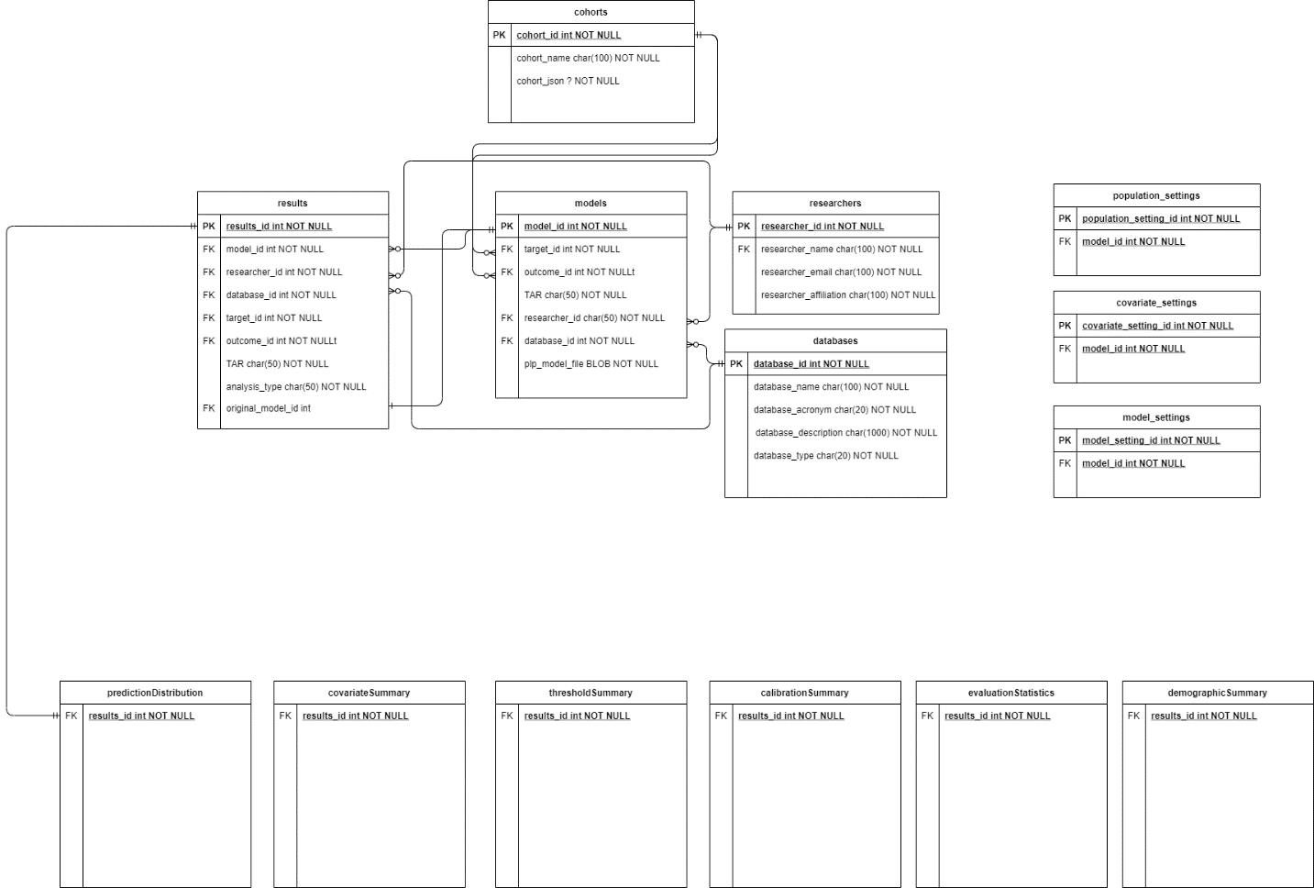
Figure 1 An entity relation diagram for the database of the prediction model library.
Results
The application contains information on more than 600 models and 20,000 different validations. An example of the application can be seen in (Figure 2).

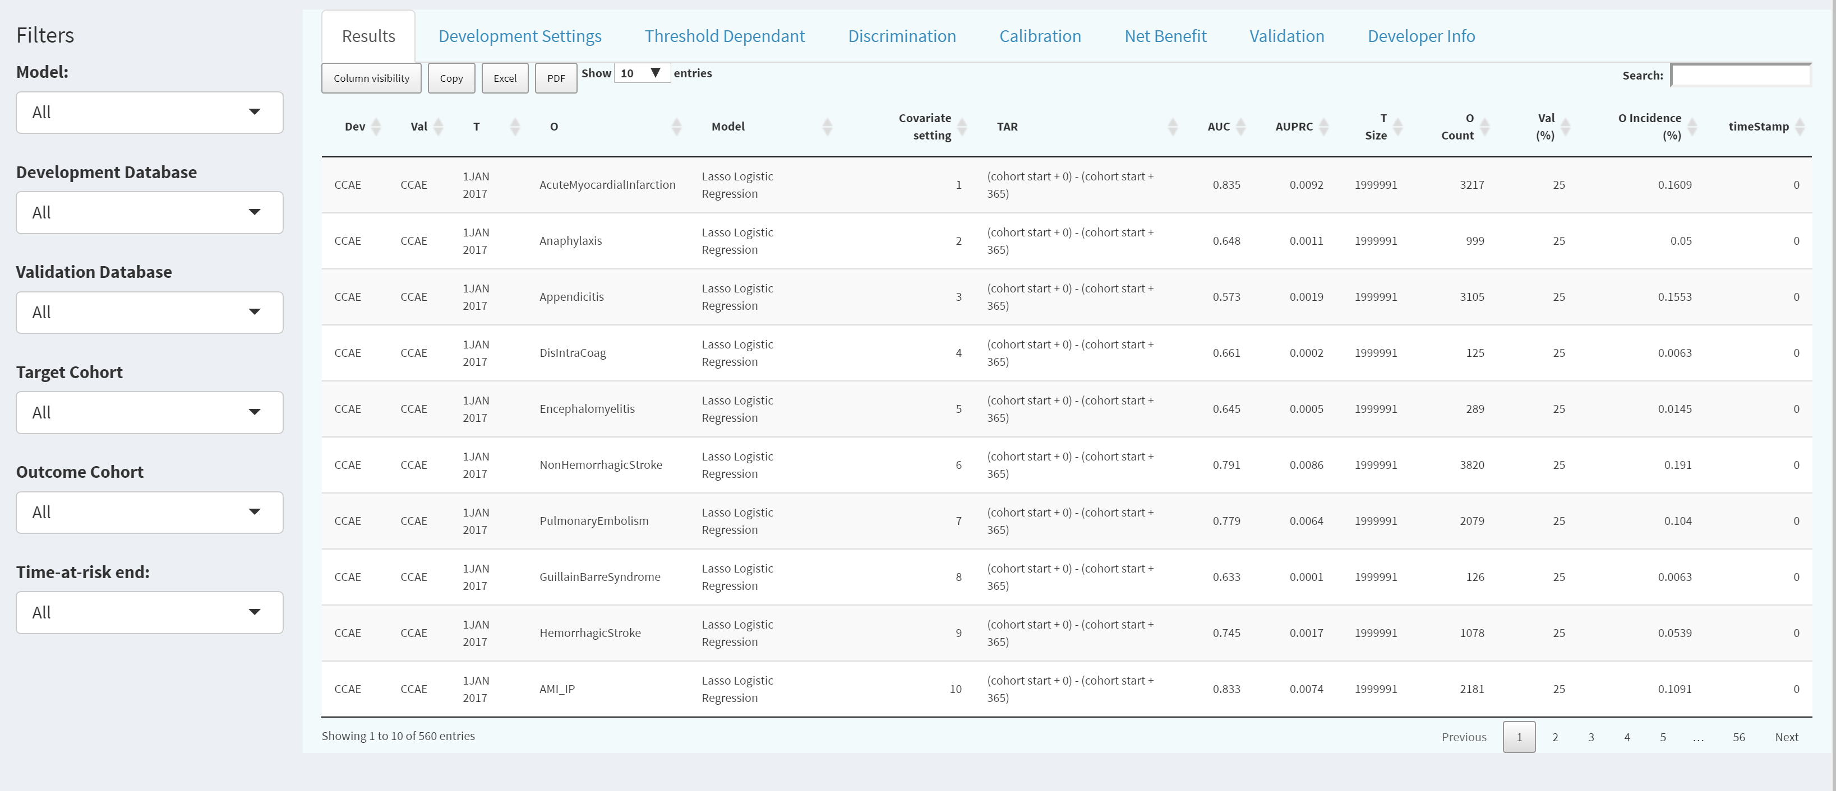
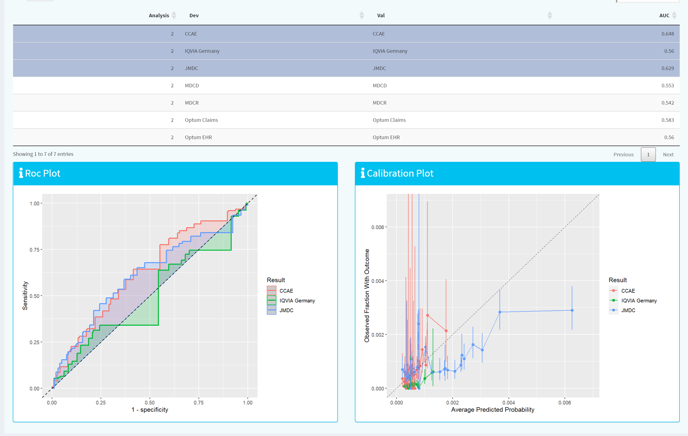

Figure 2 Screenshot of the library page and model validation exploration.

Conclusion
The current prototype library already provides a unique environment to interactively explore the results and evidence for prediction models developed within the OHDSI PLP framework. Work is ongoing to implement the tool as a fully functional website. This will provide an improved user experience and allow for even nicer exploration of results by our stakeholders.

This project has received funding from the Innovative Medicines Initiative 2 Joint Undertaking (JU) under grant agreement No 806968. The JU receives support from the European Union’s Horizon 2020 research and innovation programme and EFPIA.

