Development of Machine Learning models for Cancer Survival among Lung cancer patients with Tyrosine Kinase Inhibitors (TKIs) treatment
Alex PA. Nguyen¹, Phuc T. Nguyen¹, Min-Huei Hsu¹, Jason C. Hsu^{1,}*
¹Clinical Data Center, Office of Data Science, Taipei Medical University; *Corresponding author;
Background
Lung cancer is the most common cause of death worldwide, including in Taiwan. Mutation in the EGFR gene is a driver in lung adenocarcinoma as this gene is overexpressed in more than 50% of NSCLC in Asia. Previous studies had shown that treatment with EGFR‐TKIs offered a better response rate and produced fewer adverse events than platinum‐based chemotherapy. Most patients benefited from TKI therapies, but 5%‐10% of patients did not achieve disease control when administered EGFR‐TKIs and therefore acquired drug resistance within 10‐12 months.
The accurate prediction of disease prognosis and the outcome of drug treatment, which may serve as a reference for treatment decision-making and drug selection, has become an important topic in clinical medicine. Artificial intelligence (AI) has been increasingly used in medical research and clinical practice. Developing disease risk and prognosis prediction models using machine learning or deep learning algorithms with big data is a major area of academic research based on AI in the medical field.
In this study, we aimed to develop lung cancer survival prediction models among patients with TKIs treatment using a larger number of samples and different data types and various machine learning algorithms.

Methods
Study Design and Data Source
We conducted a retrospective study in which we obtained the data from the Taiwan Cancer Registry (TCR) database and the Taipei Medical University Clinical Research Database (TMUCRD). The TMUCRD stores various electronic medical records from three hospitals in Taiwan - Taipei Medical University Hospital (TMUH), Wan-Fang Hospital (WFH), and Shuang-Ho Hospital (SHH). The database contains the electronic medical record data of 3.8 million people accumulated from 1998 to 2020, including structured and unstructured data.
Cohort Selection
This study selected patients with lung cancer (ICD-O-3 code: C33, C34.1) from 2008 to 2018 in the TCR database. Exclusion criteria included individuals under 20, SCLC patients, and patients who did not receive lung cancer treatment in the three hospitals. Following that, only cancer patients who were undergoing TKIs (i.e., patients using EGFR‐TKIs, ATC codes L01EB) were included in our study cohorts.
Outcome Measurement
The outcome of this study was death within two years following diagnosis. Data were censored at the date of death or loss to follow-up, insurance termination, or the study's end on December 31, 2020.
Feature Selection
The selected features were as follows: (1) Demographic information: gender, age, blood type, BMI, smoking, drinking; (2) Cancer condition: tumor size, cancer stage, time to event (death); (3) Comorbidities; (4) Current medications use; and (5) Laboratory test results.
Developing the Machine Learning models
Six machine learning algorithms were used for model training and validation, including logistic regression (LR), bootstrap aggregation (bagging), gradient boosting machine (GBM), AdaBoost, random forest (RF), and extreme gradient boosting (XGBoost).
The training dataset contained the data of patients from TMUH and WFH. The 5-fold cross-validation method was applied. Data from patients recruited from SHH were used for external testing after the training models were developed to generalize the model.
The area under the receiver operating characteristic curve (AUC), accuracy, sensitivity, specificity, and F1-score were computed to evaluate and compare the performance of all prediction models. For each model, we selected the model with the largest AUC as the best model based on external testing results and analyzed the feature contribution of the best model. Data processing was performed using SQL software, and model training and testing were performed using Python.
Results
Table 1 showed the demographic of cohort patients in the study. The average age of patients was 67 years in both the training and testing cohorts. Most of the patients are male, their BMI of patients is around 23 kg/m2, and patients are less smoking and drinking in our cohorts. For cancer stages, patients were observed at most stage III of 74.8% and 81.1% in the training and testing cohort, respectively.
Table 1. Demographic of cohort patients in the study
Feature | Training cohort (n=731) | Testing cohort (n=454)
Demographic
Gender, No. (%)
Female | 327 (44.7%) | 206 (45.4%)
Male | 404 (55.3%) | 248 (54.6%)
Age, Mean (SD), y | 67.8 (13.2) | 67.3 (12.7)
Blood type, No. (%)
A | 136 (18.6%) | 80 (17.6%)
B | 22 (3.0%) | 20 (4.4%)
AB | 216 (29.5%) | 146 (32.2%)
O | 199 (27.2%) | 125 (27.5%)
Unknown | 158 (21.6%) | 83 (18.3%)
BMI
Mean (SD) | 23.4 (3.85) | 23.2 (4.00)
Median [Min, Max] | 23.1 [13.0, 61.3] | 22.9 [13.2, 38.1]
Missing | 238 (32.6%) | 94 (20.7%)
Smoking, No. (%)
No | 356 (48.7%) | 222 (48.9%)
Yes | 156 (21.3%) | 139 (30.6%)
Unknown | 219 (30.0%) | 93 (20.5%)
Drinking, No. (%)
No | 425 (58.1%) | 316 (69.6%)
Yes | 85 (11.6%) | 45 (9.9%)
Unknown | 221 (30.2%) | 93 (20.5%)
Cancer Condition
Tumor size, No. (%)
T=<3cm | 212 (29.0%) | 103 (22.7%)
3=<T=<7cm | 321 (43.9%) | 210 (46.3%)
T>7cm | 63 (8.6%) | 48 (10.6%)
Missing | 135 (18.5%) | 93 (20.5%)
Cancer stage, No. (%)
stage = 0 | 52 (7.1%) | 28 (6.2%)
stage = 1 | 17 (2.3%) | 9 (2.0%)
stage = 2 | 81 (11.1%) | 33 (7.3%)
stage = 3 | 547 (74.8%) | 368 (81.1%)
stage = 4 | 34 (4.7%) | 16 (3.5%)
Unknown | 52 (7.1%) | 28 (6.2%)

(A) Full features | (B) Top 30 features
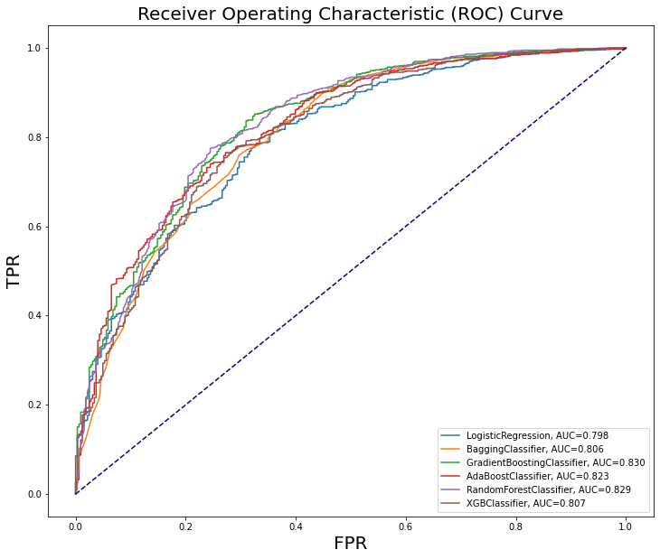 | 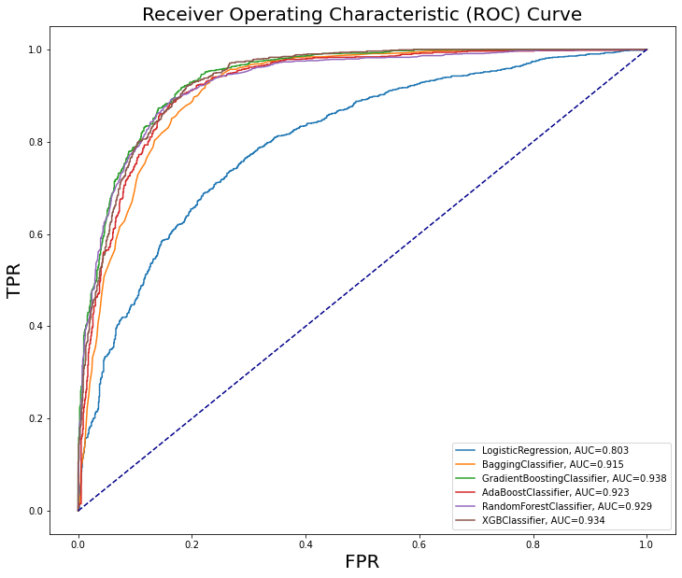
Figure 1. ROC curve of various models
Random forest was observed as the best model when using all features. Moreover, while choosing the top 30 features, Gradient Boosting Classifier was observed with the highest AUC of 0.94.

Conclusion
In summary, the model developed using the Gradient Boosting Classifier algorithm had the highest AUC regardless of the mode and was the most suitable tool for NSCLC survival prediction among patients who underwent TKIs treatment. In addition, using more types of data (especially laboratory and genomic test results) led to better predictive performance. Cancer stage, cancer size, gender, diagnosis age, and body mass index were the essential features for NSCLC survival prediction.

References/Citations
- Ferlay J, Shin HR, Bray F, Forman D, Mathers C, Parkin DM. Estimates of worldwide burden of cancer in 2008: GLOBOCAN 2008. Int J Cancer. 2010;127(12):2893-2917.
- Lynch CM, Abdollahi B, Fuqua JD, et al. Prediction of lung cancer patient survival via supervised machine learning classification techniques. Int J Med Inform. 2017;108:1-8.
- She Y, Jin Z, Wu J, et al. Development and validation of a deep learning model for non-small cell lung cancer survival. JAMA Netw Open. 2020;3(6):e205842.
- Cui L, Li H, Hui W, et al. A deep learning-based framework for lung cancer survival analysis with biomarker interpretation. BMC Bioinform. 2020;21(1):112.
- Bartholomai JA, Frieboes HB. Lung cancer survival prediction via machine learning regression, classification, and statistical techniques. Proc IEEE Int Symp Signal Proc Inf Tech. 2018;2018:632-637.

