Assessing Measurement Data Quality in the All of Us Research Program
Jason Patterson, Xinzhou Jiang, Hongjue Wang, Nripendra Acharya, Chao Pang, Matthew Spotnitz, Karthik Natarajan

Background
The All of Us (AoU) Research Program is an initiative to collect and integrate electronic health record (EHR), genomic, physical measurement, and wearable data for participants affiliated with healthcare providing organizations (HPO) around the U.S.¹ This data is cleaned, de-identified, and made available as a single dataset to researchers. A critical step in the AoU data preparation pipeline is the data quality (DQ) assessment of EHR data, which is formatted into the OMOP Common Data Model. Poor DQ may threaten the validity of study results so it is essential that issues are communicated and addressed prior to final dataset creation.
A popular framework formulated by Kahn et al models EHR data quality within 3 categories of conformance, completeness, and plausibility.² Conformance describes the compliance of DQ features against formatting, relational, and computational definitions; completeness describes the expected frequencies of data attributes; and plausibility describes the believability of the data. This framework has already been successfully integrated into OHDSI tools. Most notably, the OHDSI Data Quality Dashboard (DQD) performs 20 DQ checks – categorized in the 3 Kahn categories – on OMOP-formatted datasets.³
In order to evaluate the data quality of EHR data submitted to AoU, we adopted the Kahn framework to compare data across many healthcare sites. Recently, we expanded our evaluation of EHR data to the measurement domain by examining frequent lab tests. In order to reduce the need to create concept sets for labs, AoU created a subset of standard lab codes for a set of commonly used labs. In this work, we present a metric and process to evaluate the conformance of measurement codes in AoU.

Methods

Dataset
To date, AoU has received OMOP-formatted EHR records for 294,000 participants from 55 sites. The combined OMOP measurement table, the target of our DQ assessment, has accumulated 340 million records.

Custom Measurement Hierarchy
In order to assess measurement DQ across various sites, we needed to generate groupings of measurement concepts using the following strategy. We first had a board-certified clinician assemble a representative sample of LOINC concepts of class Lab Test that would be expected to fall into the common lab panels complete blood count (CBC), lipids, comprehensive metabolic panel (CMP), and basic metabolic panel (BMP) . Additionally, a set of physical measurement concepts with class Clinical Observation were obtained. We then programmatically ascended the OMOP hierarchy to find concepts with a class of LOINC Components that are components of (or ancestors of the components of) the initial set of concepts (Fig 1A). The LOINC Components, which represent analytic substances, became the label of our concept sets and their descendants became the contents of the sets.
Using this strategy, we obtained 36 groups of Lab Test and Clinical Observation concepts, each represented by a unique LOINC Component. Fig 1B shows a small subsection of the tree for the Cholesterol component, which subsumes cholesterol in the HDL and LDL forms.

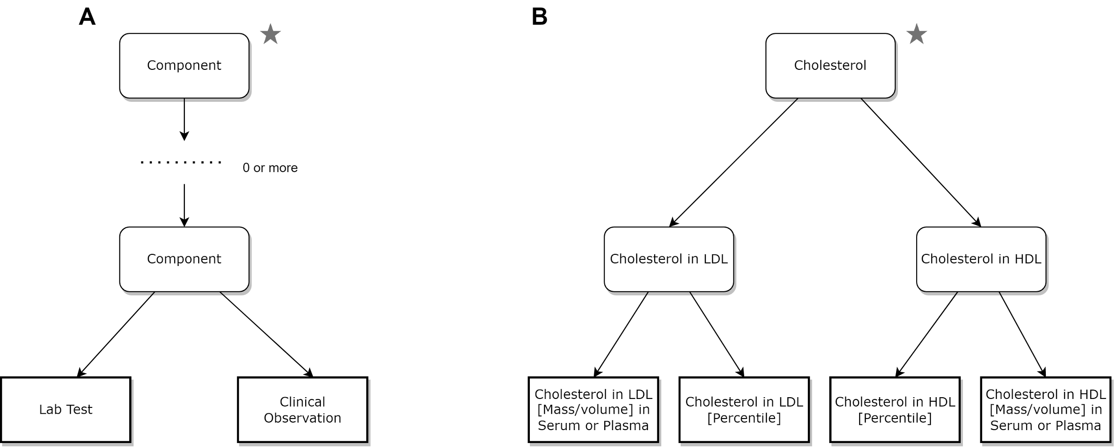
Figure 1. Custom Measurement Hierarchy
(A) OMOP class hierarchy used to generate custom concept sets. Star designates component used to define concept set. (B) An example subsection of the Cholesterol tree, which subsumes both Cholesterol in LDL and Cholesterol in HDL concepts. Star designates that the Cholesterol component defines the concept set.

Data Quality Metrics
We designed two metrics to determine the proportions of expected measurements in site submissions. The first metric, the Lab Component Inclusion Rate (LCIR), is a data completeness metric that measures the fraction of the 36 tracked components that are represented by at least one measurement concept in a site’s submission. It’s formula is:

$LCIR = \frac{\# of tracked components >= 1 submitted concept}{\# of tracked components (=36)}$

The second metric, Recommended Measurement Rate (RMR), is a data conformance metric. It assesses the proportion of a site’s measurement concepts which already fall into a tracked component concept set and also fall into a list of recommended concepts that a clinician has determined to be the most clinically relevant. It’s formula is:

$RMR = \frac{\# of recommended measurements}{\# of measurements in tracked component concept sets}$

Dashboard
In order to provide measurement DQ feedback to sites, we constructed a Tableau dashboard that displays the DQ metrics in tabular form, with additional metadata about the distribution of measurement concepts submitted.
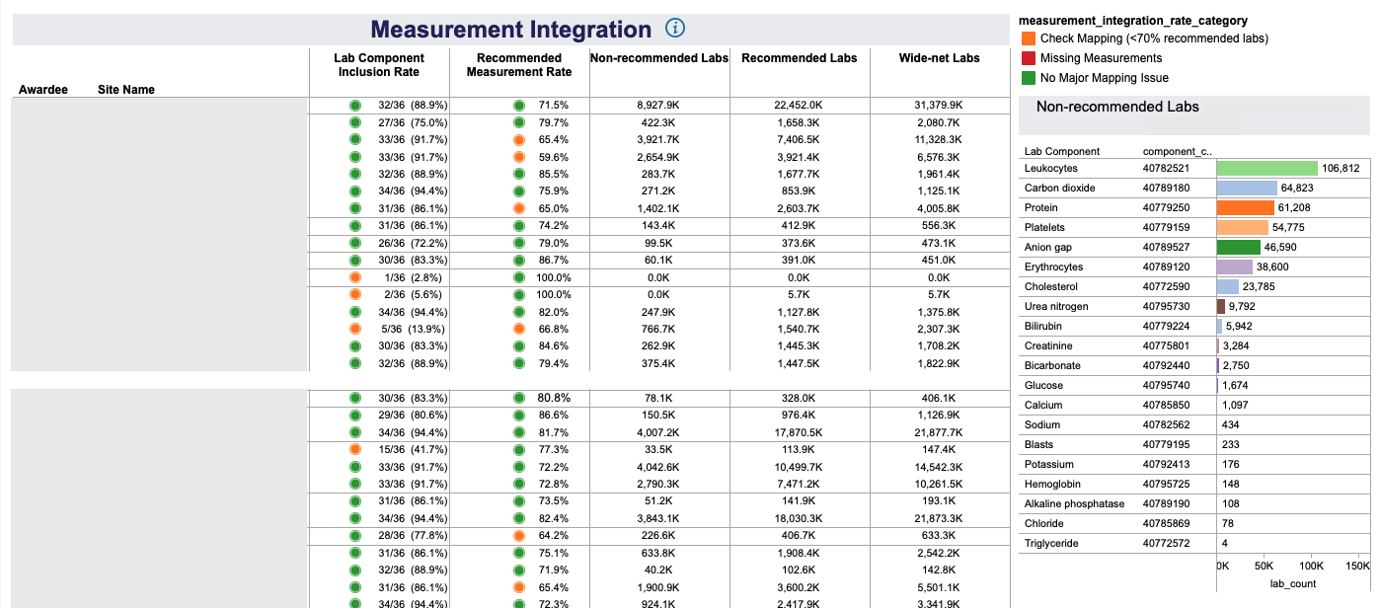
Figure 2. Measurement Integration Dashboard
Tableau dashboard displaying metrics for assessing measurement DQ. Each site has a row indicating their most recent submission’s Lab Component Inclusion Rate and Recommended Measurement Rate. Additional columns break down the total measurement counts involved in the calculations. The right hand side of the dashboard is the list of non-recommended labs sites submitted.

Results
By applying the data quality checks on measurement inclusion and conformance, All of Us EHR sites are able to evaluate and investigate submissions. From 2018q4 to 2021q3, we have generated 8 CDRs(Curated Data Repository) and the number of sites increased from 27 to 46, shown in Table 1.
Table 1 Number of Sites by CDR Release Quarter
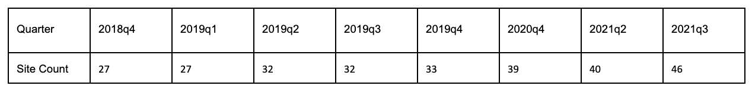
The conformance rate trending in Figure 3 highlights how the performance metrics change over time. The bar chart is the total number of recommended measurement concept sets submitted, which increased by around 1 fold both in 2019q4 and 2020q4. Though with new sites onboarded and larger data volume collected, the conformance rate stays stable between 0.79 and 0.80.
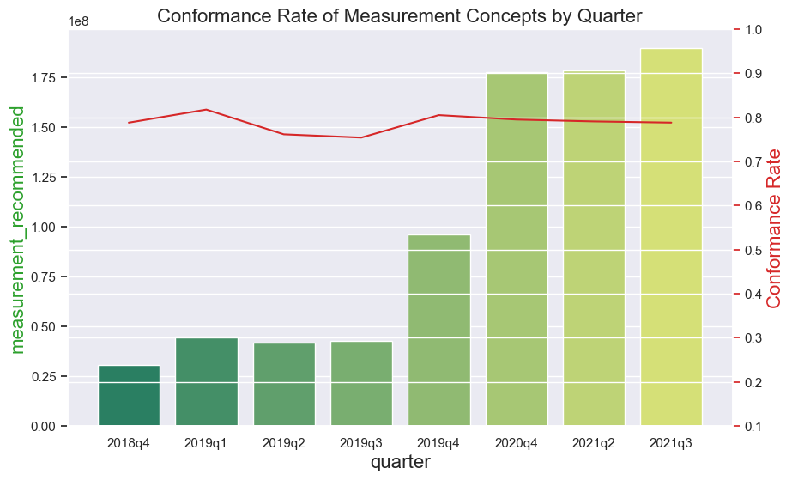
Figure 3. Conformance Rate of Measurement Concepts
The bar chart is the total recommended measurement concepts submitted by sites in each quarter. The red line represents the conformance rate of recommended concepts over tracked concepts.

Conclusion
This work presents a metric to evaluate sites conformance of required measurement codes. We developed an algorithm to create a set of acceptable LOINC-based codes. We have shown that this approach has worked on getting sites to improve their conformance. One limitation in our approach is that we have not incorporated SNOMED codes to the list of tracked component concepts. In future work, we will incorporate SNOMED to this list, and we plan to work with the OHDSI Data Quality WG to incorporate this metric to DQD.

References/Citations

1. The “All of Us” Research Program. New England Journal of Medicine. 2019 Aug 15;381(7):668–76.
2. Kahn MG, Callahan TJ, Barnard J, Bauck AE, Brown J, Davidson BN, et al. A Harmonized Data Quality Assessment Terminology and Framework for the Secondary Use of Electronic Health Record Data. EGEMS (Wash DC). 2016 Sep 11;4(1):1244.
3. Blacketer C, Defalco FJ, Ryan PB, Rijnbeek PR. Increasing trust in real-world evidence through evaluation of observational data quality. J Am Med Inform Assoc. 2021 Jul 27;28(10):2251–7.

