Cohort Diagnostics using Oncology Data Items for Multi-national Cancer Cohort
Seo Jeong Shin¹, Peter Prinsen², Chiara Attanasio², Gijs Geleijnse², Lingjie Shen³, Anna J. van Gestel², Seng Chan You¹, Han Sang Kim⁴, Sang Joon Shin⁴
¹Department of Biomedical Systems Informatics, Yonsei University College of Medicine, South Korea
²Netherlands Comprehensive Cancer Organization (IKNL), Netherlands
³Tilburg University, Netherlands
⁴Yonsei Cancer Center, Division of Medical Oncology, Department of Internal Medicine, Graduate School of Medical Science, Brain Korea 21 Project, Yonsei University College of Medicine, South Korea
⁵Yonsei Cancer Center, Division of Medical Oncology, Department of Internal Medicine, Yonsei University College of Medicine, South Korea

Background
Cancer-specific data is more detailed and explicit (e.g., stage, tumor size, mutation) more than clinical data of patients with non-cancer condition. The importance of research covering patient data from various regions is drawing attention to develop knowledge of cancer. However, cancer-specific data in EHRs are generally stored as free-text and need to be structured to be used in research. The Observational Medical Outcomes Partnership (OMOP)-Common Data Model (CDM) is a proven data model for distributed research¹. It also supports defining detailed properties of cancer patient data at the episode level through the Oncology Extension. In this study, we explore the usability of the OMOP-CDM for cohort diagnosis between cohorts of two different national cancer datasets (Figure 1).
Methods
We selected data from patients aged 18 years or older who were diagnosed with colon cancer from January 1, 2006 to May 2, 2022. The target patient group from the Severance Hospital leveraging Yonsei Cancer Center Data Lake is estimated to be about 17,500. The target patient population with the same inclusion criteria of the Netherland Cancer Registry (NCR) held by IKNL is estimated to be about 200,000 people.
Data such as birth year, gender, diagnostic information (diagnosis name, diagnosis date), surgical information (operation name, operation date), chemotherapy treatment information (treatment date, treatment name), and death information (death date) are converted into OMOP-CDM. Especially, cancer-specific items such as curative surgery, metastasis, radiotherapy, chemotherapy, hormone therapy, stage, lymph node number, invasion, KRAS, BRAF, MSI, BMI, performance score, and differentiated grade were integrated into OMOP-CDM. We then built cohort definitions though ATLAS and found the patient count of each cohort.
Results
Cancer-specific data items were integrated into the OMOP-CDM tables such as Condition_occurrence, Procedure_occurrence, Measurement, Observation. Local source codes were mapped to OMOP standard concept_id. Using the ATLAS Cohort Definition function, cohort generating SQL code was designed (Table 1). The SQL code was executed at both institutions and found how many patients with colon cancer satisfied the inclusion criteria composed with cancer-specific data items (Table 2).
Conclusion
The colon cancer-specific data items of the YCDL in South Korea and NCR in the Netherlands were converted into an OMOP-CDM. For four cohort definition, patient number was calculated leveraging ATLAS functions. Our next step is to build a common oncologic analysis code that can be applied in each database without disclosing the original data of the two organizations. Also the effects of adjuvant chemotherapy on overall 5-year survival of colon cancer patients will be explored. This will once again prove the usefulness of OMOP-CDM as a common data model for executing oncological studies between institutions without privacy issues.
References/Citations
- Morales DR, Conover MM, You SC, Pratt N, Kostka K, Duarte-Salles T, et al. Renin-angiotensin system blockers and susceptibility to COVID-19: an international, open science, cohort analysis. Lancet Digit Health. 2021;3(2):e98-e114.

Figure 1. Motivation and study design of the study
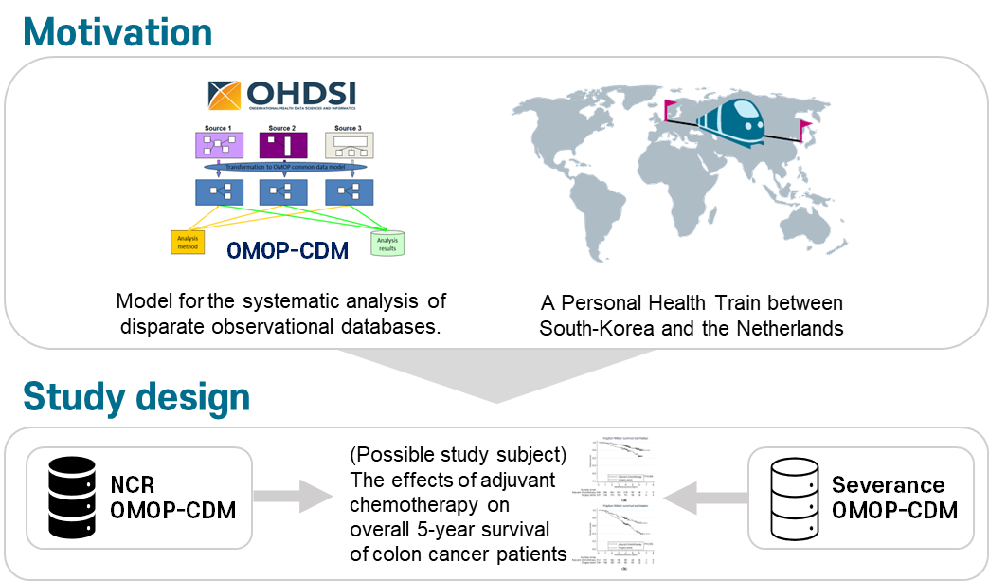

Table 1. Cohort definition
Cohort #1 | Colon cancer patients without neoadjuvant treatments
Cohort #2 | Colon cancer patients without only neoadjuvant radio and chemotherapy
Cohort #3 | Colon cancer patients with no treatment exclusions
Cohort #4 | Colon cancer patients with all-cause mortality

Table 2. Patient count for cohort definitions
Criteria | Cohort #1.  Excluding_neoadjuvant  _treatments | Cohort #2.  Only_excluding_neoadjuvant  _radio_and_chemotherapy | Cohort #3.  No_treatment  _exclusions | Cohort #4.  All_cause_  mortality
Primary Events | With Curative Surgery | With Curative Surgery | With Curative Surgery | Death
#Inclusion_0 | With C18* Code | With C18* Code | With C18* Code | -
#Inclusion_1 | With Stage 2 or 3 | With Stage 2 or 3 | With Stage 2 or 3 | -
#Inclusion_2 | Without Metastasis (M0) | Without Metastasis (M0) | Without Metastasis (M0) | -
#Inclusion_3 | Without Radiotherapy,  Immunotherapy,  Targeted therapy,  Hormonetherapy | Without Radiotherapy | - | -
#Inclusion_4 | Without Chemotherapy | Without Chemotherapy | - | -
#Inclusion_5 | Alive(30d) | Alive(30d) | Alive(30d) | -
#Inclusion_6 | Without Cancer History | Without Cancer History | Without Cancer History | -
Patient Count (Severanceª) | 1,430 | 1,434 | 1,442 | 3,520
Patient Count (NCR^{b}) | 45,615 | 46,006 | 45,652 | 102,918

ªSeverance: Onco-CDM of Severance Hospital, ^{b}NCR; Netherland Cancer Registry

