Knowledge Graph to aid Cohort Diagnostics in concept sets developing
Thi Ngoc Mai Nguyen, Christina Raabe, Stephanie von Klot

Background
Cohort Diagnostics¹ is an OHDSI HADES package, and the use of it is considered a recommended best practice step prior to conducting an OHDSI network study. The tool enables iterative decision-making by allowing comparisons of one or more cohort designs for similar clinical ideas. The diagnostics are provided at three levels: data source level, concept_id level, and cohort level, which altogether enables decisions such as the feasibility of developing cohort definitions for a clinical idea, and improvement of definitions by comparing diagnostic performance to each other and a-priori expectations.
Concept_id level diagnostics, such as “Concepts in data source” or “Orphan Concepts”, provide insights on the number of subjects picked up by each code of concept sets, or help detect codes potentially missed from a cohort definition. However, it is common in phenotype development that one would start with more than one code list for each clinical idea, especially when there is no validated algorithm built for real world data (RWD) yet, and thus would need the means to compare one among others at the codes level while maintaining their hierarchical relationships. The current version of Cohort Diagnostics does not offer such functionality; therefore, we created a knowledge graph (KG) to assist with this purpose and illustrate how we had utilized it in a use case for Acute Kidney Injury (AKI) alongside Cohort Diagnostics.

Methods
We adapted three AKI cohort definitions from OHDSI research community.^{2,3} After instantiating against the data source with Cohort Diagnostics, the three AKI concept sets used in those definitions, their included codes and the number of subjects qualified for each code were exported. In particular, these three concept sets were extracted: Charybdis from the “Characterizing Health Associated Risks, and Your Baseline Disease In SARS-COV-2” study, ³ PhPh-broad from the “Acute Kidney Injury- Phenotype Phebruary – broad” definition, and PhPh-narrow from the “Acute Kidney Injury- Phenotype Phebruary – narrow definition”. ² Charybdis includes the concept acute nephropathy with all its descendants, excluding the concept acute glomerulonephritis, acute pyelonephritis, acute rejection of renal transplant and their respective descendants. PhPh_narrow includes acute renal failure syndrome with all descendants, and PhPh_broad additionally includes acute nephritis with all descendants, and rapidly progressive nephritic syndrome with all its descendants.
To visualize the underlying connections of the concepts we constructed a knowledge graph (KG), which consisted of nodes and edges. Nodes were made up of SNOMED CT concepts, and edges were their “is a” relationship as available in Unified Medical Language System (UMLS) 2020AB. ⁴ The concept set codes of three above-mentioned AKI concept sets were mapped to SNOMED CT over an exact match of the conceptName to the SNOMED preferred term. Nodes’ size depicted the number of qualifying subjects, while the edges direction went from a general to a more granular concept. In addition, the resulting graph also contains a color layer to highlight overlap across the different concept sets.
This analysis was conducted on Optum Clinformatics(R) Extended Data Mart – Date of Death (OPTUM CDM). R package visNetwork ⁵ was used for dynamic display and filtering.

Results
Each of the concept sets is highlighted in Figure 1, demonstrating a notable heterogeneity. While Charybdis was the most sensitive concept set (panel C), PhPh-narrow appeared to be the most specific one (panel B). In particular, Charybdis included all terms covered by PhPh_narrow (except acute renal papillary necrosis with renal failure). We could also clearly see that PhPh-broad included all concepts covered by PhPh-narrow. Acute nephropathy (arrow in panel C), though not included in A or B, was the ancestor of the major concepts in A and B.
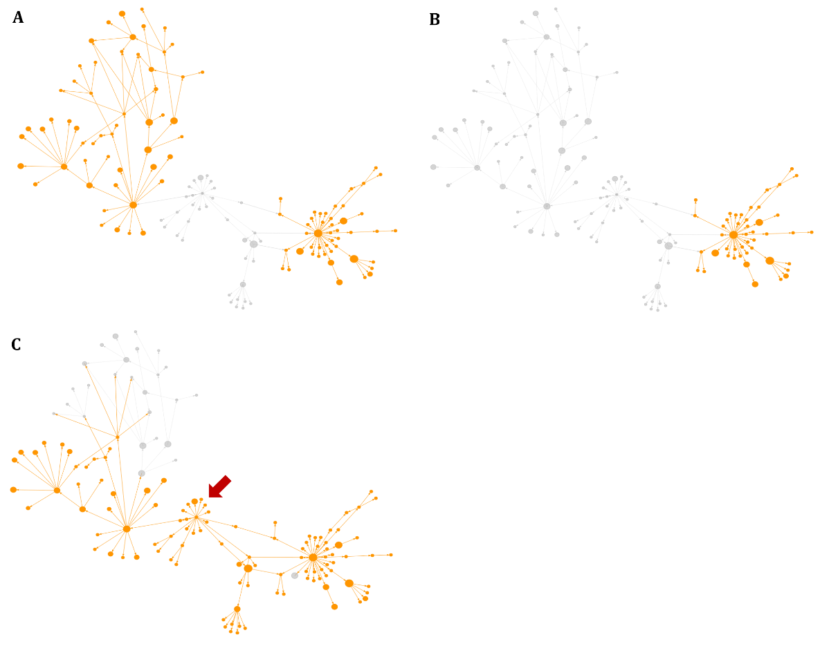
Figure 1. Codes – each presented by a node – included in each concept set and their hierarchical relationships. Panel A: PhPh-broad, B: PhPh-narrow, C: Charybdis

A zoomed-in section of the KG (Figure 2) shows that, acute nephritis was a child of nephropathy – a starting node of Charybdis, and itself was a starting node of PhPh-broad. Therefore, the two concept sets shared this branch of the knowledge graph. And while acute nephropathy did not pick up any subjects, its descendants, e.g., acute pyelonephritis with medullary necrosis and acute tubular necrosis, were included for a substantial number.
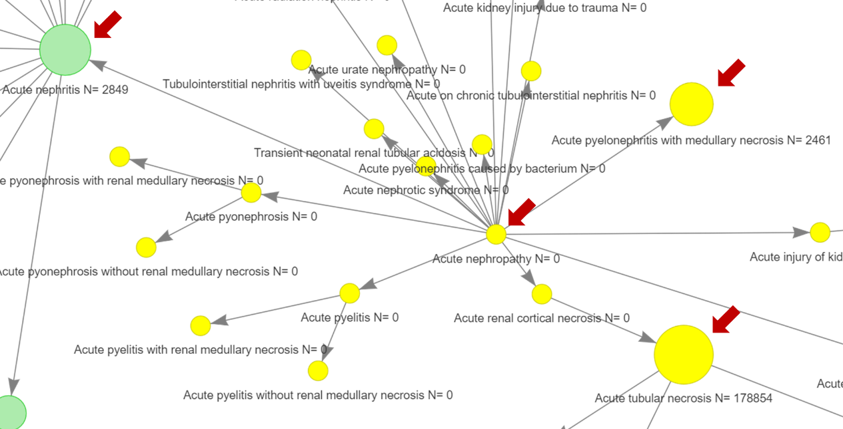
Figure 2. A zoomed-in section of the knowledge graph
Another example of the added value of a KG visualization is that one can immediately see that the concept rapidly progressive nephritic syndrome in PhPh_broad was a descendant of acute nephritis, thus it would have already been included when acute nephritis was added to the concept set.
Figure 3 shows the complete picture of all concepts and how each code relates to one another, with different colours illustrating common areas of the 3 concept sets. Only a subset of codes was presented in all three concept sets (dark green), and some degree of overlapping between Charybdis and PhPh_broad was observed (light green). A significant number of codes were presented only in PhPh_broad (light blue) and Charybdis (yellow).
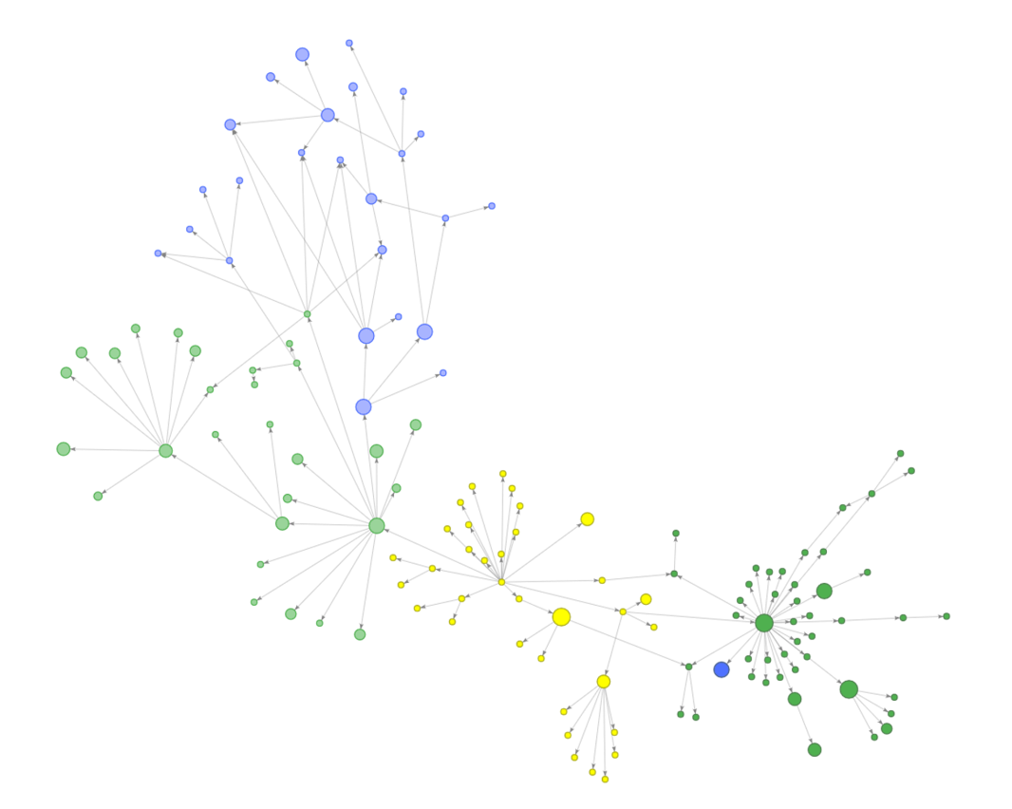
PhPh-broad only
Charybdis and PhPh-broad
Charybdis only
PhPh-broad and PhPh-narrow
Charybdis, PhPh-broad, PhPh-narrow
Figure 3. All codes included in the three AKI concept sets and their hierarchical relationships, with colored illustrating of common areas
Based on this visual and its dynamic property, the medical review team could refine and select code list that should become a part of the final AKI definition. For instance, the code list reviewing process could be conducted in the following order: starting with PhPh-narrow, followed by codes in the overlapping area of Charybdis and PhPh-broad (light green), then finally by the remaining codes (light blue and yellow).

Conclusion
We have demonstrated KG as a valuable aid to the phenotype development phase before or as a part of running the cohort diagnosis package. Future work is needed to expand the capability beyond SNOMED CT so that mix-domain code lists could be illustrated.

References

1. Rao, G., Schuemie, M., Ryan, P., Weaver, J. & Gilbert, J. CohortDiagnostics: Diagnostics for OHDSI Cohorts. https://ohdsi.github.io/CohortDiagnostics (2022).
2. Vizcaya, D. et al. Phenotype Phebruary Day 29 - Acute Kidney Injury. https://forums.ohdsi.org/t/phenotype-phebruary-day-29-acute-kidney-injury/16067 (2022).
3. Duarte-Salles, T., Kostka, K. & Prats-Uribe, A. Characterizing Health Associated Risks, and Your Baseline Disease In SARS-COV-2 (CHARYBDIS). https://github.com/ohdsi-studies/Covid19CharacterizationCharybdis (2021).
4. Wilder, V. UMLS 2020AB Release Available. https://www.nlm.nih.gov/pubs/techbull/nd20/nd20_umls_release.html (2020).
5. Thieurmel, B. visNetwork. https://github.com/datastorm-open/visNetwork (2022).

