Development of cancer-related information extraction model from pathology reports using transfer learning
Jimyung Park¹, Roh Jin ², Jianfu Li³, Hua Xu³, Rae Woong Park^{1, 4}

¹Dept. of Biomedical Sciences, Ajou University School of Medicine, Yeongtong-gu, Suwon, South Korea; ²Dept. Pathology, Ajou University Hospital, Yeongtong-gu, Suwon, South Korea; ³Shool of Biomedical Informatics, University of Texan Health Science Center at Houston, Texas, United States; ⁴Dept. of Biomedical Informatics, Ajou University School of Medicine, Yeongtong-gu, Suwon, South Korea
Background
Even with the medical coding system in electronic health records (EHRs), comprehensive information such as patient disease symptom, family history, adverse outcome to treatment, and subtypes of disease are still recorded as narrative free text¹. Especially, the cancer-related information (e.g., histology characteristics, surgery type, immunohistochemistry test, and lymphovascular invasion) is usually recorded in the pathology reports with narrative or semi-structured format². To extract the cancer-related information from the reports, there have been attempts to utilize natural language processing (NLP)³ which is a computational method that can process and analyze textual data.
Nowadays, transfer learning has become one of the most powerful computational method for NLP achieving highest performance⁴. Even though the developed systems achieved outperforming results, its validation on other databases are limited due to the lack of standardization, heterogeneous hospital information system, and limited data accessibility⁵. Furthermore, most of the systems are mainly developed on English-based corpus and non-English corpus based model is rarely developed⁶.
In this study, we aimed 1) to develop a cancer information extraction model that are developed on bi-lingual (i.e., Korean and English) pathology reports, 2) to compare the performances of the transfer learning algorithms and machine learning algorithm to identify the optimal model that works on bi-lingual pathology corpus, and 3) to propose scalable NLP application process using the standardized medical database and distributed research network.
Methods
For the proof-of-concept study, we used Ajou University School of Medicine (AUSOM) database that is a tertiary hospital database containing 2.9M patients in South Korea. The database was converted into the Observational Medical Outcomes and Partnership (OMOP) common data model (CDM). In this study, we defined target patients as the patients diagnosed with malignant neoplasm of colon and/or rectum (International Classification of Diseases [ICD]-10th: C18-21), stomach (ICD-10th: C16), breast (ICD-10th: C50), lung (ICD-10th: C34), and prostate (ICD-10th: C61). Among the overall target patients in AUSOM, we randomly selected 1,100 patients and their pathology reports for the study.
By reviewing the synoptic pathology reporting and cancer protocol templates⁷, we defined 14 annotation entities (i.e., procedure, type, size, location, and differentiation of the observed histology, depth and margin of invasion carcinoma, number of sampled and metastatic lymph nodes, lymphovascular invasion, perinerual invasion, cancer staging, and immunohistochemistry test type and its result) that can be extracted from all the defined cancer patients. The annotation was performed using the CLAMP software⁸, and the annotated corpus was used for the fine-tuning of the models.
We developed and compared the performances of 1 machine learning model and 13 transformers. Machine learning algorithm was conditional random files (CRF) in CLAMP and 13 transformers were BERT_{base}, ALBERT_{base}, RoBERT_{base}, BlueBERT_{base}, BlueBERTMimic_{base}, DeBERTa_{base}, KorBERT_{base}, MultilingualBERT_{base}, PubmedBERT_{base}, BioClinicalBERT_{base}, XLNET_{base}, Longformer_{base}, and ELECTRA_{base}. The train, test, and evaluation of the model development of 6:2:2. The hyperparameters of transformers are listed in Table 1. The models were evaluated using precision, recall, and f1-score.
Table 1. Hyperparameter setting to train transformers
Hyperparameters | Setting
Learning rate | 1e-5; 2e-5
Max sequence length | 256; 512
Batch size | 4; 8
Training epochs | 10; 20; 30; 40; 50
Warm up ratio | 0.1
Training steps | 1000
Optimizer | Adam
Results
Overall, we extracted and annotated 1,100 pathology reports of the defined cohort. The model development and validation process was implemented in R and Python environment and named the model as CASPER (Figure 1). Among the 14 developed models, consisting 1 machine learning model and 13 transformers, all the transformers showed similar performances, lowest f1-score (0.939) of BERT_{base} to highest (0.945) of BlueBERTMimic_{base} (Table 2). Meanwhile RoBERT_{base} achieved the highest precision with 0.947 and PubMedBERT_{base} achieved the best recall with 0.959. On the other hand, CRF showed the lowest performance, compared to all the transformers, precision of 0.891, recall of 0.857, and f1-score of 0.875.
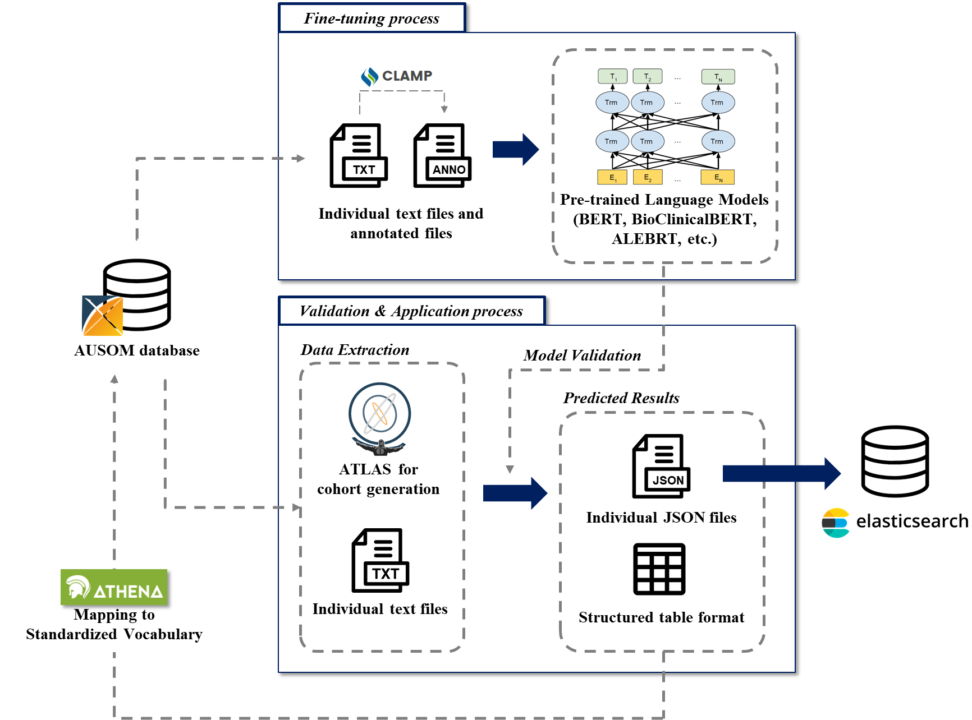
Figure 1. Model architecture of CASPER consisting fine-tuning of the transformers and its validation on cohorts in ATLAS.
Model | Precision | Recall | F1-score
CRF | 0.891 | 0.857 | 0.875
BERT_{base} | 0.931 | 0.947 | 0.939
ALBERT_{base} | 0.939 | 0.940 | 0.940
RoBERT_{base} | 0.947 | 0.941 | 0.944
BlueBERT_{base} | 0.936 | 0.946 | 0.941
BlueBERTMimic_{base} | 0.933 | 0.957 | 0.945
DeBERTa_{base} | 0.939 | 0.942 | 0.940
KorBERT_{base} | 0.932 | 0.952 | 0.942
MultilingualBERT_{base} | 0.942 | 0.944 | 0.943
PubMedBERT_{base} | 0.930 | 0.959 | 0.944
BioClinicalBERT_{base} | 0.946 | 0.941 | 0.943
XLNET_{base} | 0.917 | 0.938 | 0.927
Longformer_{base} | 0.932 | 0.952 | 0.942
ELECTRA_{base} | 0.930 | 0.955 | 0.942
Table 2. Comparison of developed model performance

Conclusion
In this study, we were able to develop a cancer-related information extraction model based on bi-lingual pathology corpus. Among 13 transformers and 1 CRF model, BlueBERTMimic_{base} achieved the highest f1-score. Furthermore, the developed BlueBERTMimic_{base} model was implemented in the CASPER.
The extracted cancer information entities are anticipated as complementary data to structured data in AUSOM database. For example, current AUSOM database contains limited information of histology, such as adenocarcinoma and tubular adenoma. In addition, the additional information such as differentiation and size of the histology are difficult to handle in current standardized vocabulary system and OMOP-CDM. Even though the episode table in OMOP CDM v5.4 can contain the information, initiating and maintaining new CDM is laborious and expensive. However, our model with the annotation schema can enables linking those information and is more cost-effective. In future, an imputation process to target cancer patients in AUSOM database is required.
There are few limitations in this study. First, we only extracted and annotated pathology reports of 1,100 patients in AUSOM database. The lack of data can make bias in the corpus and imbalance of the entities, which can impact the model performance. In future, more annotation should be performed. Second, we did not evaluate the model performance by cancer types. There were imbalance by cancer types, we did not divide and evaluate the cohort into cancer types. In future, we will acquire more annotations and will evaluate model performance by cancer types.
Acknowledgement
This research was funded by the Bio Industrial Strategic Technology Development Program (20003883, 20005021) funded By the Ministry of Trade, Industry & Energy (MOTIE, Korea) and a grant from the Korea Health Technology R&D Project through the Korea Health Industry Development Institute (KHIDI), funded by the Ministry of Health &Welfare, Republic of Korea (grant number: HR16C0001). This research was supported by a grant of the project for Infectious Disease Medical Safety, funded by the Ministry of Health, Republic of Korea (grant number: HG22C0024).
References/Citations
- Rosenbloom ST, Denny JC, Xu H, Lorenzi N, Stead WW, Johnson KB. Data from clinical notes: a perspective on the tension between structure and flexible documentation. Journal of the American Medical Informatics Association. 2011;18(2):181-6.
- Jensen K, Soguero-Ruiz C, Oyvind Mikalsen K, Lindsetmo R-O, Kouskoumvekaki I, Girolami M, et al. Analysis of free text in electronic health records for identification of cancer patient trajectories. Scientific reports. 2017;7(1):1-12.
- Datta S, Bernstam EV, Roberts K. A frame semantic overview of NLP-based information extraction for cancer-related EHR notes. Journal of biomedical informatics. 2019;100:103301.
- Peng Y, Yan S, Lu Z. Transfer learning in biomedical natural language processing: an evaluation of BERT and ELMo on ten benchmarking datasets. arXiv preprint arXiv:190605474. 2019.
- Wang Y, Wang L, Rastegar-Mojarad M, Moon S, Shen F, Afzal N, et al. Clinical information extraction applications: a literature review. Journal of biomedical informatics. 2018;77:34-49.
- Névéol A, Dalianis H, Velupillai S, Savova G, Zweigenbaum P. Clinical natural language processing in languages other than english: opportunities and challenges. Journal of biomedical semantics. 2018;9(1):1-13.
- Torous VF, Simpson RW, Balani JP, Baras AS, Berman MA, Birdsong GG, et al. College of American pathologists cancer protocols: from optimizing cancer patient care to facilitating interoperable reporting and downstream data use. JCO Clinical Cancer Informatics. 2021;5:47-55.
- Soysal E, Wang J, Jiang M, Wu Y, Pakhomov S, Liu H, et al. CLAMP–a toolkit for efficiently building customized clinical natural language processing pipelines. Journal of the American Medical Informatics Association. 2018;25(3):331-6.

