Comparing broad and narrow phenotype algorithms: differences in performance characteristics and immortal time incurred.
Joel N. Swerdel^{1,2} and Mitchell M. Conover^{1,2}

¹Observational Health Data Analytics, Global Epidemiology, Janssen Research and Development, Titusville, NJ, USA
²Observational Health Data Sciences and Informatics, New York, NY, USA
Background
Phenotype algorithms are needed to conduct observational research but developing them requires trade-offs between broad definitions, prioritizing a lower number of false negative subjects, or narrow definitions, prioritizing a lower number of false positive subjects. A common method for increasing specificity of algorithms for conditions is to require a second occurrence of the condition after the initial occurrence, which is the defined date of cohort entry. The timing of the second code relative to the first is often inconsistent across studies and, furthermore, creates the potential for incorporating immortal time bias into analyses when the index date is the date of first diagnosis (i.e. first evidence of the disease being present). We sought to estimate performance characteristics of phenotype algorithms designed for increasing specificity and to estimate the immortal time associated with each algorithm.
Methods
We examined algorithms for 11 chronic health conditions: atrial fibrillation, chronic kidney disease, chronic heart failure, coronary artery disease, migraine, multiple myeloma, multiple sclerosis, overactive bladder, plaque psoriasis, psoriatic arthritis, and ulcerative colitis. The analyses were from data from five databases: IBM® MarketScan® Commercial Database (CCAE), Optum's Clinformatics® Data Mart (DOD), IBM® MarketScan® Multi-State Medicaid Database (MDCD), IBM® MarketScan® Medicare Supplemental Database (MDCR), and IQVIA® Adjudicated Health Plan Claims Data (formerly PharMetrics Plus) - US database (PharMetrics). For each health condition we created five algorithms to examine performance (sensitivity and positive predictive value (PPV)) differences. We created a broad algorithm with a single code for the health condition which incorporates no immortal time and would potentially have high sensitivity. We also created four narrow algorithms with potentially higher specificity where a second diagnosis code was required at one of four time periods after the first diagnosis code: 1-30 days, 1-90 days, 1-365 days, and 1- all days in a patient’s continuous observation period after the first code.
For each algorithm requiring a second code, time between cohort entry (the first diagnosis) and the required second diagnosis is immortal. We examined the proportion of immortal time relative to time-at-risk (TAR) for four outcomes: death, myocardial infarction, Bell’s palsy, and ingrown toenails. For these analyses we only included data from DOD and MDCD as these were more reliable for accurately recording death. For each outcome we used four possible TAR’s for each chronic health condition: 0-30 days after the first condition occurrence (index date), 0-90 days post-index, 0-365 days post-index, and 0-1095 days post-index. Algorithm performance for chronic health conditions was estimated using PheValuator (V2.1.4) from the OHDSI toolstack. Immortal time was calculated as the time from the index date until the first of the following: 1) the outcome, 2) the end of the outcome TAR, 3) the occurrence of the second code for the chronic health condition. Total TAR was calculated as the total time, across subjects, from index date until the end of TAR. We calculated the proportion of immortal time relative to the total TAR as total immortal time/total TAR.
Results
In the first analysis, we estimated sensitivity and PPV for the single-code algorithm and the four algorithms requiring a second condition code for each of the 11 chronic conditions across five databases. The results are shown in figure 1.

Figure 1: Performance characteristics of 11 chronic conditions using PheValuator aggregated across five databases.
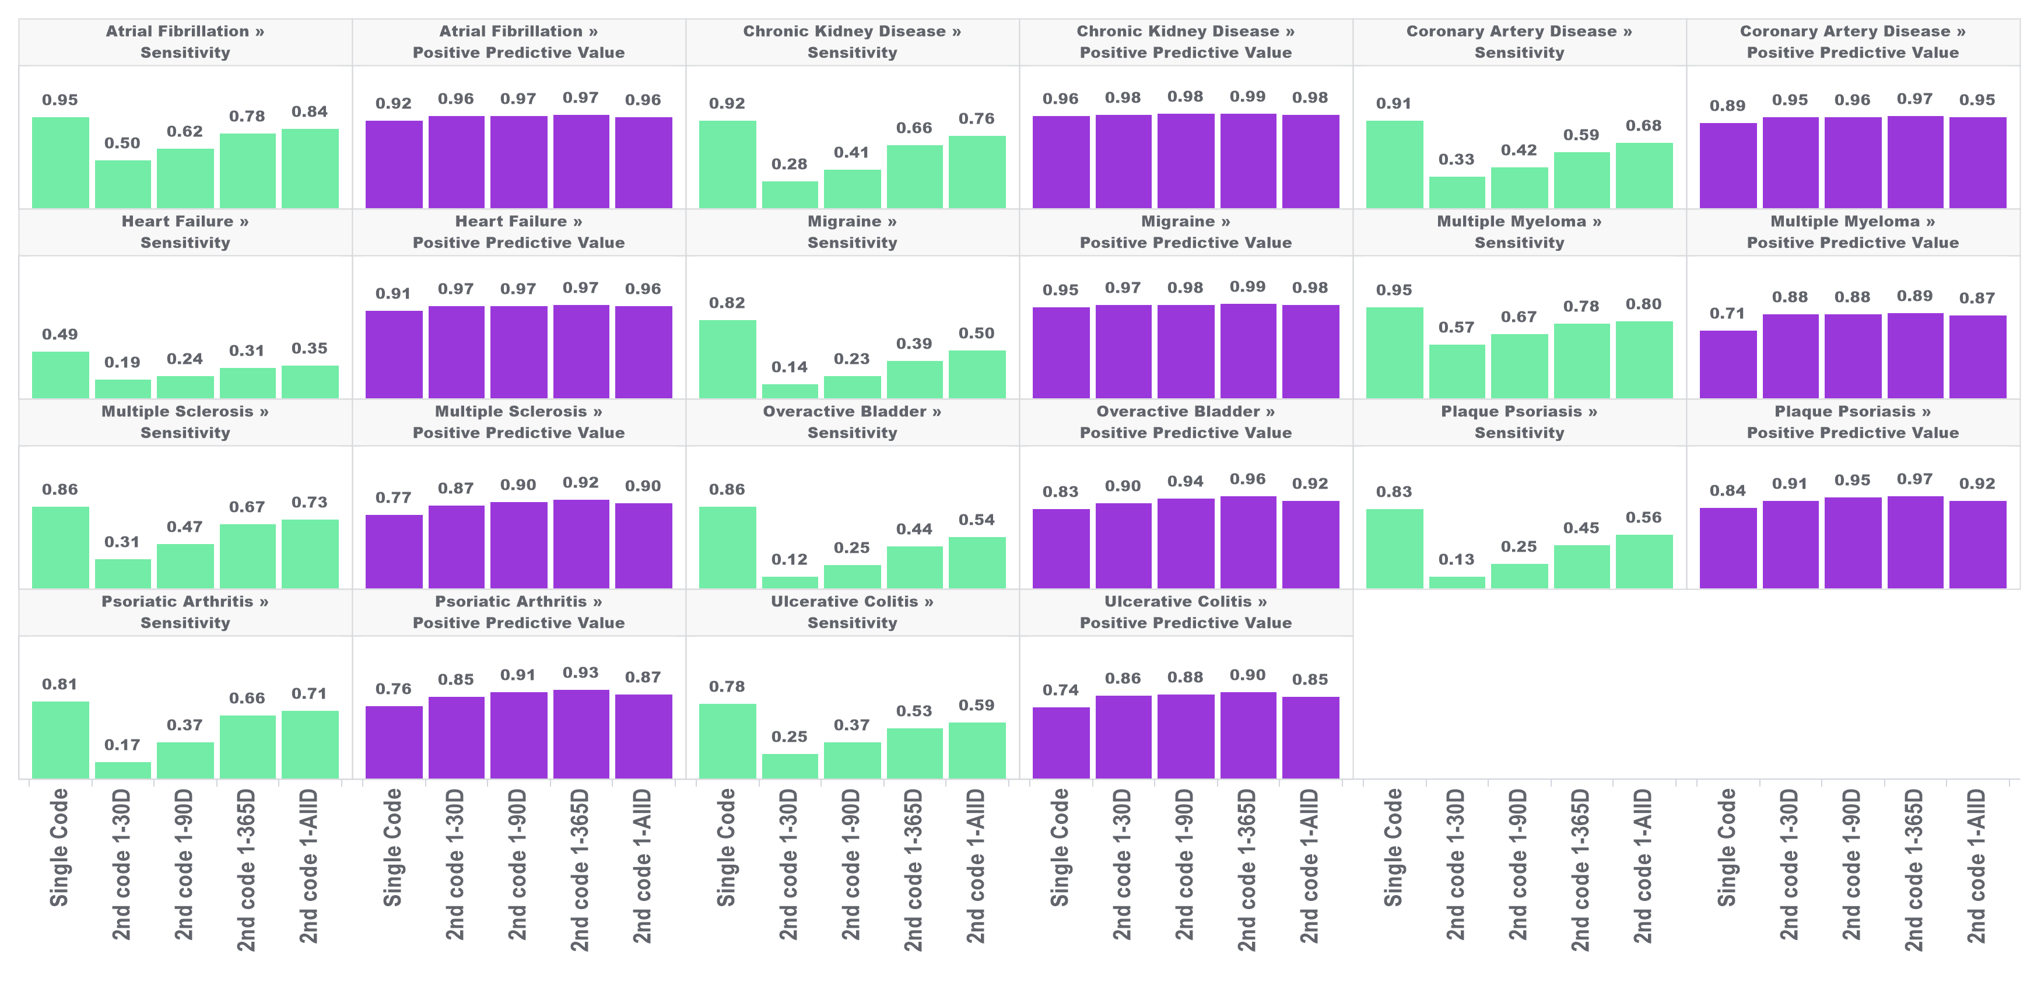

In each of these conditions, narrow phenotype algorithms, i.e., those requiring a second condition code, produced higher estimates for PPV and lower estimates for sensitivity compared to the single-code algorithm. For all conditions studied, PPV was highest in the algorithm requiring a second code 1-365 days after index with moderate decreases in PPV when the second code was allowed to occur any other time after the first. Adding a second code had more of an impact on PPV in some conditions than in others. For example, requiring a second code 1-365 days after the first (index) produced an 25% increase in PPV for multiple myeloma and a 3% increase in PPV for chronic kidney disease.
Improvements in PPV came at a cost of decreased sensitivity. There was substantial variation in loss of sensitivity depending on the time required for the second code and the condition type. For conditions with more serious/immediate clinical consequences there was a smaller drop in sensitivity from the single-code algorithm to the two-code algorithms compared to conditions with less serious/immediate clinical consequences. For example, when requiring a code 1-30 days after index, sensitivity decreased by ~47% for atrial fibrillation and ~83% for overactive bladder.
In Figure 2, we present the proportion of TAR that is immortal for four outcomes and four TARs, with the results for the outcome of death shown in Figure 2.

Figure 2: Proportion of immortal time relative to total TAR for atrial fibrillation, migraine, and multiple myeloma with an outcome of death for multiple outcome times-at-risk (TAR).
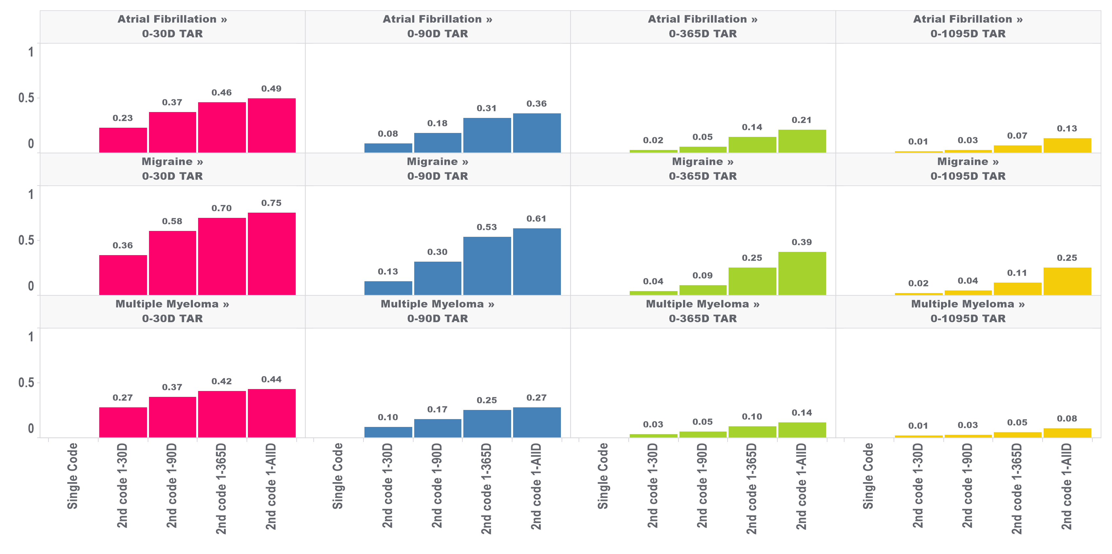

The amount of immortal time increased as the window used to identify the second diagnosis code increased. For example, in a 30-day TAR incidence rate analysis conducted on cohorts where the 2nd diagnosis code was allowed any time after the first (i.e., 1-ALL) 49%, 75%, and 44% of TAR was immortal for the atrial fibrillation, migraine, and multiple myeloma cohorts, respectively, compared to 23%, 36% and 27% when the 2nd code was required to occur within 30 days of the first. Furthermore, the proportion of TAR that is immortal is highest when the maximum-allowable TAR in the incidence rate analysis is short and decreases as the maximum-allowable TAR increases. The proportion of immortal time was substantially lower for the 1095-day TAR analyses. For migraine cohorts requiring 2 codes, which had the highest proportions of immortal time among our four outcomes, we found the 1095-day TAR analysis had 25% of TAR immortal for cohorts requiring the 2nd code any time after the first code and 2% of TAR immortal for cohorts requiring the 2nd code within 30-days of the first code. We found similar results for this analysis in the other three outcomes.
Conclusion
Increasing specificity of health condition algorithms by adding a second code is a potentially valid approach for the five US databases we tested. However, caution should be observed in analyses where the outcome is death or outcomes highly associated with death due to the necessary incorporation of immortal time, especially in analyses assessing short periods of follow-up.

References

1. Lee H, Nunan D. Immortal time bias 2020 [Available from: https://catalogofbias.org/biases/immortaltimebias/.
2. Harding BN, Weiss NS. Point: Immortal Time Bias—What Are the Determinants of Its Magnitude? Am J Epidemiol. 2019;188(6):1013-5.

