Examining differential measurement error in phenotype algorithms due to age, sex, and disease prevalence differences using PheValuator.
Joel N. Swerdel^{1,2} and Jenna M. Reps^{1,2}

¹Observational Health Data Analytics, Global Epidemiology, Janssen Research and Development, Titusville, NJ, USA
²Observational Health Data Sciences and Informatics, New York, NY, USA
Background
Misclassification of health condition status is a serious threat to validity in research involving observational data from insurance administrative claims data. The problem would be exacerbated if there was differential misclassification between population subgroups. For example, is the degree of misclassification the same for young women in a cohort of subjects as it is for older men? Is the degree of misclassification the same for groups with low prevalence of the health condition compared to groups with higher prevalence?
PheValuator is a methodology within the OHDSI toolstack that uses diagnostic predictive modeling to determine the probability that a subject has a specific health outcome during a specified period of time.(1) It was designed to evaluate the performance characteristics, i.e., sensitivity, specificity, and positive and negative predictive value, of phenotype algorithms in observational data.
The objective of this study was to use the results from PheValuator to measure the rates of false negatives, subjects with a high probability of having a health condition who went uncoded for that condition in administrative claims data, between sexes and age groups in broad phenotype algorithms of serious acute conditions. We also examined the relationship between the false negatives for an age/sex subgroup and the estimated prevalence of the health condition within that subgroup.
Methods
We developed phenotype algorithms for five acute conditions treated during an inpatient visit: myocardial infarction, ischemic stroke, acute renal failure, acute heart failure, and pneumonia. We examined these conditions in three databases which include subjects of all ages: IBM® MarketScan® Multi-State Medicaid Database (MDCD), Optum's Clinformatics® Data Mart (SES), and IQVIA® Adjudicated Health Plan Claims Data (formerly PharMetrics Plus®) - US database (PharMetrics). We stratified the subjects in the analysis by sex and the following age groups: 18-44, 45-54, 55-64, 65-74, and 75+ years of age (Y). We used PheValuator (V2.1.6) for the analyses. Each PheValuator analysis was specific for one of the following sets of sex/age parameters: 1) a combination of each sex and each age group (2X5= 10 analyses); 2) male sex and all age groups combined (1 analysis); 3) female sex and all age groups combined (1 analysis); and 4) both sexes combined for each individual age group (5 analyses) for a total 17 analyses across each database. We used a broad algorithm for each condition consisting of a single code for the condition observed in an inpatient visit. In these analyses, the first two steps of the PheValuator process, model and evaluation cohort development, used the sex/age-specific combinations for estimating algorithm performance characteristics. In these analyses, we focused on three elements: 1) false negatives (FN), subjects who were predicted health condition cases as estimated by PheValuator that were missed by the phenotype algorithm, 2) true positives (TP), subjects who were predicted cases that were included in the phenotype algorithm, and 3) the relationship between TP and FN and the estimated prevalence for each of the subgroups examined.
Results
In the first set of analyses examining the effect of age and sex on algorithm performance aggregated across databases, we found large differences in the proportion of FN’s, i.e., missed diagnosis codes, between female and male subjects with the largest differences found in the youngest two age groups (18-44Y and 45-54Y) (Figure 1). For example, in the 18-44Y age group, the percentage of the estimated total count of cases that were FN’s were 47.0% in females (F) compared to 29.2% in males (M) in those with stroke and 54.9% F to 39.6% M in those with pneumonia. The differences in the proportions of FN’s between females and males decreased with increasing age. The differences were reflective of the differences in prevalence between males and females and younger and older subjects, i.e., the proportion differences of FN’s decreased as the prevalence differences decreased.

Figure 1: Proportions of estimated health condition diagnosis codes observed (True Positives) and missed (False Negatives) in the broad algorithms and associated estimated prevalence between female (F) and male (M) subjects across three age groups aggregated across three databases.
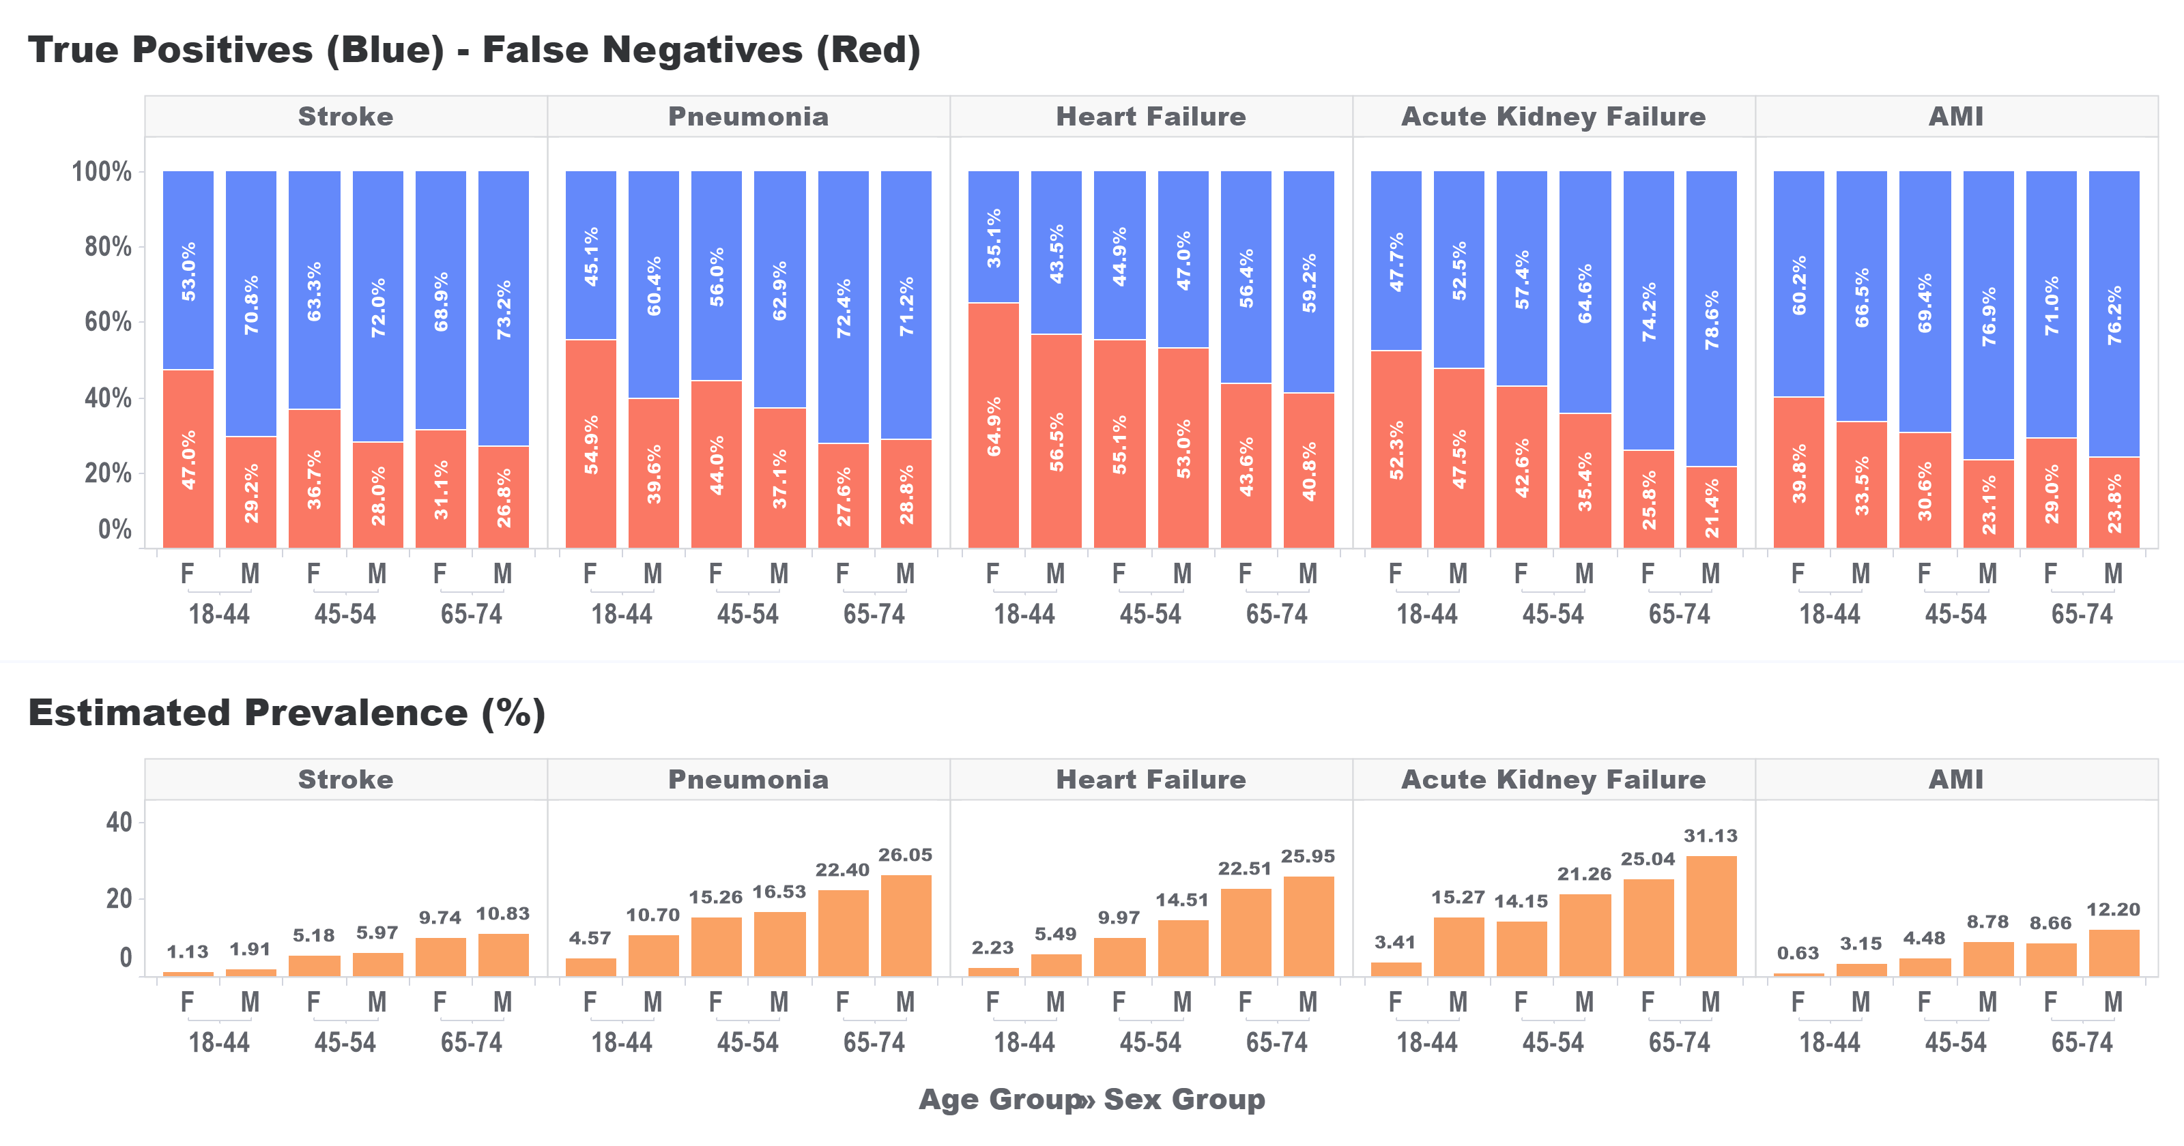

In the analyses examining FN’s across age groups, we found that the proportion of FN’s decreased with increasing age. For example, in those with stroke, the proportion of FN’s for subjects in the 18-44Y age group was 40.4% while for the 75+Y age group proportion of FN’s was 26.6%; for acute kidney failure, the proportion of FN’s for subjects in the 18-44Y age group was 49.5% while for the 75+Y age group proportion of FN’s was 18.1%. We found higher prevalence estimates with increasing age. The results are shown in Figure 2.

Figure 2: Proportions of estimated health condition diagnosis codes observed (True Positives) and missed (False Negatives) in the broad algorithms and associated estimated prevalence between age groups aggregated across three databases.

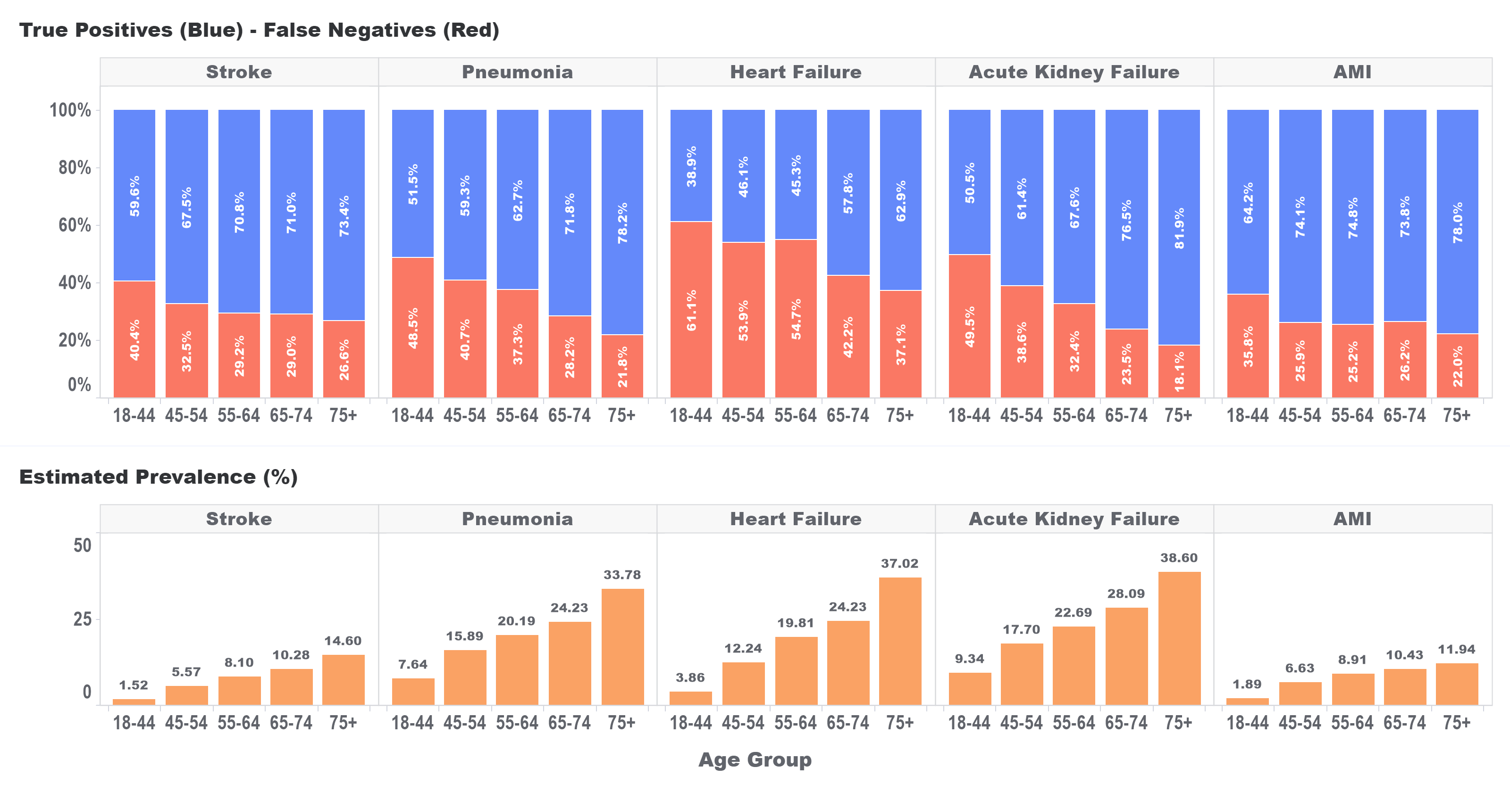
In the third set of analyses examining the effect of sex on FN’s, we found that the proportion of FN’s was higher for females as compared to males. For example, in those with pneumonia, the proportion of FN’s for females was 33.5% while for males the proportion of FN’s was 31.5%. The differences between sexes were inversely associated with differences in prevalence. The results are shown in Figure 3.
Figure 3: Proportions of estimated health condition diagnosis codes observed (True Positives) and missed (False Negatives) in the broad algorithms and associated estimated prevalence between Females (F) and Males (M) aggregated across three databases.
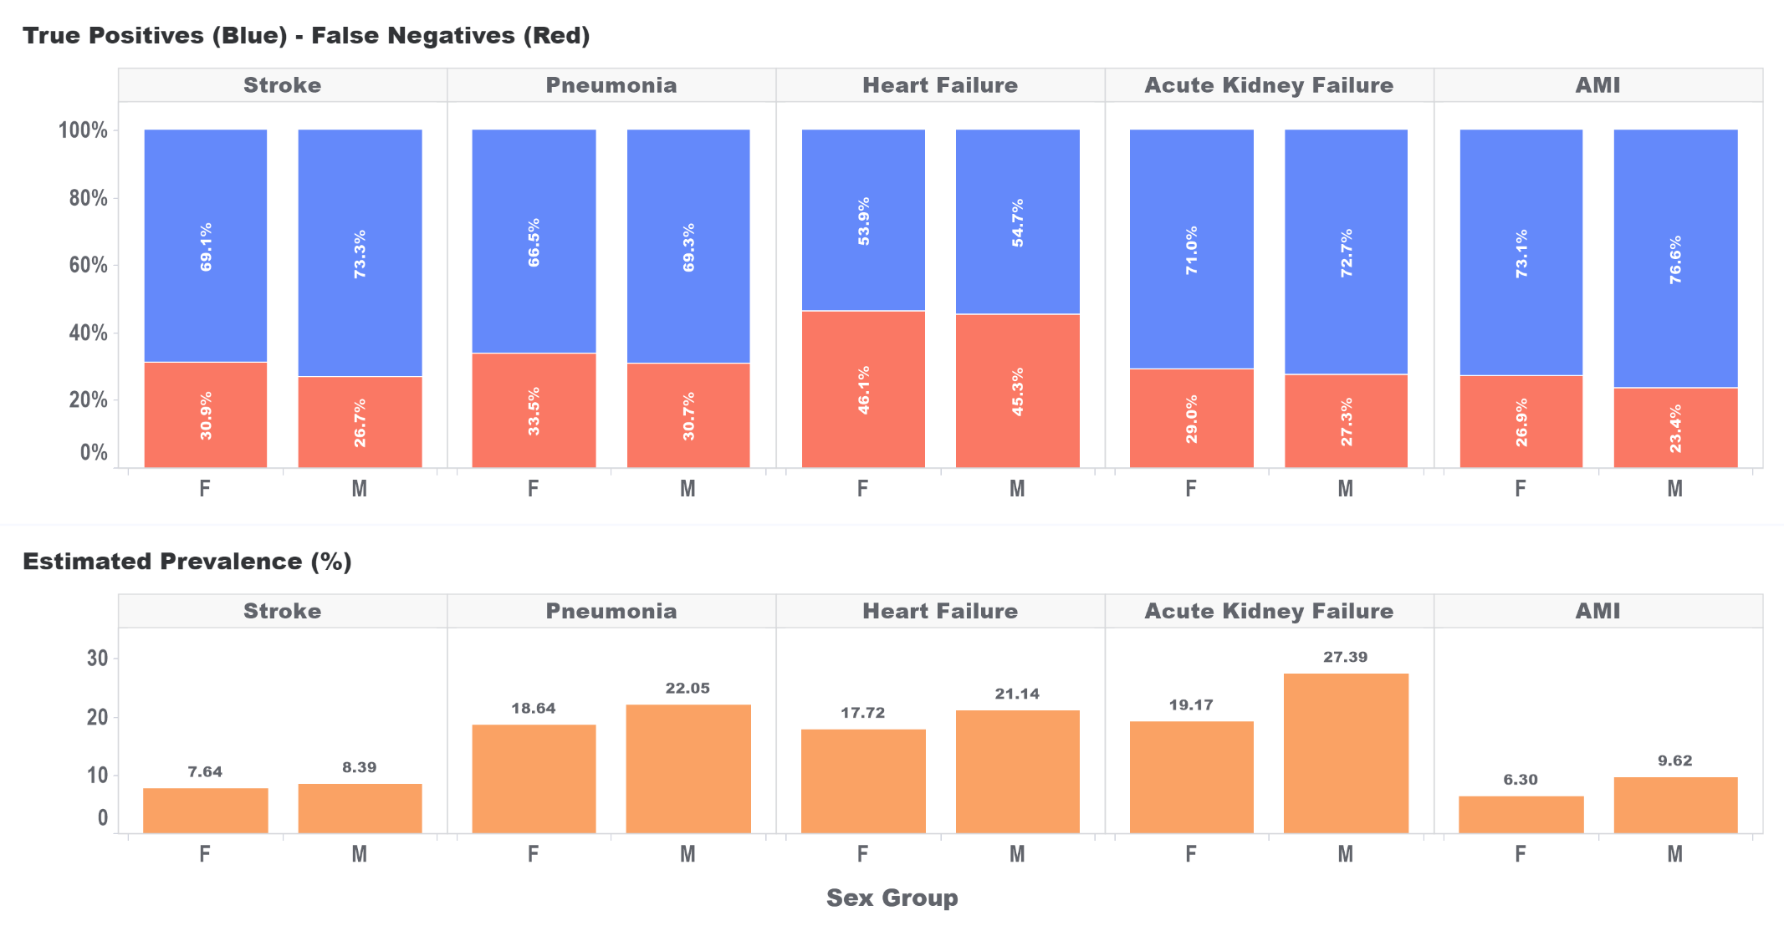

Conclusion
In this study we examined differences in the proportion of missed diagnosis codes, false negatives, in broad phenotype algorithms of acute health conditions between sexes and age groups. We found estimates of false negatives that were higher for females compared to males and for young compared to old with young female subjects (age 18-44Y) having the highest proportion of missed diagnosis codes. The proportion of false negatives of an algorithm was inversely associated with prevalence, i.e., false negative proportion decreased as prevalence increased. These differences in false negatives were observed in five acute health conditions including myocardial infarction and ischemic stroke. Thus, the threat to validity that misclassification represents may be further exacerbated by differential misclassification between cohort subgroups. The findings for stroke and myocardial infarction align with other studies that have shown higher levels of missed diagnoses in women and young adults.(2-4) Future research should be conducted to determine how these differences may affect study results such as those from drug comparative effectiveness analyses.
References
1. Swerdel JN, Hripcsak G, Ryan PB. PheValuator: Development and evaluation of a phenotype algorithm evaluator. Journal of Biomedical Informatics. 2019;97:103258.
2. Fujimoto M, Higuchi T, Hosomi K, Takada M. Association between Statin Use and Cancer: Data Mining of a Spontaneous Reporting Database and a Claims Database. Int J Med Sci. 2015;12(3):223-33.
3. Newman-Toker DE, Moy E, Valente E, Coffey R, Hines AL. Missed diagnosis of stroke in the emergency department: a cross-sectional analysis of a large population-based sample. Diagnosis. 2014;1(2):155-66.
4. Bugiardini R, Ricci B, Cenko E, Vasiljevic Z, Kedev S, Davidovic G, et al. Delayed Care and Mortality Among Women and Men With Myocardial Infarction. Journal of the American Heart Association. 2017;6(8):e005968.

