TREAD: Treatment with antidiabetics in patients with T2D and moderate to severe CKD
Martin Lavallee, David Vizcaya, Ron Herrera, Niki Oberprieler, Glen James, Darya Kosareva, and Asieh Golozar

Background
Chronic kidney disease (CKD) is a frequent complication of type 2 diabetes mellitus (T2D), so tight glycemic control is important for preventing progression of CKD (1). There are several anti-glycemics available in the US and EU market, however, due to different mechanisms, administration, side effects and patient renal health, there is no consensus treatment for persons with T2D and CKD (1). Further there is lack of real-world evidence on drug utilization and treatment patterns focused on patients with T2D and CKD. This study aims to understand patient characteristics, comorbidities, comedications, and describe longitudinal treatment patterns of patients with CKD and T2D in the real world that initiate one of 6 anti-glycemic groups of medications. This abstract reports on the study design and initial assessment of cohorts definition performance.
Methods
This study uses data from a network of commercial electronic health records (EHRs) and national claims data, all standardized to the OMOP CDM. Data sources used in this study include:
- Optum Clinformatics – US claims database with patient data available from 1/2007 to 6/2021
- CPRD Gold – UK based EHR data covering 8% of the population in all four parts of the UK
- Truven Marketscan- US claims database with patient data available from 1/2002 to 6/2020
- CPRD AURUM – UK based EHR data from general practices using the EMIS system. Currently only covers patients in England.
- Optum EMR – A US based EHR with data from different healthcare provider organizations across all 50 states.
Cohorts of patients with CKD and T2D who initiated SGLT2 inhibitors, GLP1-RA, Sulfonylurea, DPP4 inhibitors, insulin, or metformin will be identified. Characteristics of these individuals at baseline and treatment patterns and outcomes after their index date will be described using routinely collected health care data mapped to OMOP CDM. Outcomes studied in this work include:
- Treatment discontinuation: defined as at least a 90-day gap following an index therapy prescription.
- Treatment switch: defined as a new non-index prescription issued less than or equal to 30 days before or after discontinuation of the index therapy. A change to another drug within the same class is not considered a treatment switch.
Patients demographics and comorbidities in the year prior to index and outcomes at 3-, 6-, 12- and 24- months of follow-up post index will be described.
Preliminary Results
For this analysis we have created an iterative process to refine the cohort definitions for antiglycemics drug users with T2D and CKD. To be included in the cohort, the patient must have a valid case of T2D and CKD. For the case of T2D we used the phenotype from eMERGE (cite). For a valid case of CKD, we used a phenotype definition from an institutional study. After defining the inclusion rules, we optimized concept set expressions using PHOEBE to ensure we have used the most comprehensive concept sets. We used Capr to generate multiple cohort definition based on a skeleton, which was then evaluated using cohort diagnostics. Following review of cohort diagnostics, we updated the cohort definitions for antiglycemics drug users with T2D and CKD and iterated until agreement was reached for the final cohort definitions for analysis.
We have produced preliminary results from the Optum database focusing on the distribution of the comorbidities and demographics. From table 1, patients demographics are largely uniform across the antiglycemic classes. There is some small variation in the biological sex attribute, where SGLT2 is prescribed to more males. The drug index year shows changes as more patients are being prescribed newer antiglycemics like SGLT2 and GLP1. Comorbidities in the year prior to initiation of the antiglycemic drugs had similar distribution across antiglycemic cohorts per figure 1.

Conclusion
The results presented in the abstract are preliminary and we will gain more perspective of the treatment patterns of T2D and CKD patients as we analyze further. So far, we show results from the Optum database, where demographic differences were highlighted in SGLT2. This antiglycemic class had more male patients and has an increase in prescription since it came to market in 2012. As far as the comorbidities, we could not identify any major differences between the cohorts using Manhattan plots. We plan to explore the comorbidities further within the Optum cohort and as we get more data from other sources. Until more data is generated, we cannot make any major conclusions but expect to provide findings as more evidence is generated.

References/Citations
1. Davies MJ, D’Alessio DA, Fradkin J, Kernan WN, Mathieu C, Mingrone G, et al. Management of hyperglycemia in type 2 diabetes, 2018. A consensus report by the American Diabetes Association (ADA) and the European Association for the Study of Diabetes (EASD). Diabetes Care. 2018;41(12):2669–701.
2. Young MA, Wald JA, Matthews JE, Yang F, Reinhardt RR. Effect of renal impairment on the pharmacokinetics, efficacy, and safety of albiglutide. Postgrad Med. 2014;126(3):35–46.
3. Neumiller JJ, Alicic RZ, Tuttle KR. Therapeutic considerations for antihyperglycemic agents in diabetic kidney disease. J Am Soc Nephrol. 2017;28(8):2263–74.
4. Neuen BL, Young T, Heerspink HJ, Neal B, Perkovic V, Billot L, et al. SGLT2 inhibitors for the prevention of kidney failure in patients with type 2 diabetes: a systematic review and meta-analysis. Lancet Diabetes Endocrinol. 2019;7(11):845–54.
5. Dalui SK, Chakraverty R, Yasmin N, Pattanaik S, Pandit K, Chatterjee S. Effects of DPP4 Inhibitors on Renal Outcomes in Diabetes Mellitus: A Systematic Review and Meta-Analysis. Indian J Endocrinol Metab. 2021;25(4):283–92.
6. Górriz JL, Soler MJ, Navarro-González JF, García-Carro C, Puchades MJ, D’Marco L, et al. GLP-1 receptor agonists and diabetic kidney disease: a call of attention to nephrologists. J Clin Med. 2020;9(4):947.
7. Lee KA, Jin HY, Kim YJ, Im YJ, Kim EY, Park TS. Treatment Patterns of Type 2 Diabetes Assessed Using a Common Data Model Based on Electronic Health Records of 2000–2019. J Korean Med Sci. 2021;36(36):e230–e230.
8. Bang C, Mortensen MB, Lauridsen KG, Bruun JM. Trends in antidiabetic drug utilization and expenditure in Denmark: A 22‐year nationwide study. Diabetes Obes Metab. 2020;22(2):167–72.

Tables and Figures

Table 1: Summary of Demographics for Optum
 |  | Percent (%)
Group | Name | ddp4 | glp1 | insulin | metformin | SGLT2 | sulfonylureas
Age Group (5 year) | 35 - 39 | 0.78 | 1.16 | 0.70 | 0.90 | 1.04 | 0.81
Age Group (5 year) | 40 - 44 | 1.45 | 2.57 | 1.50 | 1.76 | 2.31 | 1.63
Age Group (5 year) | 45 - 49 | 2.82 | 4.62 | 2.75 | 3.28 | 4.31 | 2.88
Age Group (5 year) | 50 - 54 | 4.67 | 7.15 | 4.66 | 5.45 | 7.17 | 4.71
Age Group (5 year) | 55 - 59 | 6.86 | 10.37 | 6.99 | 7.77 | 10.07 | 6.87
Age Group (5 year) | 60 - 64 | 9.37 | 12.82 | 9.75 | 10.07 | 12.31 | 9.21
Age Group (5 year) | 65 - 69 | 15.71 | 18.93 | 15.79 | 16.33 | 17.77 | 16.73
Age Group (5 year) | 70 - 74 | 19.90 | 20.38 | 18.79 | 19.81 | 20.46 | 20.68
Age Group (5 year) | 75 - 79 | 16.15 | 12.61 | 15.58 | 15.27 | 13.60 | 16.10
Age Group (5 year) | 80 - 84 | 12.61 | 5.87 | 12.47 | 11.02 | 6.94 | 11.72
Age Group (5 year) | 85 - 89 | 8.29 | 2.63 | 9.15 | 6.78 | 3.13 | 7.13
Age Group (5 year) | 90 - 94 | 1.00 | 0.25 | 1.41 | 0.95 | 0.36 | 1.05
Index Year | 2012 | 9.59 | 3.41 | 6.55 | 7.48 | N/A | 7.54
Index Year | 2013 | 8.31 | 3.14 | 6.92 | 7.48 | 1.83 | 7.22
Index Year | 2014 | 7.43 | 2.88 | 6.40 | 7.45 | 5.25 | 6.41
Index Year | 2015 | 7.19 | 3.85 | 7.18 | 8.72 | 7.01 | 8.00
Index Year | 2016 | 8.78 | 6.05 | 8.60 | 9.83 | 7.08 | 8.95
Index Year | 2017 | 11.49 | 10.15 | 11.84 | 12.12 | 9.78 | 11.79
Index Year | 2018 | 12.59 | 14.05 | 13.34 | 11.72 | 11.23 | 12.89
Index Year | 2019 | 13.35 | 19.44 | 13.94 | 13.23 | 16.98 | 13.72
Index Year | 2020 | 13.24 | 21.57 | 15.23 | 12.48 | 22.52 | 14.03
Index Year | 2021 | 8.02 | 15.47 | 9.99 | 9.49 | 18.31 | 9.45
Sex | FEMALE | 50.63 | 50.73 | 48.03 | 49.56 | 44.41 | 47.97
Sex | MALE | 49.37 | 49.27 | 51.97 | 50.44 | 55.59 | 52.03
Race | Asian | 5.43 | 3.31 | 3.37 | 4.77 | 5.37 | 4.36
Race | Black | 16.29 | 15.84 | 15.87 | 15.38 | 14.94 | 14.77
Race | White | 54.09 | 58.27 | 58.68 | 58.95 | 55.96 | 58.52

Figure 1: Optum Claims Comorbidities Distribution for anti-glycemic cohorts
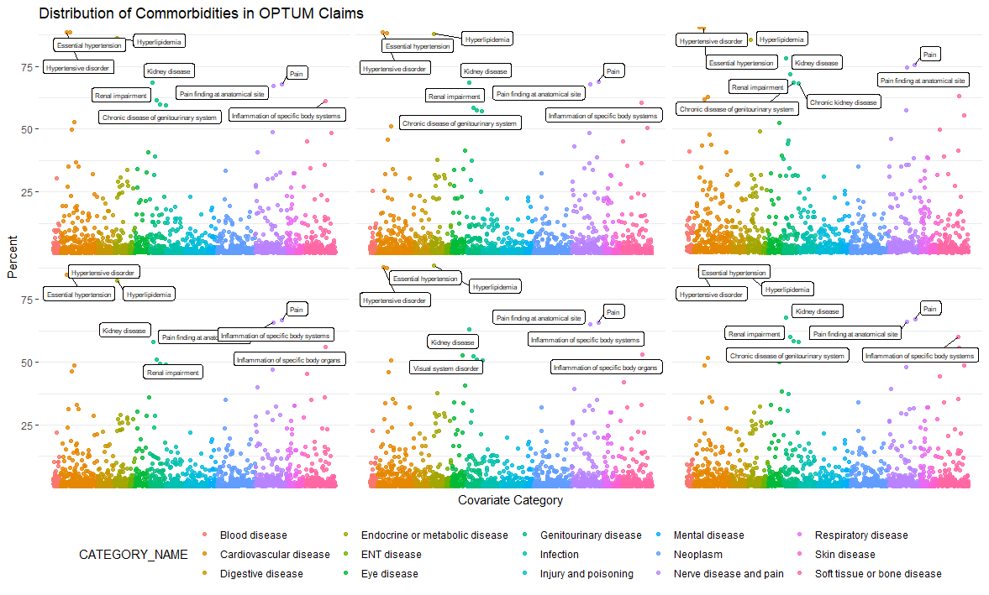

Note: a) The plots are for the cohorts going from left to right (top: ddp4, glp1, and insulin; bottom: metformin, sglt2, and sulfonylureas); b) The x-axis is based on groupings from ICD10 rollup; c) We annotate the top comorbidity for each rollup

