Development of Lung Cancer Survival Prediction Models Based on Real-world Data and Machine Learning

Jason C. Hsu; Phung-Anh Nguyen; Phan Thanh Phuc; Tsai-Chih Lo; Min-Huei Hsu; Chi-Tsun Cheng; Tzu-Hao Chang; Cheng-Yu Chen

ABSTRACT
Background
The development of disease risk and prognosis prediction models using machine learning or deep learning algorithms with big data is a major area of academic research based on AI in the medical field. Various researchers have used machine learning or deep learning algorithms to develop lung cancer risk and prognosis prediction models.¹⁻⁶
Objectives
The purpose of this study was to use clinical real-world data with multiple attributes and multiple machine learning algorithms to establish a prediction model for the survival of lung cancer patients and to determine the key factors that affect overall survival.
Methods
This study used Taipei Medical University Clinical Research Database (TMUCRD) with data from 3 hospitals as the data source, the data were mapped to OHDSI OMOP CDM. We selected non-small-cell lung cancer patients from a retrospective development dataset of TMUCRD and Taiwan Cancer Registry between January 2008 and December 2018. All patients were monitored from the index date of cancer diagnosis until the event of death or the last visit to hospitals. Variables including demographics, comorbidities, medications, laboratories, and gene tests of patients were retrieved and used to develop the machine learning models. Nine machine learning algorithms with various modes (e.g., integrating different variables) were used to develop the predicted models. The performance of the algorithms was measured by the area under the receiver operating characteristic curve (AUC), accuracy, sensitivity (Recall), specificity, positive predictive value (Precision), and F1-score.
Results
In total, 3,714 patients were included (2,280 for the training dataset and 1,434 for the testing dataset). The artificial neural network (ANN) AUC values of different modes were observed with the highest score of 89%. The best performance of the ANN model was achieved when integrating all variables with the AUC, accuracy, precision, recall, and F1-score of 0.89, 0.82, 0.91, 0.75, and 0.65, respectively. The most important features were the cancer stage, cancer size, diagnosed age, smoking, drinking status, EGFR gene, and body mass index.
Conclusion
In this evaluation of lung cancer survival, the ANN model led to a better predictive performance with high AUC, precision, and recall when integrating different data types. Further research is necessary to determine the feasibility of applying the algorithm in the clinical setting and explore whether using this tool could improve care and outcomes. This study is expected to be developed into a multinational cooperative research using OHDSI tools and OMOP CDM in the future.
Table 1. Basic Characteristics of the Study Cohort
 | Overall  n = 3,714 | Training setª  n = 2,280 | Testing set^{b}  n = 1,434
Male, N (%) | 2,136 (57.5) | 1258 (55.2) | 878 (61.2)
Age, Mean (SD), yrs. | 68.0 (13.7) | 67.9 (13.8) | 68.0 (13.4)
BMI, Mean (SD), kg/m² | 23.4 (4.33) | 23.4 (3.93) | 23.4 (4.81)
Smoking, N (%)
No | 1170 (31.5) | 710 (31.1) | 460 (32.1)
Yes | 993 (26.7) | 523 (22.9) | 470 (32.8)
Unknown | 1551 (41.8) | 1047 (45.9) | 504 (35.1)
Drinking, N (%)
No | 1750 (47.1) | 983 (43.1) | 767 (53.5)
Yes | 408 (11.0) | 247 (10.8) | 161 (11.2)
Unknown | 1556 (41.9) | 1050 (46.1) | 506 (35.3)
Tumor size, cm
Mean (SD) | 4.23 (2.45) | 4.11 (2.39) | 4.46 (2.55)
Median [IQR] | 3.8 [2.4 – 5.5] | 3.6 [2.3 – 5.5] | 4.0 [2.5 – 5.7]
Cancer stage, N (%)
0 | 11 (0.3) | 10 (0.4) | 1 (0.1)
I | 533 (14.4) | 348 (15.3) | 185 (12.9)
II | 139 (3.7) | 88 (3.9) | 51 (3.6)
III | 527 (14.1) | 330 (14.5) | 197 (13.7)
IV | 2034 (54.8) | 1207 (52.9) | 827 (57.7)
Missing | 470 (12.7) | 297 (13.0) | 173 (12.1)
Genomic Test
ALK, N (%)
Negative | 681 (18.3) | 457 (20.0) | 224 (15.6)
Positive | 39 (1.1) | 21 (0.9) | 18 (1.3)
Unknown | 2994 (80.6) | 1802 (79.0) | 1192 (83.1)
EGFR, N (%)
Negative | 842 (22.7) | 473 (20.7) | 369 (25.7)
Positive | 787 (21.2) | 467 (20.5) | 320 (22.3)
Unknown | 2085 (56.1) | 1340 (58.8) | 745 (52.0)
KRAS, N (%)
Negative | 45 (1.2) | 32 (1.4) | 13 (0.9)
Positive | 5 (0.1) | 2 (0.1) | 3 (0.2)
Unknown | 3664 (98.7) | 2246 (98.5) | 1418 (98.9)
PDL1, N (%)
Negative | 269 (7.2) | 149 (6.5) | 120 (8.4)
Positive | 66 (1.8) | 42 (1.8) | 24 (1.7)
Unknown | 3379 (91.0) | 2089 (91.6) | 1290 (90.0)
ROS1, N (%)
Negative | 288 (7.8) | 287 (12.6) | 1 (0.1)
Positive | 29 (0.8) | 27 (1.2) | 2 (0.1)
Unknown | 3397 (91.4) | 1966 (86.2) | 1431 (99.8)
Comorbidity, N (%)
CVD problems | 432 (11.6) | 296 (13.0) | 136 (9.5)
Dementia | 124 (3.3) | 71 (3.1) | 53 (3.7)
COPD | 599 (16.1) | 391 (17.1) | 208 (14.5)
Rheumatic disease | 28 (0.75) | 16 (0.7) | 12 (0.8)
PUD | 365 (9.8) | 246 (10.8) | 119 (8.3)
Renal disease | 128 (3.4) | 92 (4.0) | 31 (2.2)
Liver disease | 211 (5.7) | 147 (6.4) | 64 (4.5)
DM | 372 (10.0) | 248 (10.9) | 124 (8.6)
Anemia | 107 (2.9) | 76 (3.3) | 31 (2.2)
Depression | 245 (6.6) | 175 (7.7) | 70 (4.9)
Hyperlipidemia | 516 (13.9) | 385 (16.9) | 131 (9.1)
Hypertension | 736 (19.8) | 503 (22.1) | 233 (16.2)
Parkinson’s disease | 50 (1.3) | 29 (1.3) | 21 (1.5)
Charlson Comorbidity Index (CCI)
Mean (SD) | 3.08 (2.07) | 3.13 (2.19) | 2.97 (1.86)
Median [IQR] | 3.0 [2.0 – 4.0] | 3.0 [2.0 – 4.0] | 3.0 [2.0 – 4.0]
Follow-up, yrs.
Mean (SD) | 2.25 (2.47) | 2.44 (2.61) | 1.96 (2.19)
Median [IQR] | 1.41 [0.46 – 3.04] | 1.51 [0.53 – 3.36] | 1.24 [0.38 – 2.64]
Medications, N (%)
Alimentary tract and metabolism | 591 (15.9) | 394 (17.3) | 197 (14.7)
Blood and blood-forming organs | 446 (12.0) | 293 (12.9) | 153 (11.3)
Cardiovascular system | 675 (18.2) | 448 (19.6) | 227 (16.9)
Genitourinary system and hormones | 132 (3.6) | 74 (3.2) | 58 (4.3)
Musculoskeletal system | 252 (6.8) | 141 (6.2) | 111 (8.3)
Nervous system | 391 (10.5) | 254 (11.1) | 137 (10.2)
Respiratory system | 319 (8.6) | 226 (9.9) | 93 (6.9)
Laboratory Test, Mean (SD)
Basophil | 0.50 (0.40) | 0.53 (0.42) | 0.48 (0.39)
BUN | 19.4 (14.9) | 18.8 (13.1) | 20.5 (17.6)
Creatinine | 1.05 (0.98) | 1.02 (0.90) | 1.10 (1.07)
Eosinophil | 1.89 (2.31) | 2.03 (2.59) | 1.76 (1.97)
HCT | 38.3 (5.69) | 38.5 (5.61) | 37.9 (5.80)
HGB | 12.9 (1.97) | 13.0 (1.91) | 12.7 (2.05)
K | 3.99 (0.56) | 4.02 (0.53) | 3.95 (0.60)
Lymphocyte | 18.7 (9.98) | 19.6 (9.55) | 17.8 (10.3)
MCH | 29.9 (3.02) | 29.9 (3.03) | 29.8 (3.00)
MCHC | 33.6 (0.95) | 33.7 (0.96) | 33.6 (0.94)
MCV | 88.6 (7.61) | 88.5 (7.64) | 88.7 (7.57)
Monocyte | 7.45 (2.90) | 7.42 (2.93) | 7.48 (2.87)
Na | 137 (4.46) | 137 (4.39) | 137 (4.53)
Neutrophil | 71.3 (11.9) | 70.2 (11.4) | 72.3 (12.2)
PLT | 263 (109) | 258 (100) | 269 (121)
RBC | 4.35 (0.68) | 4.38 (0.67) | 4.29 (0.69)
WBC | 9.72 (5.38) | 9.16 (4.16) | 10.6 (6.80)
Note: SD, Standard deviation; yrs., Years; IQR, Interquartile Range; BMI, Body mass index; COPD, Chronic obstructive pulmonary disease; PUD, Peptic ulcer disease; CVD, Cardiovascular; DM, Diabetes; BUN, Blood urea nitrogen; HCT, Hematocrit; HGB, Hemoglobin; K, Potassium; MCH, Mean corpuscular hemoglobin; MCHC, Mean corpuscular hemoglobin concentration; MCV, Mean corpuscular volume; Na, Sodium; PLT, Platelet; RBC, Red blood count; WBC, White blood count;
ªThe training set included the data from Taipei Medical University and Wan-Fang hospitals;
^{b}The testing set included the data from Shuang Ho hospital;

Table 2. Performance of various Prediction Models by Modes

Modes | Models | AUC Training &  Validation | AUC External Testing | Accuracy | Precision | Recall | F1-score
Mode 1 | LR | 0.70 | 0.72 | 0.65 | 0.88 | 0.64 | 0.75
Mode 1 | LDA | 0.78 | 0.78 | 0.71 | 0.90 | 0.70 | 0.80
Mode 1 | LGBM | 0.98 | 0.81 | 0.73 | 0.92 | 0.72 | 0.81
Mode 1 | GBM | 0.96 | 0.83 | 0.75 | 0.91 | 0.76 | 0.84
Mode 1 | XGBoost | 0.99 | 0.80 | 0.75 | 0.90 | 0.77 | 0.84
Mode 1 | RF | 0.90 | 0.82 | 0.72 | 0.92 | 0.70 | 0.80
Mode 1 | AdaBoost | 0.94 | 0.81 | 0.73 | 0.91 | 0.72 | 0.81
Mode 1 | SVC | 0.78 | 0.78 | 0.71 | 0.89 | 0.72 | 0.79
Mode 1 | ANN* | 0.89 | 0.88 | 0.82 | 0.90 | 0.75 | 0.64
Mode 2 | LR | 0.74 | 0.75 | 0.60 | 0.93 | 0.53 | 0.67
Mode 2 | LDA | 0.81 | 0.79 | 0.71 | 0.90 | 0.70 | 0.80
Mode 2 | LGBM | 0.99 | 0.83 | 0.78 | 0.91 | 0.79 | 0.86
Mode 2 | GBM | 0.96 | 0.84 | 0.78 | 0.91 | 0.80 | 0.87
Mode 2 | XGBoost | 1.00 | 0.81 | 0.78 | 0.90 | 0.81 | 0.86
Mode 2 | RF | 0.92 | 0.83 | 0.69 | 0.94 | 0.64 | 0.76
Mode 2 | AdaBoost | 0.95 | 0.80 | 0.74 | 0.90 | 0.76 | 0.83
Mode 2 | SVC | 0.81 | 0.79 | 0.70 | 0.91 | 0.68 | 0.78
Mode 2 | ANN* | 0.89 | 0.89 | 0.80 | 0.91 | 0.75 | 0.64
Mode 3 | LR | 0.70 | 0.73 | 0.65 | 0.88 | 0.63 | 0.74
Mode 3 | LDA | 0.80 | 0.81 | 0.75 | 0.91 | 0.76 | 0.83
Mode 3 | LGBM | 0.98 | 0.85 | 0.80 | 0.92 | 0.81 | 0.87
Mode 3 | GBM | 0.96 | 0.85 | 0.79 | 0.92 | 0.79 | 0.86
Mode 3 | XGBoost | 1.00 | 0.83 | 0.79 | 0.91 | 0.80 | 0.86
Mode 3 | RF | 0.91 | 0.84 | 0.72 | 0.93 | 0.69 | 0.80
Mode 3 | AdaBoost | 0.95 | 0.83 | 0.79 | 0.91 | 0.80 | 0.86
Mode 3 | SVC | 0.80 | 0.81 | 0.75 | 0.90 | 0.75 | 0.83
Mode 3 | ANN* | 0.89 | 0.89 | 0.83 | 0.89 | 0.81 | 0.64
Mode 4 | LR | 0.74 | 0.75 | 0.61 | 0.93 | 0.53 | 0.67
Mode 4 | LDA | 0.83 | 0.82 | 0.76 | 0.90 | 0.77 | 0.84
Mode 4 | LGBM | 0.99 | 0.86 | 0.81 | 0.92 | 0.83 | 0.88
Mode 4 | GBM | 0.97 | 0.85 | 0.79 | 0.92 | 0.81 | 0.87
Mode 4 | XGBoost | 1.00 | 0.84 | 0.77 | 0.92 | 0.77 | 0.85
Mode 4 | RF | 0.93 | 0.85 | 0.75 | 0.93 | 0.73 | 0.82
Mode 4 | AdaBoost | 0.96 | 0.83 | 0.76 | 0.92 | 0.75 | 0.83
Mode 4 | SVC | 0.83 | 0.81 | 0.75 | 0.90 | 0.76 | 0.84
Mode 4 | ANN* | 0.89 | 0.89 | 0.82 | 0.91 | 0.75 | 0.65
Note: LR, Logistic Regression; LDA, Linear Discriminant Analysis; LGBM, Light Gradient Boosting Machine; GBM, Gradient Boosting Machine; XGBoost, Extreme Gradient Boosting; RF, Random Forest; SVC, Support Vector Machine; ANN, Artificial Neural Network; *, Best model based on AUC values;

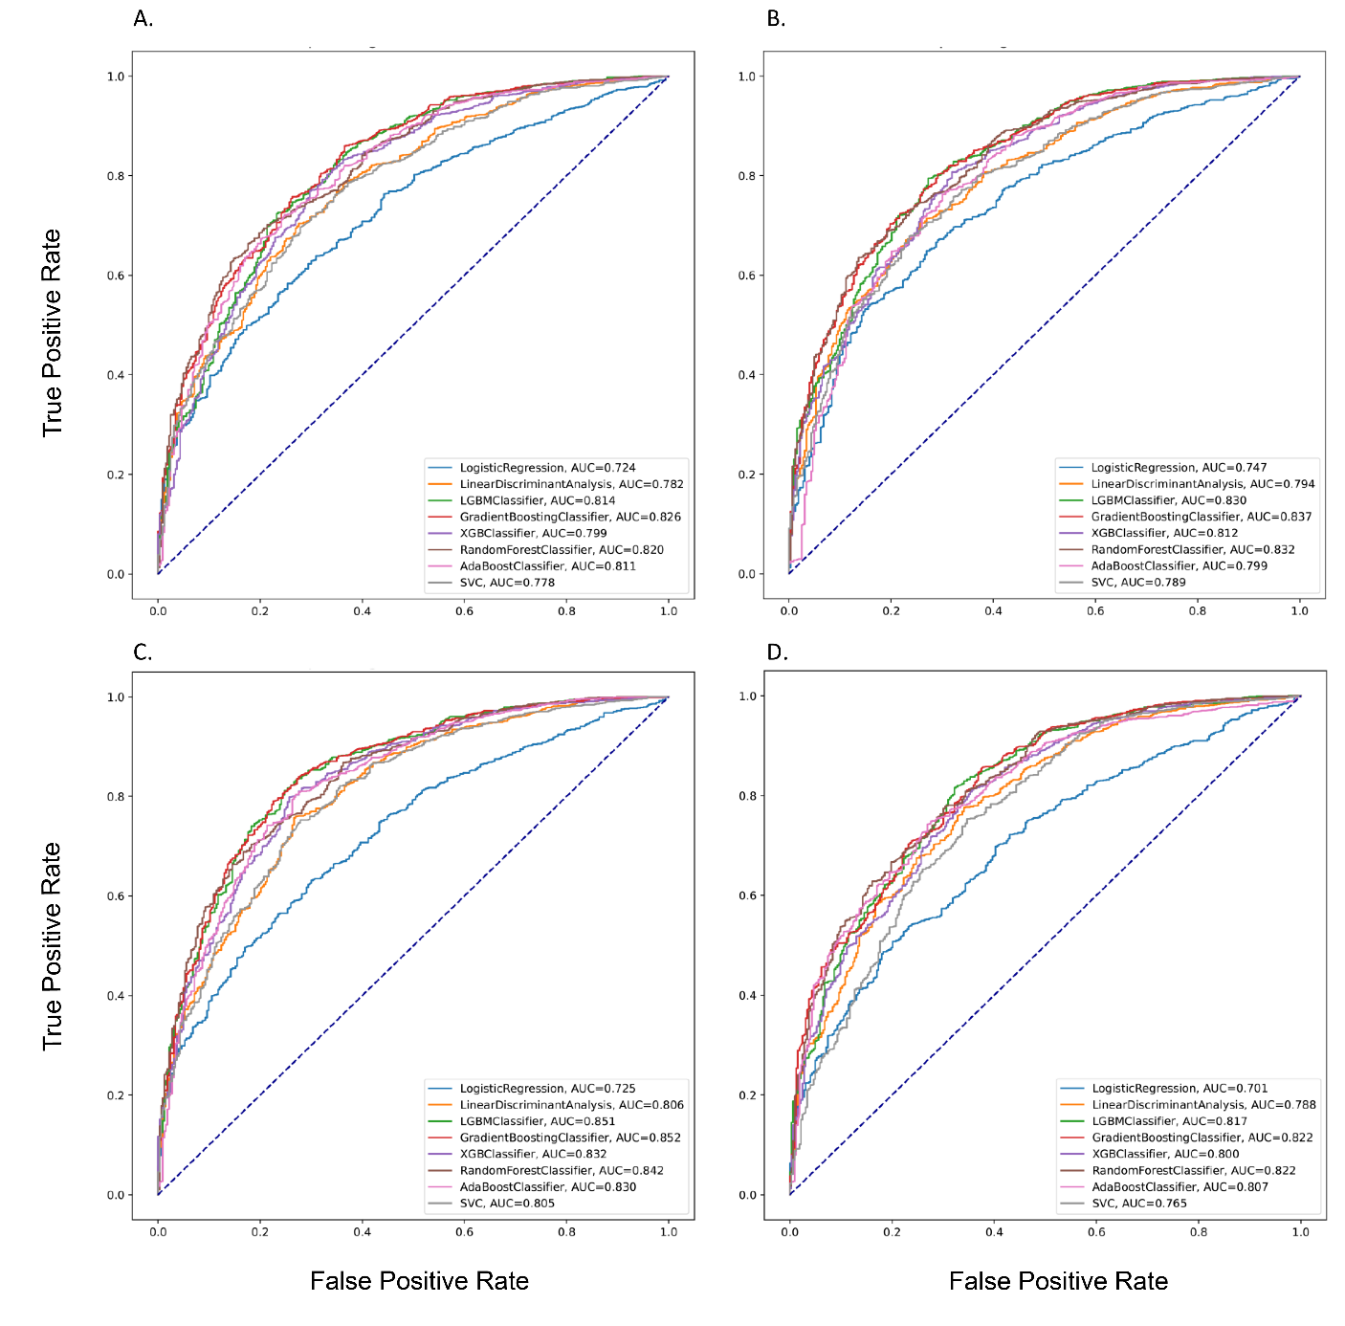
Figure 1. The Performance of the Prediction Models in the Testing dataset by different Modes
Note: A, Mode 1; B, Mode 2 ; C, Mode 3 ; D, Mode 4 ;

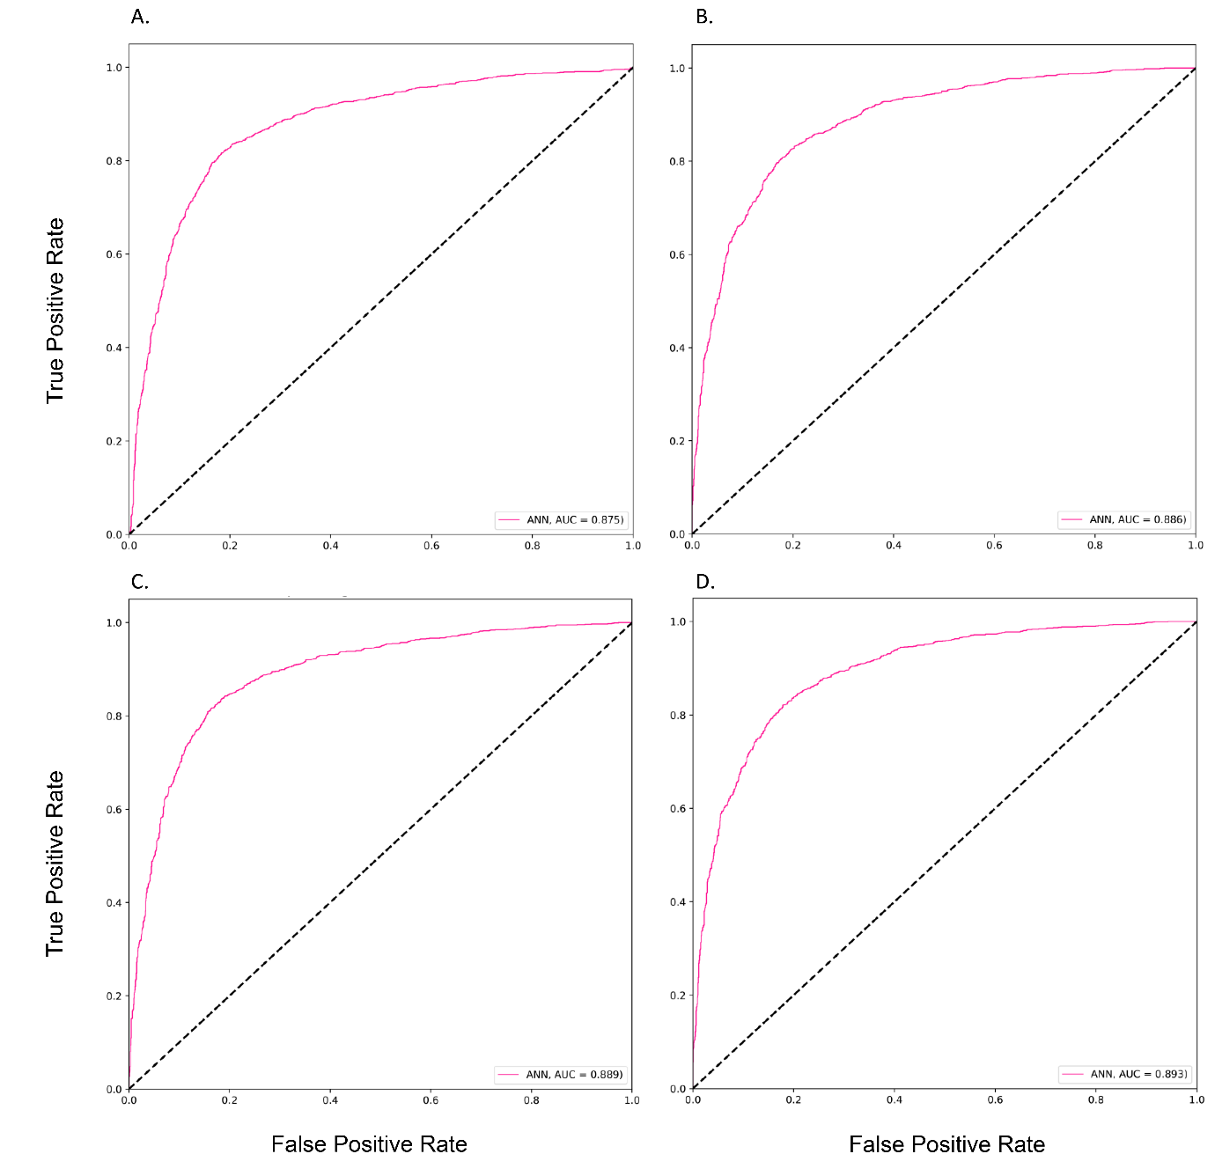
Figure 2. The Performance of the ANN Prediction Models in the Testing dataset by different Modes
Note: A, Mode 1; B, Mode 2 ; C, Mode 3 ; D, Mode 4 ;

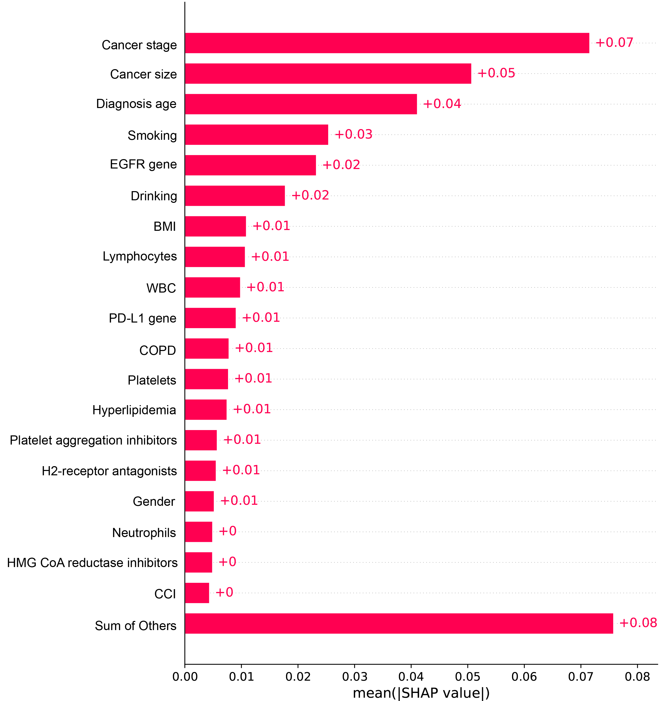
Figure 3. Feature Importance of the ANN Prediction Model in Mode 4
Note: BMI, Body mass index; EGFR, Epidermal growth factor receptor; WBC, White blood cell; PD-L1, Programmed death-ligand 1; COPD, Chronic obstructive pulmonary disease; CCI, Charlson comorbidity index

References
1. Lynch CM, Abdollahi B, Fuqua JD, et al. Prediction of lung cancer patient survival via supervised machine learning classification techniques. Int J Med Inform. 2017;108:1-8.
2. Bartholomai JA, Frieboes HB. Lung Cancer Survival Prediction via Machine Learning Regression, Classification, and Statistical Techniques. Proc IEEE Int Symp Signal Proc Inf Tech. 2018;2018:632-637.
3. Siah KW, Khozin S, Wong CH, Lo AW. Machine-Learning and Stochastic Tumor Growth Models for Predicting Outcomes in Patients With Advanced Non-Small-Cell Lung Cancer. JCO Clin Cancer Inform. 2019;3:1-11.
4. Cui L, Li H, Hui W, et al. A deep learning-based framework for lung cancer survival analysis with biomarker interpretation. BMC Bioinformatics. 2020;21(1):112.
5. He J, Zhang JX, Chen CT, et al. The Relative Importance of Clinical and Socio-demographic Variables in Prognostic Prediction in Non-Small Cell Lung Cancer: A Variable Importance Approach. Med Care. 2020;58(5):461-467.
6. She Y, Jin Z, Wu J, et al. Development and Validation of a Deep Learning Model for Non-Small Cell Lung Cancer Survival. JAMA Netw Open. 2020;3(6):e205842.
7. Dreiseitl S, Ohno-Machado L. Logistic regression and artificial neural network classification models: a methodology review. Journal of Biomedical Informatics. 2002;35(5):352-359.
8. Izenman AJ. Linear discriminant analysis. In: Modern multivariate statistical techniques. Springer 2013:237-280.
9. Ke G, Meng Q, Finley T, et al. Lightgbm: A highly efficient gradient boosting decision tree. Adv Neural Inf Process Syst. 2017;30.
10. Friedman JH. Greedy function approximation: a gradient boosting machine. Annals of statistics. 2001:1189-1232.
11. Chen T, He T, Benesty M, et al. Xgboost: extreme gradient boosting. R package version 04-2. 2015;1(4):1-4.
12. Ho TK. Random decision forests. Paper presented at: Proceedings of 3rd international conference on document analysis and recognition1995.
13. Hastie T, Rosset S, Zhu J, Zou H. Multi-class adaboost. Statistics and its Interface. 2009;2(3):349-360.
14. Gunn SR. Support vector machines for classification and regression. ISIS technical report. 1998;14(1):5-16.
15. Agatonovic-Kustrin S, Beresford R. Basic concepts of artificial neural network (ANN) modeling and its application in pharmaceutical research. Journal of pharmaceutical and biomedical analysis. 2000;22(5):717-727.

Appendix 1. Brief introduction of ML algorithms

Logistic Regression (LR): is one of the discrete choice models, which models the relationship between a response and multiple explanatory variables and is based on the concept of probability ⁷. It is widely used and more practical in various fields such as biostatistics, clinical medicine, and quantitative psychology. Its equation is:
$$y=\frac{e^{\left(b | | 0+b_{1}X\right)}}{1+e^{\left(b | | 0+b_{1}X\right)}}$$
where x is the input value, y is the predicted output, b₀ is the bias or intercept term, and b₁ is the coefficient for input (x). In this study, we used the LR function with the parameter C (Inverse of regularization strength) of 1e-4 to reduce the model's overfitting.
Linear Discriminant Analysis (LDA): is generally used to classify patterns between two classes; however, it can be extended to multiple patterns. LDA assumes that all classes are linearly separable, and according to the multiple linear discrimination functions representing several hyperplanes in the feature space are created to distinguish the classes ⁸. In this study, we set the parameters shrinkage to ‘0’ and the solver as ‘lsqr’ to improve estimation and classification accuracy.
Light Gradient Boosting Machine (LGBM): is a gradient boosting framework that uses tree-based learning algorithms. It is designed to be distributed and efficient with the following advantages: faster training speed and higher efficiency, lower memory usage, better accuracy, support of parallel, distributed, and GPU learning, and capability of large-scale handling data ⁹. The model's class_weight parameter was set as ‘balanced’, which uses the output’s value to automatically adjust weights inversely proportional to class frequencies in the input data. The learning_rate, l1 regularization – reg_alpha, and l2 regularization – reg_lambda parameters were set as 0.05, 0.1, and 0.1, respectively.
Gradient Boosting Machine (GBM): Gradient boosting regression trees produces competitive, highly robust, interpretable procedures for regression and classification. The ability of TreeBoost procedures to give a quick indication of potential predictability, coupled with their extreme robustness, makes them a useful preprocessing tool that can be applied to imperfect data ¹⁰. The default parameters were used in this model.
Extreme Gradient Boosting (XGBoost): XGBoost, an efficient and scalable implementation of the gradient boosting framework, is a machine learning system for tree boosting. The scalability of XGBoost is attributed to several critical systems and algorithmic optimizations. These innovations include a novel tree learning algorithm for handling sparse data; a theoretically justified weighted quantile sketch procedure allows the handling of instance weights in approximate tree learning ¹¹. The default parameters were used in this model.
Random Forest (RF): RF is an ensemble learning method that operates by constructing a multitude of small scales of classification modules (mostly often decision trees) at training time. The model outputs the class that combines the result of the individual modules based on some voting algorithms ¹². In the study, we set those parameters, n_estimators (the number of trees) of 500, max_depth of 10, min_samples_split of 400, and class_weight of 0.5 for each class.
AdaBoost: The AdaBoost algorithm is an iterative procedure that combines several weak classifiers to approximate the Bayes classifier C∗(x). AdaBoost builds a classifier, e.g., a classification tree that produces class labels, starting with the unweighted training sample. If a training data point is misclassified, the weight of that data point is increased (boosted). A second classifier is built using the new weights, which are no longer equal. Again, misclassified training data have their weights boosted, and the procedure is repeated ¹³. The number of estimators (n_estimators) was used as 100.
Support Vector Machine (SVC): is a machine learning algorithm that can be applied to linear and nonlinear data. SVC transforms the original data to a higher dimension from which it can use the super vectors in the training data set to find the hyperplane for categorizing the data. An SVC mainly identifies the hyperplane with the most significant margin, e.g., the maximum marginal hyperplane, to achieve higher accuracy ¹⁴. The SVC can be represented by the following equation:
$$f\left(x\right)=\sum_{i=1}^{N}{\left(α_{i}^{}−α_{i}\right)K\left(x,x_{i}\right)+Β}$$
where $K\left(x,x_{i}\right)$ is the kernel function, $α_{i}{,α}_{i}^{}≥0$ are the Lagrange multipliers, and Β is a bias term. In this study, we used a linear kernel for computations.
Artificial Neural Network (ANN): is a learning algorithm that is vaguely inspired by biological neural networks. Computations are structured in terms of an interconnected group of artificial neurons, and these neutrons will process information using a connectionist approach to computation. They are usually used to model complex relationships between inputs and outputs, find patterns in data, or capture the statistical structure ¹⁵. The number of hidden layers with the number of neurons in each layer was set at 3 and 16, respectively. Additionally, for each layer, the l2 regularization of 0.01 and the ‘relu’ activation were used in the study. We set the ‘softmax’ activation for the output layer. We also used the ‘Adam’ optimizer, a highly performant stochastic gradient descent algorithm, and ‘binary_crossentropy’ as the binary classification outcome for the loss function.

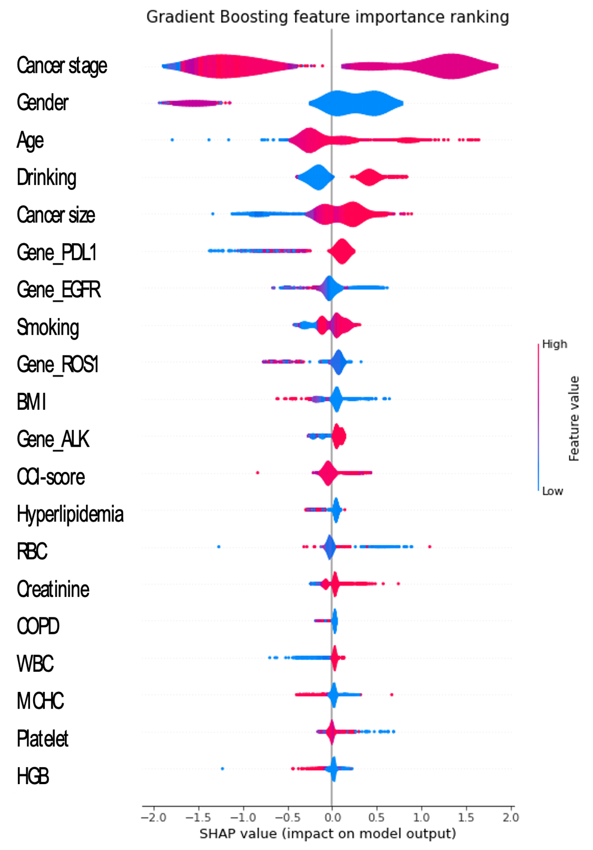

Appendix 2. Feature Importance of the GBM Prediction Model of Mode 4
Note: BMI, Body mass index; EGFR, Epidermal growth factor receptor; RBC, Red blood cell; WBC, White blood cell; PD-L1, Programmed death-ligand 1; COPD, Chronic obstructive pulmonary disease; CCI, Charlson comorbidity index; ROS1, Proto-oncogene 1, receptor tyrosine-protein kinase; ALK, Anaplastic lymphoma kinase; MCHC, Mean corpuscular hemoglobin concentration; HGB, Hemoglobin;

