

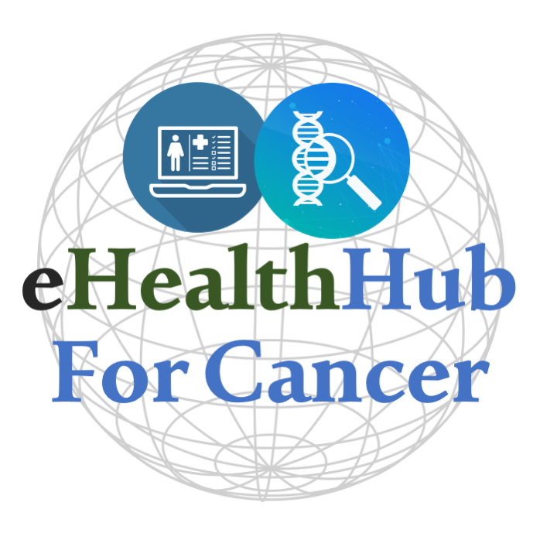

5 Fully Funded PhDs in Cancer Digital Health Real World Evidence

Project topic: Digital Health in Cancer.

Project lead: Prof Aedin Culhane

Project location: School of Medicine, University of Limerick, Queen's University Belfast

Application deadline: June 15th, 2023

Start date: Successful applicants should be registered by September 2023.

Project Description:

The eHealth-Hub for digital health research in cancer is an All-Island collaboration between the University of Limerick Digital Cancer Research Center (LDCRC), and Patrick G Johnston Centre for Cancer Research at Queen's University Belfast, which was recently established with a 4-million-euro award from the Higher Education Authority Shared Island programme. The eHealth-Hub for Cancer partners with seven universities, eight hospitals, industry, and international partners. Multidisciplinary teams of bioinformatics, biostatisticians, epidemiologists, software developers, clinicians and cancer doctors are developing new innovative algorithms and software to advance cancer digital health and real-world evidence research. The LDCRC is a recently launched research centre of excellence, that includes over 100 scientists and 10 research labs that provides an interdisciplinary, creative, scientific environment and is supported by high-end, innovative technologies in single cell spatial biology, biomaterials engineering, software engineering, data science and bioinformatics.

We are looking for 5 PhD students to work on cutting-edge cancer health data science research. Fully funded PhD studentship includes a tax-free stipend (with fees paid) along with expenses, 12-month travel to partner sites and materials are available.

Key Research Hub Areas:

Computational Cancer Genomics
Digital Health Software Development
Cancer Data Science
Real World Data Research

Faculty: School of Medicine

Skills and Competencies:

The PhD students will be responsible for the development and application of novel methods and techniques on data from all-island cancer electronic health data to harmonise cancer data and build federated cancer eHealth research that will leverage national, EU and global data. We will develop next generation clinical- decision making applications that match patients’ cancer data to clinical trials and targeted therapy.

An extensive training program in software development and cancer real-world evidence research will be provided to students. Students will have state-of-the-art local and cloud computing facilities, be immersed in an exciting, well-funded academic environment, and will have opportunities to attend national and international conferences. Students will actively contribute to global open-source software projects in digital health, work with international consortium OHDSI, HL7-FHIR, R /Bioconductor and deliver high-impact, all-island and pan-EU research that informs cancer research, patient care and public health policy.

The successful candidate will…
- Be passionate about data science, artificial intelligence, and machine learning.
- Be enthused by the opportunity to work closely in a multidisciplinary team with clinical collaborators and advance cancer research.
- Strong analytical or problem-solving skills.
- Have strong computational skills (e.g., Python, R, Java, C/C++, etc.)
- Be self-motivated, output driven, and have good communication and presentation skills.

The following attributes are desirable, but not required:
- Knowledge of natural language processing
- Experience working with clinical informatics data, clinical ontologies.
- Knowledge of cancer genetics and genomics
- Knowledge of relational databases, ETL and data API concepts
- Working with open-source software (eg OHDSI, R, Bioconductor)
- Track record in presentation or publication of research

Entry Requirements: (one of the following)

- At least a master’s degree in statistics, epidemiologists, bioinformatics, computational biology, software engineering or a related quantitative discipline.
- At least a bachelor's degree (2.1 honours, GPA 3.0 equivalent or higher) in the biostatistics, epidemiologists, bioinformatics, computational biology, software engineering or a related quantitative discipline. Candidates with relevant work experience strongly preferred.
- Candidates with a degree in another domain with relevant work experience.

Applicants for whom English is a second language will be required to demonstrate their competence in the English language in line with University of Limerick requirements.
Students must have 6.5 IELT English language.

Funding/Stipend:

Both EU and non-EU applicants will be eligible for a full award including a tax-free stipend of at least €18,500 per year for four years, with full fees paid and budget for up to 12-month travel to partner sites and materials provided.

Application Procedure:

Prospective applicants should email to eHealth@ul.ie by 15th June 2023.
- Curriculum Vitae or Resume
- Short cover letter indicating your motivation (maximum of 2 pages)
- A statement on software development experience.
- A link to your GitHub account.
- 2 Referees
- Please include “PhD Application” and your name in the subject line.

Applications should be submitted in PDF format only. The PhD Studentship will commence in September 2023.

Additional information:

The successful candidate will be required to apply formally to be admitted as a PhD student by the University of Limerick.

Informal queries can be made to Aedin Culhane by emailing eHealth@ul.ie. Website eHealth4Cancer.org, Related recent news coverage; RTE Brainstorm article.

