LEVERAGING EPIC’S NATIVE ETL INFRASTRUCTURE FOR OMOP CDM IMPLEMENTATION: A COLLABORATIVE EXPERIENCE
Aamirah Vadsariya, RN MSN¹, Mereeja Varghese, MS¹, Bhavini Nayee, BS¹, Jessica Moon, BS¹, Chaitanya Katterapalli, MS², Clark Walker, MPH², Chris Gonzalez, LPN², Sonam Sohal, MHSM MBA², Christoph U. Lehmann, MD¹, Ferdinand Velasco, MD², Mujeeb Basit, MD¹, DuWayne Willett, MD¹
¹University of Texas Southwestern Medical Center, Dallas, Texas, USA; ²Texas Health Resources, Arlington, Texas, USA

Abstract
The University of Texas Southwestern Medical Center (UTSW) and Texas Health Resources (THR) implemented an Observational Medical Outcomes Partnership (OMOP) common data model (CDM) that utilizes the Epic electronic health record’s (EHR) extract, transform, and load (ETL) system to enable collaborative research with other health institutions within the OHDSI network. We mapped EHR data from frequently utilized Epic Models to 25 OMOP CDM tables and transferred the data to a shared OMOP database housed within the Caboodle infrastructure using Epic’s pre-existing ETL system, minimizing the need for customization. ETL processes occur weekly at THR and daily at UTSW. OMOP CDM mapping resulted in data quality assessment values of 97% and 98% for THR and UTSW respectively. Our study established a reproduceable, collaborative pipeline using the OMOP CDM with Epic’s native ETL framework, expanding the OHDSI research network resulting in better quality and more generalizable data sets available for future research.
Abstract Word Count: 150

Introduction
Data contained in electronic health records (EHR) represents a potential wealth of knowledge if the data can be harvested and analyzed. Means to advance collaborative research amongst healthcare institutions are crucial for that task. Collaborative research tends to be very labor intensive for information resources teams in charge of developing ways to extract and share abundant data resources. In this paper, we imagined and implemented an efficient path to cross-institutional collaborative research by populating the Observational Medical Outcomes Partnership (OMOP) common data model (CDM)^{1,2} with data by leveraging Epic’s native extract, transform, and load (ETL) infrastructure.
Using the OMOP CDM, healthcare institutions can participate in the Observational Health Data Sciences and Informatics (OHDSI) network and collaborate with other researchers and institutions without exposing their data. Through strength in numbers and data points, collaborating researchers using the OMOP CDM can improve the quality of EHR based research studies. However, participation requires an upfront investment as significant barriers such as developing and maintaining a dedicated ETL system for converting EHR data to the OMOP CDM must be overcome first, which may have prevented many healthcare organizations from participating in the OHDSI network.
In our study, we describe the collaborative efforts of the University of Texas Southwestern Medical Center (UTSW) and Texas Health Resources (THR), two healthcare systems with Epic EHR systems, to leverage the Epic native ETL system to populate the OMOP CDM resulting in improved data transformation and performance, reduced implementation and operational costs, and limited maintenance needs.

Methods
Study Participants
As members of the multi-site Clinical and Translational Science Award (CTSA)³ UTSW and THR shared the common goal of transforming EHR data into the OMOP CDM format by using Epic’s existing ETL tools⁴. Both institutions utilize Epic’s EHR system with Epic Caboodle serving as the data warehouse and ETL infrastructure.
IRB Statement
Only aggregate data were included in this study, making deidentification of individuals impossible. Thus, patient consent or approval from an institutional review board were not required.
Data Sources, Environments, and Implementation
To ensure consistent data conversion across both UTSW and THR, our implementation of OMOP at each institution involved four environments: Development (DEV), Testing (TST), Release (REL), present only at THR, and Production (PRD). The installation of the OMOP Data Management Console (DMC), SQL Server Integration Services (SSIS) packages, and various stored procedures and views were customized to accommodate the individual database management systems, Oracle (Clarity) and Microsoft SQL Server (Caboodle) at THR and Microsoft SQL Server at UTSW, respectively. For the THR based Caboodle environment, data were loaded into the OMOP tables for the DEV, TST, and REL environments with the PRD load scheduled for post-validation in the REL environment. This data load process is completed weekly and completion of the ETL process occurs within 7 to 8 hours. For the UTSW based Caboodle environment, the data load process into the OMOP tables is completed nightly, occurring within 5 to 6 hours on average and ongoing validation is conducted for network study readiness (Figure 1). The ETL process utilizes existing Epic-to-OMOP transformation logic and standard mappings of local Epic data to Caboodle fields.
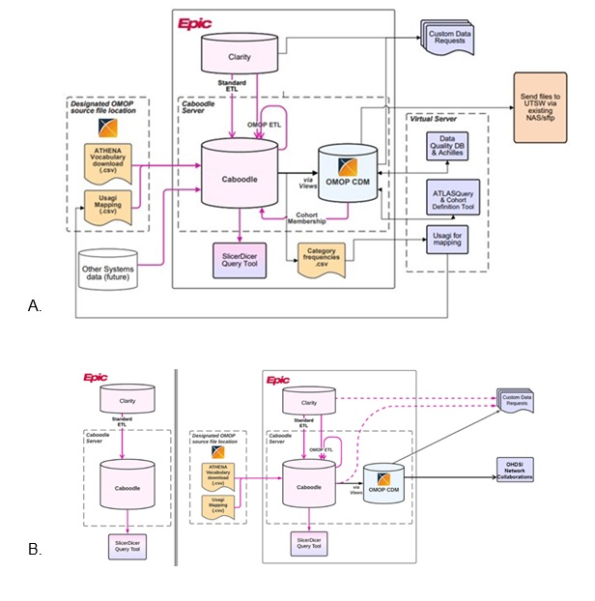
Figure 1. Epic Caboodle ETL data flow for both (A) Texas Health Resources (THR) and (B) the University of Texas Southwestern Medical Center. A Pre-OMOP Caboodle ETL data flow is shown on the left of Figure 1B.

We utilized open-source software tools provided by OHDSI in the mapping of the source data from Epic to the OMOP CDM. WhiteRabbit⁵ and Rabbit-in-a-Hat tools were used in the design stage of the ETL development, while Usagi⁶ was used to create code mappings for the ETL⁷. Epic’s existing ETL logic was reused to map local data source fields to the OMOP CDM tables, minimizing the need for site specific customizations. In total, 25 OMOP CDM tables were implemented, comprised of 10 vocabulary tables, 3 health system tables, and 12 clinical data tables, along with 2 metadata views (Figure 2). To allow for data migration between UTSW and THR, we created custom Caboodle Data Model Component (DMC) packages for both TST and PRD environments to store the procedures used to transform Epic data into the OMOP format.

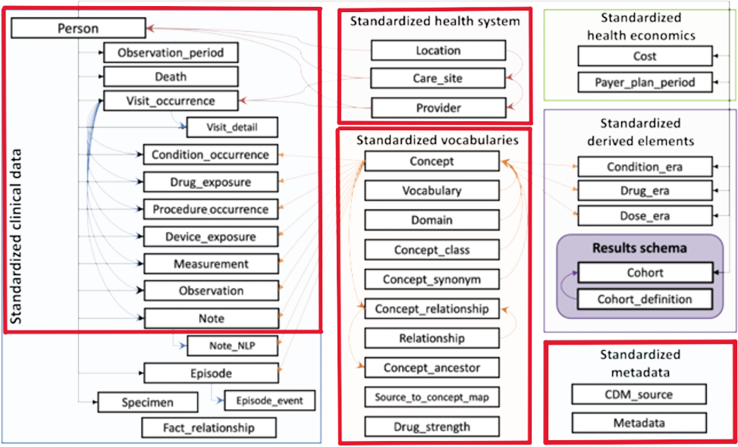
Figure 2. The twenty-five tables and 2 metadata views that were implemented in our data model outlined in red compared to tables available in the OMOP common data model.

As a key component of the OMOP implementation, the ETL process ensures that clinical data are accurately transformed and loaded into the OMOP CDM tables. Refinement of the ETL process included 1) mapping codes with the highest frequency from the local sources to the standard OHDSI concepts to facilitate clinical data integration across UTSW and THR, 2) adjusting the SSIS load packages to support Unicode text for both Oracle and Microsoft SQL platforms ensuring compatibility across the different database management system platforms, and 3) modifications of stored procedures to prevent text truncations, increase data processing speed, and reduce ETL times.
Evaluation
To warrant data integrity, we employed OHDSI’s Data Quality Dashboard^{8,9}, which provides a comprehensive overview of data quality across the OMOP tables by checking conformity to the OMOP CDM specifications and ensuring that data were correctly mapped to standardizations such as SNOMED CT and ICD codes. The dashboard was also used to identify areas for improvement and to track the resolution of any data discrepancies.
In addition to the Data Quality Dashboard, we used test queries that we compared to Epic’s SlicerDicer to validate that the data could be used for collaborative research without the need for additional processing. One example test query compared the usage of Semaglutide in patients with and without diabetes by conducting a retrospective analysis with data extracted from the OMOP CDM for a 4-year period with two patient cohorts identified: patients with pre-existing Diabetes and patients without pre-existing Diabetes. The pre-existing Diabetes cohort was based on having a recorded Diabetes diagnosis on or before the date of the first Semaglutide prescription while the cohort without pre-existing Diabetes had no recorded diagnosis prior to the Semaglutide prescription. This query ran successfully without error and provided population results in the OMOP CDM closely aligned with results obtained from UTSW’s Epic SlicerDicer instance.

Results
After we successfully implemented and loaded large datasets into the OMOP CDM, we measured the population statistics for both institutions (Table 1). As was expected, THR data had a higher person count and drug exposure count due to a larger patient population.
Person Count (n)
Texas Health Resources (THR) | 7,361,120
University of Texas Southwestern Medical Center (UTSW) | 5,617,846
Drug Exposure Count (n)
Texas Health Resources (THR) | 164,888,002
University of Texas Southwestern Medical Center (UTSW) | 128,141,943
Table 1. Population statistics for the OMOP implementation at Texas Health Resources (THR) and the University of Texas Southwestern Medical Center (UTSW).

In our study, the time required for ETL completion for THR is on average 7-8 hours and is completed on a weekly basis. For UTSW, ETL completion takes on average 5-6 hours and occurs nightly. UTSW is able to run ETL nightly due to shorter completion times as well as smaller patient populations, while THR must run their ETL process in batches of six-month time periods due to the size of their patient populations. This discrepancy can be seen when examining the performance metrics for the ETL of one of the OMOP CDM tables, OmopConditionOccurrenceFactX (Table 2). To demonstrate the effectiveness of the ETL process and its ability to transform data accurately into the OMOP CDM, we used values presented from the Data Quality Dashboard which shows that for THR and UTSW we generated data quality assessment values of 97% and 98%, respectively (Table 3). We also presented values for plausibility (the believability of the data), conformance (adherence to standards), and completeness (presence of data), each of which demonstrated values over 90% with one exception.

OmopConditionOccurrenceFactX
Duration
Texas Health Resources (THR) | 3h 1m
University of Texas Southwestern Medical Center (UTSW) | 3h 7m
Rows extraction (n)
Texas Health Resources (THR) | 246,266,249
University of Texas Southwestern Medical Center (UTSW) | 269,116,345
Records created (n)
Texas Health Resources (THR) | 766,066
University of Texas Southwestern Medical Center (UTSW) | 20,699
Records modified (n)
Texas Health Resources (THR) | 206,356
University of Texas Southwestern Medical Center (UTSW) | 10,449
Table 2. Performance metrics for the ETL of OMOP CDM table, OmopConditionOccurrenceFactX for both Texas Health Resources, executed on March 16, 2025, and the University of Texas Southwestern Medical Center, executed on March 24, 2025.

Texas Health Resources
 | Verification |  |  |  | Validation |  |  |  | Total
 | Pass  (n) | Fail  (n) | Total  (n) | % Pass | Pass  (n) | Fail  (n) | Total  (n) | % Pass | Pass  (n) | Fail  (n) | Total  (n) | % Pass
Plausibility | 237 | 5 | 242 | 98 | 0 | 0 | 0 | - | 237 | 5 | 242 | 98
Conformance | 706 | 14 | 720 | 98 | 120 | 0 | 120 | 100 | 826 | 14 | 840 | 98
Completeness | 297 | 17 | 314 | 95 | 10 | 1 | 11 | 91 | 307 | 18 | 325 | 94
Total | 1240 | 36 | 1276 | 97 | 130 | 1 | 131 | 99 | 1370 | 37 | 1407 | 97
University of Texas Southwestern Medical Center
 | Verification |  |  |  | Validation |  |  |  | Total
 | Pass  (n) | Fail  (n) | Total  (n) | % Pass | Pass  (n) | Fail  (n) | Total  (n) | % Pass | Pass  (n) | Fail  (n) | Total  (n) | % Pass
Plausibility | 156 | 0 | 156 | 100 | 0 | 0 | 0 | - | 156 | 0 | 156 | 100
Conformance | 709 | 11 | 720 | 98 | 120 | 0 | 120 | 100 | 829 | 11 | 840 | 99
Completeness | 274 | 12 | 286 | 96 | 1 | 9 | 10 | 10 | 275 | 21 | 296 | 93
Total | 1139 | 13 | 1162 | 98 | 121 | 9 | 130 | 130 | 1260 | 32 | 1292 | 98

Table 3. Data quality assessment values for plausibility, conformance, and completeness for both Texas Health Resources (THR) and the University of Texas Southwestern Medical Center (UTSW).

Discussion and Conclusions
Our collaboration between UTSW and THR culminated in a demonstration of efficiency by employing existing infrastructure to implement the OMOP CDM in multiple locations. By starting with Epic’s native ETL framework, we were able to avoid the burden of developing a new ETL system and reduced expenses and efforts for both implementation and maintenance. Significant improvements in the quality of data were also developed through the standardized data mappings between the two institutions. We were also able to increase the performance of the ETL process for both institutions, allowing for frequent data loads that can be completed in just a few hours.
The cooperative nature of our study demonstrates the feasibility of using Epic’s Caboodle infrastructure to facilitate cross-institutional research by reducing the overhead needed to implement the OMOP CDM at multiple institutions. Our project demonstrates, in turn, that our approach has the potential to allow for the expansion of the OHDSI network, further improving the diversity and quality of available data. Both of our study locations are now more capable of participating in large-scale observational health data research, expanding the availability of investigating clinical outcomes across increasingly more diverse patient populations.
Future plans for this study include content additions such as episodes, using natural language processing for clinical notes and cost data for health economics. The use of generative artificial intelligence and machine learning for data quality checks and analytics are also on the horizon, along with cloud enablement and cross-institutional linkages. Additional focus will be on the utilization and value created using OMOP for research requests with UTSW and collaboration on new research studies.
Limitations and Solutions
In our study, we encountered limitations that must be discussed. The first limitation is the long processing time needed for large datasets. We collaborated with other CTSA partner institutions, Children’s Health and St. Jude Medical Center, to incorporate additional best practices and share coding resources to optimize the ETL process and reduce processing time. Secondly, during the nightly ETL process we faced failures due to a lack of space in the TempDB database. We determined this failure was caused because the TempDB database was not configured to auto-grow. To fix this issue, we increased the space allocation for TempDB and adjusted the drug exposure lookback period.
An additional challenge was the increased size and diversity of THR’s healthcare system compared to UTSW. Mapping the local EHR code to the OMOP concepts was more challenging due to dissimilar vocabulary and code compared to UTSW. THR utilized nursing informatics experts with extensive knowledge to complete and review the concept mapping process. Additionally, the THR table “Measurement” proved too large to successfully process in a single batch, as UTSW does. After experimentation, THR is now able to run the ETL process in smaller batches of six months’ worth of data at a time for this table while other tables can be executed in full. UTSW is currently assisting THR to develop new processes that can better handle the amount of data that THR must convert into the OMOP common data model.

Conclusion
The collaborative efforts between UTSW and THR demonstrate that leveraging existing Epic Caboodle ETL Infrastructure for OMOP CDM implementation is a practical and efficient strategy. This sharable approach offers several benefits such as a reduction in operating costs, improved data quality, increased data load efficiency, minimal maintenance, increased involvement in large-scale research networks, and most importantly a scalable model for future implementations at other Epic EHR based health institutions.

References
- Hum R, Lane JC, Zhang G, Selles RW, Giladi AM. Observational Health Data Science and Informatics and Hand Surgery Research: Past, Present, and Future. J Hand Surg Am. 2024.
- Schuemie MJ, Ryan PB, Pratt N, Chen R, You SC, Krumholz HM, et al. Large-scale evidence generation and evaluation across a network of databases (LEGEND): assessing validity using hypertension as a case study. J Am Med Inform Assoc. 2020;27(8):1268-77.
- Clinical and Translational Science Award (CTSA) Program: UT Southwestern Medical Center; [Available from: https://www.utsouthwestern.edu/research/ctsa/.
- Basit MA, Varghese M, Vadsariya A, Nayee B, Langley M, Huynh A, et al. “OMOP Anywhere”: Daily Updates from EHR Data Leveraging Epic’s Native Tools. 2023 OHDSI Global Symposium; East Brunswick, New Jersey: Observational Health Data Sciences and Informatics; 2023.
- WhiteRabbit: OHDSI; 2024 [Available from: http://ohdsi.github.io/WhiteRabbit.
- Schuemie M. Usagi: OHDSI; 2021 [Available from: http://ohdsi.github.io/Usagi/.
- Blacketer C, Voss E. Extract Transform Load in OMOP. The Book of OHDSI: OHDSI; 2023.
- DataQualityDashboard: OHSDI; 2024 [Available from: https://ohdsi.github.io/DataQualityDashboard.
- Blacketer C, Voss E. Data Quality. The Book of OHDSI: OHDSI; 2023.

