Preserving the DNA of Clinical Intent: Integrating IMO Health API services into OHDSI Extract-Transform-Load Process

Evan Sholle, MS¹, David Haines, MBA², Chandan Ravishankar, BS², Tejaswini Viswanath, MS¹, Merlin Simoes, MS¹, Daniel Timke, MS², Sajjad Abedian, MS¹, Frank Naeymi-Rad, PhD²
¹Department of Population Health Sciences, Weill Cornell Medicine, New York, NY; ²Leap of Faith, LLC, Libertyville, IL; ³Illinois Institute of Technology, Chicago, IL
Background
Large-scale observational research holds the potential to unlock significant insight on human health and behavior. Studies that leverage real-world data are particularly valuable, as they afford the opportunity to assess population-level biomedical phenomena that may not be measurable using traditional clinical trials or interventional studies. However, data quality remains a pressing issue that impacts the utility of these tools¹. The Observational Health Data Science and Informatics consortium (OHDSI) has developed a widely accepted common data model (CDM) that is routinely used to represent large observational data from both electronic health records (EHR) and claims data sets.
To model data in this format, the consortium, as well as individual members, have developed a series of mapping scripts that execute the extract-transform-load (ETL) process required to populate the CDM. As part of these mapping scripts, the consortium maintains a vocabulary service² that crosswalks terminology items from source systems. The CDM requires SNOMED-CT® codes as its “standard” concept – however, physicians use interface terminology items within the EHR to select diagnoses.
Accordingly, loading data into the CDM requires sites to map local interface terminology items to SNOMED-CT® codes. At our healthcare system and at many others, our approach for mapping EHR data into the CDM leverages the existing ICD-10-CM mapping present within our EHR, mapping these ICD-10-CM codes directly to SNOMED-CT® using the OHDSI-provided mapping. As others have demonstrated3, this technique leads to a loss of granularity and laterality. We hypothesized that by incorporating terminology services from Intelligent Medical Objects, Inc. (the vendor that maintains our reference terminology) into the ETL process we could generate a resultant instance of the CDM that was more faithful to the original clinical intent. To test this hypothesis, we ran two abbreviated versions of the ETL: one that used the existing “legacy” approach and one that leveraged IMO terminology services. We then compared the performance of the two techniques by identifying the ICD-10 codes to which new mapping pathways were created and calculating the number of additional patients within local EHR data retrieved using each technique.
Methods
We began by extracting a data set comprising each unique diagnosis assigned to patients within Weill Cornell Medicine’s local EHR within the last five years (163,078 distinct interface terminology items). To obviate the need for IRB approval we then generated a synthetic/de-identified source data set by assuming that each diagnosis had been assigned to a unique patient at a unique encounter.
We then developed two different ETL pipelines. The first ETL code (the “legacy” approach) maps the source data into OHDSI tables by identifying the local EHR-based ICD-10-CM mapping, then mapping these ICD-10-CM codes to SNOMED using OHDSI’s CONCEPT_RELATIONSHIP table. The second ETL code (the “best of both worlds” approach) maps the data by running each interface terminology item against IMO’s Precision Normalize™ API and analyzing the returned mappings. If the returned mappings contained more SNOMED codes than ICD-10-CM, we additionally queried the service to map each SNOMED code back to ICD-10-CM and inserted these pairs into the OHDSI tables. Conversely, if the returned mappings contained more unique ICD-10-CM codes than SNOMED, we performed the equivalent exercise, mapping each ICD-10-CM code to SNOMED via the IMO service and then inserting the resultant pairs (see Figure 1 for more detail).
To identify the impact of the changes to the ETL process, we then ran a script in Python to identify the unique interface terminology items that had additional SNOMED-CT® and/or ICD-10-CM codes added to the mapping that were not included in the legacy approach. In other words, we analyzed the data set to identify novel relationships between interface terminology items and ICD-10-CM codes that existed only in the data created by the new ETL.
We then ran parameterized SQL code against our local EHR data to define the number of patients who would only be retrievable through this technique for each ICD-10-CM code – in other words, patients who had an interface terminology item in their chart that only mapped to a given ICD-10-CM code using the expanded technique and not using the legacy ETL technique.
We then ranked the codes retrieved in this way by percentage of patients added compared to the original retrieved cohort and measured the codes most significantly impacted by the technique.
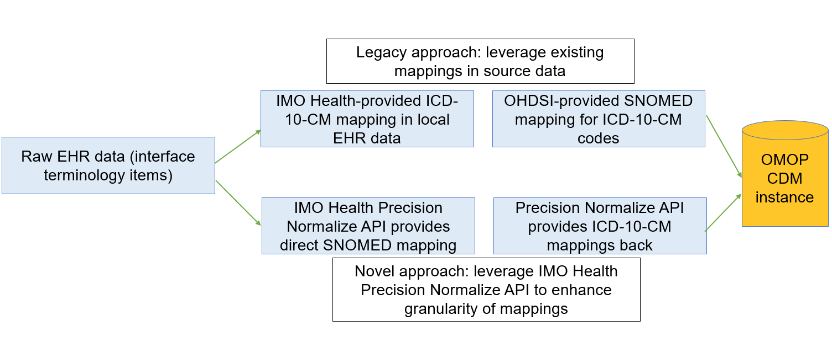
Figure 1. Alternate ETL techniques for modeling diagnosis data into the OMOP CDM

Results
Running our alternate version of the OHDSI ETL process against our synthetic data set of 163,078 terminology items then querying local EHR data revealed that the enhanced ETL technique generates additional patients for 4,473 unique ICD-10-CM codes. These ICD-10-CM codes were enhanced by an average of 587 additional patients within local EHR data. Table 1 details some of the ICD-10 codes particularly impacted by this technique.

Table 1. Five ICD-10 codes most impacted by alternate ETL method
ICD-10 code | Diagnosis name | Count of patients with legacy ETL method | Count of patients with enhanced ETL method
Z40.00 | Encounter for prophylactic removal of unspecified organ | 3 | 6336
H44.50 | Unspecified degenerated conditions of globe | 1 | 8519
Z00.71 | Encounter for examination for period of delayed growth in childhood with abnormal findings | 0 | 783
H44.9 | Unspecified disorder of globe | 0 | 6922
S76.001A | Unspecified injury of muscle, fascia and tendon of right hip, initial encounter | 1 | 162

Conclusion
These findings suggest that our alternate ETL technique affords the opportunity to significantly enhance the recall of computable phenotypes executed against the OHDSI CDM. As more observational studies rely on the use of the CDM to quantify patient exposure to adverse events, comorbidities, and others, it is critical to ensure that we are accurately representing the underlying EHR data as faithfully as possible. Employing the IMO terminology service as part of the OMOP ETL affords the opportunity to more faithfully represent clinical intent in large observational data sets. Future work will focus on replicating these findings entirely within our local EHR data by rerunning the entire OMOP ETL.
References
- Weiskopf NG, Weng C. Methods and dimensions of electronic health record data quality assessment: enabling reuse for clinical research. J Am Med Inform Assoc. 2013 Jan 1;20(1):144-51l.
- Reich C, Ostropolets A, Ryan P, Rijnbeek P, Schuemie M, Davydov A, Dymshyts D, Hripcsak G. OHDSI Standardized Vocabularies-a large-scale centralized reference ontology for international data harmonization. J Am Med Inform Assoc. 2024 Feb 16;31(3):583-590.
- Burrows EK, Razzaghi H, Utidjian L, Bailey LC. Standardizing Clinical Diagnoses: Evaluating Alternate Terminology Selection. AMIA Jt Summits Transl Sci Proc. 2020 May 30;2020:71-79.

