Onto-OMOP - An Automatic Pipeline for Generating Classification Level Terms and Relationships for OHDSI Vaccine Concepts Using the Vaccine Ontology
Jie Zheng, PhD¹, Alexander Davydov, MD², Anna Ostropolets, PhD³, Qi Yang, MD, PhD⁴, Yongqun He, PhD¹
¹University of Michigan Medical School, Ann Arbor, MI, USA; ²Thesaurus Health, New York, NY, US; ³Odysseus Data Services, Inc., Cambridge, MA, USA; ⁴IQVIA, Inc., Durham, NC, USA.
Background
The OHDSI OMOP Common Data Model (CDM)¹ is a well-known data model that standardizes clinical data from various sources to support robust and reliable analysis. The OHDSI community maintains the OMOP CDM through the OHDSI Standardized Vocabularies, which constitutes a curated repository of medical vocabularies, coding systems, and ontologies utilized across diverse countries, healthcare systems, and institutions. These vocabularies are harmonized to a global standard for observational research and consolidated into a common schema.¹ For each semantic meaning, one standard concept is chosen; equivalent concepts from different vocabularies are consolidated to this standard concept, while other concepts are considered as source concepts and linked to the standard one using ‘Maps to’ relationships. This vocabulary system serves as a cornerstone of OHDSI and is mandatory for use across all data sources in the network.
To further support semantic interoperability for large-scale observational research, it is important to integrate additional reference biomedical ontologies into the OHDSI Standardized Vocabularies. The Open Biological and Biomedical Ontology (OBO) Foundry² includes approximately 200 ontologies covering various biological and biomedical domains. One example is the Vaccine Ontology (VO)³, which represents various types of licensed vaccines, vaccines from clinical trials or research, vaccine ingredients, and vaccine responses. In our previous work,^{4,5} VO has incorporated vaccine-related concepts from RxNorm⁶ and RxNorm Extension (RxE),⁷ the two OMOP Standardized Vocabularies in the vaccine domain. Unlike RxNorm and RxE, VO provides many intermediate classification terms and their relationships, which support better classification of vaccine terms. However, it is a big challenge to automatically extract these intermediate classification terms and their relationships and to incorporate them into the OHDSI vocabulary system. Similar issues arise with other OBO ontologies, such as the Human Phenotype Ontology (HPO).⁸
In this work, we present the development of an Onto-OMOP pipeline designed to automatically generate ontology-based classification terms and their relationships from standard bottom-level OMOP vocabulary terms. To demonstrate its effectiveness, we applied the Onto-OMOP pipeline to the vaccine domain using the Vaccine Ontology (VO).
Methods
Figure 1 illustrates the Onto-OMOP pipeline applied to the VO. Initially, the VO was updated by adding classification terms to organize RxNorm and RxE concepts based on vaccine attributes, such as the diseases they target, the vaccine platform, and whether a vaccine is mono- or multivalent. These terms were particularly added when they did not already exist in the VO. The VO terms used to classify RxNorm or RxE concepts are represented using equivalent axioms when possible, allowing these concepts to be inferred under the various classification VO terms based on their logical axioms using reasoner ELK.⁹ The classification VO terms, which serve as direct parent for RxNorm and RxE vaccines, were then retrieved from VO using a SPARQL query. The results from this query were then converted into an input file for OntoFox,¹⁰ a web-based tool designed to extract ontology terms from existing ontologies. A subset of vaccine terms, including direct parents of RxNorm and RxE concepts along with their ancestor terms up to VO: ’vaccine’, is retrieved using the OntoFox tool. This subset of VO terms with the is-a relationships can be candidate vaccine terms and relationships for submission to the OHDSI as part of Standardized Vocabularies.

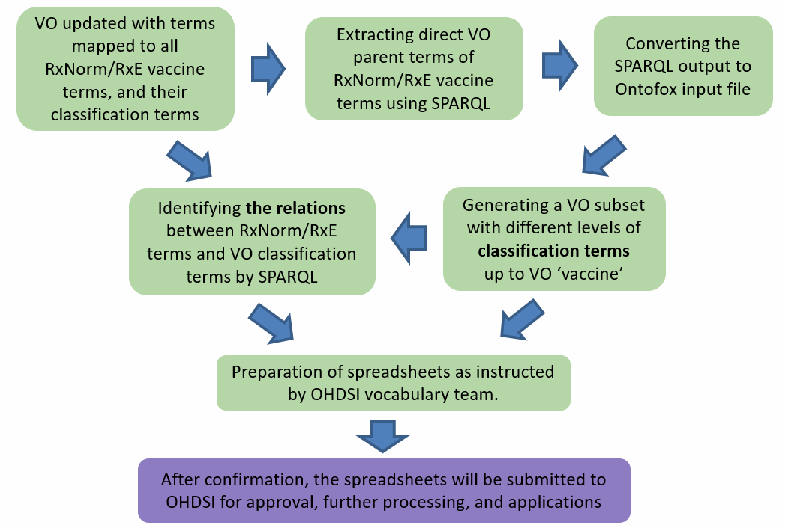
Figure 1. Illustration of automatic Onto-OMOP pipeline with the vaccine use case.

Results
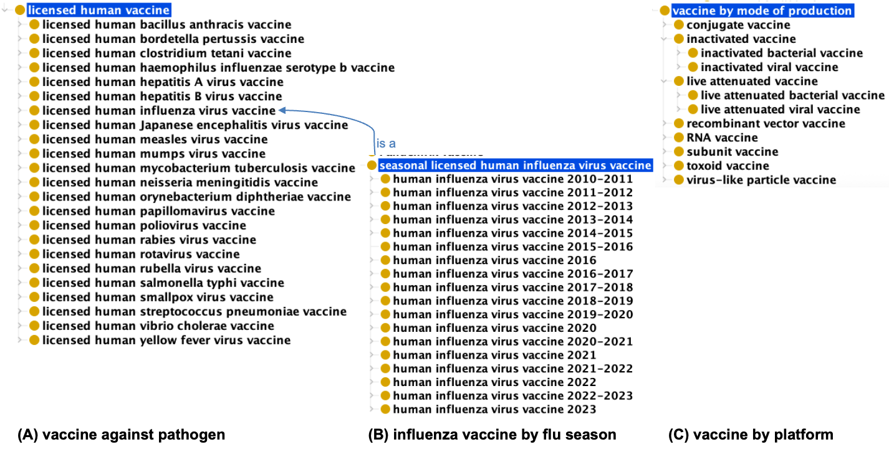
Figure 2. VO vaccines used for grouping RxNorm and RxE concepts (A) vaccines grouping by vaccine against pathogen; (B) influenza vaccines grouping by the flu season they are used for; (C) vaccines grouping by the methods they are produced.
During the integration of RxNorm and RxE vaccine concepts into VO, 251 new VO terms were added to better organize these concepts. By applying the Onto-OMOP pipeline, a total of 666 VO terms (including ‘vaccine’) were automatically retrieved. These terms are used to classify the RxNorm and RxE vaccine concepts. Figure 2 highlights the main classification terms in this VO subset.

The retrieved VO OMOP subset is available at: https://github.com/vaccineontology/VO/blob/master/OMOP_classification/OMOP_classification.owl. In addition, this information can be reformatted into specific spreadsheet formats and submitted to the OHDSI vocabulary team as indicated in their GitHub Community Contribution website: https://github.com/OHDSI/Vocabulary-v5.0/wiki/Community-contribution. Figure 3 illustrates examples of submissions using the OHDSI vocabulary submission template, which can be automatically populated using the Onto-OMOP pipeline. These submissions will include VO classification terms, along with their relationships to RxNorm and RxE concepts.
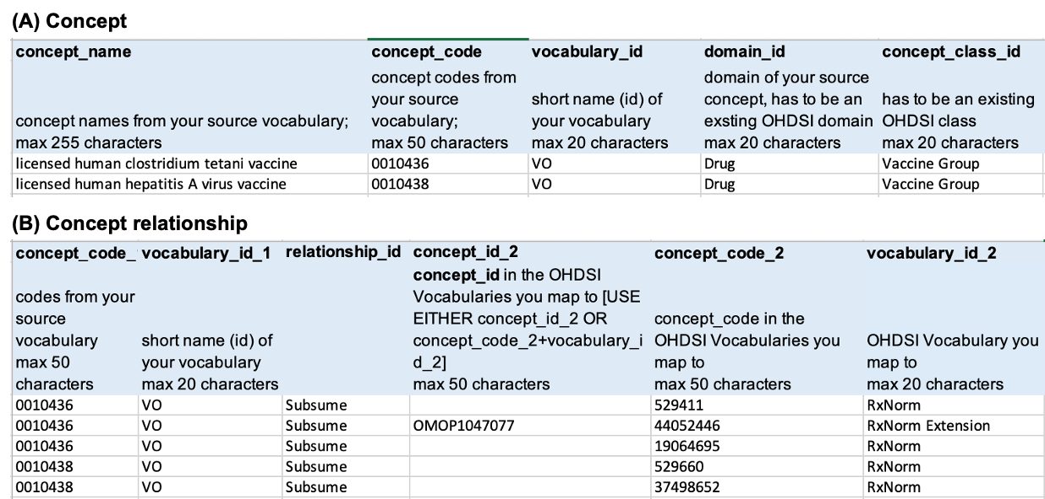
Figure 3. OHDSI vocabulary submission (A) Concept (B) Concept and relationships.

Conclusion and Discussion
We report on the development of an Onto-OMOP pipeline that automatically generates intermediate classification terms and their relationships in VO to categorize RxNorm and RxE vaccine concepts. A total of 666 VO terms are used for this categorization. These terms introduce new classifications, such as vaccines targeted at specific pathogens, vaccine platforms, and influenza vaccines used in particular flu seasons, which are not present in the OHDSI Vocabularies. Many applications can be developed once the VO set of classification terms and their relationships with the RxNorm and RxE vaccine terms is finalized and integrated into the OHDSI Vocabulary System. For example, our OHDSI presentation¹¹ last year demonstrated that the VO hierarchy systematically classified various COVID-19 vaccines, including mRNA vaccines (Pfizer/BioNTech and Moderna) and the recombinant viral vector vaccine (e.g., Janssen vaccine). The usage of such information was found to enhance the identification of COVID-19 vaccine cases from the national COVID cohort collaborative (N3C) EHR resource, which structures its data using OMOP¹¹. Furthermore, the new VO vaccine classification system can also be used to address specific vaccine-related questions, such as vaccine adverse event profiles between different vaccine types and under specific conditions. These new vaccines and their associated relationships enhance the exploration and analysis of vaccine information, making them strong candidates for inclusion in the OHDSI Vocabularies. We intend to collaborate with the OHDSI team to incorporate these VO classification terms and relationships into the OHDSI Standardized Vocabularies and then to the OHDSI ATLAS system, thereby enabling enhanced vaccine classification and concept queries in OHDSI ATLAS.
References
- Hripcsak G, Duke JD, Shah NH, Reich CG, Huser V, Schuemie MJ, et al. Observational Health Data Sciences and Informatics (OHDSI): Opportunities for observational researchers. Stud Health Technol Inform. 2015; 216:574–8.
- Smith B, The OBI Consortium, Ashburner M, Rosse C, Bard J, Bug W, et al. The OBO Foundry: coordinated evolution of ontologies to support biomedical data integration. Nat Biotechnol. 2007;25(11):1251–5. Available from: http://dx.doi.org/10.1038/nbt1346
- He Y, Chen F, Scheuermann R, Todd T, Brinkman R, Colby L, et al. VO: Vaccine Ontology. Derm Helv. 2009;1–1. Available from: https://www.nature.com/articles/npre.2009.3553.1
- Zheng J, Li X, Zhang X, Manuel W, Lin T, Liu L, et al. The 2024 OHDSI Global Symposium, Oct. 22-24, 2024, East Brunswick, New Jersey, USA.
- Pan Y, Manuel W, Abeysinghe R, Hao X, Davydov A, Yang Q, et al. Harmonization of OMOP vaccine-related vocabularies through the Vaccine Ontology. The 2023 OHDSI Global Symposium, Oct. 20-22, 2023, East Brunswick, New Jersey, USA.
- RxNorm. 2004; Available from: https://www.nlm.nih.gov/research/umls/rxnorm/index.html
- Observational health data sciences and informatics. Ohdsi.org. Available from: https://www.ohdsi.org/web/wiki/doku.php?id=documentation:international_drugs
- Gargano MA, Matentzoglu N, Coleman B, Addo-Lartey EB, Anagnostopoulos AV, Anderton J, et al. The Human Phenotype Ontology in 2024: phenotypes around the world. Nucleic Acids Res. 2024, 52(D1):D1333.
- Kazakov Y, Krötzsch M, Simancik F. ELK reasoner: architecture and evaluation. InORE 2012 Jul 1.
- Xiang Z, Courtot M, Brinkman RR, Ruttenberg A, He Y. OntoFox: web-based support for ontology reuse. BMC Research Notes. 2010, 3:175.
- Pan Y, Zheng J, He Y. Using Vaccine Ontology to Analyze and Integrate Vaccine Terms in N3C Dataset, The 2024 OHDSI Global Symposium, Oct. 22-24, 2024, East Brunswick, New Jersey, USA.

