Assessing Temporal Data Quality of Rheumatoid and Psoriatic Arthritis Patients in the All of Us Research Program
Matthew Spotnitz, MD, MPH¹, John Giannini, PhD¹, Emily Clark, MPH², Yechiam Ostchega, PhD, RN (retired)¹, Tamara R Litwin, PhD, MPH¹, Lewis Berman, PhD, MS (retired)¹

¹All of Us Research Program, Office of the Director, National Institutes of Health, Bethesda, Maryland, ²GAP Solutions, Inc., Herndon, Virginia

Background
Rheumatoid and Psoriatic Arthritis (RA and PsA) are autoimmune diseases that have overlapping clinical symptoms and can cause debilitating joint pain [1,2]. Previously, we described a data quality framework, which has been used to evaluate cohorts of All of Us participants who had a ductal carcinoma in situ (DCIS) diagnosis, a mastectomy procedure, and multiple surgical oncology procedures [3 - 5]. In this analysis, we used the same framework to evaluate the data quality of participants diagnosed with RA and PsA.
One of the data quality dimensions that we evaluated was temporality, which is a measure of whether the data followed an expected order. It is an essential component of data quality assessments and temporal relationships may be used in phenotyping complex medical conditions [6,7]. Despite being an essential component of data quality, standardized approaches to characterizing electronic health record (EHR) data are not well established. Here, we present the results from the temporality dimension analysis.
Methods
Cases were defined by the first occurrence of an ICD-9 or SNOMED CT diagnosis code for RA or PsA in adult All of Us Research Program participants, including retrospective diagnoses prior to the program enrollment date. We used ATHENA to guide concept selection and identify OMOP CDM codes for the phenotype and disease related variables. Participants with both diagnoses were excluded from further analysis.
Temporality was measured by calculating the median intervals in days between the following five clinical concept sets: 1) Nonsteroidal anti-inflammatory drugs (NSAIDs), 2) glucocorticoids, 3) rheumatoid factor, 4) any disease-modifying antirheumatic drug (DMARD), and 5) diagnosis. NSAIDs and glucocorticoids were selected because they are used for symptomatic management of both diseases. Rheumatoid factor is the most sensitive laboratory test, DMARDs disease specific therapy for both RA and PSA, and the diagnosis codes were the basis for our phenotypes.
To characterize the sequence of events, we plotted the chronology of the concept sets for the subsets of RA and PsA cohorts that had records on all five variables. We plotted the temporal sequences of those concept sets for the subset of participants who had data on all of them. The plots were generated using the Python graphviz library. No automated tools were used. The sequences of the three most common pathways varied and are shown in Figure 1. That characterization was used to evaluate whether the data followed an expected temporal pattern.
Results
There were 11,364 participants in the RA cohort and 2,457 in the PsA cohort. A total of 623 participants were in both cohorts and were excluded from further analysis. After exclusion, there were 10,741 participants in the RA cohort and 1,834 participants in the PsA cohort.
The proportion of the RA and PsA cohorts that had data for different timing between event calculations ranged from 13% to 85% and 16% to 81%, respectively. The interquartile ranges (IQRs) were 76.5-301.8 weeks and 79.7-359.7 weeks, respectively (Table 1).
Table 1: Counts and median intervals in days for Rheumatoid Arthritis and Psoriatic Arthritis Cohorts in different temporal analyses. Rheumatoid factor = RF; conventional synthetic disease-modifying antirheumatic drug = csDMARD; disease-modifying antirheumatic drug = DMARD; nonsteroidal anti-inflammatory drug = NSAID; interquartile range = IQR. Data source = The All of Us Research Program
Analysis | Rheumatoid Arthritis  No. (%) | Median (IQR)  (In Days) | Psoriatic Arthritis  No. (%) | Median (IQR)  (In Days)
RF to Diagnosis | 4638 (43.1) | 19.4 (779.8) | 585 (31.9) | 62.3 (929.6)
Diagnosis to csDMARD | 4856 (45.2) | 0 (535.5) | 705 (38.4) | 0 (557.9)
Diagnosis to NSAID | 8714 (81.1) | -279.3 (2094.4) | 1394 (76.0) | -588 (-2417.1)
Diagnosis to Glucocorticoids | 9123 (84.9) | -117.6 (1852.2) | 1491 (81.3) | -560 (-2198)
RF to csDMARD | 2780 (25.9) | 46.9 (593.6) | 314 (17.1) | 126 (827.4)
RF to Biologic DMARD | 1415 (13.2) | 461.3 (1682.1) | 296 (16.1) | 304.5 (1260.7)
RF to NSAID | 4042 (37.6) | -492.4 (2112.6) | 497 (27.1) | -685.3 (2517.9)
RF to Glucocorticoids | 4126 (38.4) | -212.5 (1871.8) | 509 (27.8) | -851.9 (2377.9)

There were 2,672 (23.5%) RA and 354 (14.4%) PsA participants who had data on all five of the clinical concept sets. We observed more than one pathway for each cohort (Figure 1). The time interval between each consecutive concept set varied from 2 days to 1,223 days. Furthermore, the intervals between DMARD therapy and disease diagnosis tended to be the shortest (2-332 days and 8-305 days for RA and PsA, respectively) and the intervals between NSAIDs are rheumatoid factor were the longest (1,007 days and 1,422 days for RA and PsA, respectively). However, there were some consistent findings across pathways and cohorts.

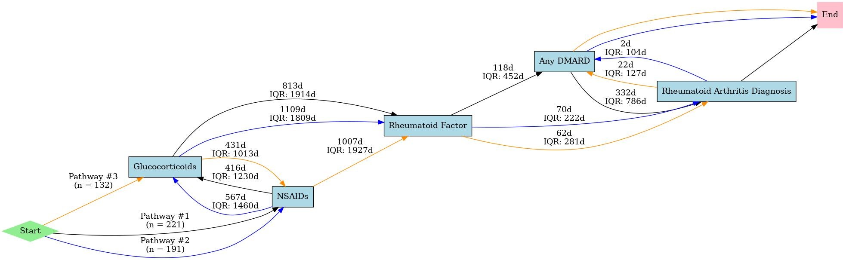
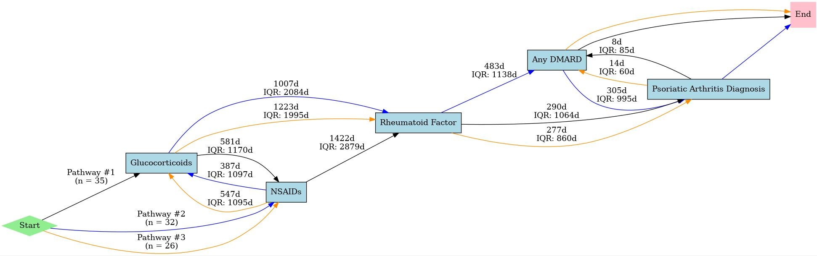

Figure 1: Timeline analysis in days of subsets of Rheumatoid (top) and Psoriatic (bottom) Arthritis cohorts with representative concept sets. For subset cohorts where participants have all relevant concept sets, these timelines show the most common orderings and median temporal separation between elements. Interquartile range = IQR; count = n; days = d; disease-modifying antirheumatic drug = DMARD; nonsteroidal anti-inflammatory drugs = NSAIDs.

Conclusion
We have shown successful implementation of our data quality dimensions analysis to evaluate temporality of RA and PsA cohorts. For the subgroup of participants in the cohorts with all five clinical concept sets, the general chronological progression was from symptomatic management to laboratory tests to DMARD therapy or diagnosis. Those data suggest that there is a tendency among providers to try empirical treatment, order a diagnostic workup, treat with disease-specific medications, and then commit to a diagnosis. Therefore, the diagnosis and disease-specific treatment of RA and PsA lagged behind symptoms. Furthermore, we observed that the lag between symptomatic treatment and diagnosis was 4 to 5 years in the RA subgroups and 6 years in the PsA subgroups. Our methods can be used to compare the temporality of cohorts from different data sources, including gold standard data sources. Those comparisons can be used to gauge whether databases can be harmonized or have temporal data of sufficient quality. Our analysis was limited by the amount of data available and manual concept selection. Also, it is unclear if alternative phenotype definitions would have yielded different results. Overall, our findings may have implications for whether RA and PsA diagnosis codes are fit for use as temporal anchors.

References
[1] Ritchlin CT, Colbert RA, and Gladman DG. Psoriatic Arthritis. N Engl J Med 2017;376:957-70. doi:10.1056/NEJMra1505557.
[2] Matteo AD, Bathon JM, and Emery P. Rheumatoid Arthritis. Lancet 2023; 402: 2019–33. https://doi.org/10.1016/
[3] Berman L, Ostchega Y, Giannini J, et. al. Application of a Data Quality Framework to Ductal Carcinoma in Situ Using Electronic Health Record Data from the All of Us Research Program. JCO Clinical Cancer Informatics. 2024;8:e2400052. doi: 10.1200/CCI.24.00052.
[4] Spotnitz M, Giannini J, Ostchega Y, et. al. Assessing the Data Quality Dimensions of Partial and Complete Mastectomy Cohorts in the All of Us Research Program: Cross-Sectional Study. JMIR Cancer 2025;11:e59298. doi: 10.2196/59298. PMID: 40068169.
[5] Spotnitz M, Giannini J, Clark E et. al. Assessing the Data Quality Dimensions of Surgical Oncology Cohorts in the All of Us Research Program. JCO Clinical Cancer Informatics. (2025) 9:e2500078. https://doi.org/10.1200/CCI-25-000.
[6] Kahn MG, Callahan TJ, Barnard J, et al. A Harmonized Data Quality Assessment Terminology and Framework for the Secondary Use of Electronic Health Record Data. EGEMS (Wash DC) 2016;4(1):1244. Published 2016 September 11. PMID: 27713905.
[7] Albers DJ, Elhadad N, Tabak E, Perotte A, Hripcsak G (2014) Dynamical Phenotyping: Using Temporal Analysis of Clinically Collected Physiologic Data to Stratify Populations. PLoS ONE 9(6): e96443. doi:10.1371/journal.pone.0096443.

