AgentDose: Toward Accurate and Scalable Steroid Dose Extraction in OMOP Using NLP Parsers and LLM Agents
Christelle Xiong¹, Benjamin Martin¹, Erik Westlund², Will Kelly³, Christopher Mecoli^{1,3}
1 – Department of Biomedical Informatics and Data Science, School of Medicine, Johns Hopkins University, Baltimore, MD, USA; 2 - Department of Biostatistics, Bloomberg School of Public Health, Johns Hopkins University, Baltimore, MD, USA; 3 - Department of Medicine, Division of Rheumatology, Johns Hopkins University, Baltimore, MD, USA

Background
Accurate derivation of daily steroid dose is essential for real-world evidence studies, particularly for understanding dose–response relationships, adverse effects, and treatment patterns across large patient populations. However, existing OMOP CDM workflows often rely on structured fields such as DRUG_STRENGTH and DRUGC_EXPOSURE, which may be incomplete or inconsistent. Previous study proposed a standardized framework to compute daily doses in OMOP CDM across multiple drug classes, demonstrating reliable and reproducible results by calculating median dose estimates aligned with WHO Defined Daily Dose (DDD) metrics¹. Yet, their approach does not sufficiently handle complexities inherent to corticosteroids, such as multi-unit dosing, free-text prescription instructions, and prednisone equivalent-conversions. In addition, the dose calculation is primarily ingredient-based rather than patient-specific, which introduces significant challenges for drug safety research.
Traditional NLP tools (e.g., MedEx², cTAKES³) have been applied to parse prescription instructions (“sig”) to extract dose and frequency information, but they often require manual rule creation and can miss nuanced expressions in real-world EHR data⁴⁻⁶. Recently, large language model (LLM) has shown promise in generalizing across heterogeneous clinical text, supporting task automation via prompt engineering and chain-of-thought reasoning^{7,8}. However, their performance for structured medication data within OMOP CDM has not yet been evaluated.
In this report, we propose AgentDose, a modular framework of processing algorithms that extend existing OMOP CDM-based methodologies by integrating structured data with advanced processing of unstructured prescription information. We defined three complementary approaches for corticosteroid daily dose computation: a structured-only baseline method, a rule-based NLP parser method, and a LLM agent-based method. To support systematic comparison, we also introduce two evaluation strategies, e.g., manual evaluation and LLM agent-assisted validation. As a result, we aimed to establish a scalable, accurate, and reproducible foundation for real-world dose extraction for downstream tasks across the OHDSI community.
Methods
We designed a modular framework of processing steps for corticosteroid median daily dose calculation and validation using OMOP CDM. The median durations were set up as 30-day. The pipeline comprises two main components: (1) three methods for calculating daily dose based on structured and unstructured medication information; and (2) evaluations to assess dose extraction performance.
Daily Dose Computation
The dose calculation process begins with the myositis patient cohort defined in the OMOP projection database. Structured data are extracted from DRUG_STRENGTH and DRUG_EXPOSURE tables, including dose values and units. Unstructured instructions from the sig field are retrieved when applicable.
- Method 1 (Baseline): Used only structured fields (e.g., quantity, amount value) without parsing sig text. It applies deterministic calculations aligned with prior work by previous study¹.
- Method 2 (NLP Parser): Augmented the baseline by applying rule-based NLP tools extract dose, frequency, and route from the sig field and merge them with structured inputs. The extracted unstructured information is merged with structured inputs to enhance dose calculation.
- Method 3 (LLM Agent): Implemented an automated pipeline using an LLM-agent system to parse both structured and unstructured data, infer missing elements, and compute daily dose. We chose Claude Opus 4 as the LLM model example.
All three methods output patient-level daily dose trajectories to be compared against a reference gold standard (i.e., Johns Hopkins Myositis registry data). The study was approved by the Johns Hopkins School of Medicine Institutional Review Board.
Evaluation Methods
To assess the validity of our dose calculation approaches, we evaluated performance at the patient-episode level by comparing calculated median daily doses with gold standard values. For each episode, the absolute and signed differences were computed, and summary statistics were derived. Specifically, we report the total number of episodes, the number with overlapping EHR dose information, and the resulting medication episodes percentage. Accuracy was quantified using the mean absolute error (MAE), while systematic bias was assessed using the mean bias error (MBE).
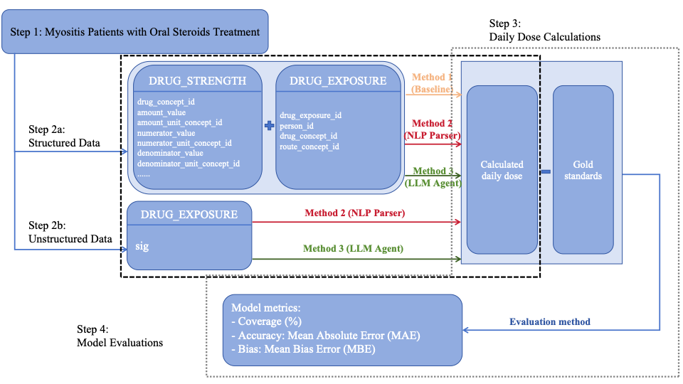
Figure 1. Framework for steroid daily dose calculation and model evaluations. This diagram illustrates the AgentDose framework for steroid median daily dose computation and evaluation. Three computation methods are applied to structured and unstructured medication data: a structured-only baseline method, a rule-based NLP parser method, and an end-to-end LLM agent-based method. sig, prescription instructions in free-text format; NLP, natural language processing; LLM, large language model.
Results
The daily oral steroid dose for myositis patients typically falls within the range of 0–80 mg prednisone-equivalent per day, depending on disease activity and treatment phase. All dose values in this study, such as for methylprednisolone and dexamethasone, were standardized to prednisone-equivalents during the calculation process to ensure comparability across medications.
In the baseline approach relying solely on structured fields, scope of overlapping episodes was limited, with only 3 of 4 episodes (75%) aligning with reference data. Accuracy was also suboptimal, with MAE of 23.5 and MBE of 21.8. These results were mainly driven by missing data, with 62.7% of entries absent in amount_value and 97.9% missing in quantity. Such gaps made it difficult to establish reliable dose information from structured fields alone.
By incorporating a rule-based NLP parser to extract dosing information from unstructured fields, performance improved substantially. Overlap increased to 96 of 115 episodes (83.5%), and the MAE was reduced to 12.6. Bias was also markedly attenuated, with an MBE of 7.6. Combining structured and unstructured data improved both accuracy and consistency in dose calculation. However, variations in how providers record sigs—differences in wording, abbreviations, and formatting—introduced noise. The rule-based parser reduced some of this variation but could not fully harmonize provider-specific styles.
With the LLM agent, dosing information was extracted from all available fields using a prompt-driven approach. Usable and computable medication episodes expanded markedly, with 478 of 687 episodes (69.6%) overlapping with reference data. Although the overlap percentage was lower than that achieved with the NLP parser, the absolute number of evaluable episodes was substantially larger. Accuracy was also improved, with MAE reduced to 5.2, and bias further attenuated, with MBE of 2.15. These findings indicate that the LLM agent not only scales medication episodes to a broader patient population but also enhances precision and reduces systematic error in dose calculation.
Table 1. Comparison of Three Daily Dose Computation Methods
Dimension | Method 1: Baseline | Method 2: NLP Parser | Method 3: LLM Agent
sig parsing | No | Yes (rule-based) | Yes (prompt-driven)
Dose derivation source | Structured fields | Structured fields + Unstructured fields | All fields
Usable and computable medication episodes | 3 out of 4 (75%) | 96 out of 115 (83.5%) | 478 out of 687 (69.6%)
MAE | 23.5 | 12.6 | 5.2
MBE | 21.8 | 7.6 | 2.15
sig, prescription instructions in free-text format; NLP, natural language processing; LLM, large language model; MAE, mean absolute error; MBE, mean bias error.
Future Directions
In future manuscripts, we will expand the framework beyond oral steroids to include other immunosuppressants administered via different routes. We also plan to investigate in more detail the sources of bias observed when comparing against gold-standard values, aiming to clarify whether discrepancies stem from documentation practices, coding artifacts, or true clinical variation. Summarized patterns of prescribing instructions will be reported to highlight provider-level differences and their impact on dose calculation. In addition, broader validation across diverse patient cohorts and care settings will be performed to strengthen generalizability. These steps will extend the utility of AgentDose and provide deeper insights into medication use in real-world data.
Conclusion
We present AgentDose, a modular framework for steroid daily dose computation from OMOP CDM, integrating structured data, rule-based NLP, and LLM agent. By comparing three complementary methods, this work enables scalable and accurate dose extraction for real-world evidence generation. Improved dose accuracy has direct implications for safety monitoring, treatment optimization, and risk stratification in clinical and pharmacoepidemiologic research.

References

1. Burkard T, Lopez-Guell K, Gorbachev A, et al. Calculating daily dose in the Observational Medical Outcomes Partnership Common Data Model. Pharmacoepidemiol Drug Saf. 2024;33(6):e5809.
2. Xu H, Stenner SP, Doan S, Johnson KB, Waitman LR, Denny JC. MedEx: a medication information extraction system for clinical narratives. J Am Med Inform Assoc. 2010;17(1):19-24.
3. Savova GK, Masanz JJ, Ogren PV, et al. Mayo clinical Text Analysis and Knowledge Extraction System (cTAKES): architecture, component evaluation and applications. J Am Med Inform Assoc. 2010;17(5):507-513.
4. Harris DR, Henderson DW, Corbeau A. sig2db: a Workflow for Processing Natural Language from Prescription Instructions for Clinical Data Warehouses. AMIA Jt Summits Transl Sci Proc. 2020;2020:221-230.
5. Goud A, Kiefer E, Keller MS, Truong L, SooHoo S, Riggs RV. Calculating maximum morphine equivalent daily dose from prescription directions for use in the electronic health record: a case report. JAMIA Open. 2019;2(3):296-300.
6. Lu CC, Leng J, Cannon GW, et al. The use of natural language processing on narrative medication schedules to compute average weekly dose. Pharmacoepidemiol Drug Saf. 2016;25(12):1414-1424.
7. Bhagat N, Mackey O, Wilcox A. Large Language Models for Efficient Medical Information Extraction. AMIA Jt Summits Transl Sci Proc. 2024;2024:509-514.
8. Wiest IC, Wolf F, Lessmann ME, et al. LLM-AIx: An open source pipeline for Information Extraction from unstructured medical text based on privacy preserving Large Language Models. medRxiv. 2024.

