A Framework for Understanding Bias and Real-World Clinical Electronic Health Record Data
Haeun Lee¹, MS, Harold Lehmann¹, MD, PhD, Benjamin Martin¹, PhD, Paul Nagy¹, PhD

1. Biomedical Informatics and Data Science, Johns Hopkins University School of Medicine, Baltimore, Maryland, USA

Background
Real-world evidence (RWE) based on electronic health records (EHRs) plays a crucial role in healthcare decision-making support, offering advantages in speed, cost efficiency, and inclusivity of diverse populations compared to traditional randomized clinical trials [1-3]. Particularly, the development of federated health data networks such as the Observational Health Data Sciences and Informatics (OHDSI) has expanded inter-institutional collaboration by enabling large-scale RWE analysis through standardized data models (OMOP Common Data Model), harmonized analytical methods and open-source tools, and has been facilitating unprecedented global collaboration in evidence generation across diverse healthcare systems and populations [4]. However, transforming raw real-world data (RWD) into reliable evidence is fraught with various biases that can compromise the reliability and generalizability of real-world evidence. These biases have many causes, yet they remain insufficiently addressed in existing studies. This study systematically identifies and categorizes the sources of biases that emerge throughout the entire evidence generation process, from data collection to analysis and interpretation, highlighting critical blind spots in observational study designs. Furthermore, we present a conceptual framework that enables the exploration of multi-layered impacts of biases on federated healthcare data research and RWE studies using RWD.

Methods
The scoping review followed the Preferred Reporting Items for Systematic Reviews and Meta-Analyses Extension for Scoping Reviews (PRISMA-ScR) framework to examine bias in the secondary use of RWD, with a primary focus on EHRs following the 21st Century Curse Acy of 2016. We searched PubMed and Web of Science for literature published between January 2016 and January 2025, limited to English-language publications with full text or open access availability. The initial search strategy included combinations of “electronic health records” AND “bias” alongside related concepts in clinical contexts, including "healthcare," "clinical," "data," "patient," "coding," "extraction," "terminology," and "phenotype." We expanded our search to additionally capture biases during information modeling and ETL (extract, transform, load) processes using keywords such as CDM, ETL, transformation and mapping. Based on the structured literature review, synthesis of established RWE generation pathways, and iterative review by a multidisciplinary expert panel of clinicians, informaticians, and biostatisticians, we developed a seven-level bias model that maps potential bias sources and their relationships to established bias types in observational research.
Results
The search strategy yielded 495 papers, of which 280 were rejected by exclusion criteria, resulting in 215 papers for analysis. From these papers, 209 distinct sources of bias were identified and subsequently mapped into a framework consisting of three major levels: Healthcare, Data Management, and Research, further subdivided into seven specific levels. At the Healthcare level, 40 bias sources (19.1%) were identified in Level 1 (Access to Medical Care) spanning demographics, lifestyle, geographic factors, socioeconomic status, clinical characteristics, and healthcare-seeking behaviors; and 29 bias sources (13.9%) in Level 2 (Provision of Care) including provider factors, geographic variation, level of care disparities, institutional characteristics, care delivery processes, encounter types, and insurance reimbursement policies; and 39 bias sources (18.7%) in Level 3 (Data Acquisition & Measurement) related to laboratory testing, operator variations, testing protocols, medical imaging, and measurement practices. At the Data Management level, 32 bias sources (15.3%) were cataloged in Level 4 (Clinical Documentation Coding Practice) concerning variations in clinical terminologies, coding heterogeneity, clinical note inconsistencies, EHR system variations, coding granularity, and documentation practices; and 22 bias sources (10.5%) in Level 5 (Data Extraction) encompassing data source variations, data quality and preprocessing challenges, data refreshes and timeliness, and format inconsistencies. Finally, at the Research level, 11 bias sources (5.3%) were identified in Level 6 (Data Model) concerning terminology standards, data transformation, and governance; and 36 bias sources (17.2%) in Level 7 (Data Analytics) related to cohort definition, data exploration and preparation, computable phenotype development, algorithm modeling, and result evaluation.

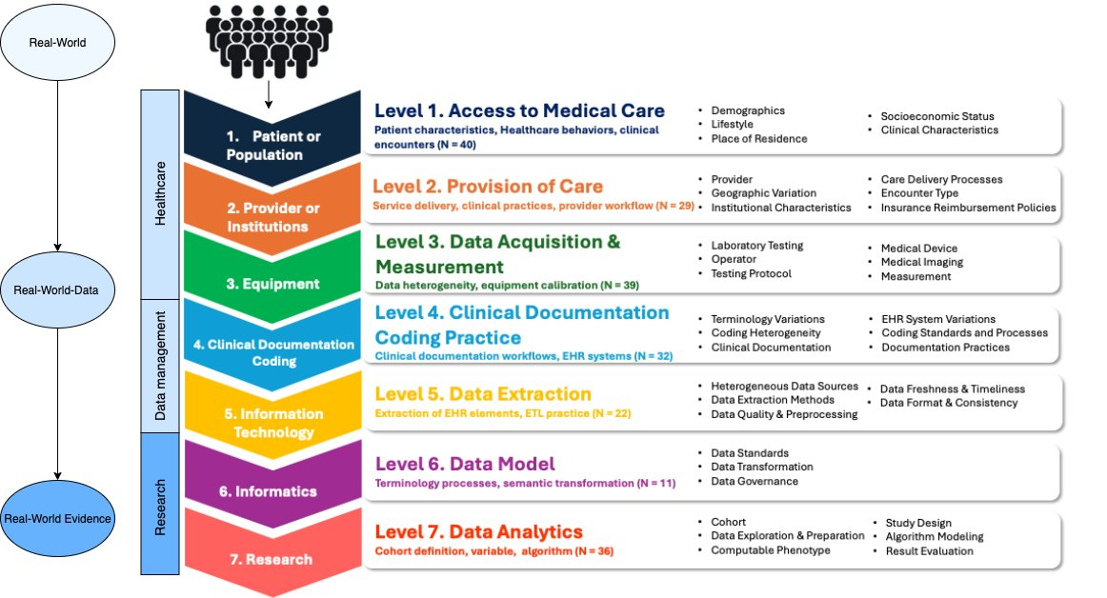
Figure 1. Hierarchical Framework of Bias Sources in the Real-World Evidence Pipeline

Conclusions

This study developed a multi-level framework across healthcare, data management, and research levels to identify and categorize 209 sources of bias in clinical evidence generation. The biases demonstrated interconnected properties that transcend traditional boundaries and amplify across multiple levels, with EHRs primarily reflecting healthcare service delivery behaviors rather than patient health status. This framework can serve as a trigger to help methodologists make sure they have considered important sources of bias. Even further, biases operating at the same "level" may have similar mathematics for correction, and therefore similar micro-models to incorporate into statistical analysis. Further work is needed to quantify bias magnitude by measuring differentials between actual and ideal data, and create predictive debiasing models for observational studies using real-world healthcare data.

References
- Sherman RE, Anderson SA, Dal Pan GJ, Gray GW, Gross T, Hunter NL, et al. Real-world evidence — what is it and what can it tell us? N Engl J Med. 2016 Dec 8;375(23):2293–7. doi:10.1056/nejmsb1609216
- U.S. Food and Drug Administration [Internet]. [cited 2025 Mar 24]. Available from: https://www.fda.gov/media/120060/download
- Klonoff DC. The expanding role of real-world evidence trials in health care decision making. J Diabetes Sci Technol. 2020;14(1):174-179. Available from: https://pmc.ncbi.nlm.nih.gov/articles/PMC7189159/
- Li C, Alsheikh AM, Robinson KA, Lehmann HP. Use of recommended real-world methods for electronic health record data analysis has not improved over 10 years. medRxiv [Preprint]. 2023 Jun 22. Available from: https://www.medrxiv.org/content/10.1101/2023.06.21.23291706v1

