Integrative Causal Machine Learning with Digital Twins: Calibration of Treatment Effects via Negative Control Outcomes
Yuqing Lei^{1,2}, Dazheng Zhang^{1,2}, Huiyuan Wang^{1,2}, Yiwen Lu^{1,3}, Yong Chen¹⁻³
¹ The Center for Health AI and Synthesis of Evidence (CHASE), University of Pennsylvania, Philadelphia, PA, USA
² Department of Biostatistics, Epidemiology, and Informatics, Perelman School of Medicine, University of Pennsylvania, Philadelphia, PA, USA
³ Applied Mathematics and Computational Science, School of Arts and Sciences, University of Pennsylvania, Philadelphia, PA, USA

Background
Real-world evidence studies must balance internal validity—often achieved in randomized trials with high-quality measurements—and external generalizability to broader clinical populations. Traditional transportability methods assume no unmeasured confounding and thus perform poorly when residual biases remain.¹ Negative control outcomes (NCOs)—variables unaffected by treatment but subject to the same confounding pathways—have been leveraged to detect and adjust for unmeasured bias within single datasets.^{2,3} However, existing NCO-based approaches offer limited guidance on transferring bias adjustment from a richly characterized source cohort to a target population lacking both primary outcomes and suitable NCOs. Here, we present a novel integration of causal machine learning with digital twin counterfactuals that generalizes NCO calibration across heterogeneous data sources.

Methods
Our framework addresses a fundamental challenge in real-world evidence generation: estimating causal effects when high-quality source data (D=1) contain complete outcome measurements but limited generalizability, while representative target data (D=1) lack essential outcome information. As illustrated in Figure 1a, our approach first trains machine learning models on the source dataset to learn relationships between covariates X and outcomes Y(a), then generates primary outcome digital twins for the target population. Critically, we simultaneously generate NCO digital twins for the same target individuals using J negative control outcomes W_j learned from the source data. These NCO digital twins capture systematic bias, which we then use to calibrate the primary outcome digital twin predictions.
The complementary nature of our data sources is depicted in Figure 1b. Source datasets typically provide comprehensive outcome measurements and extensive NCO information but may suffer from selection bias or limited external validity—characteristics common in clinical trials with strict inclusion criteria. Conversely, target datasets better reflect real-world populations but often lack structured outcome data, as frequently observed in electronic health records where specialized measurements (e.g., imaging-derived biomarkers) are unavailable.
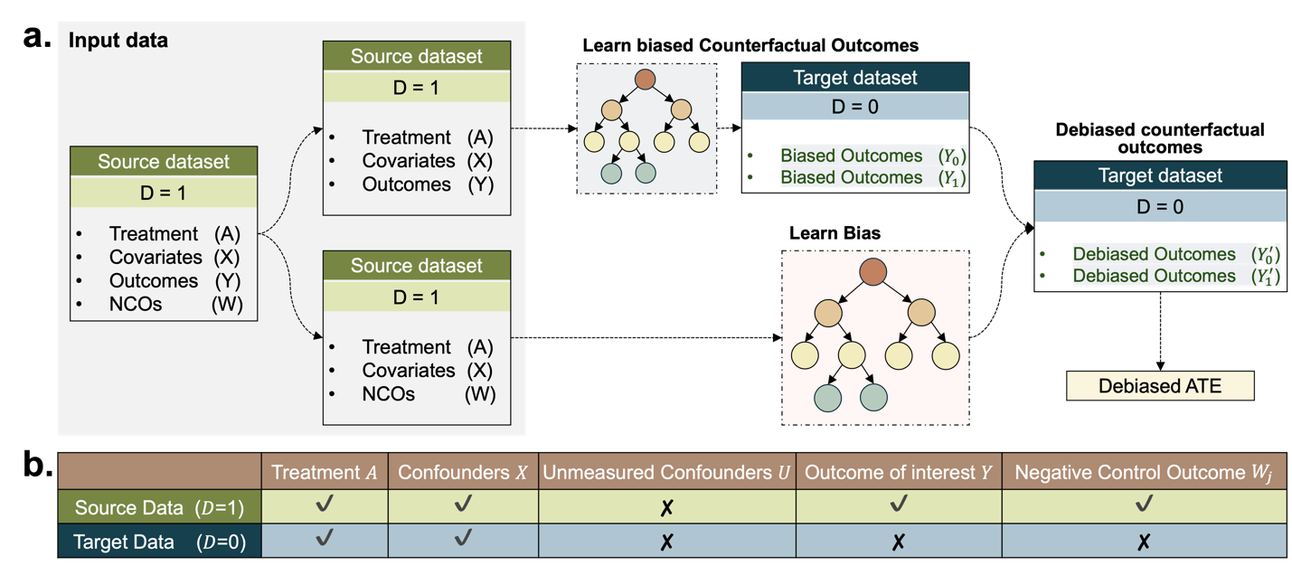
Figure 1. Framework Overview and Data Structure
(a) Schematic workflow for generating debiased digital twin outcomes and estimating calibrated treatment effects. (b) Complementary characteristics of source versus target datasets

Results
We evaluated our debiased digital twin framework through 3 complementary analyses: 1) controlled simulations with known ground truth; 2) a validation study using multi-site EHR data with masked outcomes; and 3) a real-world application combining SPRINT-MIND trial data with Penn Medicine EHR records.
Simulations: The direct NCO calibration in target data and source-trained digital twin calibration when outcomes are masked—our method recovers the true ATE with minimal bias, outperforming unadjusted estimates.
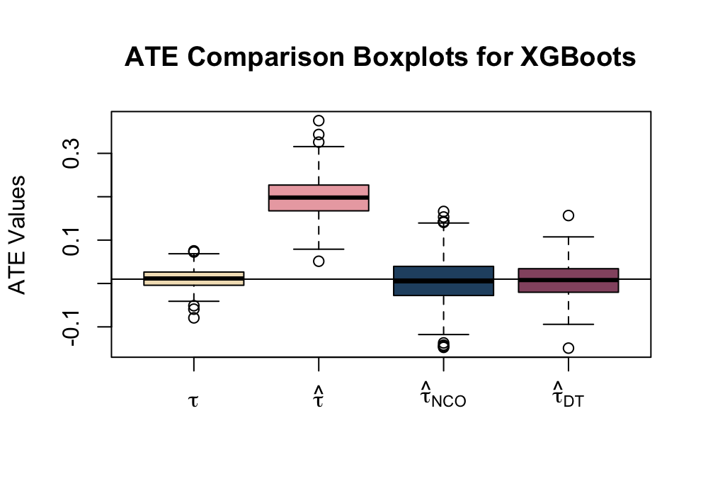
Figure 2. ATE Comparison Boxplots for Simulated Data.
Boxplots comparing ATE estimates across 500 simulation replicates using XGBoost. $τ$: true ATE from counterfactual outcomes; $\hat{τ}$: naïve ATE from uncorrected primary outcome digital twins; ${\hat{τ}}_{NCO}$: oracle estimates using true NCOs at target data; ${\hat{τ}}_{DT}$: debiased ATE by using digital twin framework with NCO digital twins. Error bars represent interquartile ranges.
Multi-sites EHR Validation: When outcomes and NCOs are masked in a Penn EHR subset, debiased digital twin ATEs align closely with gold-standard estimates from unmasked data.
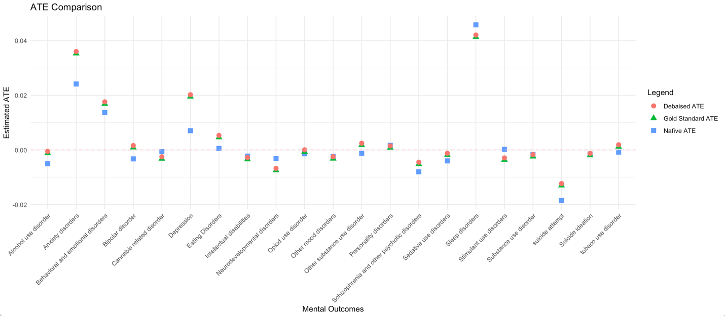
Figure 3. Dot Plot of the Estimated ATE for GLP1-RA Treatment on Mental Health Outcomes.
Comparison of ATE estimates for GLP1-RA treatment effects on mental health outcomes. Each point represents a different condition, with gold-standard ATE (complete data), naïve ATE, and debiased ATE shown. The strong correlation between debiased and gold-standard estimates demonstrates successful recovery of treatment effects despite masked outcomes in the target population through NCO digital twin-based bias correction.
Real-world Application from SPRINT-MIND to Penn EHR: Training on SPRINT-MIND imaging outcomes and calibrating on Penn EHR, our calibrated digital twins recover a modest protective effect of intensive blood pressure control on mental health–related outcomes, consistent with original trial findings.
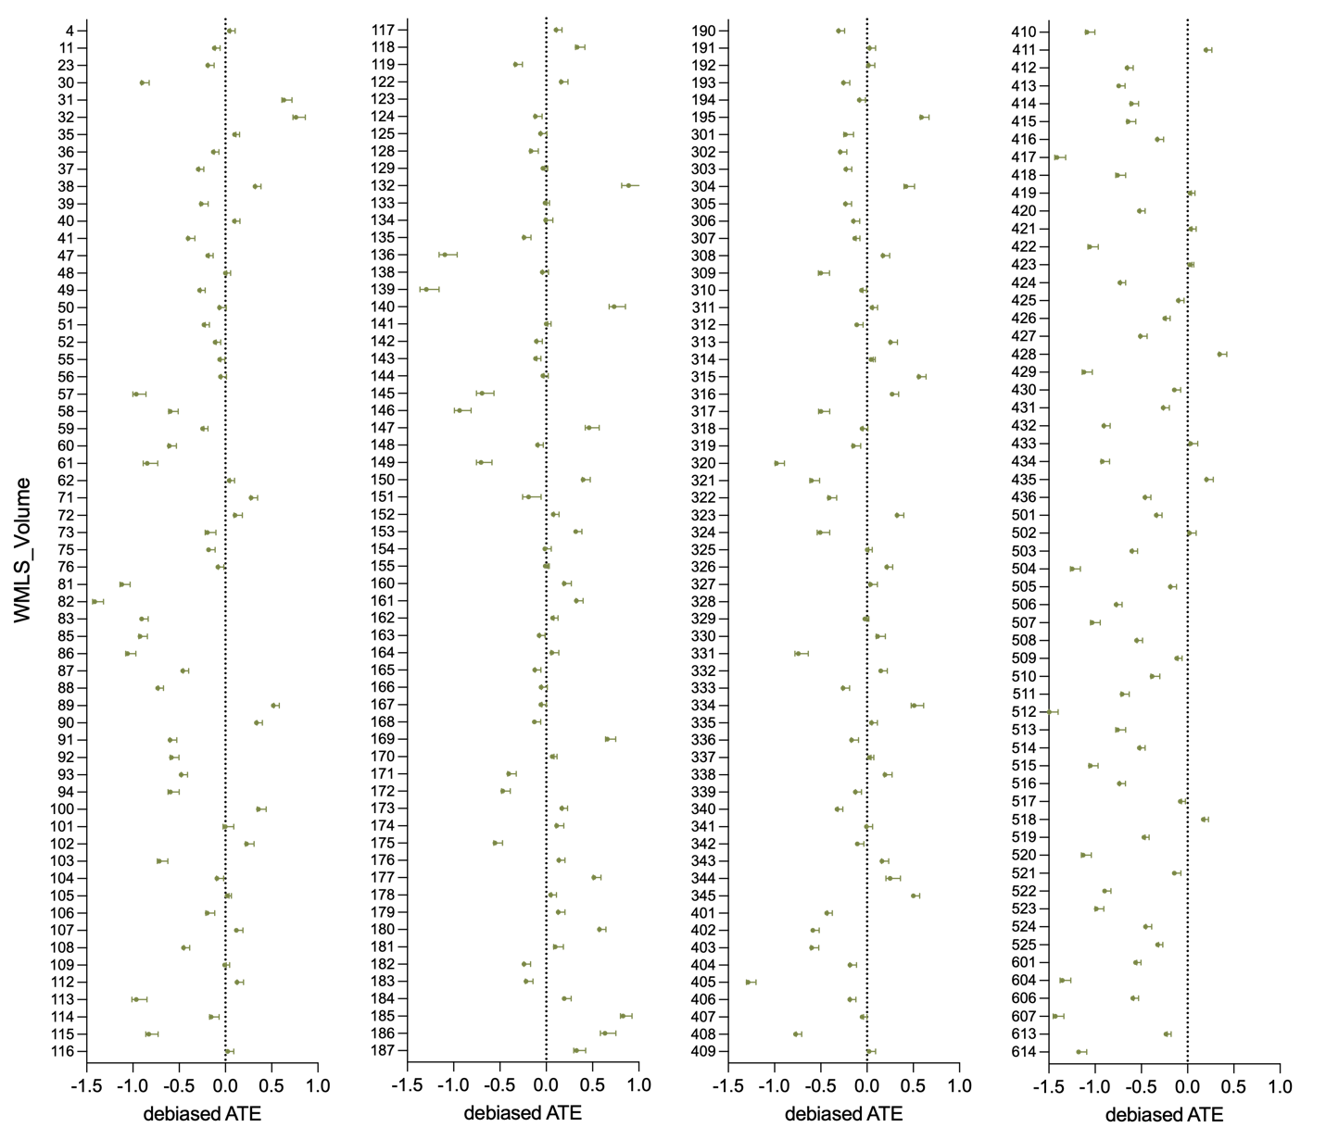
Figure 4. Forest Plot of Debiased ATEs Generalizing SPRINT-MIND to Penn EHR.
Forest plot showing debiased ATE estimates for intensive versus standard blood pressure control on white matter lesion (WML) Volume outcomes in the Penn EHR population. Each point represents the estimated treatment effect with 95% confidence intervals. Negative values indicate protective effects of intensive treatment.
Conclusion
Our debiased digital twin framework leverages NCO calibration and machine learning to estimate treatment effects in target populations lacking key measurements. By uniting high-quality trial or curated cohorts with representative but incomplete real-world data, this approach enhances both validity and generalizability of causal estimates. We invite the OHDSI community to explore digital twin counterfactuals as a scalable strategy for bias correction in federated and heterogeneous observational settings.

References
- Cole, S. R., & Stuart, E. A. (2010). Generalizing evidence from randomized clinical trials to target populations: the ACTG 320 trial. American journal of epidemiology, 172(1), 107-115.
- Miao, W., Geng, Z., & Tchetgen Tchetgen, E. J. (2018). Identifying causal effects with proxy variables of an unmeasured confounder. Biometrika, 105(4), 987-993.
- Schuemie, M. J., Ryan, P. B., DuMouchel, W., Suchard, M. A., & Madigan, D. (2014). Interpreting observational studies: why empirical calibration is needed to correct p‐values. Statistics in medicine, 33(2), 209-218.

