Standardized Imaging Phenotyping and AI Validation for Tuberculosis
Using Medical Imaging Extension for OMOP CDM and ATLAS
< Kyulee Jeon^{1,2*}>, <Minseong Kim^{3*}>, <Soon Ho Yoon⁴>, <Seng Chan You^{1,2†}>
¹Department of Biomedical Systems Informatics, Yonsei University College of Medicine, Seoul, Republic of Korea ²Institute for Innovation in Digital Healthcare, Yonsei University, Seoul, Republic of Korea ³Department of Material Sciences and Engineering, Yonsei University College of Engineering, Seoul, Republic of Korea ⁴Department of Radiology, Seoul National University College of Medicine, Seoul, Republic of Korea
Background
Although AI models for medical imaging have shown high performance in lab environments, their performance often fails to reproduce in real-world clinical settings. A key reason for this gap is the difference in data representation between development and deployment settings, due to variability in patient characteristics and imaging acquisition protocols. Parameters such as tube voltage (kVp), view position, and scanner settings directly influence image characteristics, yet these acquisition details are typically absent from structured electronic health records (EHR) data.
The Digital Imaging and Communications in Medicine (DICOM) standard captures these protocol-level attributes as metadata. However, DICOM metadata are often inconsistently formatted, lack semantic standardization, and remain disconnected from clinical data, making them difficult to use for cohort definition or AI model validation. The Medical Imaging Common Data Model (MI-CDM), developed as an extension of the OMOP CDM, addresses this challenge by standardizing DICOM metadata and linking them with structured clinical information. Imaging acquisition parameters are stored in dedicated tables (e.g., Measurement, Image_feature) and connected to patient-level data through the Image_occurrence table.
In this study, we implemented MI-CDM using real-world chest X-ray (CXR) data from tuberculosis (TB) patients at a tertiary hospital. We constructed protocol-based imaging datasets using acquisition metadata and evaluated the utility of this approach for AI model validation through an extended version of ATLAS, a unified interface for OHDSI tools that supports consistent cohort definition.

Methods
We collected chest X-ray (CXR) DICOM files from 1,309 adult tuberculosis (TB) patients treated at Severance Hospital, Seoul, South Korea between 2015 and 2020, including images acquired within 60 days prior to treatment initiation. As a control group, we randomly sampled CXR images from 3,000 patients without evidence of active lung lesions during the same period. All images were initially retrieved using the local procedure code name "Chest PA."
Raw DICOM files were processed and transformed into the Medical Imaging Common Data Model (MI-CDM). Key acquisition parameters such as view position and tube voltage (kVp), referenced in prior TB imaging studies (Lakhani & Sundaram, Radiology, 2017) were extracted from DICOM metadata and semantically standardized using SNOMED CT concepts (Table 1).
Table 1. Semantic Mapping Example of View Position Value
Local Procedure Code (Code Name)  [Records, %] | OMOP Procedure  Concept ID (Concept Name) | DICOM Metadata  (0018,5101) View Position  [File Counts, %] | MI-CDM Standardized Concept ID (Concept Name)  [Rows, %]
YG2101_2  (Chest PA)  [5147, 100%] | 4163872  (Plain chest X-ray)  [5147, 100%] | Chest PA [1, 0%] | 4156493 (SNOMED)  (Posteroanterior projection) [2,643, 51.4%]
YG2101_2  (Chest PA)  [5147, 100%] | 4163872  (Plain chest X-ray)  [5147, 100%] | PA [2,616, 50.8%]
YG2101_2  (Chest PA)  [5147, 100%] | 4163872  (Plain chest X-ray)  [5147, 100%] | PA (EXPIR) [27, 0.5%]
YG2101_2  (Chest PA)  [5147, 100%] | 4163872  (Plain chest X-ray)  [5147, 100%] | PA (INSPIR) [4, 0.1%]
YG2101_2  (Chest PA)  [5147, 100%] | 4163872  (Plain chest X-ray)  [5147, 100%] | PA (visa) [22, 0.4%]
YG2101_2  (Chest PA)  [5147, 100%] | 4163872  (Plain chest X-ray)  [5147, 100%] | PA_VISA [4, 0.1%]
YG2101_2  (Chest PA)  [5147, 100%] | 4163872  (Plain chest X-ray)  [5147, 100%] | AP [35, 0.7%] | 4161423 (SNOMED)  (Anteroposterior projection) [36, 0.7%]
YG2101_2  (Chest PA)  [5147, 100%] | 4163872  (Plain chest X-ray)  [5147, 100%] | CHEST AP [1, 0%] | 4161423 (SNOMED)  (Anteroposterior projection) [36, 0.7%]
YG2101_2  (Chest PA)  [5147, 100%] | 4163872  (Plain chest X-ray)  [5147, 100%] | LAT [80, 1.6%] | 4160332 (SNOMED)  (Lateral) [155, 3.0%]
YG2101_2  (Chest PA)  [5147, 100%] | 4163872  (Plain chest X-ray)  [5147, 100%] | RL [10, 0.2%] | 4160332 (SNOMED)  (Lateral) [155, 3.0%]
YG2101_2  (Chest PA)  [5147, 100%] | 4163872  (Plain chest X-ray)  [5147, 100%] | LL [65, 1.3%] | 4160332 (SNOMED)  (Lateral) [155, 3.0%]
YG2101_2  (Chest PA)  [5147, 100%] | 4163872  (Plain chest X-ray)  [5147, 100%] | NULL  [2,313, 44.9%] | NULL  [2,313, 44.9%]

These metadata were structured and stored in MI-CDM extension tables (Image_occurrence, Image_feature) and linked to corresponding clinical data in the OMOP CDM (Figure 1).

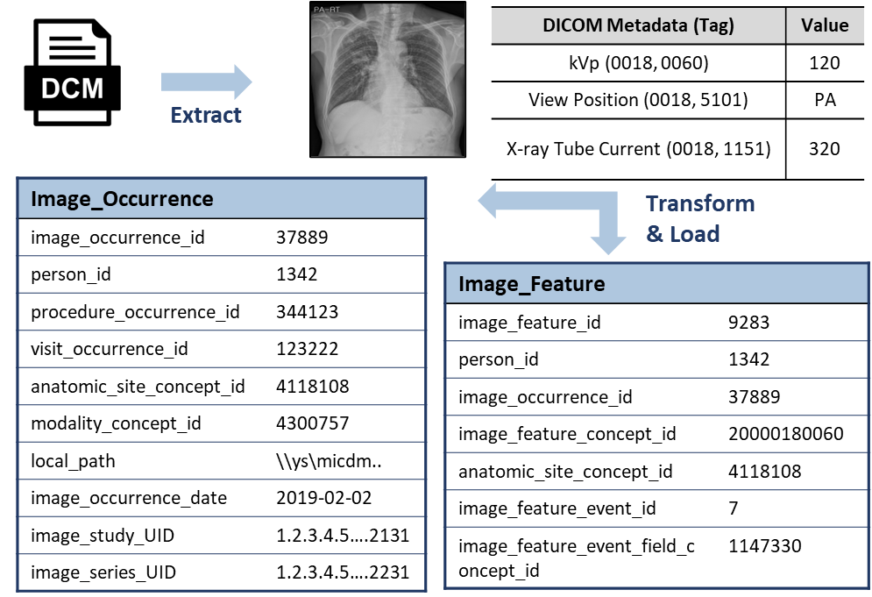
Figure 1. Extract-Transform-Load (ETL) Process of Medical Imaging CDM (MI-CDM)

A protocol-constrained imaging dataset was then defined using acquisition criteria (kVp 40–150; view position = PA) through an extended version of the ATLAS platform. The dataset definition utilized MI-CDM tables and was exported as SQL for downstream processing (Figure 2). A ResNet-based convolutional neural network was applied to classify TB versus non-TB across two validation datasets: (1) the protocol-constrained dataset filtered by DICOM metadata and (2) a randomly sampled dataset based solely on procedure codes. Ground-truth labels were assigned using structured TB diagnosis data, and model performance was evaluated using the area under the receiver operating characteristic curve (AUROC).
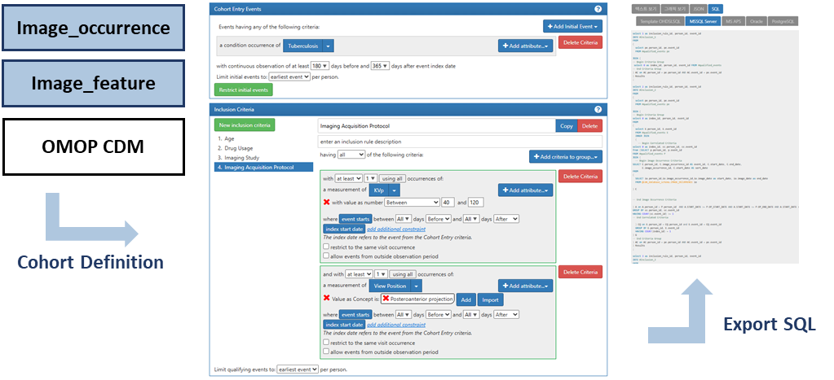
Figure 2. Cohort Definition using extended-ATLAS

Results
A total of 8,706 CXR DICOM files were collected from 4,309 patients. Of these, 3,559 files could not be linked to any entry in the procedure_occurrence table of the OMOP CDM and were excluded. The remaining 5,147 files from 3,050 patients were transformed and loaded into MI-CDM tables: Image_occurrence (5,147 rows, 2.1 MB), Measurement (288,806 rows, 32 MB), and Image_feature (288,806 rows, 15 MB) (Figure 1).
Two validation datasets were constructed: (1) a metadata-constrained dataset defined by DICOM acquisition parameters (view position = PA, kVp 40–150) using MI-CDM, and (2) a randomly sampled dataset selected based solely on procedure code ("Chest PA"). Both datasets included 2,614 images.
The AI model achieved significantly higher performance in the metadata-constrained dataset (AUROC = 0.838, 95% CI: 0.813–0.862) compared to the procedure-code–based dataset (AUROC = 0.683, 95% CI: 0.652–0.713). Despite comparable visual appearances, variation in acquisition parameters resulted in substantial differences in model performance, highlighting the importance of standardized imaging metadata for reproducible AI validation framework.

Conclusion
Using MI-CDM, we integrated real-world imaging metadata with structured clinical data and constructed validation datasets based on standardized acquisition parameters. Our findings demonstrate that relying solely on procedure codes can overlook critical imaging-specific context, leading to inconsistent model performance. By enabling structured, metadata-driven phenotyping, MI-CDM supports more precise dataset definition and improves the reproducibility of AI validation. Further validation across institutions and with refined protocol definitions is needed to support scalable, reproducible AI evaluation within distributed research networks.

References

- Park, W. Y., Jeon, K., Schmidt, T. S., Kondylakis, H., Alkasab, T., Dewey, B. E., You, S. C., & Nagy, P. (2024). Development of Medical Imaging Data Standardization for Imaging-Based Observational Research: OMOP Common Data Model Extension. Journal of Imaging Informatics in Medicine, 37(2), 899–908. https://doi.org/10.1007/s10278-024-00982-6
- Jeon, K., Park, W. Y., Kahn, C. E. J., Nagy, P., You, S. C., & Yoon, S. H. (2023). Advancing Medical Imaging Research Through Standardization: The Path to Rapid Development, Rigorous Validation, and Robust Reproducibility. Investigative Radiology, 10.1097/RLI.0000000000001106. https://doi.org/10.1097/RLI.0000000000001106
- Lakhani, P., & Sundaram, B. (2017). Deep Learning at Chest Radiography: Automated Classification of Pulmonary Tuberculosis by Using Convolutional Neural Networks. Radiology, 284(2), 574–582. https://doi.org/10.1148/radiol.2017162326
- Qin, Z. Z., Ahmed, S., Sarker, M. S., Paul, K., Adel, A. S. S., Naheyan, T., Barrett, R., Banu, S., & Creswell, J. (2021). Tuberculosis detection from chest x-rays for triaging in a high tuberculosis-burden setting: An evaluation of five artificial intelligence algorithms. The Lancet Digital Health, 3(9), e543–e554. https://doi.org/10.1016/S2589-7500(21)00116-3
- He, K., Zhang, X., Ren, S., & Sun, J. (2015). Deep Residual Learning for Image Recognition (arXiv:1512.03385). arXiv. https://doi.org/10.48550/arXiv.1512.03385
- Muralidharan, V., Adewale, B. A., Huang, C. J., Nta, M. T., Ademiju, P. O., Pathmarajah, P., Hang, M. K., Adesanya, O., Abdullateef, R. O., Babatunde, A. O., Ajibade, A., Onyeka, S., Cai, Z. R., Daneshjou, R., & Olatunji, T. (2024). A scoping review of reporting gaps in FDA-approved AI medical devices. Npj Digital Medicine, 7(1), 1–9. https://doi.org/10.1038/s41746-024-01270-x
- Naderalvojoud, B., Curtin, C. M., Yanover, C., El-Hay, T., Choi, B., Park, R. W., Tabuenca, J. G., Reeve, M. P., Falconer, T., Humphreys, K., Asch, S. M., & Hernandez-Boussard, T. (2024). Towards global model generalizability: Independent cross-site feature evaluation for patient-level risk prediction models using the OHDSI network. Journal of the American Medical Informatics Association, ocae028. https://doi.org/10.1093/jamia/ocae028
- Murad, M. H., Katabi, A., Benkhadra, R., & Montori, V. M. (2018). External validity, generalisability, applicability and directness: A brief primer. BMJ Evidence-Based Medicine, 23(1), 17–19. https://doi.org/10.1136/ebmed-2017-110800
- Pesapane, F., Codari, M., & Sardanelli, F. (2018). Artificial intelligence in medical imaging: Threat or opportunity? Radiologists again at the forefront of innovation in medicine. European Radiology Experimental, 2(1), 35. https://doi.org/10.1186/s41747-018-0061-6
- Oakden-Rayner, L. (2020). Exploring Large-scale Public Medical Image Datasets. Academic Radiology, 27(1), 106–112. https://doi.org/10.1016/j.acra.2019.10.006

