Cardiovascular and Kidney Outcomes of GLP-1 Receptor Agonists in Adults with Obesity: A Target Trial Emulation Study
Huilin Tang, PhD, MS^{1,2}, Yiwen Lu, BS^{1,3}, Bingyu Zhang, MS^{1,3}, Ting Zhou, MD, PhD^{1,2}, Dazheng Zhang, PhD^{1,2}, Jiajie Chen, PhD^{1,2}, Yong Chen, PhD⁴, David A. Asch, MD, MBA⁵⁻⁷, Yong Chen, PhD^{1-3,8-9}
- The Center for Health AI and Synthesis of Evidence (CHASE), University of Pennsylvania, Philadelphia, PA, USA
- Department of Biostatistics, Epidemiology, and Informatics, University of Pennsylvania Perelman School of Medicine, Philadelphia, PA, USA
- The Graduate Group in Applied Mathematics and Computational Science, School of Arts and Sciences, University of Pennsylvania, Philadelphia, PA, USA
- Pfizer Inc., New York City, NY, USA
- Leonard Davis Institute of Health Economics, University of Pennsylvania, Philadelphia, PA, USA
- Wharton School, University of Pennsylvania, Philadelphia, PA, USA
- Division of General Internal Medicine, Department of Medicine, Perelman School of Medicine, University of Pennsylvania, Philadelphia, PA, USA
- Penn Medicine Center for Evidence-based Practice (CEP), University of Pennsylvania, Philadelphia, PA, USA
- Penn Institute for Biomedical Informatics (IBI), University of Pennsylvania, Philadelphia, PA, USA

Background
Obesity is a growing global health issue, affecting over 890 million adults and contributing to type 2 diabetes (T2D), cardiovascular disease (CVD), chronic kidney disease (CKD), and mental health disorders^{1–4}. Glucagon-like peptide-1 receptor agonists (GLP-1RAs) have shown promise in obesity treatment by promoting weight loss via appetite suppression and delayed gastric emptying^{5–7}. Beyond weight control, GLP-1RAs have demonstrated cardiovascular and renal benefits in T2D, leading to their widespread use. However, their long-term effectiveness and safety in people with obesity without diabetes remain unclear, as most studies focus on short-term outcomes^{5–7}.
To address this gap, we conducted a target trial emulation using TriNetX electronic health record (EHR) data to compare GLP-1RAs with other anti-obesity medications (AOMs) in adults with obesity and no prior diabetes. We assessed cardiovascular, renal, mental health, and safety outcomes.
Methods
Study Design and Population
We emulated a target trial using de-identified data from TriNetX (July 2021–May 2025) ⁸. Adults aged ≥18 years with obesity (BMI ≥30 kg/m² or ICD-10-CM codes) and no diabetes diagnosis or glucose-lowering drug use were included. We included new users of GLP-1RAs (liraglutide, semaglutide, tirzepatide) or AOMs (orlistat, naltrexone/bupropion, phentermine/topiramate, lorcaserin). Exclusions included prior use of these drugs, end-stage kidney disease (ESKD)/dialysis, or history of study outcomes.
Exposure and Outcomes
The exposure was initiation of GLP-1RAs, with other AOMs serving as the comparator. Medications were identified using Anatomical Therapeutic Chemical (ATC) or RxNorm codes.
Primary outcomes included major adverse cardiovascular events (MACE: acute coronary syndrome, heart failure, stroke), major adverse kidney events (MAKE: end-stage kidney disease, dialysis, or estimated glomerular filtration rate [eGFR] <15), and all-cause mortality. Secondary outcomes encompassed individual cardiovascular and kidney events, acute kidney injury, mental health outcomes (e.g., suicidal ideation/attempt, depression, substance use disorder), and safety events (e.g., acute pancreatitis, hypoglycemia, gastrointestinal symptoms). Participants were followed from the index date until the first occurrence of the outcome, death, or end of the study period.
Statistical Analysis
We conducted 1:1 propensity score matching (PSM) using logistic regression based on all baseline covariates, including demographics, comorbidities, medications, laboratory values, and healthcare utilization measured in the year prior to treatment initiation. Covariate balance between treatment groups was evaluated using standardized mean differences (SMD), with values <0.1 indicating adequate balance.
Hazard ratios (HRs) and 95% confidence intervals (CIs) were estimated using Cox proportional hazards models, and Kaplan-Meier curves were generated to visualize event-free survival. Sensitivity analyses included limiting follow-up to one year and among older adults (aged ≥65 years). To assess potential unmeasured confounding, we examined two negative control outcomes: dog bite, nail disorders, hearing test and sebaceous cyst. All analyses were performed in R within the TriNetX platform.
Results
Study Cohort
After applying the inclusion criteria, 174,946 GLP-1RA and 197,057 AOM users were identified. PSM yielded 140,169 individuals per group with well-balanced characteristics (mean age 48 years; 71% women; 70% White). Mean follow-up was 392 days for GLP-1RAs and 564 days for AOMs.
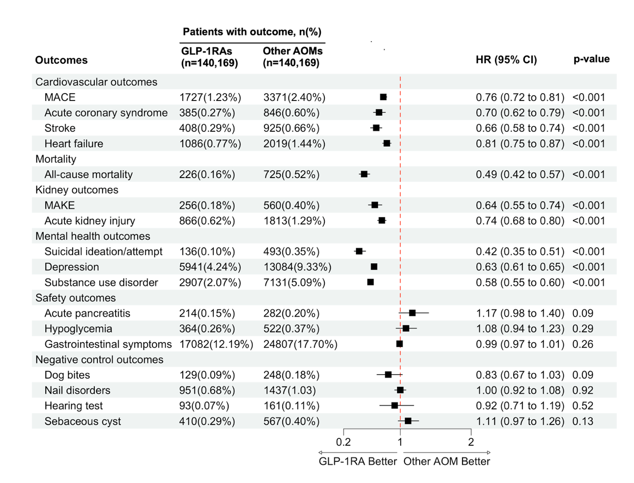
Figure 1. Effectiveness and safety outcomes with glucagon-like peptide-1 receptor agonists versus other anti-obesity medications in obese adults without diabetes.
Primary Results
The results were summarized in Figure 1. GLP-1RA use was associated with reduced risk of MACE (HR 0.76; 95% CI, 0.72–0.81), MAKE (HR 0.64; 95% CI, 0.55–0.74), and all-cause mortality (HR 0.49; 95% CI, 0.42–0.57). GLP-1RA users had lower risks of acute coronary syndrome (HR 0.70), heart failure (HR 0.81), stroke (HR 0.66), and acute kidney injury (HR 0.74). Mental health outcomes were also improved: depression (HR 0.63), suicidal ideation/attempt (HR 0.42), and substance use disorder (HR 0.58). No significant differences were observed for risks of pancreatitis (HR 1.17) or gastrointestinal symptoms (HR 0.99) and Hypoglycemia (HR 1.08).
Sensitivity Analyses
Results remained consistent when limited to one-year follow-up or to older adults. No associations were found for negative control outcomes, suggesting minimal unmeasured confounding.
Conclusion
In this large real-world study, GLP-1RAs were associated with lower risks of cardiovascular, kidney, mental health events, and mortality in obese adults without diabetes, with no major safety concerns. These findings support the expanded use of GLP-1RAs in obesity management beyond glycemic control.

References
1. World Health Organization. Obesity and overweight. 2025. Accessed February 21, 2025. https://www.who.int/news-room/fact-sheets/detail/obesity-and-overweight
2. Powell-Wiley TM, Poirier P, Burke LE, et al. Obesity and Cardiovascular Disease: A Scientific Statement From the American Heart Association. Circulation. 2021;143(21):e984-e1010. doi:10.1161/CIR.0000000000000973
3. Field AE, Coakley EH, Must A, et al. Impact of Overweight on the Risk of Developing Common Chronic Diseases During a 10-Year Period. Arch Intern Med. 2001;161(13):1581-1586. doi:10.1001/archinte.161.13.1581
4. Kivimäki M, Strandberg T, Pentti J, et al. Body-mass index and risk of obesity-related complex multimorbidity: an observational multicohort study. Lancet Diabetes Endocrinol. 2022;10(4):253-263. doi:10.1016/S2213-8587(22)00033-X
5. Wilding JPH, Batterham RL, Calanna S, et al. Once-Weekly Semaglutide in Adults with Overweight or Obesity. N Engl J Med. 2021;384(11):989-1002. doi:10.1056/NEJMoa2032183
6. Jastreboff AM, le Roux CW, Stefanski A, et al. Tirzepatide for Obesity Treatment and Diabetes Prevention. N Engl J Med. Published online November 13, 2024. doi:10.1056/NEJMoa2410819
7. Garvey WT, Frias JP, Jastreboff AM, et al. Tirzepatide once weekly for the treatment of obesity in people with type 2 diabetes (SURMOUNT-2): a double-blind, randomised, multicentre, placebo-controlled, phase 3 trial. Lancet Lond Engl. 2023;402(10402):613-626. doi:10.1016/S0140-6736(23)01200-X
8. Palchuk MB, London JW, Perez-Rey D, et al. A global federated real-world data and analytics platform for research. JAMIA Open. 2023;6(2):ooad035. doi:10.1093/jamiaopen/ooad035

