Impact of Comorbid Depression on Insulin Initiation and Cardiovascular Events Among Patients with Type 2 Diabetes Mellitus: A Multinational Cohort Study
Christianus Heru Setiawan^{1,2}, Seonghwan Shin³, Seonji Kim^{4,5}, Seng Chan You^{4,5}, Phan Thanh-Phuc⁶, Septi Melisa⁶, Muhammad Solihuddin Muhtar⁶, Nguyen Phung-Anh^{7,8,9}, Jason C. Hsu^{6,7,8,9*}

¹ Ph.D. Program, School of Pharmacy, Taipei Medical University, Taipei, Taiwan
² Faculty of Pharmacy, Sanata Dharma University, Yogyakarta, Indonesia
³ Department of Biomedical Informatics, Ajou University Graduate School of Medicine
⁴ Department of Biomedical Systems Informatics, Yonsei University College of Medicine, Seoul, Korea
⁵ Yonsei Institute for Digital Health, Yonsei University, Seoul, Korea
⁶ International Ph.D. Program in Biotech and Healthcare Management, College of Management, Taipei Medical University, Taipei, Taiwan
⁷ Clinical Data Center, Office of Data Science, Taipei Medical University, Taipei, Taiwan
⁸ Research Center of Data Science on Healthcare Industry, College of Management, Taipei Medical University, Taipei, Taiwan
⁹ Clinical Big Data Research Center, Taipei Medical University Hospital, Taipei Medical University, Taipei, Taiwan
*Supervisor

Background
The relationship between depression and diabetes is complex and bidirectional. Depression can lead to poorer diabetes management, which can in turn worsen depressive symptoms¹. Depression can also lead to poor outcomes and may cause insulin resistance, which can worsen high blood sugar levels and cause complications^{2,3}. In individuals with type 2 diabetes, the comorbidity of depression is a critical factor that contributes to increased cardiovascular morbidity and mortality. It has been suggested that depression in type 2 diabetes may exacerbate cardiovascular risk through pathways such as chronic inflammation, dysregulation of the hypothalamic-pituitary-adrenal (HPA) axis, enhanced sympathetic nervous system (SNS) tone, and poorer adherence to diabetes self-care and pharmacotherapy^{4,5}. Through the application of the Observational Health Data Sciences and Informatics (OHDSI) framework, this research seeks to elucidate the complex interplay between mental health, diabetes progression, and vascular complications, potentially informing more targeted therapeutic strategies for this high-risk patient population.

Methods
Data source
This was a comparative cohort study that included 3 Observational Medical Outcomes Partnership (OMOP) Common Data Model (CDM) databases: Taipei Medical University Clinical Research Database (TMUCRD), Ajou University School of Medicine (AUSOM), and Yonsei University Health System (YUHS).

Cohort construction
We included T2DM patients with at least one oral antidiabetic medication prescription, age ≥18 years old, and having at least 1-year database history. The exclusion criteria are the history of maternity-related codes, schizophrenia, and bipolar disorder-related codes. An index date was designated corresponding to the initial prescription of oral antidiabetic agents after T2DM diagnosis.

The comparative group consisted of T2DM patients without depression diagnosis and depression medication before or after the index date. The target group consisted of T2DM patients who had depression diagnosis and depression medication after the first DM medication and without depression diagnosis and depression medication before the index date. The outcome is the cardiovascular event consists of occurrence of acute coronary syndrome (ACS), myocardial infarction (MI), and stroke event with same-day hospitalization (inpatient or emergency department visit) with at least 6 months after the index date. The cohort end date will be based on a continuous exposure to 'Oral DM Medication': allowing 90 days between exposures and adding 0 days after exposure ends.

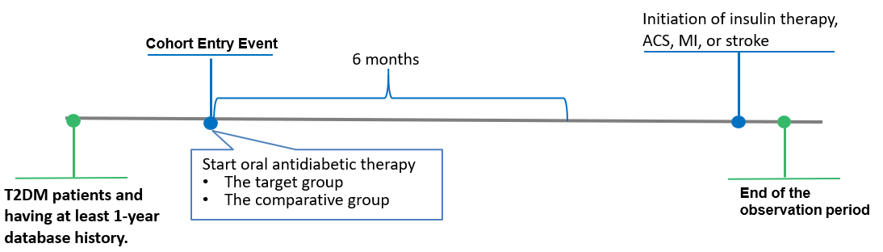
Figure 1. The cohort design

Analysis methods
The target cohort and comparator cohorts will be stratified into ten quantiles of the propensity score distribution. The final outcome model will apply a conditional Cox proportional hazard model, conditions on the propensity score strata. Furthermore, we used negative control outcomes to calibrate the P values for the HRs estimated from Cox proportional hazard models. The negative controls were obtained from Atlas Demo (https://atlas-demo.ohdsi.org/). We selected exposure-outcome pairs, in this case, we used concept sets of depression and type 2 diabetes. However, the concept set must contain only conditions or drugs to explore evidence. So, we generated from the type 2 diabetes and depression medications from the suggested list (we exclude without standard vocabulary). We used on-treatment risk window of which time-at-risk starts on 180 days after cohort entry event treatment initiation to avoid immortal time bias. To avoid misclassification bias, on-treatment risk windows of which time-at-risk end on 60 days after cohort exit.

The time-to-event of outcome among patients in the target and comparator cohorts is determined by calculating the number of days from the start of the time-at-risk window (at least 6 months after the cohort start date), until the earliest event among 1) the first occurrence of the outcome and 2) the end of continuous observation. We remove subjects that have the outcome prior to the risk window start. The HR of each outcome from each study site was obtained and meta-analyzed using a random-effects model to quantify a consensus HR for each outcome, using the meta R package (R 4.3.2).

Results
- Outcome: Insulin initiation
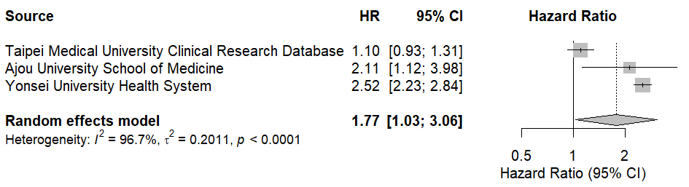

- Outcome: ACS
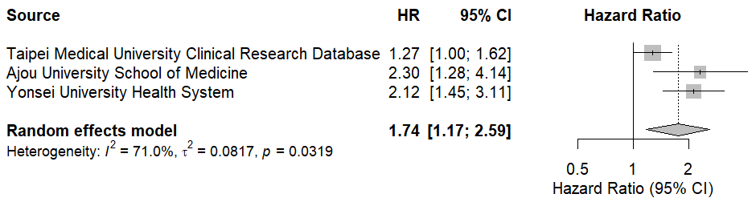

- Outcome: MI
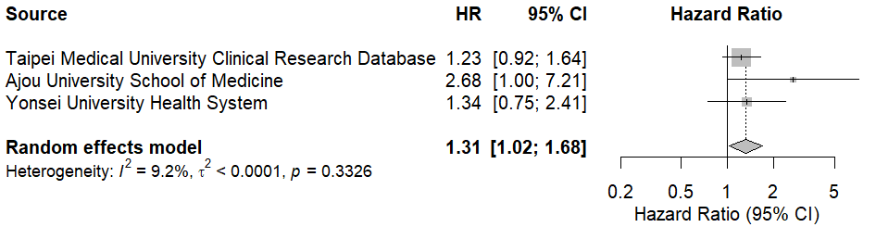

- Outcome: Stroke
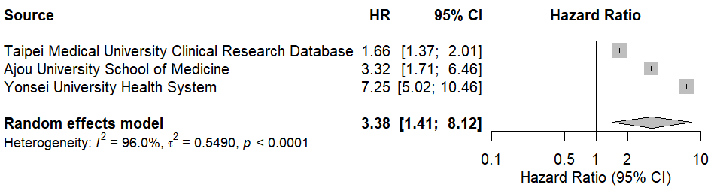
Figure 2. Estimated and Consensus Hazard Ratios for the Comparative Effectiveness and Safety
of T2DM patient with depression vs T2DM patient without depression
Meta-analytic synthesis demonstrated a significantly elevated risk of insulin initiation among patients with type 2 diabetes mellitus (T2DM) and comorbid depression compared to those without depression (HR = 1.77, 95% CI: 1.03–3.06, I² = 96.7%), with consistent directionality across the three participating databases, indicating robustness despite high heterogeneity. The association between comorbid depression and acute coronary syndrome (ACS) was statistically significant (HR = 1.74, 95% CI: 1.17–2.59, I² = 71.0%). Similarly, pooled estimates for myocardial infarction (MI) and stroke failed to reach statistical significance (MI: HR = 1.31, 95% CI: 1.02–1.68, I² = 9.2%; stroke: HR = 3.38, 95% CI: 1.41–8.12, I² = 96.0%).

Conclusion
This multinational OHDSI-based cohort study identified a significant association between comorbid depression and increased risks of insulin initiation and cardiovascular outcome in patients with type 2 diabetes mellitus. The elevated hazard for stroke, despite low heterogeneity, further suggests a potential cerebrovascular impact. These findings underscore the importance of integrated mental and metabolic care and support the need for routine depression screening in diabetes management to mitigate adverse clinical outcomes.

References
1. Nouwen A, Adriaanse MC, van Dam K, et al. Longitudinal associations between depression and diabetes complications: a systematic review and meta-analysis. Diabetic Medicine. 2019;36(12):1562-1572. doi:https://doi.org/10.1111/dme.14054
2. Moulton CD, Pickup JC, Ismail K. The link between depression and diabetes: the search for shared mechanisms. Lancet Diabetes Endocrinol. Jun 2015;3(6):461-471. doi:10.1016/s2213-8587(15)00134-5
3. Semenkovich K, Brown ME, Svrakic DM, Lustman PJ. Depression in type 2 diabetes mellitus: prevalence, impact, and treatment. Drugs. Apr 2015;75(6):577-87. doi:10.1007/s40265-015-0347-4
4. Champaneri S, Wand GS, Malhotra SS, Casagrande SS, Golden SH. Biological basis of depression in adults with diabetes. Curr Diab Rep. Dec 2010;10(6):396-405. doi:10.1007/s11892-010-0148-9
5. Laake JP, Stahl D, Amiel SA, et al. The association between depressive symptoms and systemic inflammation in people with type 2 diabetes: findings from the South London Diabetes Study. Diabetes Care. Aug 2014;37(8):2186-92. doi:10.2337/dc13-2522

Supplementary Table 1. Data Source
Data source | Population | Patients (millions) | History | Description
Taipei Medical University Clinical Research Database (TMUCRD) | Taiwan, general | 4.15 | 2004 to 2021 | Electronic health record database from academic medical center (Taipei Medical University Hospital, Wanfang Hospital, and Shuang Ho Hospital)
Ajou University School of Medicine (AUSOM) | Korea, general | 2.8 | 1994-2023 | Electronic health record database from academic medical center
Yonsei University Health System (YUHS) | Korea, general | 5.4 | 1997-2023 | Electronic health record database from academic medical center

Supplementary Table 2. Oral antidiabetic agent
Concept Id | Concept Name | Domain | Vocabulary | Excluded | Descendants | Mapped
1510202 | Miglitol | Drug | RxNorm | NO | YES | NO
1529331 | Acarbose | Drug | RxNorm | NO | YES | NO
19033909 | phenformin | Drug | RxNorm | NO | YES | NO
1503297 | metformin | Drug | RxNorm | NO | YES | NO
19122137 | vildagliptin | Drug | RxNorm | NO | YES | NO
1580747 | sitagliptin | Drug | RxNorm | NO | YES | NO
40166035 | saxagliptin | Drug | RxNorm | NO | YES | NO
40239216 | linagliptin | Drug | RxNorm | NO | YES | NO
43009089 | gemigliptin | Drug | RxNorm | NO | YES | NO
43009051 | evogliptin | Drug | RxNorm | NO | YES | NO
43013884 | alogliptin | Drug | RxNorm | NO | YES | NO
793143 | semaglutide | Drug | RxNorm | NO | YES | NO
44506754 | lixisenatide | Drug | RxNorm | NO | YES | NO
40170911 | liraglutide | Drug | RxNorm | NO | YES | NO
1583722 | exenatide | Drug | RxNorm | NO | YES | NO
45774435 | dulaglutide | Drug | RxNorm | NO | YES | NO
44816332 | albiglutide | Drug | RxNorm | NO | YES | NO
43009020 | ipragliflozin | Drug | RxNorm | NO | YES | NO
793293 | ertugliflozin | Drug | RxNorm | NO | YES | NO
45774751 | empagliflozin | Drug | RxNorm | NO | YES | NO
44785829 | dapagliflozin | Drug | RxNorm | NO | YES | NO
43526465 | canagliflozin | Drug | RxNorm | NO | YES | NO
1502855 | tolbutamide | Drug | RxNorm | NO | YES | NO
1502809 | tolazamide | Drug | RxNorm | NO | YES | NO
1559684 | glyburide | Drug | RxNorm | NO | YES | NO
40798860 | Glisoxepide | Drug | RxNorm | NO | YES | NO
19097821 | gliquidone | Drug | RxNorm | NO | YES | NO
1560171 | glipizide | Drug | RxNorm | NO | YES | NO
1597756 | glimepiride | Drug | RxNorm | NO | YES | NO
19059796 | gliclazide | Drug | RxNorm | NO | YES | NO
19001409 | glibornuride | Drug | RxNorm | NO | YES | NO
1594973 | chlorpropamide | Drug | RxNorm | NO | YES | NO
19033498 | carbutamide | Drug | RxNorm | NO | YES | NO
1530014 | acetohexamide | Drug | RxNorm | NO | YES | NO
1515249 | troglitazone | Drug | RxNorm | NO | YES | NO
1547504 | rosiglitazone | Drug | RxNorm | NO | YES | NO
1525215 | pioglitazone | Drug | RxNorm | NO | YES | NO

Supplementary Table 3. Type 2 diabetes mellitus
Concept Id | Concept Name | Domain | Vocabulary | Excluded | Descendants | Mapped
45766052 | Type II diabetes mellitus in remission | Condition | SNOMED | YES | NO | NO
201826 | Type 2 diabetes mellitus | Condition | SNOMED | NO | YES | NO
43531010 | Pre-existing type 2 diabetes mellitus in pregnancy | Condition | SNOMED | YES | NO | NO
4063043 | Pre-existing type 2 diabetes mellitus | Condition | SNOMED | YES | NO | NO

Supplementary Table 4. Insulin
Concept Id | Concept Name | Domain | Vocabulary | Excluded | Descendants | Mapped
1586369 | ultralente insulin, human | Drug | RxNorm | NO | YES | NO
19090221 | ultralente insulin, beef-pork | Drug | RxNorm | NO | YES | NO
19090226 | ultralente insulin, beef | Drug | RxNorm | NO | YES | NO
44506754 | lixisenatide | Drug | RxNorm | NO | YES | NO
40170911 | liraglutide | Drug | RxNorm | NO | YES | NO
1562586 | lente insulin, pork | Drug | RxNorm | NO | YES | NO
1513843 | lente insulin, beef-pork | Drug | RxNorm | NO | YES | NO
19090204 | lente insulin, beef | Drug | RxNorm | NO | YES | NO
1586346 | insulin, regular, pork | Drug | RxNorm | NO | YES | NO
1596977 | insulin, regular, human | Drug | RxNorm | NO | YES | NO
1590165 | insulin, regular, beef-pork | Drug | RxNorm | NO | YES | NO
19013951 | insulin, regular, beef | Drug | RxNorm | NO | YES | NO
19090187 | insulin, protamine zinc, pork | Drug | RxNorm | NO | YES | NO
19091621 | insulin, protamine zinc, human | Drug | RxNorm | NO | YES | NO
19013926 | insulin, protamine zinc, beef-pork | Drug | RxNorm | NO | YES | NO
19090180 | insulin, protamine zinc, beef | Drug | RxNorm | NO | YES | NO
19090249 | insulin, prompt zinc, pork | Drug | RxNorm | NO | YES | NO
19090247 | insulin, prompt zinc, human | Drug | RxNorm | NO | YES | NO
19090229 | insulin, prompt zinc, beef-pork | Drug | RxNorm | NO | YES | NO
19090244 | insulin, prompt zinc, beef | Drug | RxNorm | NO | YES | NO
42899447 | insulin, pork | Drug | RxNorm | NO | YES | NO
1513876 | insulin lispro protamine, human | Drug | RxNorm | NO | YES | NO
1550023 | insulin lispro | Drug | RxNorm | NO | YES | NO
46221581 | insulin isophane | Drug | RxNorm | NO | YES | NO
1588986 | insulin human, rDNA origin | Drug | RxNorm | NO | YES | NO
1544838 | insulin glulisine, human | Drug | RxNorm | NO | YES | NO
1502905 | insulin glargine | Drug | RxNorm | NO | YES | NO
1516976 | insulin detemir | Drug | RxNorm | NO | YES | NO
35602717 | insulin degludec | Drug | RxNorm | NO | YES | NO
1567198 | insulin aspart, human | Drug | RxNorm | NO | YES | NO
1531601 | insulin aspart protamine, human | Drug | RxNorm | NO | YES | NO
35198096 | insulin aspart | Drug | RxNorm | NO | YES | NO

Supplementary Table 5. Exclusion criteria
Concept Id | Concept Name | Domain | Vocabulary | Excluded | Descendants | Mapped
4224940 | Schizoaffective disorder, depressive type | Condition | SNOMED | NO | YES | NO
4244078 | Schizoaffective disorder, bipolar type | Condition | SNOMED | NO | YES | NO
4332994 | Post-schizophrenic depression | Condition | SNOMED | NO | YES | NO
4133073 | Maternity blues | Condition | SNOMED | NO | YES | NO
436665 | Bipolar disorder | Condition | SNOMED | NO | YES | NO

Supplementary Table 6. Depression
Concept Id | Concept Name | Domain | Vocabulary | Excluded | Descendants | Mapped
4224940 | Schizoaffective disorder, depressive type | Condition | SNOMED | NO | YES | NO
4332994 | Post-schizophrenic depression | Condition | SNOMED | NO | YES | NO
4175329 | Organic mood disorder of depressed type | Condition | SNOMED | NO | YES | NO
4133073 | Maternity blues | Condition | SNOMED | YES | NO | NO
440383 | Depressive disorder | Condition | SNOMED | NO | YES | NO
436665 | Bipolar disorder | Condition | SNOMED | YES | NO | NO
442306 | Adjustment disorder with depressed mood | Condition | SNOMED | NO | YES | NO

Supplementary Table 7. Depression medication
Concept Id | Concept Name | Domain | Vocabulary | Excluded | Descendants | Mapped
44507700 | vortioxetine | Drug | RxNorm | NO | YES | NO
42899140 | Hypericum perforatum leaf extract | Drug | RxNorm | NO | YES | NO
42899139 | Hypericum extract | Drug | RxNorm | NO | YES | NO
40799195 | Zimeldine | Drug | RxNorm | NO | YES | NO
40798767 | Dimetacrine | Drug | RxNorm | NO | YES | NO
40234834 | vilazodone | Drug | RxNorm | NO | YES | NO
36878783 | Agomelatine | Drug | RxNorm | NO | YES | NO
19129635 | opipramol | Drug | RxNorm | NO | YES | NO
19128066 | nomifensine | Drug | RxNorm | NO | YES | NO
19127550 | nialamide | Drug | RxNorm | NO | YES | NO
19122204 | iprindole | Drug | RxNorm | NO | YES | NO
19110751 | melitracen | Drug | RxNorm | NO | YES | NO
19100775 | toloxatone | Drug | RxNorm | NO | YES | NO
19098514 | quinupramine | Drug | RxNorm | NO | YES | NO
19091830 | lofepramine | Drug | RxNorm | NO | YES | NO
19084693 | reboxetine | Drug | RxNorm | NO | YES | NO
19080226 | milnacipran | Drug | RxNorm | NO | YES | NO
19072123 | minaprine | Drug | RxNorm | NO | YES | NO
19072021 | medifoxamine | Drug | RxNorm | NO | YES | NO
19058055 | bifemelane | Drug | RxNorm | NO | YES | NO
19041910 | tianeptine | Drug | RxNorm | NO | YES | NO
19039883 | butriptyline | Drug | RxNorm | NO | YES | NO
19037989 | dothiepin | Drug | RxNorm | NO | YES | NO
19032424 | amineptin | Drug | RxNorm | NO | YES | NO
19023846 | dibenzepin | Drug | RxNorm | NO | YES | NO
19010652 | moclobemide | Drug | RxNorm | NO | YES | NO
19008261 | viloxazine | Drug | RxNorm | NO | YES | NO
19007737 | mianserin | Drug | RxNorm | NO | YES | NO
19006186 | tryptophan | Drug | RxNorm | NO | YES | NO
1366610 | esketamine | Drug | RxNorm | NO | YES | NO
1363516 | 5-hydroxytryptophan | Drug | RxNorm | NO | YES | NO
798834 | clomipramine | Drug | RxNorm | NO | YES | NO
797617 | citalopram | Drug | RxNorm | NO | YES | NO
794147 | maprotiline | Drug | RxNorm | NO | YES | NO
781705 | isocarboxazid | Drug | RxNorm | NO | YES | NO
778268 | imipramine | Drug | RxNorm | NO | YES | NO
755695 | fluoxetine | Drug | RxNorm | NO | YES | NO
754270 | protriptyline | Drug | RxNorm | NO | YES | NO
751412 | fluvoxamine | Drug | RxNorm | NO | YES | NO
750982 | bupropion | Drug | RxNorm | NO | YES | NO
743670 | venlafaxine | Drug | RxNorm | NO | YES | NO
739138 | sertraline | Drug | RxNorm | NO | YES | NO
738156 | doxepin | Drug | RxNorm | NO | YES | NO
733896 | phenelzine | Drug | RxNorm | NO | YES | NO
725131 | mirtazapine | Drug | RxNorm | NO | YES | NO
722031 | paroxetine | Drug | RxNorm | NO | YES | NO
721724 | nortriptyline | Drug | RxNorm | NO | YES | NO
717607 | desvenlafaxine | Drug | RxNorm | NO | YES | NO
716968 | desipramine | Drug | RxNorm | NO | YES | NO
715939 | escitalopram | Drug | RxNorm | NO | YES | NO
715259 | duloxetine | Drug | RxNorm | NO | YES | NO
714684 | nefazodone | Drug | RxNorm | NO | YES | NO
713109 | amoxapine | Drug | RxNorm | NO | YES | NO
710062 | amitriptyline | Drug | RxNorm | NO | YES | NO
705755 | trimipramine | Drug | RxNorm | NO | YES | NO
703547 | trazodone | Drug | RxNorm | NO | YES | NO
703470 | tranylcypromine | Drug | RxNorm | NO | YES | NO

Supplementary Table 8. Acute coronary syndrome
Concept Id | Concept Name | Domain | Vocabulary | Excluded | Descendants | Mapped
312327 | Acute myocardial infarction | Condition | SNOMED | NO | YES | NO
315296 | Preinfarction syndrome | Condition | SNOMED | NO | YES | NO
434376 | Acute myocardial infarction of anterior wall | Condition | SNOMED | NO | YES | NO
438170 | Acute myocardial infarction of inferior wall | Condition | SNOMED | NO | YES | NO
444406 | Acute subendocardial infarction | Condition | SNOMED | NO | YES | NO

Supplementary Table 9. Myocardial infarction
Concept Id | Concept Name | Domain | Vocabulary | Excluded | Descendants | Mapped
4329847 | Myocardial infarction | Condition | SNOMED | NO | YES | NO
314666 | Old myocardial infarction | Condition | SNOMED | YES | YES | NO

Supplementary Table 10. Stroke
Concept Id | Concept Name |  | Domain | Vocabulary | Excluded | Descendants | Mapped
372924 | Cerebral artery occlusion | Condition |  | SNOMED | NO | NO | NO
375557 | Cerebral embolism | Condition |  | SNOMED | NO | NO | NO
376713 | Cerebral hemorrhage | Condition |  | SNOMED | NO | NO | NO
432923 | Subarachnoid hemorrhage | Condition |  | SNOMED | NO | NO | NO
439847 | Intracranial hemorrhage | Condition |  | SNOMED | NO | NO | NO
441874 | Cerebral thrombosis | Condition |  | SNOMED | NO | NO | NO
443454 | Cerebral infarction | Condition |  | SNOMED | NO | YES | NO
4148906 | Spontaneous subarachnoid hemorrhage | Condition |  | SNOMED | NO | NO | NO
43530727 | Spontaneous cerebral hemorrhage | Condition |  | SNOMED | NO | NO | NO

