Enhancing empirical comparator recommendations with user specified weights: approach and assessment

Cameron R. Atkins, Jamie P. Gilbert, Christopher Knoll, David M. Kern, Patrick B. Ryan, Justin Bohn

Background
The active comparator new user (ACNU) cohort design has emerged as a best practice for the estimation of drug effects from observational data. However, despite its advantages, this design requires the sometimes-challenging process of selecting and evaluating comparators for appropriateness. We previously sought to address this challenge by introducing an empirical method to rank candidate comparators by their similarity to a target drug in high-dimensional covariate space and implemented it in an interactive web application(1). In this latest iteration, we extend the tool to allow users to apply custom weights to specific covariate domains, enabling more tailored and context-specific comparator selection based on user-defined requirements.

Methods
Our similarity pipeline involves the bulk generation of ingredient and class-level new user cohorts, followed by covariate data extraction, and similarity calculation (see (2) for details). In particular, aggregated pre-treatment covariate data is extracted for each cohort using five clinically oriented covariate domains: demographics (age and sex), presentation (conditions occurring ≤30 days before treatment), medical history (conditions occurring > 30 days before treatment), prior medications (medications begun > 30 days before treatment), and visit context (inpatient and emergency visits in the 30 days before treatment). A web application(1) was also developed to allow users to specify a target drug and receive a list of candidate comparators ranked by overall similarity, computed as the unweighted average of domain-specific cosine similarities. In this software demonstration, we will describe the implementation of user-specifiable weights for the five covariate domains and discuss their impact on final similarity scores and corresponding comparator recommendations.

Results
The comparator selection explorer tool interface allows users to input custom weights for covariate domains, enabling personalized similarity calculations. This is shown in Figure 1, where users adjust sliders to reflect the relative importance of each domain.
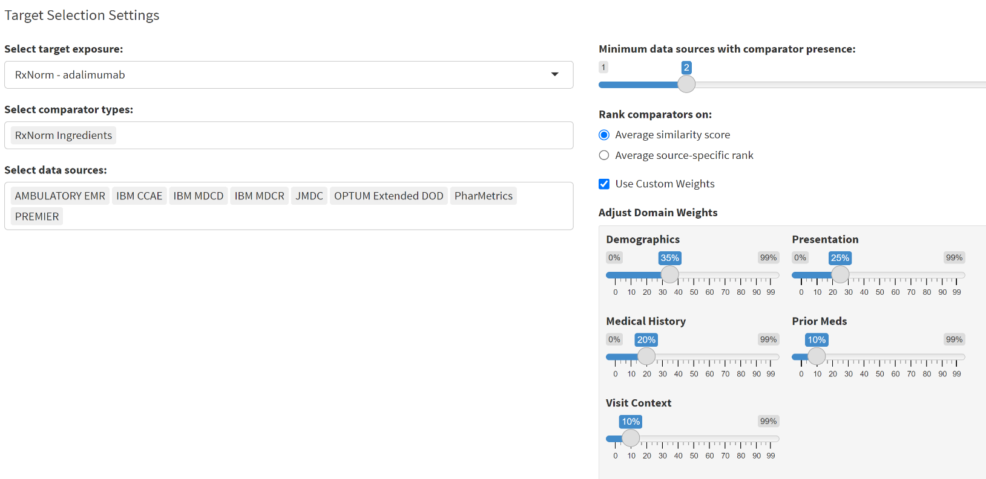
Figure 1: User assigns optional weights to covariate domains via sliders. These weights are normalized to sum to 1 before being applied to the similarity calculation.

Table 1 summarizes the impact of user-defined domain weights on the overall similarity score between a target (adalimumab) and a comparator (azathioprine) cohort. The Unweighted Cosine Similarity column displays cosine similarity scores for each domain. User Weight Set A and User Weight Set B reflect different user priorities, where Set A emphasizes prior meds (weight = 0.5) and Medical history (weight = 0.3), while Set B places greater weight on Presentation (weight = 0.5) and Demographics (weight = 0.3). Applying these weights shifts the contribution of each domain to the final score, resulting in a weighted final similarity score of 0.949 under Set A and 0.785 under Set B. This capability supports more nuanced interpretation and enables investigator-specific tailoring of comparator selection beyond uniform weighting.
Covariate Domain | Unweighted Cosine Similarity | User Weight Set A | User Weight Set B
Demographics | .997 | 0.05 | 0.3
Presentation | .588 | 0.05 | 0.5
Medical history | .946 | 0.3 | 0.05
prior meds | .979 | 0.5 | 0.05
visit context | .962 | 0.1 | 0.1
average | .895 | Re-weighted average similarity under set A .949 | Re-weighted average similarity under set B .785

Table 1: Domain-level cosine similarities before and after applying user-defined weights, illustrating each domain’s contribution to the overall weighted similarity score.

Conclusion
This software demonstration presents an enhanced utility for generating empirical comparator recommendations, with the added capability for users to apply custom covariate domain weights. This added flexibility allows investigators to tailor similarity assessments to the specific context of their research, potentially improving the relevance of recommendations. While the core (i.e., equally-weighted) method continues to align broadly with clinical knowledge, published literature, and drug hierarchies, the ability to emphasize selected domains may refine the comparator selection process further, albeit at the cost of introducing additional investigator subjectivity. Despite these challenges, this enhanced tool offers flexible, context-aware comparator recommendations that can balance empirical information with user-defined beliefs concerning covariate relevance. Demonstration of this functionality will therefore aid in the assessment of its utility to the broader scientific community.

References/Citations
1. ComparatorSelectionExplorer [Internet]. [cited 2025 Jun 19]. Available from: https://data.ohdsi.org/ComparatorSelectionExplorer/
2. Bohn J, Gilbert JP, Knoll C, Kern DM, Ryan PB. Large-scale Empirical Identification of Candidate Comparators for Pharmacoepidemiological Studies. Drug Saf. 2025 Jun 4;

